Queen Elizabeth’s High School

An Outstanding 11-18 Grammar. Original Charter 1589.

Vacancy Information Booklet
Design and Technology Technician
32.5 hours per week, 38 weeks per year, permanent
Grade 5, Points 12-15 (£21,153 – £23,971 per annum pro rata)

Queen Elizabeth’s High School is entirely committed to safeguarding and promoting the well-being of all of its students. Each student’s welfare is of paramount importance. Successful candidates are therefore required to reveal information concerning all convictions and offers of employment will be subject to an enhanced background check by the Disclosure and Barring Service (DBS)

Closing Date: Midday on Monday 27 September 2021
Interviews: To be held week commencing 4 October 2021

School Vision
Queen Elizabeth’s High School is a school where children can grow and develop into successful young adults who are equipped with the knowledge, skills and qualifications to follow their dreams and aspirations. Qualifications are a key element of that success and our past results at both GCSE and A Level speak for themselves; we are regularly listed in The Times top 200 schools list. However, education is more than that, and here at QEHS we provide a safe environment in which young people can grow and learn who they are, what interests them and who they would like to be in the future.
School Motto and Values
Tradition Achievement Opportunity
At Queen Elizabeth's High School we aim for high standards in all we do.
♦ We strive to fulfil the potential of each student.
♦ We aim to achieve this through a carefully planned, broad education in which enthusiastic teachers use a variety of teaching styles in activities inside and outside the classroom.
♦ We aim to maintain a friendly and caring atmosphere in which students and staff share a mutual respect.
♦ When they leave Queen Elizabeth's High School we want students to be well-balanced adults, inspired to continue their learning and able to contribute positively to society.
♦ Queen Elizabeth’s High School is committed to the highest possible standards of child protection.
The selection criteria for student admission to QEHS in Years 7-11 benefits children of staff who have worked at our school for more than two years, or who are recruited to fill certain key posts. See the full Admissions Policy on our school website (www.qehs.lincs.sch.uk).
The Vacancy
This vacancy has arisen for a Design and Technology Technician.
The successful candidate will work as a technician in a successful Design and Technology Faculty. They will support the teaching staff within the faculty by providing a practical and competent service through maintenance, preparation and provision of equipment enabling the school to progress in technical subjects.
It is essential that the technician is aware of current health and safety requirements, ensuring that safety standards are understood, met and maintained by those employees and students who are working with technical equipment. They will also ensure that all equipment is safe to use and service the machinery as required. The candidate will be responsible for preparing a range of materials and setting up machinery and equipment for design and technology lessons.
The applicant will be enthusiastic, willing to learn and keen to take advantage of the training opportunities available, which may be in, or out of, school. Above all the applicant will be friendly, flexible, good humoured and able to work effectively as part of a team.
The salary for this post is Grade 5, Points 12-15. This equates to £21,153 to £23,971 per annum (pro rata).
The successful candidate will work 32.5 hours per week/39 weeks per year.

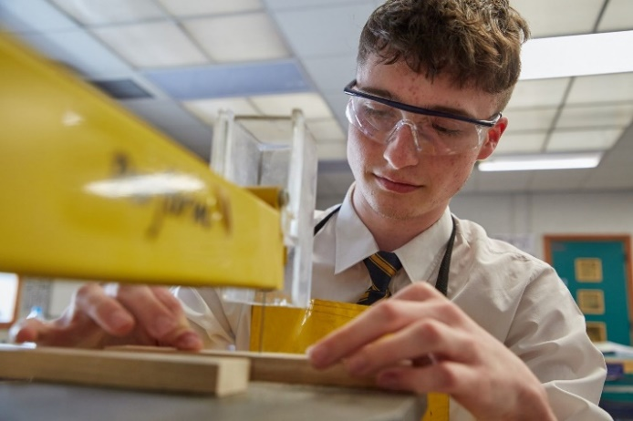

HOW TO APPLY
We believe that QEHS is a great place to work. Please read the information in this booklet, the subject teacher job description and have a look at our website. Should you wish to apply, application details are available on our school website (www.qehs.lincs.sch.uk) or by emailing a request to recruitment@qehs.lincs.sch.uk.

A letter of application is required to accompany the formal application form. This must be limited to one side of A4 paper and is an opportunity for you to explain how you believe your own experience equips you for the post and for you to outline how you would approach this role at QEHS.
You are also welcome to telephone 01427 612354 ext. 267/264 if you have any questions about the post.

Completed applications should be submitted by email to recruitment@qehs.lincs.sch.uk by midday on Monday 27 September 2021. We will contact your referees for a reference before the interviews and, for shortlisted candidates, the references will be taken into account in deliberations at the conclusion of the final panel interviews. Interviews will be held week commencing 4 October 2021.

Candidates are required to bring to interview evidence of all relevant qualifications listed on their application as well as certificates for A Level, degree, teaching and other qualifications acquired. Please also bring proof of identity, including at least one item of photographic evidence (current passport or new style UK driving license with associated counterpart licence). A list will be provided detailing which documents can support your application. Please be aware that at least one document should include your National Insurance number. Candidates will also be provided with a self-disclosure form. This will allow them the opportunity to disclose and fully explain any information with regard to disciplinary sanctions, anything they are concerned might appear on their DBS, etc.

Candidates are required to bring to interview evidence of all relevant qualifications listed on their application as well as certificates for A Level, degree, teaching and other qualifications acquired. Please also bring proof of identity, including at least one item of photographic evidence (current passport or new style UK driving license with associated counterpart licence). A list will be provided detailing which documents can support your application. Please be aware that at least one document should include your National Insurance number. Candidates will also be provided with a self-disclosure form. This will allow them the opportunity to disclose and fully explain any information with regard to disciplinary sanctions, anything they are concerned might appear on their DBS, etc.
Queen Elizabeth’s High School is committed to safeguarding and promoting the welfare of children and young people and expects all staff and volunteers to share this commitment. The successful candidate will be subject to an enhanced DBS check.
Queen Elizabeth’s High School is committed to equal opportunities and staff development. Our policy is to ensure that no job applicant or employee receives less favourable treatment because of race, colour or nationality, gender, marital status, religion, disablement or criminal record. Members of staff are expected to set a good example in their appearance and smart office dress is a good guide for all staff.
QEHS and Lincolnshire Children Services are committed to the highest standards of child protection and
staff development.
Queen Elizabeth’s High School

Original Charter 1589

Morton Terrace ∙ Gainsborough ∙ Lincs DN21 2ST ∙ Tel (01427) 612354
Website: www.qehs.lincs.sch.uk Email: office@qehs.lincs.sch.uk
HEADTEACHERS: Mr R M Eastham BSc(Hons), MEd, NPQH

Original Charter 1589

