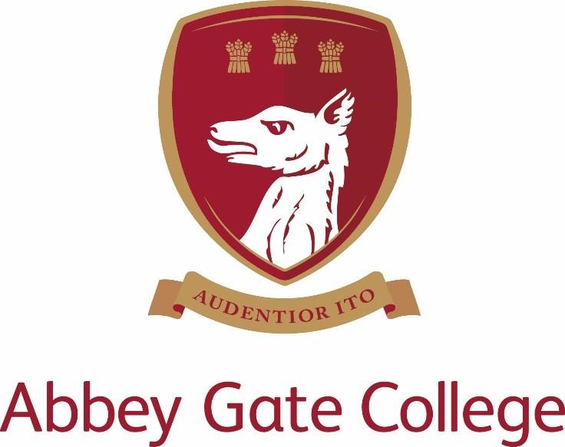

Teacher of Physics

Required from: September 2020

Teacher of Physics

Job Description and Person Specification

The College
Abbey Gate College is the longest-running coeducational independent school in the Chester area, catering for circa 485 pupils aged 4-18 years. Set in the idyllic rural villages of Saighton and Aldford on the outskirts of Chester.
Our pupils are at the heart of everything we do. We believe education is about building self-esteem, a love of learning and igniting a desire in all our students, to ensure they fulfil their academic and personal potential. We strive to guarantee our children leave Abbey Gate College as confident, articulate, respectful and happy young high achievers.
From the youngest in Foundation to our Sixth Formers, we aim to develop skills for life; core values such as respect and compassion within the framework of an excellent education. Developing talents and skills in a wide range of areas are encouraged, success is celebrated and endeavour is recognised.
Abbey Gate College is committed to the safeguarding and promoting the welfare of children and expects all staff and volunteers to share this commitment.
The Post
The post will have responsibility primarily for the delivery of Physics lessons and any additional responsibilities as directed by the Head of Science and/or The Head of Physics;
- Responsibilities for Physics Teachers:

- to ensure that you are effective and efficient delivering your subject curriculum area.
- to ensure that the appropriate Schemes of Work are followed and are applied effectively.
- to review the Schemes of Work when required and help the Head of Physics update them on an annual basis.
- to keep up to date with all aspects of the development of teaching and learning related to Physics.
- to contribute to the Science Department Handbook (which contains the Science Development plan) as and when required by the Head of Physics.
- to help and advise the Head of Physics with the population of the VLE with appropriate content.
- to liaise with the Learning Support Department and Head of Science to ensure pupils have the necessary access arrangement for public exams and internal assessments.
- Any other duties as required

2.) Pupils

- to take responsibility for the learning and academic performance of all pupils who are taught by you.
- to ensure efforts are properly rewarded.
- to provide pupils with careers advice as appropriate.
- to ensure the use of target setting such as CAT and ALIS data in the department.

3.) Departmental Management

- to work well with other colleagues to ensure effective teaching and learning.
- to renew and monitor procedure to ensure best practice.
- to share good practice in the department.
- to develop cross curricular links with other subjects or departments as directed by the Head of Science and/or the Head of Physics.

4.) Assessment, Examinations and Record Keeping

- to provide details by the specified date to the Head of Science and/or the Head of Physics the number and duration of papers set for the College examinations.
- to ensure that College examinations are marked and appropriately moderated by the dates specified.
- to ensure that the results of College examinations in Physics are reviewed and that the information is used to inform teaching in the future.
- to ensure that candidates are entered correctly for external examinations in conjunction with the Head of Science and/or the Head of Physics.
- to ensure the frequent and regular assessment of the progress of pupils in Physics.
- to ensure that assessment is used to inform teaching and learning within Physics lessons.
- to ensure that records of all internal and external examination predictions, results and assessments are kept within the department following departmental procedures.
- to ensure that reports to parents are of good quality. Maintain high standards of communication with parents too.

5.) Marking and Homework

- to ensure that the College Policies on marking are applied.
- to ensure that marking is used to inform teaching and learning in your planning.
- to ensure that appropriate homework is and set according to the College timetable.
- to ensure that work is marked promptly, accurately and in a diagnostic.

6.) Outside the Classroom/Teaching Area

- to help with extra-curricular clubs and activities in the department.
- to help participate in and run appropriate visits, field courses etc.
- to arrange performances, competitions, social events etc which would raise the level of interest in Physics amongst pupils and the wider community.
- to assist the Head of Science and/or the Head of Physics in providing taster sessions/taster days for prospective pupils whether they be external or from the Infant and Junior Department.
- to help with the setting up of the Physics Department for the Open Morning.
- to co-ordinate and provide information and guidance for prospective pupils and their parents at the 6th Form Information Evening if required by the Head of Science and/or Head of Physics.

7.) Communication

- to be responsible for attendance at INSET sessions.
- to represent the department at parents’
- to assist the Head of Science and/or Head of Physics with regard to the Infant and Junior Department and build links between KS2 and KS3. This includes taster sessions and Science Week initiatives.
- to oversee the writing of subject reports.
- to draft articles for press, media and website publication concerning events or developments at the College in connection with the department. All such articles must first be submitted to the Head of Science and/or Head of Physics.
- to help establish links with the alumni, local industry and higher education which would prove beneficial to the teaching of the subject.

8.) Facilities and Resources

- to ensure that rooms, furniture, equipment, wall displays etc are maintained to a high standard in the Physics department.
- to notify the Head of Science and site manager of any jobs that need addressing.

9.) Health and Safety

- to be responsible for the implementation of the Department Health and Safety Policy
- to be responsible for following the agreed Health & Safety policy and risk assessments when carrying out practical work.

Key qualities and person specification:-

The person appointed should show and demonstrate the following skills and qualities:

- Inspirational teacher
- Enthusiastic, innovative and creative
- Ability to teach across the curriculum, including A-level and GCSE
- Excellent People Manager
- Be abreast of new trends and educational developments related to the subject
- Excellent communication skills
- Committed to raising standards and monitoring pupil progress
- Outstanding professional and personal qualities
- Caring, supportive and willing to adapt their teaching to suit the needs of the pupils
- Willingness to lead extra-curricular sessions
- Act as a good role model to staff and pupils
- Proficient with the use of ICT in the classroom
- Excellent planning skills
- Well-organised
- Excellent attention to detail
- Calm under pressure

Salary, Terms and Conditions
The salary for this position will depend upon the qualifications and relevant experience of the successful candidate.

Child Protection
Abbey Gate College regards as paramount the welfare and safety of children. Whilst criminal convictions are not necessarily a bar, this safety consideration will be key to all decisions regarding the employment of staff, approval of volunteers and standards of external contractors. An enhanced DBS check and barred check will be completed as part of the pre-employment checks for this position.

Equal Opportunities
We are committed to treating all employees with dignity and respect regardless of race, ethnic background, nationality, colour, gender, transgender status, pregnancy, age, sexual orientation, religion or belief. We therefore welcome applications from all segments of the community.

Applications:

Deadline: 12 noon Friday 6 March 2020
Interviews: Friday 20 March 2020

Please apply by providing a covering letter with application form to Mrs Tracy Pollard explaining your interest and suitability for the role.

The interview process will include; Lesson Observation an Interview with the Headmistress and there will also be a tour of the College.

References will be taken for this vacancy before interviews, please inform your referees.

