Application pack
Assistant Headteacher – Lower school lead
March 2021
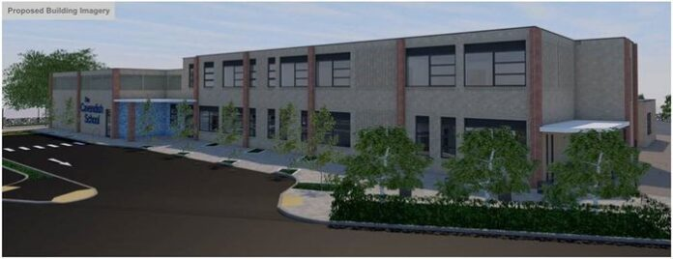
Contents

Welcome from Ryan Kelsall 3
Welcome from Stephanie Smith 4
Welcome from Julie Bailey 5
About The Cavendish School 6
About the Eastern Learning Alliance 7
Job Description 8
Person Specification 11
Interviews and application process 13

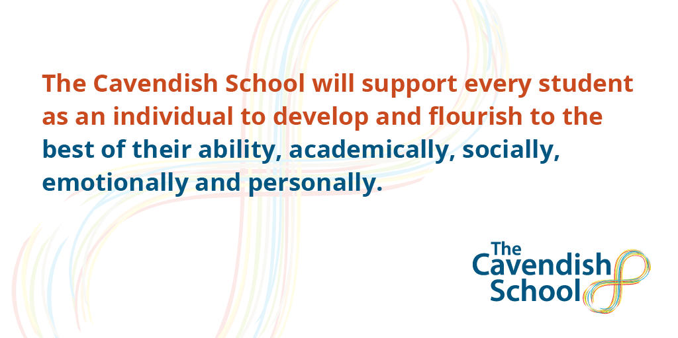

Welcome from Ryan Kelsall
Deputy CEO of Eastern Learning Alliance

Thank you for your interest in the post of Assistant Headteacher at The Cavendish School (or TCS as it tends to be known). I very much hope that from reading all the details, you would like to apply for the role, which we believe will offer a great opportunity for a school leader looking to have a real and unique impact. In return you will be strongly supported by a multi-academy trust that has as its core vision the drive to ‘build a better world through education and to enable all students to achieve their full potential’.

TCS came into existence as an idea in early 2016, when the Cambridge News highlighted the poverty of specialized provision locally for children with autism. It seemed ideal therefore for a trust with a track record in inclusion and special needs to create a new provision via the Free School programme. The Local Authority was delighted with our approach, as was the DfE and Regional Schools Commissioner. We therefore reached out across the local community for support and successfully submitted our plans in September 2016.

With the slowing down of government and delays to the funding, the project has taken time to get to this stage. However, we have our contractors (McAvoy’s who successfully built The Rise School, another excellent school for children with autism in West London) and our designs/plans have now been given approval by South Cambs’ District Council. We are on course to open the new school on part of the site of IVC in autumn 2021 we have appointed a Deputy Headteacher to play the lead role in finalizing plans for the school and are now planning recruitment of a passionate senior leader.

I look forward to receiving and reading your application. If you decide not to apply, I wish you every success with the next step in your career.

Ryan Kelsall
Deputy CEO, Eastern Learning Alliance

Welcome from Stephanie Smith
Deputy Headteacher of The Cavendish School
It is an exciting time for The Cavendish School as we look to opening in September ‘21 and I would first like to thank you for your interest in joining us on our journey.

The Cavendish School will be Cambridgeshire’s first state maintained special free school provision for young people with autism and aspires to support students in its mission of ‘enabling the self’; equipping students with the skills, confidence and abilities to take their place in the world.

It is difficult this early in the inception of a new school, to give you a clear idea of the hustle and bustle that school life with us would bring, but what we can offer you is a clear picture of the ethos that we live and breathe. Our core aims are to provide a safe, nurturing space, alongside inclusive and comprehensive support so that all students thrive academically and in their own personal development journeys. We will provide a unique educational environment that young people with autism need to thrive and succeed when their needs cannot be met in a mainstream school. Every pupil at our school deserves our high expectations and support to have equitable access to education and the world, Autism does not mean less.

School plans include fully supported therapy rooms, sensory and calming areas, Life skills rooms as well as a full range of areas dedicated to the sciences and arts. Our onsite orchard, outdoor learning areas and the ability to develop a forest school area will ensure that learning goes beyond the classroom.
We are looking for someone who is not only an outstanding teacher but is absolutely passionate about developing those skills in others. I want someone in my leadership team, to inject enthusiasm, inspiring others using research based evidence and innovation, to truly develop teaching and learning. We want the child to be at the centre of everything we do no matter how challenging that may be. Autism must be viewed as a different way of thinking and processing the world; one that provides unique insights and skills that we need in an ever-developing climate of society and work.
Initially the school will admit around 40 students (Years 3 to 7) and will then grow, year on year, to a maximum capacity of 80 students, aged 7 to 19 years (Years 3 to 13). Joining us at this pivotal time will give you as a leader the enviable opportunity to really support the developing shape of the school community, curriculum and strong foundations.

If you, like us at the Eastern Learning Alliance, are passionate about inclusion and providing a quality education for young people with Autism, so they may live out their dreams and aspirations, then I hope to receive your application soon. If you would like more information on the school please contact me on ssmith@tcs.tela.org.uk

Stephanie Smith
Deputy Headteacher, The Cavendish School

Welcome from Julie Bailey

Chair Designate of the Local Governing Body

The role of Assistant headteacher at TCS is a unique opportunity to be a part of the Senior leadership team for this new school from its opening in brand new purpose built accommodation and the formation of a new school community within one of the most successful and innovative multi-academy trusts in the country. The trust’s commitment to inclusive education is the reason its schools are communities in which children and young people thrive as well as the reason that this new school will have the best possible start.
As a former secondary teacher myself, an academic researcher into autism education and a parent of children at IVC, you will supported by a chair of your LGB who is passionate about improving acceptance of and tolerance about neurodiversity and who also knows and understands the locality very well. You can also expect support in bringing together our team, our pupils and their families as a strong school community.
As part of the leadership team for the first specialist state funded school for children with autism in the Cambridge area, you will have support and encouragement in sharing your team’s skills and knowledge with local schools, colleges and other organisations. We already have links with local researchers, teachers and professionals who share our commitment to providing the best possible education for children and young people with autism who are unable to access mainstream schooling.
Together we will build a school community that joins the trust in taking a lead in inclusive education, with the highest expectations for its pupils and a clear vision of a community in which our children will thrive and prepare to take their place in the world.
The combination of the trust’s commitment to inclusive and innovative education, access to leading autism and education research locally, and the enthusiastic support of our local community means that this is truly an exceptional opportunity to establish a school in which children and young people with autism can thrive.
Julie Bailey
Chair (designate) of The Cavendish School Local Governing Body

About The Cavendish School

As a school that is yet to open, we appreciate that there is not as much to see or read about the school as one that is open and bustling. On the one hand that can be unnerving because you are looking for information about the place where you will work. On the other hand, it is very exciting as place of work you will be a part of creating!

We have a website which provides some information: http://www.thecavendishschool.org.uk/. The school was founded to give families of children with autism the opportunity to attend a local state provider where the young person’s needs would be met in a therapeutic and specialised environment. Our vision for the school is encapsulated around the phrase ‘Enabling the self’. We know and recognise that too many children and adults with autism struggle to achieve independence in their lives and often face significant challenges coming to terms with the condition as well as gaining greater acceptance and tolerance. Our ultimate ambition for TCS is for all young people to leave our care walking tall and proud, confident in the knowledge and understanding that there is a real opportunity for them in the world they will inhabit.

Broadly speaking, our school curriculum will follow International Baccalaureate (IB) programmes and accredited qualifications, alongside specific therapies or interventions as appropriate for individuals. Initially the school will admit students in years 3 to 7, who will follow the Primary Years Programme. When students reach year 9 they will chose from a range of accredited qualifications including GCSEs where appropriate. Our sixth form will be small and bespoke, with access for those students for whom this is appropriate to Impington International College or other providers further afield. The IB Primary Years Programme (PYP), an inquiry-based transdisciplinary curriculum model. The PYP is a broad and balanced curriculum model that encourages students to make practical connections between their learning and real-life contexts, to develop the IB characteristics and become global citizens. The PYP curriculum framework emphasises the central principle of agency that is threaded throughout the three pillars of the curriculum: the learner, learning and teaching and the learning community it underlines that everyone connected to the school community has voice, choice and ownership to impact learning and teaching. These holistic components complement and reinforce each other to form a coherent whole. Subjects are studied in relation to transdisciplinary themes (such as “how the world works”) to ensure that learning is contextualised and holistic.

Our design for TCS saw us looking to create a therapeutic environment with plenty of space for individual work and for places where the young people could head during the day for periods of calm. We will place a great accent on staff training and expect to appoint from a wide range of settings. We are looking for practitioners with resilience and a ‘can-do’ mindset and those who believe that people with autism are not inhibited but who have a life condition which needs a supportive and flexible environment in which they can flourish.

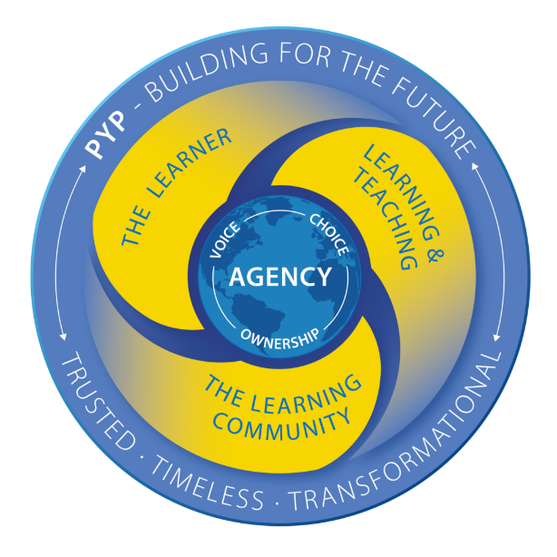
Our community will naturally have close relations with the staff at IVC, but also with colleagues across the whole trust. There will also be a strong partnership with Girton Glebe, our primary school, and with colleagues in the local authority and in Cambridge University, with whom we hope to work on research into autism.

About the Eastern Learning Alliance
The Eastern Learning Alliance (ELA) was formed in 2020 following the merger of Cambridgeshire Educational Trust (CET) and Morris Education Trust (MET), creating a strong local multi-phase/setting MAT rich in our distinctive values.
The ELA Trust is a small purposeful family of schools, each with its own distinct identity which, combined, offer more choice than any other group of schools, enabling every student to pursue their dreams and passions. As our Trust grows, each school will retain that identity but share the same values and standards of academic rigour, excellent extra-curricular opportunities and exceptional arts and performing arts.
What makes ELA so very different is that it is born out of an alliance between two existing trusts, not out of a need for one school to grow. Our joint commitment is to being proudly international and internationally minded, serving a diverse community of families from Cambridge, across the UK and overseas, facilitated by our host family network, with a broad, specialist and inclusive provision.
We are a trust with an excellent track record in inclusion and special needs that has as its core vision the drive to ‘build a better world through education’. We are very excited for the opening of TCS and to be providing new local provision for children with autism.

MET-Living

Our schools are proud of their community work. This includes on-site sports/leisure provision, adult learning and lettings which bring in many varied groups across the year. We recognise that the ‘non-school’ elements of the village college are no less important than the ‘school’ and require their own leadership and management. Therefore the Trustees have created a subsidiary company (which is still part of ELA) called ‘MET-Living’ to oversee and operate the ‘non-school’ elements. To ensure this works well, an agreement is put in place to manage the facilities best for the benefit of both ‘school’ and ‘non-school’.

What we can offer you
You will be joining a relatively new MAT at an exciting stage of its growth and development. We are passionate about the environment we create and how we look after our staff.

As a newly appointed member of the Senior Leadership team, we can provide you with:
- The opportunity to shape and model an outstanding curriculum
- The opportunity to contribute to a growing community and take learning beyond the classroom.
- The opportunity to join and engage with the IB world schools global network of leaders
- A brand new and autism-friendly innovative learning environment
- bespoke professional development linked to your identified needs and forward looking, evidence informed, CPD programme with Trust wide CPD
- Preferential rates for access to the excellent sports/leisure facilities within our Trust

Job Description

Post: Lower School Assistant Headteacher
Salary: L6-L10
Responsible to: Deputy Headteacher

Primary Purpose of the Role
As an Assistant Headteacher you will work with the Deputy Headteacher, and other members of the leadership, management and teaching team to support the operational day-to-day leadership of the Lower school department within the school.
The Assistant Headteacher will take the lead in developing and refining the Lower school curriculum in line with the International Baccalaureate Primary Years Programme with a view to creating a collaborative learning community both in and out of the classroom, with all stakeholders. You will have responsibilities as Lower school lead to ensure that all pupils are making at least projected progress both academically and against their personal development targets including Education, Health and Care Plan outcomes.
Other specific leadership duties will include being a member of the designated safeguarding leadership team, taking responsibility for Safeguarding for pupils within the Lower school department and to deputise for the Deputy Headteacher as appropriate and where necessary.

As a member of the Senior leadership team you will play an integral role in promoting the vision and values of The Cavendish School.

This post will initially have a 0.8 teaching commitment for the first term reducing to a minimum of 0.4 teaching commitment.

Shaping the Future and strengthening the Community
- Ensure that The Cavendish School’s vision is clearly articulated, shared, understood and acted upon effectively by all within the school
- Demonstrate TCS’s vision and values in everyday work and practice and motivate and work with others to create a shared collaborative culture and positive climate
- Ensure creativity, innovation and the use of appropriate new technologies to achieve excellence
- Collaborate at operational levels with parents, carers and across multiple agencies for the well-being of all children.
- Host students, volunteers and visitors within the department.
- Promote and facilitate family participation in learning and life of the school

Leadership and Management
- Ensure effective communication for the smooth day to day operational running of a department within the school
- Lead, manage and support Teachers and Teaching Assistants within the department
- Contribute to decision making as part of the school’s leadership team
- Support the Deputy Head Teacher with appraisals
- Promote positive standards of conduct from all staff and support well-being and attendance
- Liaise with families and professionals to support pupil outcomes
- Represent The Cavendish School as an ambassador at local, regional and national SEND events
- Promote equal opportunities throughout the school and ensure the application of the school equal opportunities policy
- Participate in the design and delivery of training sessions within school and potentially for other schools or organisations

Leading department Teaching and Learning with continual Monitoring and Evaluation
- Lead teaching and learning by example, providing inspiration and motivation
- Support and be an ambassador for the IB programmes and learner profile.
- Ensure every individual child has access to high quality teaching and learning
- Ensure a continuous and consistent focus on students’ achievement and personal development, using relevant data and benchmarks to monitor progress
- Challenge under-performance at all levels and ensure effective corrective action and follow-up
- Maintain and promote the highest standards of student behaviour, discipline and attendance within the school in line with the school’s behaviour and intervention policies
- Manage and organise the school environment efficiently and effectively to ensure that it meets the needs of the pupils, curriculum and all health and safety regulations.
- Oversee department events and contributions to whole school events
- Lead on the planning and implementation of educational visits and journeys for the pupils within your department
- Monitor and chair Education, Health and Care Plan reviews for allocated pupils

Developing Self and Working with Others
- Treat people fairly, equitably and with dignity and respect to create and maintain a positive trusting culture that exhibits ‘Humans first, professional second’ (Myatt, 2016)
- Build a collaborative learning culture within the school
- Ensure effective planning, allocation, support and evaluation of work undertaken by teams and individuals, with clear delegation of tasks and devolution of responsibilities
- Acknowledge the responsibilities and celebrate the achievements of individuals and teams
- Develop and maintain a culture of high expectations for self and others
- Regularly review own practice, set personal targets and take responsibility for own personal development by participating positively in arrangements made for the appraisal
- Manage own workload and that of others to allow an appropriate work/life balance
- Support an inclusive and inspirational ethos within the school (aligned with that of the Trust) that enables everyone to work collaboratively, share knowledge and understanding, celebrate success and accept responsibility for outcomes
- Present a coherent, understandable and accurate account of the department’s performance to a range of audiences including Deputy Headteacher, staff, parents and carers and students

Keeping pupils safe
- Ensure the welfare and safeguarding of pupils across the whole school through rigorous application of the school child protection, behaviour management and pupil well-being policies.
- Take the role of Deputy Designated Safeguarding lead with specific responsibilities for pupils within the Lower school department.
- Promote excellent standards of pupil safety and positive behaviour through application of schools behaviour principles.
- Ensure that pupils with health and medical needs have their needs safely met in line with school, local and national policy.

This job description should be seen as enabling rather than restrictive and will be subject to regular review.
These duties and responsibilities should be regarded as neither exhaustive nor exclusive as the post holder may be required to undertake other reasonably determined duties and responsibilities commensurate with the grading of the post.
You will be required to attend meetings outside of school working hours to support school governance and other school functions.

Person Specification

Job Title: | Assistant Headteacher, Lower School Lead – The Cavendish School
Reports to: | Deputy Headteacher

 | ESSENTIAL | DESIRABLE
Qualifications and Training | Qualified teacher status.  Honours degree or equivalent  Relevant training in SEND and autism, specifically A recognised professional qualification such as an NPQM/SL or an intention to pursue further relevant study in the near future | A professional qualification in SEND relevant to this post  Further relevant study; such as a postgraduate Diploma or Masters level degree (Level 7 or 8)
Experience | An outstanding teacher with a proven track record of delivering results, achieving high standards and the ability to demonstrate and inspire outstanding teaching/classroom practice.  Implementing effective and inclusive systems to support students’ well-being, positive behaviour and achievement for pupils with autism.  Sound understanding of high quality teaching and learning in order to carry out lesson observations and feedback and contribute to the monitoring systems within school  An understanding of what best practice looks like for supporting pupils with communication needs and knowing how these needs can impact upon behaviour; planning and providing for the appropriate support and resourcing  Working knowledge of the SEND Code of Practice, to support effective reviews of EHCPs, targets and transition planning  An understanding of the potential health and safety risks within a school environment and the skills to monitor H&S checks including risk benefit analysis | Leadership experience in an outstanding or good special school.  Experience of working with pupils with complex needs as a result of Autism and comorbid conditions  Planning and leading extra curricular education visits and residential trips.  First aid or emergency first aid training
Knowledge  /Skills  (Ability to) | Will respect parents and carers as partners and involve them in the education and learning community of their children  Will seek to develop links with local schools and community groups.  Is prepared to work collaboratively with a wide range of professionals in order to provide the best possible education for pupils.  Knowledge of current child protection guidance, safeguarding, and health and safety requirements.  Successful experience of working with challenging and vulnerable young people and appropriately meeting their needs  In depth knowledge and understanding of education policies and issues, particularly those affecting children and adults with autism.  Ability to formulate and implement effective and efficient strategies that improve teaching and learning in a sustained way and challenge underachievement.  Ability to communicate effectively with all members of the school and wider community to facilitate partnerships between school and home.  Ability to deal with confidential information sensitively and appropriately in line with school and trust policies.  Clear and successful decision making skills and a proven track record of problem solving and conflict resolution.  Is prepared to undertake training appropriate to the role | A working knowledge of specific interventions such as Makaton, Attention Autism, TEACCH, PECS Lego Therapy, Rebound Therapy, colourful semantics, dyslexia interventions such as Toe by Toe and English interventions such as Corrective reading and Switch on reading, be able to share your knowledge with others.  Successful teaching in a special needs class /unit /school
Personal Qualities | Empathy with the ethos and values of ELA and TCS a commitment to working collaboratively with the Trust and embedding the Trust ethos and values in the school.  Is enthusiastic about teaching children and young people with special educational needs and disabilities and has a high level of commitment.  Commitment to young people’s wellbeing, safeguarding and development  A positive ‘can do’ attitude, shared with pupils and colleagues to build and sustain a great team ethos  High levels of resilience and determination Demonstrable experience of highly effective communication skills, both orally and in writing and as an active listener  Role model of best practice, with a professional manner that motivates others and inspires confidence, trust and respect.  Be highly organised and able to plan and prioritise work within timeframes and to meet deadlines.  Creative approach to problem solving  Flexibility and willingness to adapt quickly and effectively to changing situations/circumstances.  Open minded and good sense of humour  Willingness to undertake International baccalaureate (IB) Leading learning training prior to start of post. | Minibus driver, or the willingness to complete minibus training (MIDAS)  Full UK Driving license and business insurance  Confident swimmer and pool side spotter

The post holder will have a shared responsibility for the safeguarding of all children and young people. The post holder has an implicit duty to promote the welfare of all children and young people and to be committed to promote diversity and equality for all.

Interviews and application process

The interviews will take place at Impington Village College during the week commencing April 19th 2021 and will include a range of activities and interviews. The interview day will consist of

- a tour of the site
- data and written tasks
- observing a lesson and giving feedback
- interview with IVC students
- Interview Panel of Deputy CEO, Deputy Headteacher and Local Governing Body Chair

If you would like to apply, please complete the application form and a letter (no more than 2 sides of A4) outlining:

- your reasons for applying
- what you will bring to the role
- why you believe you might be suited to this particular challenge/opportunity.

Applications close at 12noon on Monday April 12th 2021.

Please ensure your form and letter is returned to HR@TCS.tela.org.uk

