Headteacher  Mr M R Crofts | Deputy Headteacher  Mr R Wardman | Deputy Headteacher  Mrs R Pindar | Assistant Headteacher  Mr R Mabbott | Business Manager  Mrs S Evans | Systems Manager  Mr S Petrow
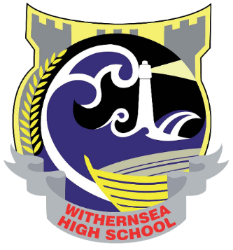

May 2019

Dear Applicant

Teacher of Modern Foreign Languages
Fulltime permanent post
MPS/UPS

Thank you for your enquiry about the above position. I believe this is a position that would suit a teacher early in their career as well as a more experienced colleague.

Please find enclosed with this letter the following items:

- Person Specification
- Job Description : Teacher
- Job Description : Form Tutor
- General information for applicants about the faculty
- Brief notes relating to our recent Ofsted Inspection
- An Application Form

The closing date for receipt of completed application forms is 3.30pm on Tuesday 21st May 2019. These should be addressed to Mrs K Burton (Headteacher’s PA). Interviews will be held on Friday 24th May 2019.

Please contact Mr R Mabbott, Assistant Headteacher if you would like an informal discussion about this role.

I look forward to receiving your application.

Yours faithfully

Mr M R Crofts
Headteacher

Working together, achieving more
Withernsea High School
Hull Road, Withernsea, East Riding of Yorkshire, HU19 2EQ
Tel: 01964 613133 Email: whstc@wscampus.net Web: www.withernseahigh.org.uk
24 Hour Attendance Line: 01964 611523

