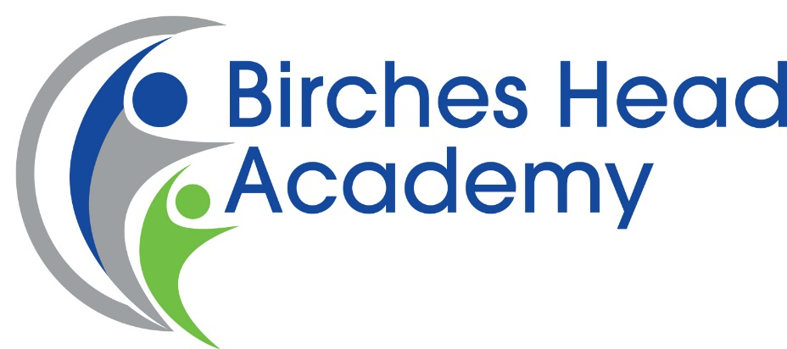

Recruitment Pack

Job Title
Teacher of English
(with the possibility of additional responsibilities)

Closing Date: 14th January 2019
Interviews: TBC

A Message from the Headteacher

Dear Applicant,

Thank you for downloading this application pack and for your interest in becoming an English teacher at Birches Head Academy, in Stoke-on-Trent.

This is an exciting time at Birches Head Academy as the academy has made dramatic improvements and has seen a complete culture change in recent years.
The Academy works in partnership with a number of schools locally including Excel Academy and Discovery Academy to ensure all students have the very best opportunities and outcomes.
Furthermore the academy is currently in the process of joining the Alpha Academies Trust, a successful and growing Multi Academy Trust. We believe that becoming part of this Multi Academy Trust will provide further support and opportunities for staff and students at the academy.
The Academy has excellent facilities and has undergone extensive building work under Building Schools for the Future.
I have very high aspirations for the young people at Birches Head Academy. I want the very best for them. If you feel you can make a contribution to this important enterprise then I look forward to receiving your application.
Yours faithfully,

Ms K Dixon
Headteacher

The Context

The City of Stoke-on-Trent is in the West Midlands and has a population, of 249,000, which is predominately white British but with a significant minority ethnic community. Ambitious plans are underway to transform and renew the City through major investment in health, housing, economic development, and education. The ‘Potteries’ as Stoke-on-Trent is affectionately called is renowned for its world class ceramics industry and industrial heritage. The Midlands power house is driving economic growth and renewed prosperity.

The City boasts a strong cultural tradition and is a contender for City of Culture 2020/2021 with its Premier League football team, ceramics heritage and Performing Arts tradition.

With a 10% increase in the number of children, education is of critical importance to the future prosperity of the City, and the BSF programme has established excellent facilities for our young people.

Aims & Vision

As a student of Birches Head:

• I will have self-belief and the social skills to continue to succeed in an ever-changing world
• I will take pride in my efforts and have the confidence to celebrate my successes
- I will embrace challenges and opportunities; I will make a positive contribution with honesty and integrity

Staff of Birches Head will:

• Inspire you to grow in confidence, resilience, self-respect and with a sense of responsibility
• Foster a sense of pride in you and celebrate your successes
• Expand your horizons, challenge you to reach your full potential and realise your aspirations

Our
- Children and young people develop strong literacy, numeracy and employability skills
- Children and young people enjoy innovative learning experiences, including sport and the arts which lead to high levels of success
- Children and young people’s progress is always tracked and monitored and no one falls behind
- Children and young people understand the pathways open to them. Through our Academy the gates to next steps and phases are opened
- Children and young people, parents and staff feel valued, safe, supported and have a voice
- Children and young people have the best staff and Academy leaders as their role models
- Children and young people enjoy inspirational learning environments which are safe, well maintained and constantly improved
- Children and young people enjoy the best catering and nutrition
- Staff have an entitlement to first class training, coaching and support
- Staff have opportunities to progress from the start of their career onwards
- Employer partners contribute to curriculum design
- Governance is strong, challenging and supportive
- Parents are partners in their children’s education
Our Academy
Birches Head
At Birches Head we believe strongly in the power of high expectations. We understand that each student has their own potential, which we are determined to help fulfil through academic study and wider enrichment.

All students will take part in exciting learning, both inside and outside the classroom, so they can make rapid and sustained progress.

Our Academy motto ‘Aspire to be More’ summarises our determination to meet the needs of all students through individual support and out-of-hours learning opportunities. We challenge students to be the best that they can be and never compromise the high standards which encourage student to achieve.

The key to success for our students is a strong partnership between home and school ensuring that their time at Birches Head Academy is happy, fulfilling and academically successful. It is the academy’s ambition is to see every child leave Birches Head Academy as a well-rounded, responsible citizen.

Job Description
We are seeking to appoint a committed and enthusiastic teacher of English who has a passion for their subject with a vibrant and collaborative approach to working with our students and team.
Having a strong subject knowledge is essential and will add value to the curriculum delivered at KS3 and KS4. The successful candidate will contribute to the continuing development of the English curriculum and to the overall development of this already strong and successful department. You will also promote a love of English, supporting students to be life-long learners, resilient and committed to their studies, this includes a dedication to extra-curricular activities.
This exciting role can offer you an opportunity to join a well-resourced, supportive and forward thinking department. There may be the possibility of additional responsibilities for a suitable candidate.
We are federated to the Alpha Academies Trust which will provide opportunities and benefits from our partnership with other local primary and secondary schools. You can expect expert guidance, full support, and passionate leadership as part of an innovative team determined to succeed.
This is an opportunity for a dedicated professional with a strong vocation to make a real difference to some wonderful children and leave a lasting legacy for the local community.
If you feel that this position is of interest then we would like to hear from you.
Further details and an application form are available to download from our website https://birches.alphaacademiestrust.co.uk/ Alternatively you can contact the school for an information pack.

JOB DESCRIPTION FOR ENGLISH TEACHER
TEACHING

- Plan work in accordance with subject schemes of work and programmes of study.
- Liaise with relevant colleagues on the planning of units of work for collaborative delivery.
- Work in collaboration with Learning Support Assistants attached to any teaching group.
- Take account of students' prior levels of attainment and use them to set targets for future improvements and plan curriculum provision
- Set work for students absent from school for health or disciplinary reasons.
- Maintain good classroom management by adherence to the advice given to staff in the staff handbook and elsewhere.
- Set high expectations for students' behaviour by establishing a purposeful working atmosphere in accordance with the school's behaviour policy.
- Set appropriate and demanding expectations for students' learning, motivation and presentation of work.

- ASSESSMENT, RECORDING & REPORTING

- Maintain notes and plans of lessons undertaken and records of students’ work.
- Mark, monitor and return work in line with school policy and provide constructive oral and/or written feedback and clear targets for future learning as appropriate.
- Carry out assessment programmes (e.g. reports) as agreed by the school policy.
- Attend the appropriate parents’ evenings to keep parents informed as to the progress of their child.
- Be familiar with the Code of Practice for identification and assessment of Special Educational Needs and keep appropriate records on Individual Education Plans for students.

3. PASTORAL WORK
- Undertake responsibility for a personal tutor group as required including tutor/student interviews.
- Be the first point of contact for parents of students in the personal tutor group.
- Monitor the social and academic progress of individuals in the personal tutor group.
- Be prepared to undertake responsibility report writing, references and other forms of record for personal tutor group and support the application process to post 16.
- Promote good attendance and punctuality and monitor in accordance with the school's attendance procedures.

PROFESSIONAL STANDARDS
- Support the aims of the school to promote a “strong culture of ambition".
- Treat all members of the community, colleagues and students, with respect and consideration.
- Treat all students fairly, consistently and without prejudice.
- Set a good example to students in terms of appropriate dress, standards of punctuality and attendance.
- Promote the aims of the school by attendance at and participation in events such as open evenings. (as appropriate to their responsibilities).
- Support the ethos of the school by upholding the behaviour policy, uniform regulations etc.
- Take responsibility for own professional development and participate in staff training when provided.
- Reflect on own practice as well as the practices of the school with aim of improving all that we do.
- Read, adhere to and undertake duties as prescribed within the various policies of the school.
- Participate in the management of school by attending various team and staff meetings as published in the school calendar.
- Ensure that all deadlines are met as published in the school calendar.
- Undertake professional duties that may be reasonably assigned to them by the headteacher.
- Be proactive and take responsibility for matters relating to health and safety

Person Specification

DEPARTMENT: English
APPOINTMENT OF: Teacher of English

 | ESSENTIAL | DESIRABLE
QUALIFICATIONS
Degree in English | Y
QTS for secondary education | Y
PGCE (secondary) |  | Y
EXPERIENCE
Successful secondary teaching practice/record | Y
Creative, engaging lesson preparation. | Y
Ability to produce and implement plans and policies | Y
Experience of monitoring and evaluation processes |  | Y
Experience as a personal tutor / form tutor | Y
Experience of running extra-curricular activities & trips |  | Y
SPECIALISM
A high level of competence in teaching English | Y
Able to use new technologies in the teaching of English |  | Y
Ability to develop new and imaginative units of work. | Y
Good subject knowledge | Y
PRACTICAL & INTELLECTUAL SKILLS
Effective and successful classroom teacher. | Y
A commitment to being developed in the use of I.C.T. | Y
Excellent organisational, communication and decision making skills | Y
Good time management skills. | Y
Good analytical, conceptual and problem solving skills. | Y
DISPOSITION, APPTITUDE, ATTRIBUTES
The ability to relate to and build relationships with students, parents and other members of the school community. | Y
Proactivity. | Y
Commitment to hard work. | Y
Commitment to meeting departmental deadlines | Y
Commitment to participative and continuous improvement. | Y
Openness and willingness to learn. | Y
Enthusiasm for change. | Y
Resilience | Y
A willingness to participate in after school activities | Y
Reliability | Y
Student focused commitment | Y

How to Apply
If you decide to apply for this post please complete an application form: curriculum vitae alone will not be accepted. Your formal letter of application (supporting statement) should be no longer than 2 sides of A4 and should address:

- Why the post attracts you
- How your experiences and achievements match the job and person specification

Please return your completed application to: apply@alphaacademiestrust.co.uk

Please note, it is the policy of Birches Head Academy to contact shortlisted candidates only.

Key Dates

Closing Date: 14th January 2019
Interviews: TBC

Job Description
This tells you the main responsibilities of the post and explains what we are looking for. It tells you about the personal and professional qualities you need for this post. These criteria will be used to make the appointment.

Academy Location

Birches Head Academy:
Birches Head Road
Stoke on Trent
ST2 8DD
01782233595
Email: info@bircheshead.org.uk

Additional Information

Ofsted Reports: www.ofsted.gov.uk

Information about Stoke City council: www.stoke.gov.uk

