JOHN TAYLOR HIGH SCHOOL

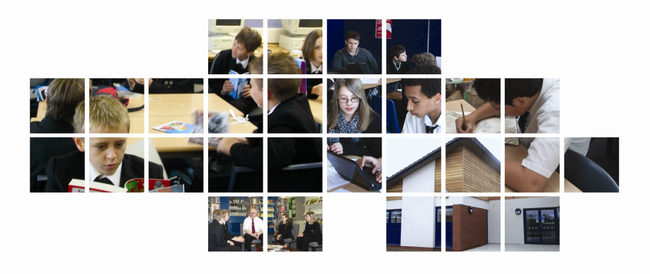
DESIGN AND TECHNOLOGY TEACHER

The school is committed to safeguarding and promoting the welfare of children and young people/vulnerable adults and expects all staff and volunteers to share this commitment.

An enhanced disclosure check will be a requirement of the post.

Dear Applicant
Please complete the application form and return to recruitment@jths.co.uk accompanied by a supporting letter outlining your experience and potential to fulfil the responsibilities of the post on or before 9am on Monday 27th January 2020.

Katie Cochrane
Head of School

JOHN TAYLOR HIGH SCHOOL
DESIGN & TECHNOLOGY TEACHER

Post description
We are seeking to appoint an inspirational teacher of Design & Technology, who is dedicated to providing exceptional learning experiences in the classroom and keen to contribute to wider aspects of school life. The successful applicant will be required to teach
- Design & Technology at Key stage 3 (Product Design, Textiles, Graphics)
- Key stage 4 GCSE for the new AQA GCSE Design & Technology (Theory/NEA)
- AQA A Level Design & Technology specification. (Theory/NEA)
In the Design Technology Department at John Taylor, we aim to stimulate pupils’ interest, curiosity, creativity and enjoyment when designing and developing solutions to improve people’s lives. The team continually works hard to create projects that encourage the development of problem-solving skills, evaluation, imagination, design expertise, practical ability as well as an appreciation of how technology has and will affect our lives.

The Design & Technology curriculum
Key Stage 3
In Year 7 Design & Technology is delivered as part of a whole school skills-based curriculum which provides pupils with the opportunity of engaging in compelling project-based learning activities.
In Years 8 and 9 pupils follow a balanced Design & Technology programme, covering a range of Technology disciplines on a termly rotational basis. You would be expected to be flexible on KS3 disciplines across Product Design, Textiles and Graphics.
Key Stage 4
Our Key Stage 4 pupils follow the AQA Design & Technology course. In 2019, 90% of students achieved a grade 4+ and the course residual was +1.00
Post-16
We are passionate about our subject and proud of our uptake in 6th form. We currently offer AQA Design & Technology. In 2019, our L3VA was positive.

The Department
The Design Technology department is forward thinking and offers an open door approach to teaching and learning. The department is open at lunchtimes and after school for extra-curricular activities, including coursework and support clinics.

The team includes:
Kirby Dowler Curriculum Area Leader, full-time teacher of Design & Technology and Product Design
Rebecca Smith Lead Teacher, part-time teacher of KS3 Food Technology and KS4 Catering
Jenny Greenaway Teacher of Design &Technology, full-time teaching KS3, KS4, KS5. Lead Teacher of STRIPE
Joanna Young Teacher of Design & Technology, part-time, teaching KS3, KS4, KS5 Product Design
Jamie Proctor Teacher of Design & Technology, temporary, teaching KS3, KS4 Product Design
Kevin Irvine Food Technician, part-time
Kenneth Crane Design & Technology Technician, part-time

Facilities and Resources
The department has undergone significant refurbishment and now comprises two specialist fully equipped workshops, a purpose build preparation area, multimedia room, computer suite, computer hub and design studio for small group work plus a state of the art Food Technology and Catering room. We have good CAD CAM facilities which include a 3D Printer, Laser Cutter and CNC Router.

Person Specification
The successful candidate should:
- Be an outstanding teacher of Design Technology
- Be highly competent in using ICT/CAD/Digital Technologies
- Have a forward looking view of developments in the subject
- Have a good understanding of how Assessment for Learning and Target Setting can raise achievement
- Be a team player, prepared to work collaboratively to take the department forward
- Be committed to equal opportunities
- Be positive in outlook, believing in the power of education to improve children’s lives
- Be hardworking, creative, innovative, committed, reliable and enthusiastic.

