

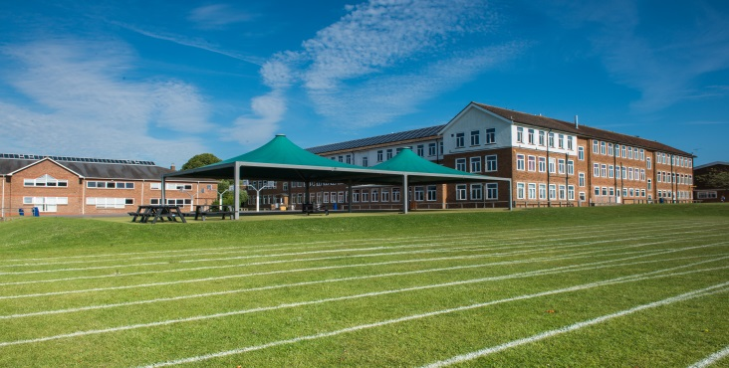

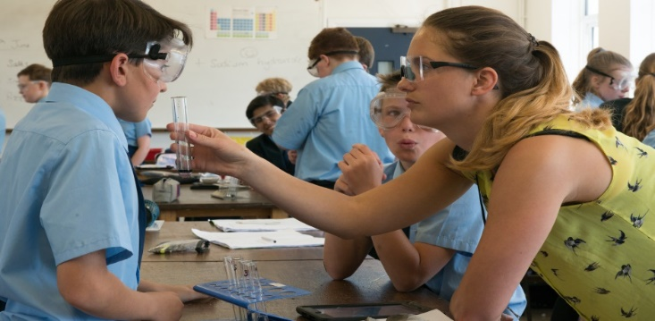

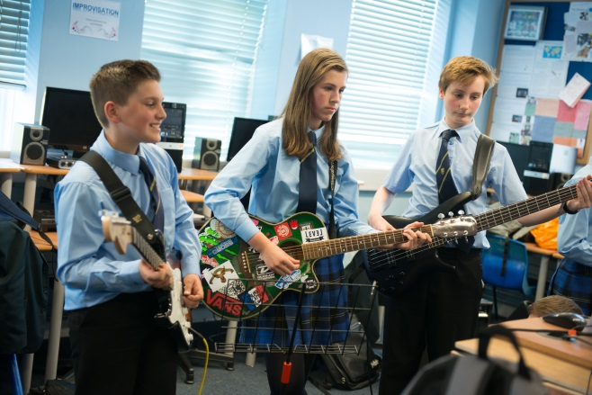

Information for Prospective Candidates

For the post of
DESIGN TECHNOLOGY TEACHER
(September 2018)

Dear Potential Candidates January 2018

Thank you for your interest in this teaching vacancy and I hope that the information contained in this pack helps answer your questions about the post and the academy and that this leads to an application from you.

The most important thing you need to know is that Warden Park Secondary Academy is a fantastic school to work in! The academy is very well respected in the local community and has a long tradition for excellence and our students’ outcomes are very strong. Our students are excellent - generally above average ability on intake they have an excellent work ethic, standards of behaviour are very high and they are enthusiastic in their support of the academy evidenced, for example, by the very high numbers who engage in extra-curricular activities. You will therefore not be surprised to hear that the academy is significantly over-subscribed for the 300 places on offer in Year 7 each year. Places in our excellent SSC which caters for 18 students with Education Health and Care Plans are equally sought after.

I have been in post since September 2017 as Headteacher of the academy which, along with two local primary schools, Warden Park Primary Academy and Northlands Wood Primary, make up the Sussex Learning Trust. The three Headteachers work closely and opportunities for partnership work across the curriculum are evolving as the Trust develops.

There is a strong focus in the academy on developing teacher practice. It is our stated intention to become a research driven learning institution and our professional development is focused on reviewing best practice and carrying out our own research in order to improve the quality of teaching in our classrooms. There is excellent pastoral care in the school coordinated by a very experienced team of Heads of Year and Pastoral Support Officers who contribute to ensuring that, even in a large academy such as ours, every student is known and well-cared for.

Ensuring students leave Year 11 with the best possible GCSE results is a priority for all who work in the academy. In 2017, 56% achieved Grade 5 or above in both English and Maths making Warden Park Secondary Academy one of the highest attaining schools in the county. However, it is also a priority that students leave well-equipped to be successful in the next phase of their learning and, beyond that, to be confident and empowered with the skills and capabilities to go one to be successful employees, citizens, partners and parents. These are equally important outcomes.

The Technology Department

The Design and Technology department (Child Development, Product Design and Food & Nutrition) consists of six experienced members of staff all of whom teach at least one specialist area of our curriculum. We also have two full time and experienced technicians. All our staff in D&T have a passion for delivering high quality, creative lessons. The team takes pride in the products it produces. Lessons are dynamic and engaging and our subjects at GCSE are usually oversubscribed. Design and Technology students at Warden Park frequently leave the academy with a real passion for the subject, with many choosing to study it post-16.

We have recently embarked on a mission to become as near to “Carbon Neutral” as we can. We pride ourselves on investigating, designing and making “useful and inventive” products that students want to keep. We have installed colour coded recycling stations in each room and model a responsible and ethical approach to waste. As part of our Sustainable vision we are developing a “Technology Garden” to replicate a renewable energy system to grow food products. We have a packed enrichment programme offering activities including STEM, Model Making, Textiles and Food & Nutrition.

The department has had a very successful record in recent examinations, with results in D&T frequently being above 80% A*-C with some areas achieving 90% plus A*-C. It is well-resourced, being accommodated in a self-contained ‘Technology Wing’ consisting of 3 mixed media workshops, a graphics suite and two fully equipped food rooms. We also have our own dedicated ICT suite with 22 computers. Digital learning is central to our teaching. The department is well resourced with 3 laser cutters and 3 fully equipped workshops. The Food & Nutrition department enjoys the use of two fully equipped and well maintained cooking and food preparation suites which include the recent addition of a blast chiller in each room. Students in all years have mini-iPads, and wi-fi access is available in all teaching rooms. The department is a leader in developing digital learning strategies and we are committed to using the iPads to maximise student progress.

Students are taught in mixed ability groups in Years 7 and 8 on a carousel. (⅔ Product Design, ⅓ Food & Nutrition) These students are taught an exciting and varied curriculum that has been designed to prepare them for the new GCSE specifications.

Warden Park operates a three-year KS4, with students selecting their options in year 8. In year 9 students are placed into their GCSE classes. They will begin studying the GCSE course in the summer term of year 9 to help cover the increased content of the new GCSE specifications.

From September 2017 we have been delivering the Edexcel GCSE specification for Design and Technology and already deliver the new AQA specification for Food & Nutrition. Child Development will follow the new OCR specification from September 2017.

We are a high-performing, passionate department who aim to instil a love of Design & Technology with all its individual strands. It is a very supportive environment, with best-practice being constantly shared between staff. Students are ambitious, polite and have an extremely positive attitude to learning. It is an excellent place to develop as a practitioner..

Job Description – the following is indicative rather than exhaustive

This post is subject to the current conditions of employment for Class Teachers contained in the School Teachers' Pay and Conditions Document, the 1998 School Standards and Framework Act, the required standards for Qualified Teacher Status and Class Teachers and other current legislation.

This job description may be amended at any time following discussion between the head teacher and member of staff, and will be reviewed annually.

Job Purpose
- To ensure effective learning for each student taught
- To plan and deliver effective lessons
- To be accountable for high standards of student achievement and behaviour

Responsibilities:

- Responsible to the Curriculum Leader
- Responsible for students’ learning, development and progress

Main duties:

- To individually and with colleagues, plan inspiring lessons and teach with a focus on ensuring that all students make better than expected progress
- To have a secure knowledge of students’ prior attainment, individual learning needs and any barriers they may have to learning
- To use a broad range of assessment strategies to identify gaps in students’ knowledge, understanding and capabilities and modify and/or plan learning to address these
- To record student progress information as required and provide data as necessary for reporting to parents
- To effective utilise the classroom and department environment to support students’ learning
- To utilise and develop the opportunities that ipads and other technologies provide to enhance, deepen and accelerate students’ learning
- To engage in the professional development structured by the academy and to work independently and with colleagues to develop own practice through research, collaboration and peer observation
- To maintain and develop positive professional relationships with colleagues, students and parents
- To undertake required student supervision duties
- To act as a positive role model and set and uphold high expectations in relation to students’ conduct
- To act as a Form Tutor

Whilst every effort has been made to explain the main duties and responsibilities of the post, each individual task undertaken may not be identified.

Employees will be expected to comply with any reasonable request from a line manager to undertake work of a similar level that is not specified in this job description.

In Conclusion:

Securing the best possible outcomes for the young people in our care is the absolute priority for me and in applying you will be seeking to join a highly professional and supportive team of colleagues committed to achieving exactly this. As an individual you will possess a growth mindset, be relentlessly optimistic, enthusiastic and determined with an unwavering energy and determination to make a significant contribution to the on-going success of the academy.

Visits from prospective candidates are very much encouraged. We look forward to meeting you!

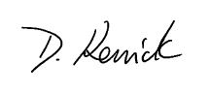

Dom Kenrick
Headteacher

Candidate information

Individual visits:

We would be delighted to organise individual visits with any potential candidate who wishes to visit or find out more detail about a particular area of the Academy. Please contact our Reception staff on 01444 457881 to arrange a tour.

Submitting your application:

If you would like to apply for this post:
- Please complete an application form, available on the Warden Park website
- Submit a letter of application, no longer than two sides of A4. In your letter please focus on the following:

  - How will you ensure that all students in your classes make outstanding progress?

Your completed application should be emailed to jobs@wardenpark.co.uk by 9 am, Monday 29th January 2018. Please note that we will be considering applications as they are submitted up until the closing date. Our HR Manager, Roseanne Gainsford (rgainsford@wardenpark.co.uk ) will be happy to answer any questions you may have about this process or vacancy.

Safer Recruitment:

Warden Park Academy is committed to safeguarding and promoting the welfare of children and young people and expects all staff and volunteers to share this commitment. We will ensure that all our recruitment and selection practices reflect this commitment. All successful candidates will be subject to DBS checks along with other relevant employment checks

Short listing:

The selection panel with undertake short listing wherever possible on the same day as the vacancy closing date, however if there is no closing date we will contact successfully shortlisted candidates as soon as possible. Shortlisted candidates will be notified by telephone and/or email giving them as much notice of the date of interview as possible. If shortlisted, Please bring with you your passport, driving licence (both parts) and a recent bill or statement less than 3 months old along with your degree/educational certificates when you attend for interview. This is for DBS purposes and will save time later should you be appointed.

Local information

Location:

The school is ideally situated in the lovely Sussex village of Cuckfield, in a rural location, yet within easy reach of excellent facilities and communications. There are a good range of local amenities, including restaurants, boutiques and pubs found in Cuckfield and the nearby town of Haywards Heath. Haywards Heath lies in the centre of the Mid Sussex District of West Sussex, surrounded on all sides by stunning countryside, which is less than a five-minute drive in any direction from the town centre.

The vibrant seaside city of Brighton (15 miles) offers first-rate shopping, restaurants and cultural facilities.

Transport:

There are regular trains from Haywards Heath to London and the South East (London Bridge/Victoria from 42 minutes). Gatwick airport (14 miles) has a fast rail connection to London (Victoria 30 minutes).

www.southernrailway.com

There is very easy access to the A23/M23 and in turn the M25 and national motorway network.

Schools:

There are a number of highly regarded primary schools in the area:

www.wardenparkprimary.co.uk

www.northlandswood.co.uk

www.harlandsprimaryschool.org

www.holytrinity-cuckfield.w-sussex.sch.uk

www.bolnorevillage.w-sussex.sch.uk

