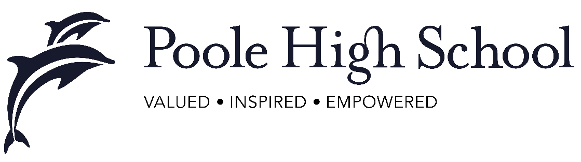
Religious Studies Department

Our Community:
We are a large and vibrant Religious Studies Team, with four full time and one part-time member of staff
The Curriculum:
We currently broadly follow the Poole Locally Agreed Syllabus in Key Stage 3, concentrating on Christianity, Buddhism and Islam. We also teach Philosophy and Ethics topics to all year groups. Currently, at GCSE, Full Course GCSE Religious Studies (AQA) is taken by approximately half the year group, and the remaining students study Core RE. We are starting to teach Full Course GCSE Religious Studies to all students from 2019. OCR A Level Religious Studies (Philosophy, Ethics and Developments in Christian Thought) is a popular A Level and results are good.
Resources and Facilities Available:
The Religious Studies team have four dedicated classrooms and a shared office space. We work within the Humanities Faculty, working closely with a large History and Geography team.

Results and Achievements:
Results are good, and improving. In 2018, the department achieved 78% 9-4 for the Full Course GCSE.

Team Activities, Teamwork and Planning:
The team work closely together, and are currently applying for the RE Quality Mark for excellence in Religious Education.

We plan collaboratively, sharing resources and working together to provide students with an excellent curriculum, supporting their academic and personal wellbeing. We work closely with the PSHE and SMSC leads to ensure that students have a broad and balanced curriculum.

