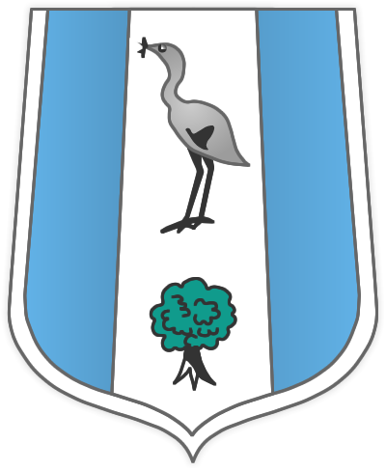

INFORMATION FOR CANDIDATES FOR THE
POSITION OF ENGLISH TEACHER

The English Department is made up of an excellent team of experienced and committed teachers. It is a highly effective department whose students achieve excellent results. Ofsted praised the team for the quality of teaching, high standards of work and behaviour and good relationships with students.

The Department is housed together in a range of rooms. Currently we have six full-time and four part-time members of staff. Most English staff have a permanent base. We have our own set of thirty laptops used for English classes exclusively. Within classrooms, there are digital projectors, tablet pcs and access to media equipment. Branston Community Academy library is also based at the Academy and the English department makes use of this facility. There are many opportunities for professional development within the Academy.

KS3

All KS3 students are set and follow the Department’s schemes of work which broadly follow the National Strategy. In addition, English staff teach Drama to KS3 students.

KS4

Year 10 students have 5 periods and Year 11 have 6 periods. There are two separately setted bands at KS4 with students following the AQA A courses at GCSE for English and Literature. We have been involved in a number of highly successful projects to raise achievement of the C/D borderline students and to develop our most able.

KS5

Students follow the AQA B English Literature course. The Department’s success is reflected in the numbers recruited and students achieving their predicted expectations.

We are looking for a committed, enthusiastic and well-qualified teacher able to teach the full age and ability range, if possible. The successful applicant should have an interest in both the teaching and development of English and Drama at Branston Community Academy. We would welcome applications from both NQTs and experienced teachers.

Thank you for your interest in this post. We look forward to receiving your application.

Closing date: Friday 26th April 2019

Branston Community Academy is committed to safeguarding and promoting the welfare of students and young people and rigorous Child Protection procedures are in place. This post is therefore subject to an enhanced Disclosure and Barring Service (DBS) check.

In the interests of economy we will not be writing to all unsuccessful candidates and you should assume that if you have not heard from us within four weeks of the closing date you are not being called for interview.

