Vision: Embedding & Sustaining
Excellence
2015 – 2020

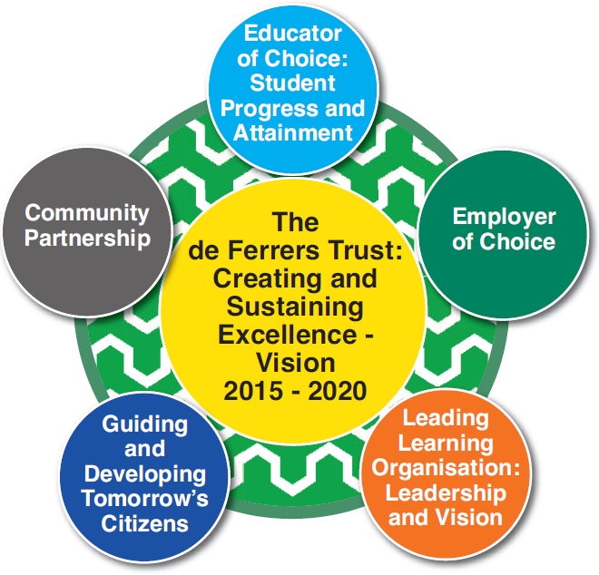

Job Description: | Inclusion Support Assistant
Responsible to: | SENCO
Current Postholder:
Signed: | Date:

THE PINGLE ACADEMY
Job No. | Post Title | Grade | JE Pts | Date
C1170.a | Inclusion Support Assistant | Grade 4 | 358 NJC | April 2008

Statement of Purpose

To work under the direct instruction of teaching staff, usually in the classroom with the teacher. Provide specific support to the teacher in the care of students and management of the classroom. Work may be carried out in the classroom or outside the main teaching area. Assist teachers in the following:

Support to Students

Provide pastoral support to students within the school environment.
- Assist children in matters of personal needs and their general health including first aid and welfare matters.
- Provide structured support in accordance with specific work programmes designed and supervised by individual teachers
- To contribute to raising standards by ensuring high expectations are promoted for students.
- Involvement in the implementation of Individual Education/Behaviour/Support/Mentoring plans.
- Arrange medical/dental visits as appropriate.
- Provide general support to students, ensuring their safety, by complying with good H&S practice.
- Accompany teaching staff and students on visits, trips and out of school activities as required.
- Encourage students to interact with others and engage in activities led by the teacher.

Support to Teacher

- Provide structured support in accordance with specific work programmes designed and supervised by individual teachers.
- Support the teacher in the development and implementation of Individual Education/Behaviour Plans.
- Assist in maintaining classroom discipline through the implementation of the school’s behaviour management strategies.
- Provide support to students to achieve learning goals, e.g. guided reading.
- Supervise students for a particular curriculum activity under the supervision and guidance of a qualified teacher.
- Assist the teacher with the planning of learning activities.
- Assist the teacher in monitoring students’ responses to learning activities and accurately record achievement/progress as directed.
- Co-ordinate and organise students attending extra-curricular activities/work experience or other out of school activities under guidance of teacher.
- Provide detailed and regular feedback to teachers on students’ achievement, progress, problems etc. Provide general admin support, for classroom activities e.g. produce worksheets for agreed activities etc.

Support to Curriculum

- To provide support in literacy/numeracy/SEN strategies.
- Support the use of ICT in learning activities and develop students’ competence and independence in its use.
- Contribute to curriculum planning, evaluation and implementation.
- Contribute to development of school policies and procedures by participation in working groups.
- Contribute to the development, preparation and dissemination of appropriate materials.

Special Features

- The postholder shall be required to work in any of the schools/academies within The de Ferrers Trust group of academies as directed by the Chief Executive
- Be a professional role model, and understand and promote the aims and values of the Trust.

Professional Accountabilities (this list is not exhaustive and should reflect the ethos of the school)

The post holder is required to be aware of and comply with policies and procedures relating to child protection, health, safety and security, confidentiality and data protection, reporting all concerns to an appropriate person. In addition they are to contribute to the achievement of the Academy’s objectives through:

Safeguarding
- Promote and safeguard the welfare of children and young persons you are responsible for or come into contact with, reporting all concerns to the Designated/Deputy Designated Safeguarding Lead as soon as possible.

Financial Management
- Personally accountable for delivering services efficiently, efficiently within budget and to implement any approved savings and investment allocated to the service area.

People Management
- Comply and engage with people management policies and processes
- Contribute to the overall ethos/work/aims of the school.
- Establish constructive relationships and communicate with other agencies/professionals.
- Attend and participate in regular meetings.
- Participate in training and other learning activities and performance development as required.
- Recognise own strengths, areas of expertise and use these to advise and support others.

Equalities
- Ensure that all work is completed with a commitment to equality and anti-discriminatory practice, as a minimum to standards required by legislation.

Health and Safety
- Ensure a work environment which protects people’s health and safety and that promotes welfare and which is in accordance with the Academy’s Health and Safety policy.

Note 1:
The content of this job description may be subject to review. However, any significant change in level of accountability that could result in a change to the grade must be discussed with the post holder and the relevant trade union before submitting for re-evaluation.

Signed: ………………………………………………………………..

Date: ………………………………………………………………..

Person Specification
Inclusion Support Assistant

Essential Criteria | Measured by
Experience  - Supporting children’s learning in a school. | AF/I
Qualifications/Training  - Good numeracy/literacy skills.  - Completion of DfE Teacher Assistant Induction Programme.  - NVQ 2 for Teaching Assistants (or demonstrate equivalent knowledge skills and experience.  - First aid training as appropriate (e.g. emergency first aid course). | T/AF/I
Knowledge/Skills  - Understanding of relevant policies/codes of practice.  - Good understanding of areas of learning, e.g. literacy, numeracy, science, SEN or Early Years.  - Use of other equipment technology – video, photocopier.  - Well-developed interpersonal skills to be able to relate well to a wide range of people.  - Work constructively as part of a team whilst being able to demonstrate initiative.  - Good communication skills.  - Effective use of ICT to support learning.  - Willing to work towards NVQ Level 3 or recognised equivalent. | AF/I /A
Behavioural Attributes  - Customer focused.  - Has a friendly yet professional and respectful approach which demonstrates support and shows mutual respect.  - Open, honest and an active listener.  - Takes responsibility and accountability.  - Committed to the needs of the students, parents and other stakeholders and challenge barriers and blocks to providing an effective service.  - Demonstrates a “can do” attitude including suggesting solutions, participating, trusting and encouraging others and achieving expectations.  - Is committed to the provision and improvement of quality service provision.  - Is adaptable to change/embraces and welcomes change.  - Acts with pace and urgency being energetic, enthusiastic and decisive.  - Communicates effectively.  - Has the ability to learn from experiences and challenges.  - Is committed to the continuous development of self and others by keeping up to date and sharing knowledge, encouraging new ideas, seeking new opportunities and challenges, open to ideas and developing new skills. | AF/I
AF - Application form A – Assessment I – Interview T - Test

Note 1:
In addition to the ability to perform the duties of the post, issues relating to safeguarding and promoting the welfare of children will need to be demonstrated these will include:

- Motivation to work with children and young people.
- Ability to form and maintain appropriate relationships and personal boundaries with children and young people.
- Emotional resilience in working with challenging behaviours and
- Attitudes to use of authority and maintaining discipline.

Every effort should be made to ensure support is within contractual hours.

