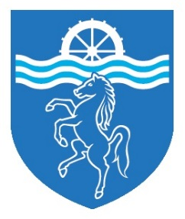

Art Department Information

Art is a well-established and popular subject where the traditional meets the contemporary. It has and continues to achieve outstanding results at both GCSE and Advanced Level. Students enjoy devoting their time to Art and this has contributed to many of them achieving the top grades. This success rate has been consistently achieved for many years with students gaining excellent grades in Art & Design, Fine Art and Photography.

The Art Department is well-resourced in a suite of adjacent rooms in the main school building. These spacious rooms have a healthy complement of computers to assist student learning and all rooms have an interactive whiteboard available to use for teaching. Whole-class activities using computers can be carried out in one of the devoted ICT suites around the school which can be booked for student use in advance. Our own extensive departmental library of books and electronic images is supplemented by the well-stocked library in the Learning Resource Centre.

Art at Beths Grammar School is currently taught in mixed ability groups in Years 7, 8 and 9. Students have the opportunity to express themselves using a variety of media and gain a rich cultural experience throughout Key Stage 3. The subject attracts a healthy number of students in Years 10 and 11 who develop their ideas further as they study the Edexcel GCSE specification. At A-Level students continue with the Edexcel specification both Art & Design and Photography are offered.

One of the many strengths of the Department is its accessibility for students. Art rooms are available for use at lunch times and after school; and students across all key stages make use of the facilities. Extra-curricular sessions are provided to students who have been identified as having strong artistic gifts and who wish to develop their interests further. A number of visits to galleries and to sites of artistic interest are arranged for students in each Key Stage, both locally and overseas, to broaden their artistic and cultural education.

We are proud of the work produced by our students. Such work is regularly displayed in the local community with many winning individual recognition and awards. The end of year Art Exhibition in July is a rich, popular and well-established cultural event on the school calendar where the local community is invited into school to share our students’ talent.

The successful applicant joining the team will have energy, innovation, an excellent range of creative skills, effective organisational skills, a proven track record of firm but fair discipline and have an understanding of best practice in the teaching of Art & Design. They will be joining a supportive team of experienced individuals who are united in their ethos of providing excellence of teaching and learning for all students in a stimulating environment.

