
The Castle School Guide to completing an application form

Thank you for your interest in applying for a job at The Castle School.

We have stringent safer recruitment processes and are committed to safeguarding and promoting the welfare of children and young people and expect all staff and volunteers to share this commitment. We will ensure that all our recruitment and selection practices reflect this commitment and are in line with guidance in KCSIE.

The first step to a successful application is the application form. Our safer recruitment practices begin with the scrutiny of this form so here are some hints and tips to ensure that you complete the form correctly.

Firstly, please ensure that all parts of the form are complete. We are not able to accept CVs and do not open and look at them so we only take what is included on the form.

Education section.
Please ensure that you have all of your qualifications and time spent at school listed, including GSCE’s, A-levels and any college and university courses.
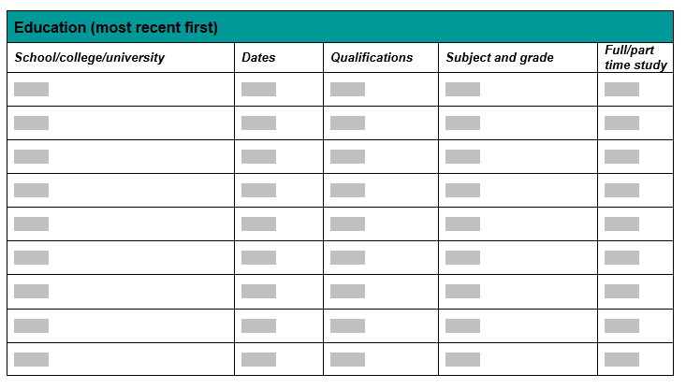
Employment section
Your current employment section must be completed with your current or most recent first. Please ensure that you complete all sections of this form.
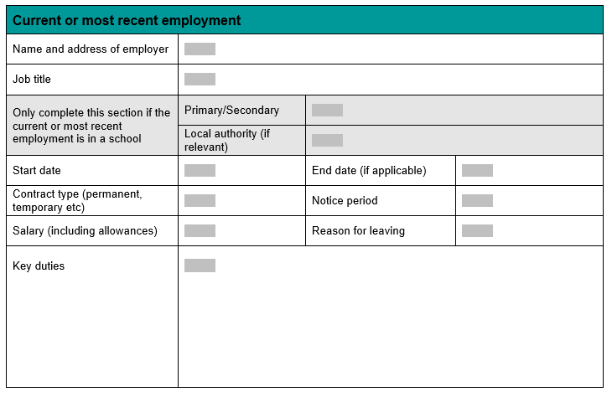

Previous employment section.
This needs to cover all dates since you left education, all of your employment history. It is important to ensure that any gaps are explained, so please state if you were job seeking, being a stay at home parent or any other reasons for not being in formal employment. This is very important.
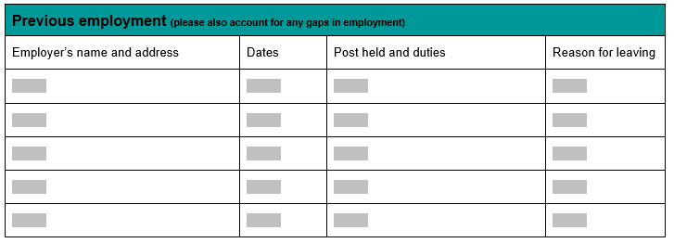

Supporting statement
The supporting statement is important as this is your chance to explain the skills and knowledge that you have that are relevant to the post. You need to look closely at the person specification for the things we are looking for. If you haven’t worked in a school before there are lots of skills, you can transfer over. You can include things your do outside of work. This is your chance to sell yourself and explain why you want to work with us.
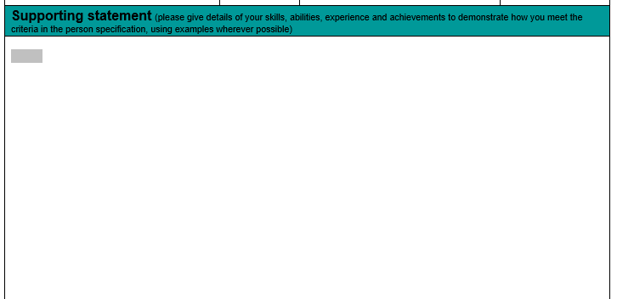

References
References are very important.
Your first referee should be your current employment. If you have worked in a school before this should be the Headteacher. Please ensure that you provide as much contact information including an email address. This helps to speed up the process. We would also recommend letting your referees know you are putting them on the form.
References should be from formal employment or from education.
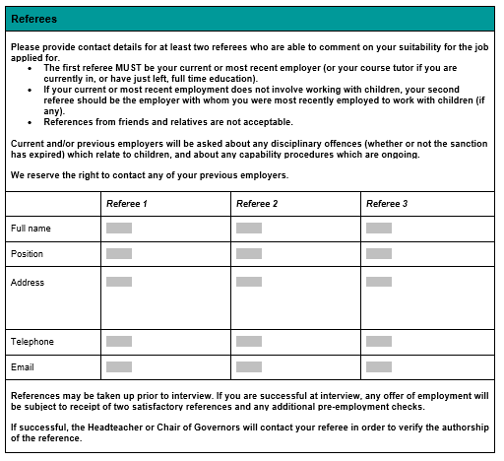
Declaration
Please ensure that you list anyone who you know who works within West Berkshire, including if they work in a school setting.
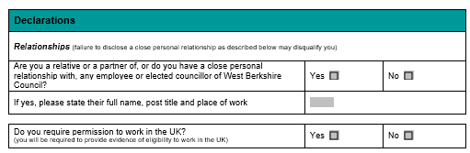

The equal opportunities form
This is on the last page and is often missed. This needs to be completed in full. This bit is not looked at as part of the shortlisting process so is removed from the form.
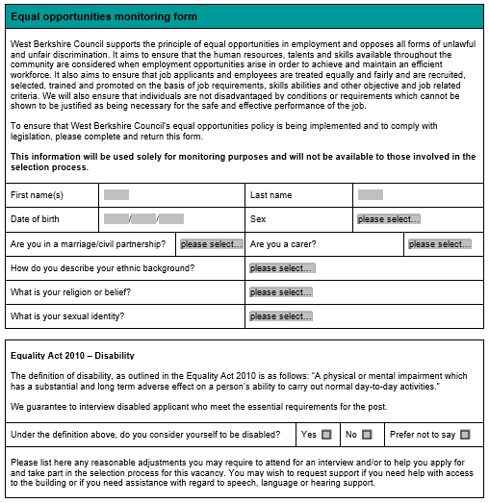

If forms are not completed correctly it will have an impact on your chances of being shortlisted for an interview, especially if there is a higher volume of applications for a post. If you complete the form to the best of your abilities, it gives it the best chance to stand out and sell yourself.
Once the closing date is reached applications will be reviewed and shortlisted in line with the key criteria on the person specification. If you are shortlisted for interview you will be asked to complete a criminal records self-disclosure form. If you are offered the role after an interview you will be subject to Disclosure and Baring Service (DBS) checks along with other relevant checks including online searches to help us identify any incidents and/or issues which may be relevant to your suitability for the role, which the school may want to explore further with you.

Good Luck!

