Finham Park Multi Academy Trust



Headteacher’s Application Pack for
Finham Park 2
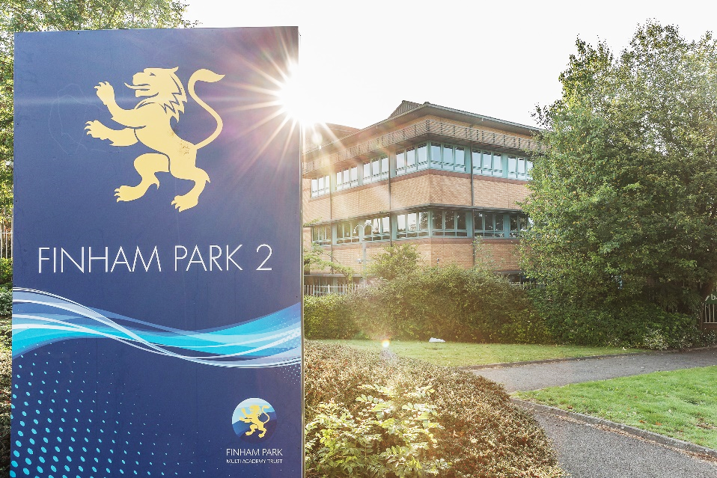
February 2023

CONTENTS
Letter from the CEO | Page 3
Letter from the Chair of Trustees | Page 4
Finham Park 2 – School Overview | Page 5
Latest Ofsted Report | Page 5
Local Area and Location | Page 5
Application Process | Page 6
Selection Process | Page 6

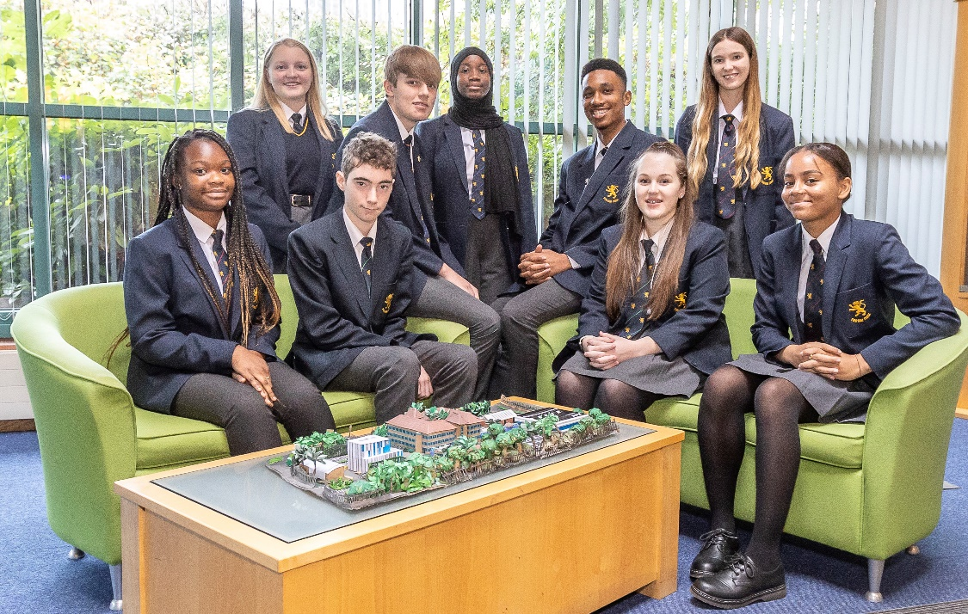

Letter from the Executive Headteacher – Mr Mark Bailie

Dear Candidate,
I am thrilled that you are interested in our Finham Park 2 Headteacher vacancy.
Finham Park Multi Academy Trust was created in March 2015, with the aim of creating a small Coventry/West Midlands based Multi Academy Trust that pioneers, innovates and delivers a “World Class” education for all children from the age of 3-19, where the artificial barriers of stage and age are removed.
Our Trust aims to exceed the highest national and international benchmarks for academic achievement, whilst ensuring young people develop a passion for learning in all its contexts and are ready to take their place as active members of our global community.
Our vision is to move beyond collaboration and into co-construction – ensuring our education is developed with and by all members of the Trust to reflect the needs of our children, their families and the wider community.
We are immensely proud of our schools, which include a vibrant mix of Primary and Secondary schools, representing a diverse range of communities that we are honoured to serve.
We are in a very fortunate position where we have exceptionally strong and talented teams in each school and across the Trust. Staff well-being, welfare and professional development are priorities which are underpinned by our academy core values of collaboration, equity, achievement and trust. In addition, working towards a work life balance is something we strive to do. We fervently believe that if we get it right for staff, we then get it right for pupils.
I very much look forward to hearing from you.

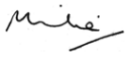

Mark Bailie
CEO
Finham Park Multi Academy Trust

Letter from the Chair of Trustees & Chair of the LGB

Dear Candidate,
We are writing to thank you for your interest in the vacancy for a Headteacher at Finham Park 2. We sincerely hope that this letter, together with any additional supporting documentation and opportunities to visit the school will inspire and encourage you to want to work with us. This unique and exciting opportunity has become available due to the rapid growth of our Trust and the recent promotion of the current Headteacher.
Finham Park 2 opened as a new Free School in September 2015, the same year as Finham Park Multi Academy Trust was formed. The family of schools within our Trust currently comprises Finham Park School; Finham Park 2; Finham Primary School, Lyng Hall School, Lillington Primary School and Meadow Park School. The Trust’s vision is summarised below:
“Schools in the Finham Park MAT will set out to pioneer, innovate and deliver a “World Class” education for all children from the age of 0-19 where the artificial barriers of stage and age are removed. Our education will aim to exceed the highest national and international benchmarks for academic achievement, whilst ensuring young people develop a passion for learning in all its contexts and are ready to take their place as active members of our global community.”
This is mirrored in the vision for Finham Park 2: “We aim to provide another outstanding secondary school for parents and children in Coventry with ‘World Class’ aspirations and the highest expectations. Finham Park 2 is a non-selective, comprehensive school for students aged 11-18 and is built on the traditional values of pride, respect, and responsibility. Pivotal to this is a positive ethos and culture of learning and success for all students. We pay particular regard to outstanding achievement for all students whatever their academic starting point and a commitment to lifelong learning for all stakeholders.”
We want to appoint an inspirational headteacher for Finham Park 2 – a leader with charisma, expertise, and the skills to motivate both adults and young people to achieve the very best for themselves and their school community. We are hopeful that the next headteacher will lead our school towards our stated ambition of being a “World Class” school – to this end we are not a community that rests on its laurels; rather we are constantly striving to improve the experience we offer our pupils and, whilst proud of our track record and history, recognise that there is much still to do.
We feel we can offer many things to a successful applicant. These would include the support of an experienced governing body; the collegiate support of other headteachers from both primary and secondary phases; the guidance of our Executive Headteacher, Mark Bailie (also a National Leader of Education and Ofsted Inspector) and a MAT Central Support Service (Finance, Human Resources, Estates, IT and Education Development departments) that allows our Headteachers to focus on the most important things – opportunities for students! Finham Park 2 is fortunate in possessing an excellent team of specialist teachers and support staff together with opportunities to develop the links and networks that a school like this needs not just to be successful in its own right, but also to support and learn from other partner organisations – In our view, this is an exceptional opportunity for the right person to develop our school and develop themselves as a school leader.
Thank you for your interest. We hope to receive an application from you in due course if you feel Finham Park 2 may be an interesting place to work.
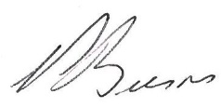

Mr Peter Burns MBE Mr Antony Hopker
Chair of Finham Park Multi Academy Trust Chair of Finham Park 2 Local Governing Body
Finham Park 2 – School Overview
Ofsted Report
Finham Park 2 was rated ‘Good’ by Ofsted on 5th June 2018.
To view the Ofsted Report, please click here.

Finham Park 2 Spring Census 2023 Data
Pupils on roll | Total
Pupils on roll | 669
Gender | Mixed

Local Area and Location
Local Travel
Finham Park 2 is located on Torrington Avenue in Tile Hill, in West Coventry.
This means it is easy to reach Midlands towns and cities and their attractions including:
Birmingham & Solihull: NEC, NIA, Cadbury World, numerous theatres, shops and sporting venues
Leicester: Resting place of Richard III, New Walk Museum, Abbey Park, Cultural Quarter
Warwick: Royal Leamington Spa and Shakespeare’s Stratford-upon-Avon
Birmingham Airport can be reached within 30 minutes’ drive and good rail links include London Euston which is just over an hour away.

Coventry
Coventry grew to become one of the most important cities in England during the Middle Ages due to its booming cloth and textiles trade.
The city was noted for its part in the English Civil War, and later became an important industrial city during the 19th and 20th centuries, becoming the centre of the British bicycle and late motor industry.
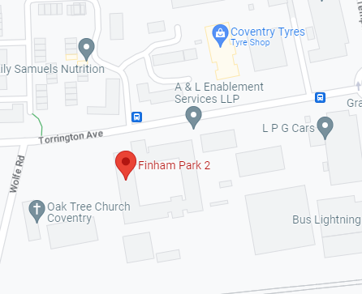
The devastating Blitz in 1940 destroyed much of the city centre, and saw its rebuilding during the 1950s and 60s. In the new millennium the city, along with many others saw significant urban renaissance and in 2017 the city was awarded the title of 2021 UK City of Culture.

Finham Park 2
Torrington Avenue
Coventry

CV4 9WT

Application Process

Closing date for applications: Monday 27th February 2023

Shortlisting: Tuesday 28th February 2023

Interview dates: w/c 20th March 2023

Please return your application by email to: apply@finhampark.co.uk

Selection Process

Stage 1: Applicants should send their completed application form along with a covering letter including a supporting statement evidencing how you fulfil the Person Specification to the HR Department by the 27th February 2023.
Please use the application form provided.

Stage 2: Applicants will be reviewed and a short list produced for interview. Short listing will take place on 28th February 2023. Successful applicants will be notified by email and by telephone.

Stage 3: Interviews will take place w/c 20th March 2023. Candidates will take part in a number of recruitment activities, including a presentation and formal interview.

We welcome and strongly encourage informal visits to the school by prior arrangement.

Please telephone Leigh Thomson, PA to the Headteacher, on 02477 710720 or email l.thomson@finhampark2.co.uk, to arrange a visit. The following dates have been made available:

4.30-6pm 8th February
4.30-6pm 9th February
9-10am- 16th February
11-3pm 17th February


We very much look forward to meeting you.

