
St Catherine’s Catholic School

Learning Support Assistant

We are seeking to appoint a highly motivated, enthusiastic, and energetic individual to work as a Learning Support Assistant for the SEND department. Learning Support Assistants are a vital element in supporting the learning of our most vulnerable pupils on the SEN register. This is a full-time position for 37.5 hours per week (5 days per week) and term time only (39 weeks per year).

St Catherine’s is a Catholic girl’s mainstream school with a range of pupils with special educational needs. The majority of pupils have social and communication difficulties including autism, dyslexia and social, emotional mental health.
Staff at St Catherine’s benefit from an excellent team ethos. We encourage all staff to be active in their professional development and offer a comprehensive package of induction along with the opportunity to further develop skills and knowledge through training. We are committed to the wellbeing of all our staff and offer a programme of activities in support of this.
At St Catherine’s Catholic School, we are committed to safeguarding and promoting the welfare of our young people and expect all staff to share this commitment. Appointments are subject to the completion of an enhanced DBS check and receipt of satisfactory references.
We are an equal opportunities employer.
To be successful at St Catherine’s, you will:
- commit to our supportive but challenging ethos and culture
- thrive on working in teams but be able to work independently
- constantly challenge yourself to become a better practitioner
- be committed to our comprehensive extracurricular programme
- be passionate about diversity and inclusion
- demonstrate an unwavering commitment to Catholic education and the ethos of the school.

In return, we will offer you:
- a school where students are keen to learn
- a school where GCSE outcomes are consistently strong. This summer our students achieved outstanding results achieving a Progress 8 score of +.77 (FFT estimates) and an Attainment 8 score of 59.11.
- an incredibly supportive group of colleagues and leaders
- a personalised professional development programme delivered through twilight sessions and dedicated training days
- fast track promotion opportunities
- the chance to perform on a wider stage through our proud membership of the LSU group of schools and the Archdiocese of Southwark.

For an informal conversation about the role, please contact Ms Konadu-Aboagye, SENDCO/ Assistant Headteacher

Key information

Start date: October 2024 at 9am (or before)
Salary: Bexley Scale 5.1
Visits: By arrangement
Closing date: Monday 30th September 2024 at 9am
Interviews: Week commencing 30th September 2023

We particularly welcome applications from candidates who will help us to make our staffing body more representative of London’s rich and diverse community.

St Catherine’s Catholic School is committed to safeguarding and expects all applicants, referees and members of the school community to share this commitment

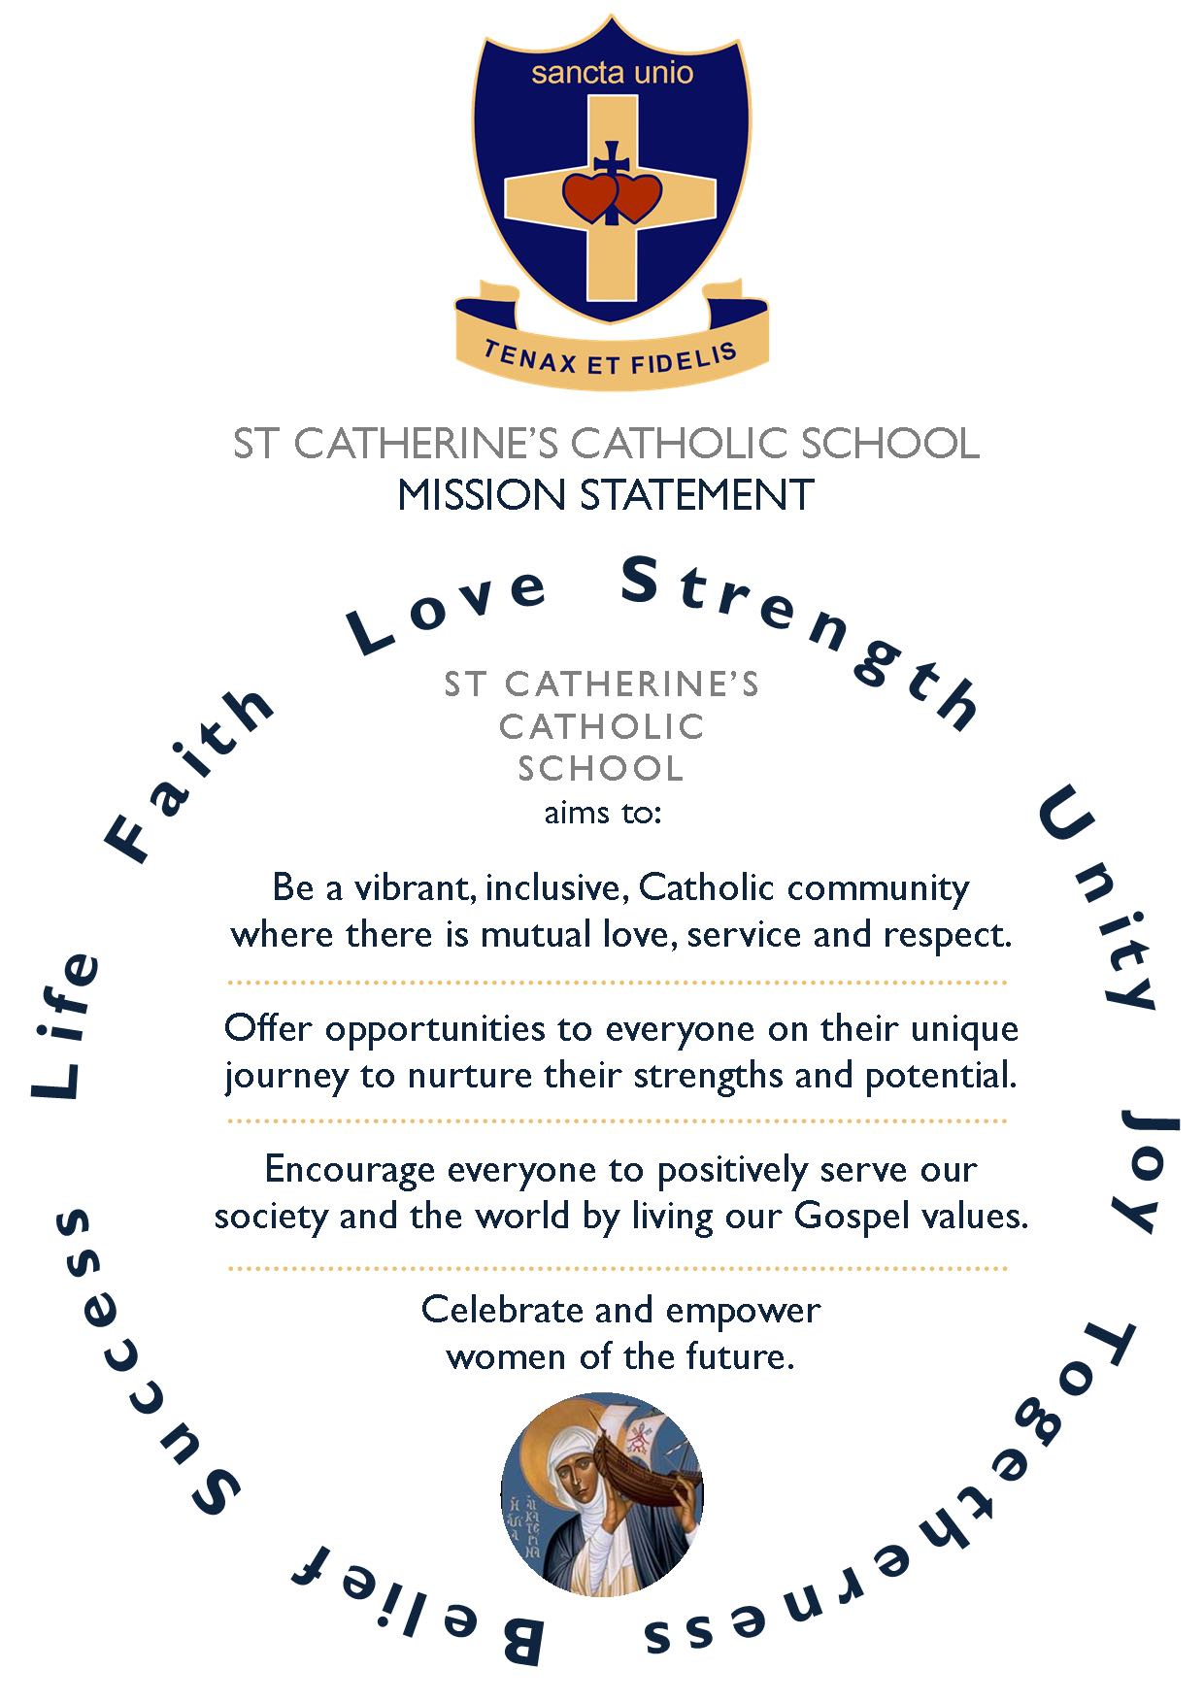



St Catherine’s Catholic School

How to Apply

We look forward to receiving your application.

We will only consider complete applications. These will consist of two parts:

- A CES application form, available to download from our school website or the TES.
- A covering letter of no more than three sides of A4, explaining:
  - Why you would be a suitable candidate for St Catherine’s school, based on your experience to date
  - How you will inspire our students and raise their aspirations
  - What you will bring to the Catholic ethos of the school
  - Why you want the job at this stage of your career
  - How you will contribute to the wider life of the school.

In addition to the application form and covering letter, we are happy to accept CVs, although it is not essential.

Timeline for appointment

Visits: Actively encouraged and can be arranged by emailing info@stccg.co.uk

Application deadline: Monday 30th September 2024 at 9am

Invitation to interview: Week commencing 30th September 2024

Interviews: Week commencing 30th September 2024

Post begins: October 2024 or before





St Catherine’s Catholic School

 Watling Street, Bexleyheath, Kent, DA6 7QJ  01322 556333  info@stccg.co.uk  www.STCCG.co.uk

Headteacher : Nicola Thompson BSc (Hons) NPQH
: Mrs Nicola Thompson BSc (Hons) NPQH

