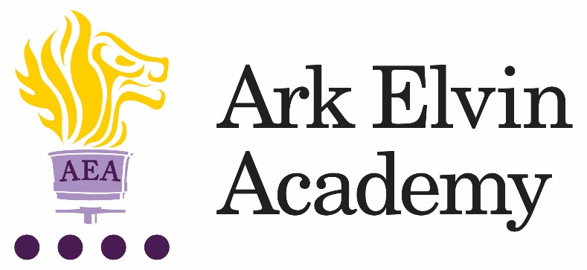

Graduate EAL Teaching Assistant

At Ark Elvin Academy we are working hard to give all our pupils an excellent education and are looking for committed teachers and support staff to join us at this exciting stage in our school improvement journey. We are a large, non-selective secondary school in the London Borough of Brent, with excellent transport links to central London. Our new building works are underway and will be ready in December 2017, www.arkelvinacademy.org to find out more about our new building.

We are seeking to recruit a Graduate EAL Teaching Assistant who will work with the SENCO to provide tailored support to new to English pupils. EAL Teaching Assistants play a vital role in teaching pupils, both in a one to one setting and in larger and whole class groups. We need exceptional graduates who will be inspirational role models to our pupils and work with both teachers and the wider school community to establish a supportive and nurturing learning environment in which pupils make rapid academic progress.

Your role will focus on teaching pupils who a new to English and delivering a rapid English intervention programme. This will include:

- Supporting EAL pupils with their induction to our school community
- Delivering induction activities for pupils new to the country
- Phonics teaching
- One to one language support
- EAL small group support
- Tracking and monitoring language acquisition over time

In recruiting for the Graduate EAL Teaching Assistant role we are seeking the following from applicants:
- Bilingual, preferably Gujarati, Arabic, Somali or Romanian speaking
- Educated to degree level
- A commitment to our school improvement process
- A growth mindset
- High standards of professionalism
- Courteousness
- Experience of establishing successful learning relationships with a variety of children at the relevant age
We encourage and welcome you to visit our school; to arrange a visit, please contact Anita Amaning a.amaning@arkelvinacademy.org or 020 8902 6362.
For any technical queries about submitting your application, please contact Anita Amaning on the details above.
To apply for the role, go to http://arkelvinacademy.org/vacancies

Closing Date: 30th June 2017
Location: Brent, London
Start date: September 2017
Salary: Ark band 5 (£20,379 - £24,135) 40 weeks, pro rata

Ark is committed to safeguarding children; successful candidates will be subject to an enhanced DBS

Job description: Graduate EAL Teaching Assistant

Reports to: SENCO
Salary: Ark band 5 (£20,379 - £24,135) 40 weeks, pro rata

The role
To work with our team to provide tailored support to pupils who are learning English as an additional Language. Graduate EAL Teaching Assistants play a vital role in supporting pupils, both in a one to one setting and in larger and whole class groups. Ideally you will be bilingual, preferably being able to speak Gujarati, Arabic, Somali or Romanian

Key responsibilities
- To primarily support pupils who are learning English as an additional Language
- To support with the induction of new pupils to the school
- To plan and deliver sessions to support with the early acquisition of English
- To plan tailored interventions for individual and small groups of pupils.
- To provide in class support for pupils, as directed by the SENCO and class teachers.
- To work with class teachers to plan support in lessons, including translating resources
- To liaise with families to gain a thorough understanding of the needs of pupils.
- To update pupil records as required.
- To share information about individual pupils with teachers and other colleagues so that all colleagues understand differentiation needs and how best to support learners.
- To prepare additional resources for pupils as required.
- To carry out duties around the school to support the smooth running of the school and promote school values.
- To carry out additional interventions and assessments as required, e.g. reading tests and phonics interventions.
- To liaise with primary schools to gather further information to support the learning of pupils before they join year 7.

Other
- Undertake other various responsibilities as directed by the Principal

This job description sets out the main duties of the post at the time of drafting. It cannot be read as an exhaustive list. These responsibilities will be discussed annually as part of the postholder’s annual performance review and are subject to change. However, it may be altered at any time subject to need in consultation with the postholder subject to the Principal’s approval.

Person Specification: EAL Teaching Assistant
Qualification criteria
Essential:
- Right to work in UK
- Good literacy and numeracy
- Degree level qualification (ideally 2:1 or above)
- Bilingual – preferably able to speak Gujarati, Arabic, Somalian or Romanian
For those interested in training to teach:
- GCSE math’s and English at grade C or above or equivalent (this a national requirement to enter teacher training)
Desirable:
- A qualification in teaching English as an additional language such as a CELTA or DELTA

Essential experience
- Experience of establishing successful learning relationships with a variety of children at secondary school age
- Experience and/or understanding of the role of an EAL teaching assistant
- Experience of teaching English as a foreign language

Skills and attributes
We are looking for these skills and attributes or at the very least, a candidate’s clear, demonstrable capacity to develop them:
Alignment with Elvin vision
- Relentless drive to do whatever it takes to ensure all pupils succeed.
- Embody our core values – integrity, courage, community and mastery – in all aspects of work and conduct.
- The belief that with the right environment all of our pupils are able to excel at university, or in a meaningful alternative.
- The courage and conviction to make a difference.

Communication skills
- The ability to listen and communicate effectively.
- Empathy and the ability to understand the needs, aspirations and motivation of diverse individuals and groups.
- The ability to influence and motivate others.

Working with others
- Develop and communicate a shared vision.
- Model desired behaviour and values.

- Empower, support and coach others.
- Hold others to account for high standards of performance.
- Understand and resolve conflict.

Problem solving
- Identify, analyse and resolve problems and issues.
- Develop plans with concrete outcomes and effective solutions.
- Evaluate results and identify necessary actions.
- Make fact-based decisions.

Resilience
- Sustain energy, optimism and motivation in the face of pressure and setbacks.
- Stay calm in difficult situations and maintain clarity of vision.
- Be adaptable in the face of adversity.

Results and learning orientation
- Awareness of own strengths and limits.
- Commitment to ongoing improvement and learning.
- A passion for own role and that of others.
- Focus on achieving challenging goals and results.
- Resourcefulness and flexibility in delivering outcomes.

Leadership
- Effective team worker and leader.
- Demonstrates resilience, motivation and commitment to driving up standards of achievement.
- Acts as a role model to staff and students.
- Vision aligned with Elvin’s high aspirations, high expectations of self and others.

Other
- This post is subject to an enhanced DBS disclosure.

Ark is committed to safeguarding and promoting the welfare of children and young people in our academies. In order to meet this responsibility, we follow a rigorous selection process. This process is outlined here, but can be provided in more detail if requested. All successful candidates will be subject to an enhanced Disclosure and Barring Service check.

