

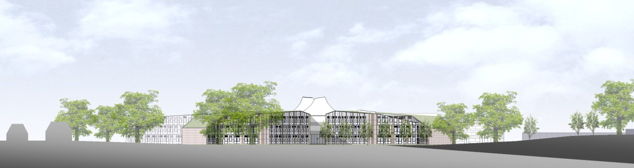

**ST BARTHOLOMEW’S SCHOOL**

**TEACHER OF MATHEMATICS**

**FULL-TIME, PERMANENT**

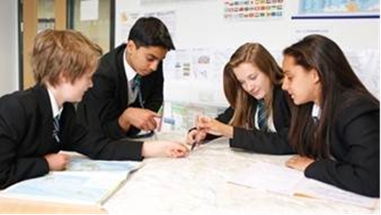

**Andover Road**

**Newbury**

**Berkshire**

**RG14 6JP**

**Tel: 01635 521255**

**Email:** [**recruitment@stbarts.co.uk**](mailto:recruitment@stbarts.co.uk)

**Website:** [**www.stbarts.co.uk**](http://www.stbarts.co.uk)

Dear Colleague,

Thank you for your interest in the position of Teacher of Mathematics at St Bartholomew’s School. I hope that the details contained in this pack will provide you with a clear picture of this post and give you a flavour of the school and its values. This post really is an exciting opportunity as you will be joining a highly achieving faculty in the school with outstanding facilities.

I recognise that looking for or considering changing jobs in this current pandemic is more challenging and a more difficult decision, but a new post is still a great opportunity. Therefore, this is something we take really seriously and give all interested applicants the opportunity to talk to a member of the Mathematics & Computing faculty or Leadership Team on line prior to applying. If selected for interview we are happy to still give you a tour of the school and to meet some staff and students in a COVID safe way so that you can really appreciate what life at St Bart’s is like.

We also place considerable emphasis on professional development for all staff at all times and any new member of staff will get a thorough induction, even in these more difficult times. There are also many materials and some videos on our website which are useful to view to help you to get to know our school.

Working at St Bartholomew’s really is very rewarding, and the Governors and I look forward to hearing from you if you feel you have the qualities and experience we are looking for.

If you would like to have a discussion with the Head of Faculty: Mathematics & Computing or a member of the Leadership Team about this post or require any further information please contact Human Resources on the above number or [recruitment@stbarts.co.uk](mailto:recruitment@stbarts.co.uk).

Yours faithfully,

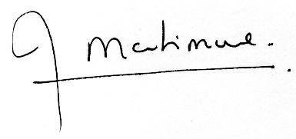

Julia Mortimore

Headteacher

**ABOUT OUR SCHOOL**

**Academic Success**

For the last 5 years St Bart’s has secured the highest level of student attainment in West Berkshire state schools. We think our academic success is something to be very proud of.

Our key headlines are:

1. In 2019 83% of our students achieved both GCSE English and Mathematics at level 4 or better and 29% of all grades were 9 – 7.
2. Over the last 3 years our average Progress 8 score has been 0.62 which put St Bartholomew’s in the top 8% of schools nationally which we are very proud of.
3. In 2019 A level results were above national averages with 27% of all grades A*/A and 75% of all grades A* – C.

**Ofsted and School Development**

This is an important appointment for the school at an exciting time when we are working towards becoming outstanding as recognised in our recent short Ofsted Inspection. At St Bartholomew’s we all work together as a team to share good practice, and really develop outstanding teaching and learning to ensure every student makes expected or greater than expected progress.

Every member of staff is part of an Action Research Group and you will also contribute to whole school development in this way. The staff at St Bartholomew’s care very much about the community and are ambitious for the school in terms of learning and enrichment opportunities for all the students.

Teaching at St Bartholomew’s School is a rewarding experience. Our students are eager to learn, well behaved and proud of their school, and this was reflected in our last Ofsted inspection which judged students’ behaviour and safety as outstanding. As a school we are committed to ensuring that all the students and staff realise their full potential. Students leave the school as good citizens and this is underpinned by an exceptional house system and a vast range of extra curricular activities.

**Professional Development**

The professional development of staff is a significant factor in ensuring that we achieve our aim of improving on our previous best and there are rich professional development opportunities at St Bartholomew’s (see CPD offer on our website under Job Opportunities) at all levels. We are praised for our induction and NQT programmes for new staff which are supportive and thorough. Coaching is available for all staff across the school upon request, or maybe you’d like to become a Coach yourself?

**Our School**

Our modern building reflects the importance of the House system, with House blocks (Curnock, Davis, Evers and Patterson) sited around a covered outdoor Hub space.

Our school buildings include outstanding teaching facilities: drama and dance studios, extensive music practice rooms, IT and media suites, specialist design technology rooms and well-equipped laboratories. Sports provision is exceptional including a multi-purpose sports hall, a well-equipped gym hall, an outdoor synthetic turf pitch, a multi-use games area and extensive playing fields.

The wide range of extra-curricular enrichment offers all students new opportunities for learning and enjoyment. This includes clubs and activities such as debating, equestrian, moth club, craft and horticulture, as well as Chinese and Latin classes and a huge range of activities in music, drama and dance. House competitions and activities involve all students. Sporting traditions are very strong with an exceptional range of sports teams competing successfully at the highest standard. Our students love representing their school.

**What’s in it for me?**

1. Excellent IT infrastructure.
2. Smaller than average class sizes.
3. All staff are issued with their own laptop.
4. All faculties have their own office within which teachers have their own designated workspace.
5. A subsidised meal at Activity Time.
6. Ample on-site parking.
7. Staff may be eligible for student places at the school for their children.
8. Staff Forum – an opportunity for staff to meet and voice their suggestions for improvements to the school.

**The Faculty – Welcome**

We have a large team of Maths and Computing teachers in the faculty, both full time and part time. Currently there are 19 Maths specialists and 4 Computing teachers, with a wide range of interests, and experience both in and out of teaching. In Maths we are lucky to have our own suite of 12 classrooms in our block, including a computer room. Full time teachers in the faculty have their own teaching room which they use for almost all lessons, and part time teachers are timetabled in rooms consistently wherever possible. We are fortunate to have a Lead Practitioner in our team, who also has a leading role in the local Maths Hub. In addition we have one full time and one part-time Teaching Assistant dedicated to supporting students in Maths lessons.

The Mathematics and Computing Faculty have a strong ethos of teamwork. Conversation in the faculty office is frequently dominated by resource sharing ideas and sharing of good practice with different types of classes. This also happens more formally in regular faculty meetings, and staff are encouraged to participate in Professional Development opportunities both in school and on external courses.

In Maths, each key stage has a co-ordinator who oversees the schemes of work and assessments, and provides support to other teachers as needed. The department is well resources with textbooks, and a variety of practical and more active resources. Use of a variety of teaching methods and resources is encouraged, and we are fortunate to have an open plan area outside classrooms which can be used to run some of these activities, as well as an interactive board in all teaching rooms. There are also 30 netbooks available for use in lessons.

In terms of arranging the teaching of our different year groups, 135 students are set into five groups by ability in year 7, and 6 groups by ability in years 8 to 11. Students across the curriculum are in two bands according to which House they are in, giving ten or twelve groups in each year.

At Key Stage 4, students in 8 out of the 12 groups are entered for the higher tier at GCSE. Most students in the 2 highest sets will also be entered for the AQA Level 2 Certificate in Further Maths. Results in recent years have been excellent, with impressive results at GCSE resulting consistently in an ALPS of 3 or above.

Maths is also one of the most popular subjects in the Sixth Form with 4 classes in each year group, plus a separate Further Maths class each year. All specialist Maths teachers are given the opportunity to teach A Level if they want to, and the wide ranging experience of the department means there is a great deal of flexibility between teaching Statistics or Mechanics alongside Pure Maths. Results at A Level are also consistent with an ALPS 3 or above most years, with a high number of A* grades every year. Each year, we are proud that a number of students achieve A8/A grades in both Maths and Further Maths, and students frequently carry on to study Maths related courses in further education, including some who are prepared for Oxbridge entrance. In addition we offer the opportunity to take the Core Maths Level 3 qualification to those students who have achieved a GCSE grade 4 or above and want to continue to study Maths, but not at A Level. We also offer a one-year GCSE course for sixth formers wishing to improve their qualifications.

Year 8 students annually participate in a Crystal Maze Day, and students in all years participate in the National Maths Challenge. There are opportunities to participate in a range of other extra-curricular activities run by members of the Maths department, including chess, speed cubing, origami and a board games club.

Overall, team work and a spirit of co-operation and sharing of ideas are key features of our thriving and successful department and we’re keen to continue developing and improving our practice, hopefully with you on board.

If you’d like to learn more, please do contact me via our HR department. Below is also a link to a video we made for our year 6 open evening that gives a flavour of what our Faculty is like.

<https://drive.google.com/file/d/1J0HDc_sgGcTXA-Tp7v5rEz-kS0XOKr1n/view?usp=sharing>

**The Post**

* We are seeking to appoint a suitably qualified inspiring Teacher of Mathematics to join the Mathematics & Computing Faculty with effect from 1 September 2021 on a permanent basis.
* The position is full-time.
* Applications are welcome from newly qualified and experienced teachers.

**The Salary**

* The successful candidate will be appointed to the main or upper pay scale in accordance with her/his experience and qualifications.

**How to Apply**

Full post details, an application form and instructions on how to upload your completed application are available via the Jobs & Training / Job Opportunities section on the School’s website:

[**www.stbarts.co.uk**](http://www.stbarts.co.uk)

(Please note that curriculum vitae and covering letters cannot be accepted)

Successful candidates will be subject to a DBS enhanced check along with other relevant employment checks.

## Closing date: Sunday 17 January 2021

Thank you for considering St Bartholomew’s School, we look forward to hearing from you.