
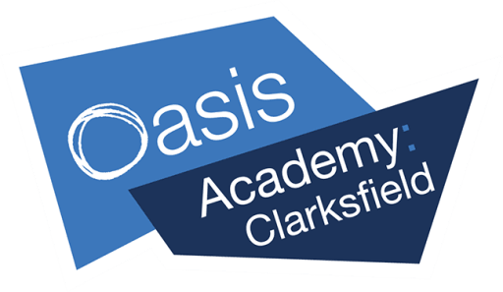
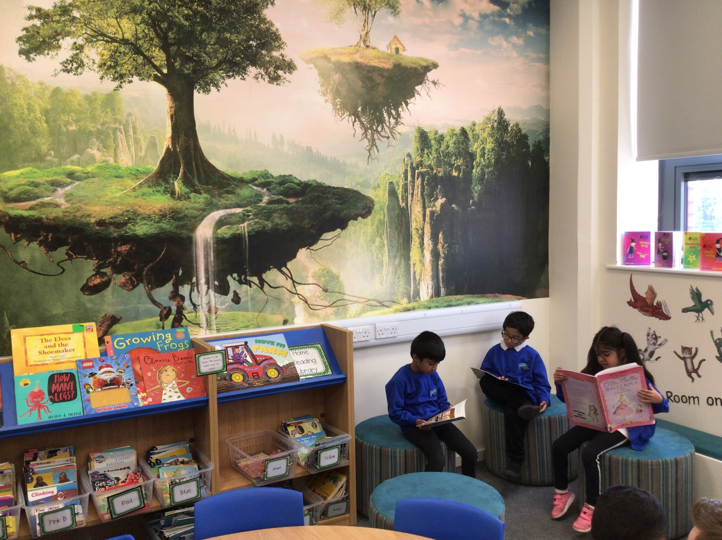
Deputy Principal

Oasis Academy Clarksfield



Exceptional Education at the Heart of the Community
Academy
Leesbr
ook
Dear Candidate,
A warm welcome and thank you for your interest in leading Oasis Academy Clarksfield. “Pupils are friendly, polite and well-motivated. The calm and inclusive school environment means that pupils learn happily together.” (Ofsted April 2023)
Finding the right Deputy Principal is extremely important to us. The successful candidate will need to be completely committed to our school vision and the Oasis ethos and values. There is a requirement for the successful candidate to be flexible and dedicated to help ensure that our academy is exceptional every single day. This is a truly wonderful opportunity to join a forward-facing, community driven team.
At Oasis Academy Clarksfield we believe in investing in our children, families and staff. Our children are the future generation of pilots, doctors, scientists and politicians. Our children are ready for whomever they want to be and whatever they want to do. What happens at Oasis Academy Clarksfield will shape them not just for the here and now, but for the next phase of their education and beyond. “Pupils work enthusiastically in their lessons and achieve increasingly well because leaders have increased everyone’s expectations of what pupils can do.” (Ofsted 2023)
We believe that learning is the most precious gift that people have and as education professionals it is our responsibility to ensure that children recognise the longevity of their learning journey and develop the skills to approach learning with awe, wonder and self-motivation.
We believe passionately in making a difference to all children, holistically and academically. Everything we do is built on an ethos of mutual respect for all, which is linked to the Oasis 9 habits: compassionate, considerate, forgiving, honest, hopeful, humble, joyful, patient and self-controlled.
I invite you to apply for this exciting role, where you can join a team of professionals dedicated to ensuring that every child has the opportunity to ‘Dare to know and Dare to be wise.’
I look forward to receiving your application.
Very best wishes

Emma Johnson
Regional Director North West Primary Academies

Oasis Academy Clarksfield
Grasmere Road, Oldham OL4 1NG
T: 0161 213 1235

About Oasis Community Learning
Thank you for your interest in joining the Oasis Community Learning (OCL) family. I am delighted that you are interested in finding out more about us. Oasis Community Learning was established as a Multi-Academy Trust in 2004 with the vision to create “Exceptional Education at the Heart of the Community”. We now run academies in five main regions throughout the UK, providing either Primary, Secondary or All-through education to over 32,000 young people - 47% of whom are from disadvantaged backgrounds and 31% speak English as an additional language.
All of our academies are committed to providing a rich educational experience and ensuring that every child and young person has the opportunity to achieve at the highest level. Our ethos is integral to that provision. It is an expression of our character, a statement of who we are and therefore the lens through which we assess all we do. We are committed to a model of inclusion, equality, healthy relationships, hope and perseverance throughout all aspects of the life and culture of each academy community.
We passionately embrace learning and are committed to every child within our care reaching their full potential, developing holistically across every area of their lives both now and in their future. All of this is underpinned by our philosophy of education which highlights our focus on inspirational leadership, deep learning and healthy communities. It aspires to develop the character and competence of every child within every community of which we are a part.
At Oasis Community Learning therefore, we believe we are all ‘the architects of our students’ lives’ and as such we are committed to laying the right foundations for every one of our young people.
We also know that great schools are only sustainable within happy, healthy communities. In order to tackle the root causes of disadvantage we seek to ensure that school improvement and community development go hand in hand. In this way, the improvement is likely to be deeper, mutually supporting and long lasting.
Our academies are therefore just a part of an Oasis ‘Hub’ that provides wide-ranging and integrated services, designed to meet the needs of local people. Our shared aim is to work with and alongside disadvantaged children, young people, whole families and members of the wider community, empowering them to transform their neighbourhoods into places that are safe, supportive and full of opportunity. We want to see no one excluded or isolated, inclusive communities where every individual is supported to thrive and flourish.
Our people are our most important resource and our catalyst for change. Are you the one to help us do this?
We hope that you find everything you need in this brochure and welcome you to get in touch with the Academy you are applying for with any questions you may have.

John Barneby
CEO, Oasis Community Learning


The Oasis Ethos
Everything within Oasis Community Learning is framed by our ethos.
Our ethos is rooted in what we believe and who we are. Grounded in our story, it is an expression of our character; a set of values that inform and provide the lens on everything we do.
- A passion to include
- A desire to treat people equally respecting differences
- A commitment to healthy, open relationships
- A deep sense of hope that things can change and be transformed
- A sense of perseverance to keep going for the long haul
It is these ethos values that we want to be known for and to live by. We are committed to a model of inclusion, equality, healthy relationships, hope, and perseverance throughout all the aspects of the life and culture of every Oasis Hub and academy community.
We encourage every member of our family, be that staff or student, to align themselves to these ethos values. The values themselves are Christ-centred, but we make it clear that we will not impose on anyone, the beliefs that underpin our ethos values. We recognise and celebrate the richness that spiritual and cultural diversity brings to our community, respecting the beliefs and practices of other faiths in the hope that we will provide a welcoming environment for all.

Community Learning: Oasis Hubs
Developing and running Hubs is core to the global purpose of Oasis and vision for healthy communities. To this end, our staff are committed to working in an inclusive, integrated and empowering way so that all people experience wholeness and wellbeing. We want to see local communities that are characterised by trust, safety, cohesion, mutual support, vibrancy, health and opportunity, as well as increasing capacity to address their own issues. We want to see those who are excluded brought back into the community to share the experience of wholeness and wellbeing.
Each Oasis Academy is part of an Oasis Hub that responds to the needs of the local community through many different forms of outreach. Our united goal is to see the entire community transformed for the better.

The Oasis Curriculum
Our curriculum is the heart of our academies' educational provision. Through this - and our commitment to an exceptional climate for learning and great pedagogy - we make focused learning the foundation of every lesson. We have designed our Ofsted-praised curriculum to meet the needs of all, striving for personal as well as academic and vocational excellence. Through our curriculum we will achieve outcomes that drive social mobility and give everyone freedom of choice throughout their lives
The Oasis ethos and 9 Habits are a foundation stone to the design and delivery of our curriculum. We know that the development of character doesn’t happen by chance but by purpose and intention: it is therefore an explicit part of our curriculum. We therefore work hard at preparing our students to be the best version of themselves not just for today but for their futures too. We provide our students with information on careers and the world of work encouraging them to be aspirational and ambitious so that they can secure their dream job and enjoy fulfilling careers.
Our curriculum has been designed to ensure our young people thrive, achieve and flourish. It enables them to understand what it is to be human and equips them for life so that they become kind and model citizens. Our curriculum not only develops our young people academically but socially, emotionally, culturally, physically and spiritually.
Whilst our knowledge-rich curriculum is designed to ensure the very best academic outcomes for our young people using the latest research in how the brain and memory works, it is about so much more than simply securing great results. It is about our academy’s determination to achieve excellence with equity and integrity: where we bring advantage to the disadvantaged, where barriers to learning are successfully overcome and there are no limits to the achievement and ambition of our most able.
Our knowledge-rich curriculum and our commitment to the Oasis ethos and Nine Habits is supported by our Trust’s policies on Learning and Behaviour for Learning and the work of our National Lead Practitioners and Leads for Learning Innovation.
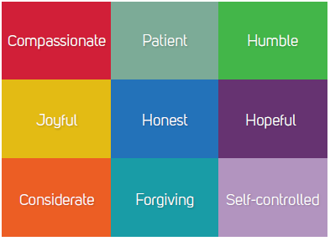

Our Offer to you

Integrated training and development opportunities
As our curriculum and our technology develops, so do our staff. We offer opportunities for training to all our staff, whether that is through external certification courses, internal development or training days. If you are interested in taking your career with us in a specific direction, we will do our best to ensure you have the opportunity to learn and grow with us.

A clear progression route
Our staff understand that there is room to progress with us; our training packages and staffing structure allows for a clear progression route within the organisation.

Support and sharing best practice
Through ongoing support from our National Lead Practitioners, Best Practice Academies, Regional Directors and Monitoring and Standards Team, our academies are able to continually progress and innovate learning for both students and staff alike. The Oasis Teaching School, in Oldham, acts a key source for training within the family.

Expenses and travel costs (as appropriate)

We remunerate our staff for incurred expenses and travel costs when asked to work outside of the normal school environment. This is in line with our Staff Expense Policy.

Cycle to Work Scheme
We have partnered with the Green Commute Initiative's cycle to work scheme to give our employees access to a conventional, electric or adapted bicycle that they can use for their everyday commute to work and during their leisure time.

Staff wellbeing resources
We release regular wellbeing resources to help our family out with all sorts of needs. From advice and support on managing anxiety and low mood to guilt and shame, to podcast recommendations, recipes, helpful videos and signposting. We are there to support you in any way we can. We also have a good offer through our Occupational Health providers with resources for help with stopping smoking, stress, diet, exercise sleep and healthy living.
Health Scheme
We are proud to be part of the Health Shield Cash Plan Scheme. Our employees can opt in* for a small monthly fee for:
- Money back for everyday healthcare such as dental, optical, physiotherapy and chiropody
- Access to a GP over the phone 24/7 at a prearranged time to suit you
- Direct access to a qualified Physiotherapist
- Access to a selection of tests that help to detect the early stages of some common cancers
- A 24/7 helpline that offers practical information and emotional support for issues relating to family, bereavement, trauma, relationships, stress, personal legal information, tax information, medical information, money management, alcohol/drugs and debt support.
- An online rewards portal, which includes exclusive member discounts, great deals and cashback on weekly food shopping, travel, restaurants, etc
Children up to the age of 21 living at home and studying full time are covered at no extra cost.
*Opting in periods will depend on which month you join Oasis.
Free counselling service
As an employee of Oasis you will have access to a free confidential counselling service. Our leaders also go through training to be more understanding of the needs of their teams.

About you
We are seeking an outstanding teacher with experience of successful primary school leadership. As deputy and part of the senior leadership team you will have high expectations for all, be able to effectively support and develop teachers and leaders, empower staff teams and drive forward standards whilst demonstrating emotional resilience and being a champion of the Oasis ethos and 9 habits.

About Oasis Academy Clarksfield
Oasis Academy Clarksfield is an inclusive Academy for children aged between 3 and 11. We aim to cultivate habits and attitudes that enable young people to become better learners; face difficulty and uncertainty calmly, confidently and creatively. Within our Academy we celebrate diversity and relentlessly focus on progress and attainment of all our children. We are an Ofsted rated ‘Good’ school and a school of choice within Oldham. At Oasis Academy Clarksfield, we pride ourselves on having a staff body who are committed and dedicated, going above and beyond to serve our children and community.

Our Motto
Dare to know, dare to be wise!




Effective Partnerships
Oasis Academy Clarksfield is outward looking and has engaged with a wide range of external partners, both within the Oasis family and beyond, to ensure continued improvement and dynamic opportunities. The Academy benefits from support from National Lead Practitioners both from within the Northern region and further afield. The Academy is heavily involved in the local education system and works closely with all schools and Academies within the region.

To Apply
If you would like more information about this exciting opportunity and/or would like a confidential discussion about the position, please don’t hesitate to email the Interim Principal: Becky Morrish – rebecca.morrish@oasisclarksfield.org or contact the academy directly on 0161 213 1235.

To apply, please submit a completed application form to suzanne.caffery@oasisclarksfield.org by no later than 9.00 am on Wednesday 27th March 2024.

This role offers a challenging but highly rewarding opportunity to make a significant impact on the
educational outcomes of thousands of students. Our young people deserve the best: your role will be to ensure that they receive it.

Additional Information
This post is covered by Part 7 of the Immigration Act (2016) and therefore the ability to speak fluent spoken English is an essential requirement for this role. Oasis is committed to making a difference to the lives of the communities it works in, and as such you must show a willingness to demonstrate commitment to the values and behaviours, which flow from the Oasis ethos.

We are committed to safeguarding and promoting the welfare of children and young people. We
expect all staff to share this commitment and to undergo appropriate checks, including enhanced DBS checks.



Job Description
POST: Deputy Principal
ACCOUNTABLE TO: Principal
THE ROLE: Exciting opportunity for an experienced, ambitious, dynamic and driven leader to join one of the largest and most successful MATs in the UK. We are looking for someone to unleash the potential and drive sustainable improvement for Oasis Academy Clarksfield.
LOCATION: Oasis Academy Clarksfield, Grasmere Road, Oldham OL4 1NG
WORKING HOURS: Full time and as described in the STPCD
ABOUT THE ACADEMY: Oasis Academy Clarksfield is a local Nursery and Primary School serving children aged 3 – 11 years. We are dedicated to developing and preparing students to be local, national and global leaders.
JOB PURPOSE: The Principal will be accountable for the leadership, internal organisation, management and control of the Academy. It will be for them to lead the staff in realising the vision of investing in our children, families and staff, generating future pilots, doctors, scientists and politicians.
KEY RESPONSIBILITIES: In seeking the vision for the Academy, the Principal would be expected to carry out the following duties and to recognise that the list is only indicative and that there might be other, similar duties which he/she might be required to carry out, at the discretion of the Regional Director.
SALARY: L6-L10 (£53,380 - £ 58,959) + Teachers Pension Scheme

The Deputy Principal will be responsible for:

- LEADERSHIP
  - To lead through the lens of the Oasis Ethos & 9 Habits.
  - To lead the overall strategic management and operational activity of the academy
  - To create a positive, inspiring, high achieving ethos within the academies, in line with the wider Oasis Vision – for community – a place where everyone is included, making a contribution and reaching their God-given potential and specifically to deliver ‘exceptional education at the heart of the community’.
  - To work positively with the community to ensure the best possible outcomes for students.
  - To ensure that national policies, strategies and processes are implemented at a local level and where appropriate any local policies, strategies and processes are consulted on and implemented effectively in order to transform the outcome for students and staff at the academy.
  - To ensure that students are healthy, stay safe, enjoy and achieve maximum potential, achieve economic and personal well-being once they leave the academy.
  - To develop the reputation of the academy, locally, regionally and nationally.
  - To ensure staffing matters are managed in accordance with national OCL policy and in line with the Oasis Ethos and 9 Habits.
  - Developing and maintaining good working relationship with regional and national People Directorate colleagues, keeping them informed of any staffing matters, seeking their advice at the earliest opportunity and working in partnership to resolve any issues.
  - To help foster a culture where staff feel equipped and empowered to flourish and thrive in their roles and safe to feedback any concerns.
  - To work collaboratively with the local Oasis Hub Leader and Community staff to achieve the Hub strategy.

- QUALITY OF EDUCATION
  - To support the Regional Director to ensure curriculum delivery is translated into effective learning and assessment practice.
  - To encourage and promote innovation in educational provision, ensuring that the academy can meet changing needs and demands consistent with government guidelines and requirements.
  - To ensure that high quality provision is available to all students regardless of race, religion, sexual orientation, gender, disability, economic background or special educational needs.
  - To lead a culture rooted in the five Oasis Ethos values and enacted through the 9 Habits where students feel safe, confident and are able to thrive and grow in all aspects of who they are including attaining their maximum educational outcomes.

- DEVELOPING YOURSELF AND WORKING WITH OTHERS
  - To develop and maintain a culture of high expectations for self and others.
  - To support the development of effective strategies and procedures for staff induction, professional development and performance management in line with agreed local and national policy and procedures.
  - To support the clear delegation of tasks and responsibilities.
  - To line manage in a people-centered way, in line with the Oasis Ethos and 9 Habits.
  - To treat people fairly, equitably and with dignity and respect to create and maintain a positive culture upholding and enabling a culture underpinned by the Oasis Ethos to thrive.

- CHAMPIONING THE OASIS ETHOS
  - To model the way of the Oasis 9 Habits engaging in this as a journey of personal transformation.
  - To engage others in their journey of personal transformation through the lens of the 9 Habits.
  - To access resources within the Oasis family to create the ongoing alignment to the Oasis Vision, Mission, Ethos & 9 Habits within the Cluster.

- GENERAL
  - To be aware of and comply with policies and procedures relating to child protection, inclusion, health, staffing, safety and security, confidentiality and data protection, reporting all concerns to an appropriate person without delay.
  - To participate in training and other learning activities and performance development as required.
  - To ensure you carry out your role in a way that enables high standards to be achieved by proactively utilizing the benefits of inclusion and diverse thinking to achieve this.
  - To ensure strict confidentiality in all areas of work.
  - To work and process personal and sensitive information in accordance with the Data Protection Act 2018 and the UK General Data Protection Regulations (UK GDPR).
  - To ensure work is conducted in a way that protects the safety and security of information (e.g., strong passwords, reporting breaches, securing paper records, securely disposing of records).
  - To understand and comply with the statutory guidance regarding safeguarding of children, always ensuring the safeguarding and promotion of children’s welfare, reporting any concerns to the Designated Safeguarding Officer at once.
  - To always comply with the Trust’s policies and procedures.

OTHER:
The above responsibilities are subject to the general duties and responsibilities contained in the Statement of Conditions of Employment.
The duties of this post may vary from time to time without changing the general character of the post or level of responsibility entailed.

Oasis is committed to safeguarding and promoting the welfare of children and young people. We expect all staff to share this commitment and to undergo appropriate checks including an enhanced DBS check.

Signed:
Employee: |  | Line Manager:
Print Name |  | Print Name
Date |  | Date

Deputy Principal - Person Specification

Our Purpose
The vision of Oasis Community Learning (OCL) is to create ‘Exceptional Education at the Heart of the Community.’ All our academies are committed to achieving this vision through developing character, competence and sense of community with every child, providing a rich educational experience that is underpinned by our philosophy of education; inspirational leadership, deep learning, and healthy communities.

Oasis Ethos
Our ethos is an expression of our character - it is a statement of who we are and therefore the lens through which we assess all we do. We are committed to a model of inclusion, hope, perseverance, healthy relationships and compassion throughout all the aspects of the life and culture of each Academy community.

Our ethos is rooted in what we believe and who we are. It is an expression of our character. Rooted in the story and beliefs of Oasis, we describe our ethos through a particular set of values that inform and provide the lens on everything we do.

- A passion to include
- A desire to treat people equally respecting differences
- A commitment to healthy, open relationships
- A deep sense of hope that things can change and be transformed
- A sense of perseverance to keep going for the long haul

It is these ethos values that we want to be known for and live by. They are the organisational values we aspire to. We are committed to a model of inclusion, equality, healthy relationships, hope, and perseverance throughout all the aspects of the life and culture of every Oasis Hub and Academy community.

 | Essential | Desirable
Qualifications | *Qualified Teacher Status | *Masters’ Degree  **Working towards NPQH  *Achievement of a Certificated / Nationally recognised leadership qualification
Leadership and management – evidence of experience, skills and knowledge | **Evidence of successful leadership and management in more than one primary school, both in successful and underperforming or challenging circumstances  ***Proven record of successful leadership at a senior level including:-  - Developing and implementing a vision for improvement and success in current post  - Evidence of successful leadership and management in a challenging/underperforming school as a senior leader and able to demonstrate success in raising standards  - Current responsibility for the strategic development of teaching and learning/curriculum design or new technologies  - Successful innovator and manager of change across the whole school that has impacted upon achievement  - Clear and understandable vision and evidence base for new technologies and their capacity to improve teaching and learning  - Involvement in the creation of the SEF in current school  - Responsibility for development and improvement or sustained performance in current school through significant whole school projects  - Effective use and development of a wide range of strategies for managing dis-affection, poor behaviour and under achievement across the school  **Evidence of outstanding classroom practice (evidenced by AST or excellent teacher status and/or Ofsted recognition) with evidence of high achievement in teaching across the Key Stages  **Effective use of Assessment for Learning to engage pupils as partners in their learning | **Experience in several primary schools, both in successful and underperforming or challenging circumstances  **Responsibility for professional development/ mentoring of colleagues  **Experience of employment outside the educational environment  **Development of partnerships with other schools, business and the community  **Experience of working with ITE/GTP providers  ***Ability to demonstrate a range of strategies to enhance teaching and learning of ICT  ***An understanding of education within a Multicultural/Multi-faith community  ***An understanding of Emotional Literacy developments to support learning and teaching  **Knowledge of school finance/ BSF  **Competent use of SIMS packages including Assessment Manager and other related packages  **Ability to train on an analogous package  **Full driving licence
Leadership and management – evidence of experience, skills and knowledge | **Knowledge and understanding of current curriculum thinking and innovation - Curriculum and National strategies and developments that are improving achievement at EYFS, KS1 and KS2  **Knowledge of a variety of learning pathways, the inter-relationships between them and their impact on learning  **A thorough understanding of the Oasis vision, ethos and core values and its relevance to improving achievement and outcomes for young people, their families and the communities the Academy serves  **A firm grasp of educational policy and the implications for the leadership and management of Academies  **Use of national and school assessment and attainment information to improve practice and raise standards  **Use of strategies to promote good pupil relationships and high attainment in an inclusive environment  ***Ability to demonstrate enthusiasm as an effective leader and manager who can inspire colleagues  ***Excellent communication, presentation and ICT skills  ***Excellent interpersonal skills  **Evidence of being a competent leader and manager, able to inspire and motivate all members of the Academy community  **Ability to plan and resource effective interventions to meet curricular objectives  **Ability to use and promote a wide range of teaching methodologies  **Effective behaviour management strategies combined with high expectations of pupils’ behaviour  ***Ability to anticipate and solve problems  ***Creative and flexible thinker  **Ability to respond positively to constructive criticism  **Ability to deliver constructive criticism
Personal Qualities | ***Commitment to safeguarding and promoting the welfare of children and young people.  **Willingness to undergo appropriate checks, including enhanced DBS checks.  **Motivation to work with children and young people  **Ability to form and maintain appropriate relationships and personal boundaries with children and young people  **Emotional resilience in working with challenging behaviours and attitudes to use of authority and maintaining discipline  ***Have a willingness to demonstrate commitment to the values and behaviours which flow from the Oasis ethos.
Personal Values | ***A belief that young people can be successful with appropriate support to challenge barriers to learning through:-  - Full engagement with inclusive and comprehensive education  - An inherent belief in the importance of raising standards and life-long learning  - To actively support the Academy’s aims  - Innovative curriculum development  - Promotion of vocational and work-related learning  - Partnership with other schools and the wider community including business and industry links  - Promotion of extra-curricular activities/ educational visits / out-of-school learning
Professional Development | **Evidence of a commitment to own professional development with the ultimate goal of achieving Principal role | ***Recent relevant in-service training in Management and Leadership

Those elements marked *will be assessed in your application.
Those elements marked **will be assessed in your application and during the selection process e.g., interview, presentation.
Those elements marked ***will be evaluated during the selection process e.g., interview, presentation.
NB references will be used to support the selection panel’s assessment.

The Oasis Education Charter
Ethos
Our ethos is rooted in what we believe and who we are.
- We have a passion to include everyone.
- We have a desire to treat everyone equally, respecting differences.
- We have a commitment to healthy and open relationships.
- We have a deep sense of hope that things can change and be transformed.
- We persevere and keep going for the long haul.

Learning
The purpose of education is to understand what it means to be human - living intentionally and asking two key questions: Who am I? Who am I becoming?
- The foundation of our students’ learning is made up of five integrated objectives.
- We develop competence, striving for excellence in skills, knowledge and qualifications.
- We foster character and self-belief and encourage our students and staff to become the best versions of themselves through the 9 Habits.
- We embrace community, advocating the value of living interdependently with others.
- We equip our students and staff to be engaged local and global citizens who strive for a better society
- We nurture and empower a life-long passion for learning in all the people we serve.

People
As an interdependent family, we enjoy exceptional strength and opportunity.
- We believe that good relationships are at the heart of everything we do.
- We support and encourage each other in championing the Oasis ethos.
- We work, learn and develop together so that students and staff can share and benefit from everyone’s best practice.

Purpose
We work in partnership with our communities to transform lives, where everyone is included, can contribute and is able to reach their God-given potential. We deliver this through an Oasis Hub our model of integrated community development.
- We deliver education in the context of our Hubs.
- We create a culture of excellence for all.

Inclusion
Our vision is driven through a passion and commitment to include everyone.
- We believe all our children and young people are precious; we prioritise social inclusion and integration in all we do.
- We model and set high aspirations and expectations for every child and young person and member of staff.
- We provide opportunities and experiences for all our students, as well as their wider families, giving advantage to the disadvantaged.
Curriculum
The curriculum is the heart of Oasis’s educational provision.
- We make great learning the foundation of every lesson.
- We design our curriculum to meet the needs of all.
- We strive for personal as well as academic and vocational excellence, achieving outcomes that drive social mobility, and give everyone freedom of choice through their lives

A number of reference documents support the Oasis Education Charter and are available on www.oasiscommunitylearning.org

