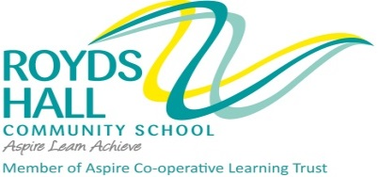

KIRKLEES METROPOLITAN COUNCIL

SERVICE: Children and Young People

PERSONNEL SPECIFICATION

POST TITLE : Second in Mathematics at Royds Hall Community School MPS/UPS plus TLR 2b
ATTRIBUTES | ESSENTIAL | DESIRABLE | HOW IDENTIFIED
RELEVANT EXPERIENCE | Evidence of successful teaching and learning in Mathematics with students of all abilities in the 11- 16 or 11-18 age range. | Experience of successful development work relating to teaching and learning and/or leadership and management. | Letter of application  Letter of application  References
EDUCATION AND TRAINING | Qualified teacher status  A degree in Mathematics / or a subject with a large component of Mathematics.  A willingness to undertake further professional development activity in both the specialist subject and leadership and management training. | Recent relevant in-service training | Application form  Application form  Interview  References  Letter of application
SPECIAL KNOWLEDGE AND SKILLS | Able to demonstrate a thorough knowledge of the curriculum and approaches to teaching and learning in Mathematics.  An effective classroom practitioner, skilful in assisting individuals and groups to make progress in their learning.  The ability to lead the department to produce the highest quality teaching and learning experience for students. | Able to demonstrate a thorough knowledge of the curriculum and approaches to teaching and learning in Mathematics.  Knowledge and understanding of current and potential uses of ICT to aid Teaching and Learning in Mathematics and to assist with leadership and management work.  Knowledge and experience of monitoring, evaluating and reviewing strategies to foster improvements. | References  Interview  Application Form  References  Interview  Letter of application
ANY ADDITIONAL FACTORS | Confident, flexible, approachable, resilient, unfailingly optimistic about what excellent teachers and excellent schools can achieve and able to inspire others.  Committed and able to work as part of a team. |  | Interview  References

