Hills Road Sixth Form College, Cambridge
Appointment of
Teacher of Physical Education

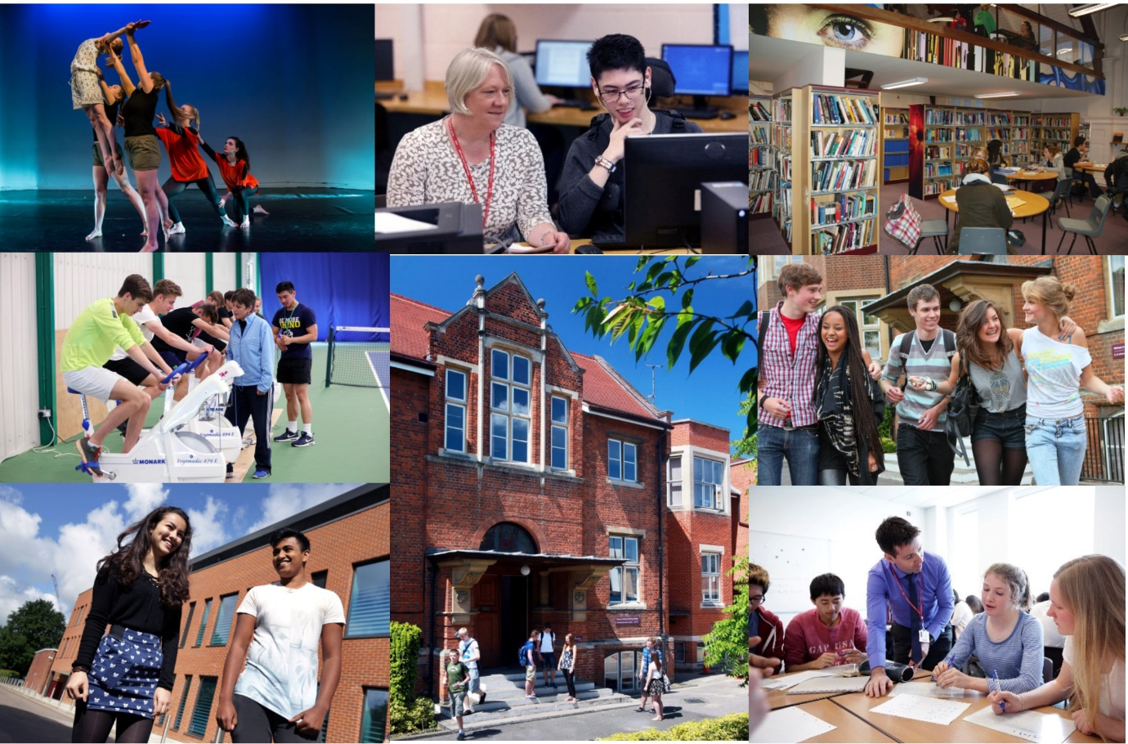

Opportunity ● Quality ● Achievement

Welcome from the Principal
Thank you for your interest in Hills Road Sixth Form College and in this post. We really hope that the information in this booklet will support you in making an application to our College and will provide all you need for deciding whether our College is right for your next career step. We hope it is!

Choosing an institution where you find a fit in terms of ethos and values is hugely important. Hills Road Sixth Form College enjoys a strong national reputation, having topped Sixth Form College performance league tables for outcomes since their inception over twenty years ago. But that doesn’t make us complacent. We still want to evaluate and improve the ways in which we work with young people to get the best for them and from them, whatever that might take.

We are therefore looking for a colleague to join us who shares that drive and wants to ensure that the department they are joining continues to achieve excellent outcomes. Everything we achieve relies on the quality and commitment of our staff team whatever their role in the College and we are keen to recruit colleagues for whom excellence comes as standard. We also want you to continue to grow professionally while you are with us and will explore with you ways in which we can support that development. Through the application and interview process, we’ll be keen to understand your ideas and approaches to supporting delivery of the best educational outcomes at this specialist A level college.

As a busy, vibrant community of 2,500 young people, there’s always a great deal going on and lots to be part of and take part in. Extra-curricular opportunities abound and we hope you will want to get involved with the extraordinary range of activities that is on offer. We have an on-site sports centre, including a fully equipped gym, plus squash and tennis courts, to which all staff colleagues have free membership and our staff wellbeing programme includes access to on-site talking therapy, fitness and relaxation sessions. If you would like to talk through a prospective application or to explore the College’s ethos and values a little more, please don’t hesitate to make contact for an informal chat.

Finally, I do appreciate the time commitment involved in completing a job application and, if you do decide to apply, can I thank you for the investment of time you have chosen to make. Whatever the outcome, can I wish you all the very best with your future career, wherever that may be.

With very best wishes

Jo Trump
Principal

Overview of the College

The College

The College operates on an attractive site just over a mile south of the centre of the historic city of Cambridge. The site has been occupied from 1903 when it was originally home to the Cambridge and County School for Boys. Since its inception in 1974, succeeding the former boys’ grammar school, the College has concentrated mainly on providing Advanced level courses to students in the Cambridge area. Having responded to strong and sustained demand for places over a number of years, we now have 2,500 full-time 16-19 students for whom we provide a choice of 34 A level subjects plus the Extended Project Qualification, an extensive programme of enrichment and extra-curricular activities and responsive individual support and guidance. The breadth, depth and challenge of this curriculum are at the heart of our long-standing educational vision.

The College is a member of the Cambridge Area 14-19 Partnership: there are ten other centres for post-16 education: Cambridge Regional College, Long Road Sixth Form College, The College of West Anglia, The Cambridge Academy of Science and Technology, (formerly the UTC Cambridge), and six school sixth forms. The Cambridge Area 14-19 Partnership provides a common application procedure for post-16 courses and co-ordinates the information and guidance services for student transfer at 16+. The great majority of our full-time sixth form students are recruited from 21 maintained secondary comprehensive schools in the Cambridge area, 14 of which do not have their own sixth form.

We deliver an Adult Education programme, mainly during evenings and some weekends. The number of part-time adult student enrolments is around 2,900 a year. The range of courses reflects the needs of a much wider community in Cambridge and the surrounding area. The College is also a study centre for the Open University.

The Hills Road Sports and Tennis Centre is solely owned by the College and operates as Cantabrigian Ltd. While providing an outstanding facility for staff and students of the College, it also serves as a community sports centre working in partnership with Cambridge City Council and the Lawn Tennis Association. Local residents use the centre on a pay-as-you-play basis or via the membership scheme. Activities range from tennis and fitness room sessions to squash, cricket and Pilates.

College Performance

Hills Road Sixth Form College enjoys a national reputation for excellence and, in its last two Ofsted inspections, was rated outstanding in all graded areas.
A summary of the College’s performance
- In the Government’s examination performance table for ‘points per examination entry’, the College has consistently posted the highest score of any sixth form college in the country.
- In recent years the tables have included the percentage of students achieving at least AAB at A level in at least two of the Russell Group's 'facilitating subjects'. In every year, Hills Road has recorded the strongest sixth form college percentage.
- Retention and success rates also remain high (the second strongest amongst sixth form colleges), with about 96% of those enrolled on two-year courses going on to achieve the equivalent of at least two A level passes.
- Typically, over 90% of Hills Road students progress to higher education, with significant numbers going to the most sought after universities (for example, on average, our students earn 70 offers per year to Oxford and Cambridge universities).
- Hills Road students consistently thrive in higher education with 46% earning first class honours degrees in 2018 according to the Sixth Form College Association report which is based on HESA data.
- Hills Road has been consistently shortlisted since 2017 as a finalist in the TES ‘Sixth Form College of the Year’ award including for 2020.

Exam Results 2020

The 2020 A Level results are very similar to the typical, strong level in recent years and are likely to translate into another good performance in the Government’s league tables:

 | 2020  HRSFC | 2020  National
A* | 19.1% | 14.3%
A* - B | 77.1% | 65.4%
A* - E | 99.9% | 99.7%

College Ethos

At Hills Road we are strongly committed to providing our students with a broad sixth form education characterised by academic excellence, high quality learning experiences and extensive enrichment opportunities. Students are encouraged to achieve the highest standards not only in the classroom but also in a range of extra-curricular activities which help them to develop new skills, think independently and exercise their responsibilities as global citizens. We seek to promote a caring and supportive atmosphere with a strong sense of community in which all students are valued equally as individuals and treated as young adults.

From teaching and tutorial departments to administrative and support functions, Hills Road staff are deployed within specialist teams where their expertise, knowledge and skills may be used to best effect: each student has a specialist tutor with whom s/he meets regularly; subject departments offer lunchtime workshops where students can receive one-to-one support with homework queries or extension work; help with all aspects of learning, from essay writing to time management, is available from the specialist team in the Study Skills Department; and the Careers Department advises students on the world outside and beyond Hills Road, from work experience to UCAS applications. The Student Services Team respond to all manner of student need and ensures a qualified staff member is available throughout the College day to respond to student concerns in respect of wellbeing and mental health.
Specialisation brings considerable benefits to staff as well as to students: not only does it have a significant impact on the quality of teaching, support and guidance, but it also helps to enrich working relationships and to promote a culture of learning and continuous improvement. Teams are encouraged to work in creative and collaborative ways and to reflect on their own and each other’s performance.

College Facilities

Throughout our history the buildings have been extended and refurbished to meet changing needs. All lessons take place in high quality, purpose-built accommodation. In addition to excellent classrooms which are fully equipped with digital media resources, the College enjoys first class facilities including: extensive open-access IT facilities, a Library and Resources Centre, The Robinson Theatre, a modern well-equipped Music Department with recital room and practice rooms, an Art and Design Centre and specialist laboratories for science and language learning. Indoor and outdoor sports facilities are excellent, with the Sports and Tennis Centre located on the main site and a well-maintained ten-acre sports ground, including a modern pavilion, situated within a short walk from the College. The most recent addition to our facilities is The Linda Sinclair Building, a fabulous three-storey building at the edge of our site which provides outstanding accommodation for the Mathematics, Performing Arts and Sport departments.

We recently opened a new Student Services area at the heart of the College site. This houses the Supported Independent Learning Service, the Careers department, a new library-style student study space and a reception area staffed by members of the Student Services Team.

College Finances

Since incorporation the College has managed its finances effectively and has continually met the financial criteria under the different funding bodies. The College’s financial returns have been consistently assessed as ‘outstanding’ over many years, including 2019. The years ending July 2016 and July 2017 scored ‘good’ as a result of cash being invested in the most recent stage of the College’s Property Strategy at that time. Full management accounts are produced each month in order to monitor and manage the finances and to report to senior management and the Corporation in a timely manner. Sound financial management has allowed the College to maximise the potential for investment in human and physical resources and, in particular, to fulfil the phases of its long-term property strategy.

A Stimulating Environment

We hope this has helped to convey some of the qualities which make Hills Road Sixth Form College a stimulating and rewarding place in which to work and learn. If your application is successful, you will experience a College which enjoys a happy and purposeful atmosphere and a unique blend of opportunity, quality and achievement.

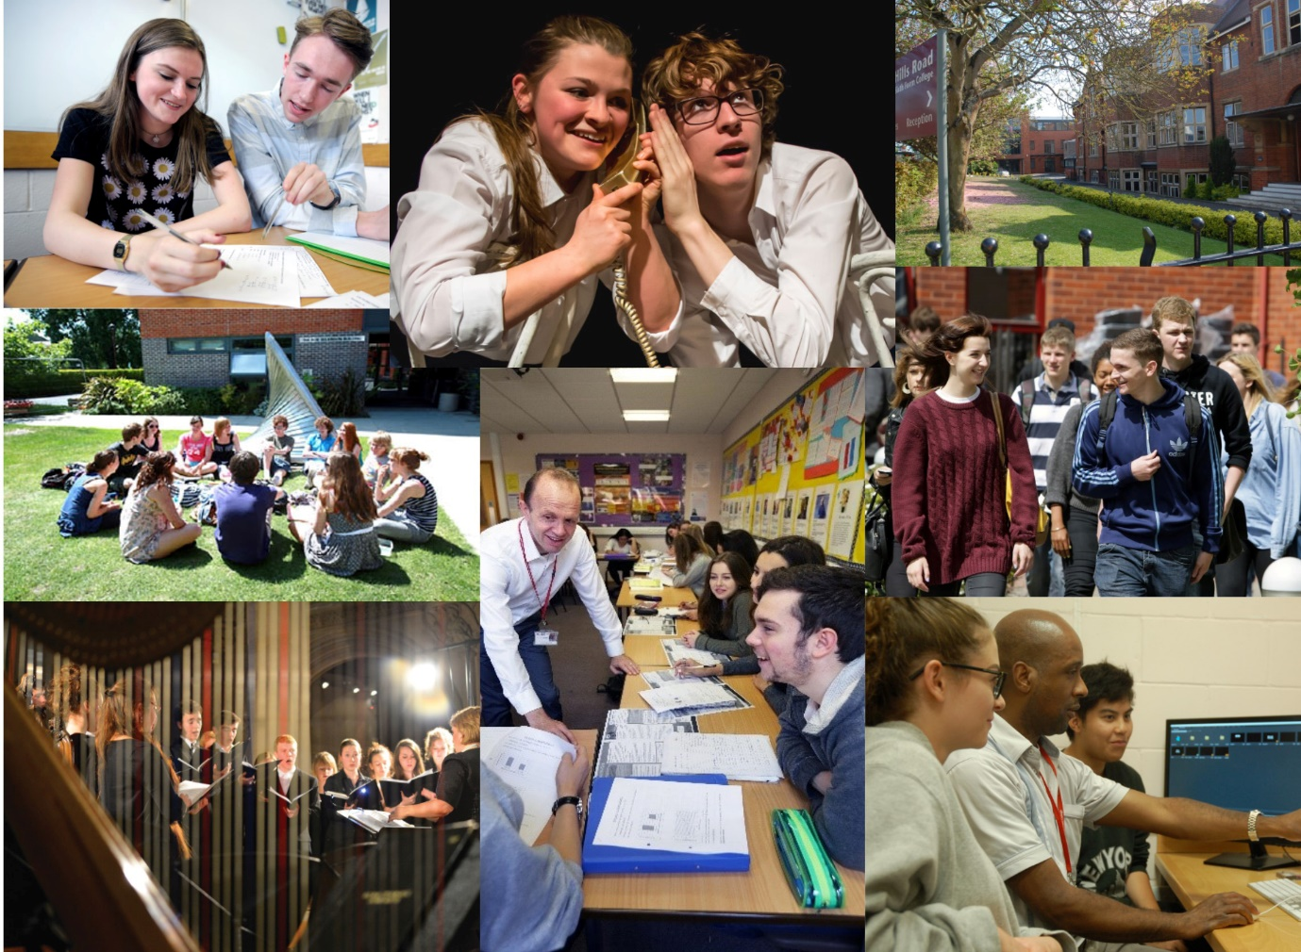

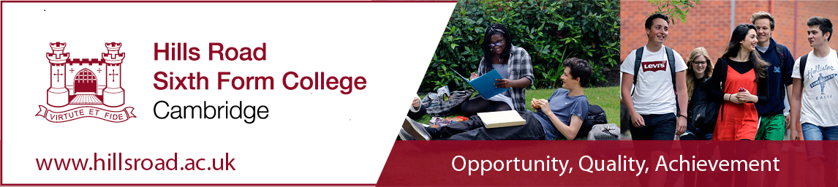

Teacher of Physical Education (Maternity Cover)

Full-time
£25,260 to £41,226 (FTE per annum), depending on qualifications and experience

This vacancy is for maternity cover which is due to end in December at the close of the Autumn term. However, we are keen to work flexibly with our successful candidate as there is the potential for either full or part time work on a permanent or fixed term basis from January 2022 onwards.

This is an exciting opportunity to join the College’s outstanding Sport department in its provision of A Level PE along with an offering of both a competitive and participative sport programme. The Sport department enables over 900 students to take part in sport each week through either the College enrichment programme or the programme of competitive sport fixtures. 37 teams participate in 21 different sports on a competitive basis in regional, national and on occasions international competitions, with great success. The department also has a strong track record in delivering excellent academic results in A Level PE. The successful candidate will be a passionate advocate of teaching and learning, in addition, they will be a qualified coach in at least one major sport. Organised, driven and open to new ideas and ways of working, the successful candidate maybe an established PE teacher looking for a new challenge or a NQT with prior sporting experience.

Closing date: Monday 12th April at 9.00am
Interviews: Monday 19th April

Details and an application form for the above post may be obtained from our website www.hillsroad.ac.uk.

The College is committed to safeguarding and promoting the welfare of its students and staff and expects all members of the College community, volunteers and visitors to share this commitment. The College actively promotes equality and diversity and welcomes applications from all sections of the community.

TEACHER OF PHYSICAL EDUCATION (MATERNITY COVER)
Full time
(an ability to contribute to College Sport essential)

The Post

We are looking for an enthusiastic and well qualified teacher (full-time) to contribute to College sport as well as to teach A Level Physical Education. In addition to the provision of A Level PE, the department co-ordinate the participation of approximately 900 students each week in sport-related enrichment activities. As part of this programme, 37 teams participate competitively in 21 different sports including football, rugby, basketball, netball, hockey, golf, badminton, squash and rowing.

Given the importance of the provision of sport to the work of the department, it will be important that the appointed person has coaching qualifications in at least one major college sport.

This vacancy is for maternity cover which is due to end at the close of the Autumn Term in December. However, we are keen to work flexibly with our successful candidate as there is the potential for either full or part time work on a permanent or fixed term basis from January 2022 onwards.

The Department

The Sport Department is highly successful. It works in a supportive environment that values academic as well as sporting excellence. There are two full-time staff delivering A level and a further fifteen part-time staff who contribute to the delivery of the Enrichment programme. The Department operates as a team, sharing sets and resources and working closely together in planning, delivery and monitoring of the curriculum. There are regular Departmental meetings but much is achieved through day-to-day informal interactions.

Accommodation and Resources

The Department has excellent facilities based in the college’s well-resourced teaching block. There is a specialist teaching room, access to IT facilities in a central resources area as well as substantial resources in the PE resources room. The resources room has specialist editing facilities for digital analysis of performance. The department is well resourced with filming equipment including a 25’ telescopic mast aiding the recording of practical performances. The classroom is well resourced, with DVD, TV, internet/intranet access and a power point projector. The Department’s office is adjacent to the classroom and there is a reprographics area nearby. The superbly equipped Hills Road Sports and Tennis Centre enhance practical components and the Enrichment programme. The Centre includes four indoor tennis courts and six outdoor courts (four acrylic and two clay), a multi-purpose sports hall, a projectile gallery and a well-equipped fitness room. The playing fields are within walking distance of the college.

Courses Offered and Examination Results

Most A level sets contain about 20 students and are taught by two teachers, covering the weekly 4 x 65 minutes lessons.
Course 2019 | Awarding Body | Number of sets in Year 12 | Number of sets in Year 13
Physical Education | Edexcel | 3 | 3

A level results in Physical Education are very good. 2019 A level results were A*/A - 39% and A*-B 80%. Added value is also a department strength (+0.33).

https://www.hillsroad.ac.uk/sixthform/how-to-apply/subjects/physical-education

Extra-curricular Activities

Students’ experience and knowledge are broadened through an extensive programme of enrichment activities. For A Level PE, this includes visits to sporting events (e.g. Wimbledon and international matches), visiting speakers/conferences, Loughborough’s Inspire Day, a Sport Psychology team building day and an annual visit to Boston, USA. The department also benefits from having close links with Anglia Ruskin Sport Science Faculty.

The Enrichment programme

The College has a strong sporting tradition and runs very successful teams in all major games. This is highlighted by Hills Road winning the coveted Clifford Dixon Trophy (presented to the Top AoC Sport College in the East) for 6 years in a row. Whilst striving for sporting excellence the Department fully supports sport equity and encourages all students, irrespective of gender and ability, to realise their full potential. The Department offers a wide variety of sporting activities as part of the Enrichment programme, so that the elite and social players are equally provided for. The Department also has a commitment to student volunteering and leadership. Many of the teams are student led and the student body, the Sport Committee, liaises with staff to ensure we continue to provide the highest provision possible.

https://www.hillsroad.ac.uk/sixthform/student-life/sport

Applications

The closing date for applications is HR Monday April 12th at 9am. Short listed applicants will be advised accordingly and called for interview. Interviews will be held on April 19th. Applicants are asked to:

• complete the enclosed application form
• write a concise supporting letter of application
• write a brief CV
• complete the enclosed Equal Opportunities Monitoring Form (optional)
- check the following link for minibus driving requirements noting in particular, if you do not already have a D1 PCV licence, the need to meet the criteria for satisfactory medical and eye requirements https://www.gov.uk/driving-a-minibus

I should like to thank you in advance for your interest in this post and for taking the time and trouble to complete an application.

Kind regards

Ayden Duffy

Head of Sport
Hills Road Sixth Form College
Cambridge
01223 247251 ex 1220
www.hillsroad.ac.uk/sixthform/student-life/sport

Job Description

Teacher at Hills Road Sixth Form College

Purpose: To teach students within the College and to carry out such other associated duties as are reasonably assigned by the Principal or Head of Department, and to make a positive contribution to the wider life and ethos of the College

Reports to: The Head of Department and, where appropriate, to the Head of Subject, in respect of departmental matters and curriculum development

Main Accountabilities:

Set high expectations which inspire, motivate and challenge students

- establish a safe and stimulating environment for students, rooted in mutual respect
- set goals that stretch and challenge students of all backgrounds, abilities and dispositions
- demonstrate the positive attitudes, values and behaviour which are expected of students.

Promote good progress and outcomes by students

- be accountable for students’ attainment, progress and outcomes
- be aware of students’ capabilities and their prior knowledge, and plan teaching to build on these
- guide students to reflect on the progress they have made and their emerging needs
- demonstrate knowledge and understanding of how students learn and how this impacts on teaching
- encourage students to take a responsible and conscientious attitude to their own work and study.

Demonstrate good subject and curriculum knowledge

- have a secure knowledge of the relevant subject(s) and curriculum areas, foster and maintain students’ interest in the subject, and address misunderstandings
- demonstrate a critical understanding of developments in the subject and curriculum areas, and promote the value of scholarship
- demonstrate an understanding of and take responsibility for promoting high standards of literacy, articulacy and the correct use of standard English, whatever the teacher’s specialist subject

Plan and teach well-structured lessons

- impart knowledge and develop understanding through effective use of lesson time
- promote a love of learning and encourage young people’s intellectual curiosity
- set homework and plan other out-of-class activities to consolidate and extend the knowledge and understanding students have acquired
- reflect systematically on the effectiveness of lessons and approaches to teaching
- contribute to the design and provision of an engaging curriculum and scheme of work within the relevant subject area(s).

Adapt teaching to respond to the strengths and needs of all students

- know when and how to differentiate appropriately, using approaches which enable students to be taught effectively
- have a secure understanding of how a range of factors can inhibit students’ ability to learn, and how best to overcome these
- demonstrate an awareness of the physical, social and intellectual development of young people, and know how to adapt teaching to support students’ education at different stages of development
- have a clear understanding of the needs of all students, including those with special educational needs; those of high ability; those with English as an additional language; those with disabilities; and be able to use and evaluate distinctive teaching approaches to engage and support them.

Make accurate and productive use of assessment

- know and understand how to assess the relevant subject and curriculum areas, including statutory assessment requirements
- make use of formative and summative assessment to secure students’ progress
- use relevant data to monitor progress, set targets, and plan subsequent lessons
- give students regular feedback, both orally and through accurate marking, and encourage students to respond to the feedback.

Manage behaviour effectively to ensure a good and safe learning environment

- have clear expectations and routines for behaviour in classrooms and take responsibility for promoting good and courteous behaviour both in classrooms and around the College in accordance with appropriate College policies
- manage classes effectively, using approaches which are appropriate to students’ needs in order to involve and motivate them
- maintain good relationships with students, exercise appropriate authority, and act decisively when necessary.

Accountabilities that relate to all staff at the College:

- demonstrate behaviour and values consistent with the person specification for this role
- promote equality of opportunity in accordance with the College’s Single Equality Scheme
- maintain high standards of attendance and punctuality
- have proper and professional regard for the ethos, policies and practices of the College
- this includes those where each member of staff has an individual duty to act and for which the College can be held vicariously responsible for the actions of its employees:
- equality and diversity
- safeguarding the welfare of young people
- health and safety

Person Specification for the post of Physical Education (Maternity Cover)
 | Essential | Desirable
Qualifications, training and experience | - A degree in Physical Education or sport related subject  - Relevant teaching qualification e.g. PGCE  - Experience of teaching GCSE PE  - Driving license | - First Aid qualification (or willingness to take a qualification)  - Level 2 coaching qualification in one or more sports  - D1 minibus license  - Experience of teaching A Level PE  - Experience of teaching Sports Psychology, Skill Acquisition, History of Sport, Commercialisation
 | Evidence: Application  form/letter of application | Evidence: Application form/letter of application
In addition, the successful candidate will demonstrate, or have the potential to develop, strengths in the following areas.
Class room  Teaching/sport coaching | - deliver lively, energetic and well planned classroom teaching  - employ strong subject knowledge in facilitating students’ learning and progress  - develop and use effective and varied resources in support of students’ learning  - focus clearly on maximising student potential and encourage high levels of attainment by all students  - demonstrate strong and positive commitment to individual students  - apply creativity to contribute to the on-going development of schemes of work  - coach one or more sports at representative level or coach a broad spectrum of sports as part of the enrichment programme with a commitment to coach education.
Professional standards | - make a positive contribution to the wider life and ethos of the college  - develop effective professional relationships with colleagues, knowing how and when to draw on advice and specialist support  - take responsibility for improving your teaching through appropriate professional development, responding to advice and feedback from colleagues  - communicate effectively with parents/carers with regards to students’ achievements and well-being.  - Representing the department and the College in a positive light
Personal and Professional Conduct | - treat students with dignity, building relationships rooted in mutual respect, and at all times observing proper boundaries appropriate to a teacher’s professional position  - have regard for the need to safeguard students’ well-being, in accordance with statutory provisions  - show tolerance of and respect for the rights of others  - support fundamental British values, including democracy, the rule of law, individual liberty and mutual respect, and tolerance of those with different faiths and beliefs  - ensure that personal beliefs are not expressed in ways which exploit students’ vulnerability or might lead them to break the law.

How to Apply for the Post of a Teacher of Physical Education

Applicants are asked to do the following:

- complete the Hills Road Sixth Form College application form
- complete the equality and diversity monitoring form
- write a supporting letter of application
- supply a brief CV

The completed application form should be submitted via email to recruitment@hillsroad.ac.uk. All documents should be submitted by 9.00am on Monday 12th April.

Please note that applications received after the closing date may not be eligible for consideration. If Human Resources have not contacted you by 19th April 2021 then unfortunately your application has not been successful.

Interviews will be held on Monday 19th April.

Hills Road Sixth Form College will base its decision as to whether to invite you for interview solely on the details provided on your application and how well they match the criteria for this post.

In accordance with Home Office guidance successful candidates will be required to evidence their right to work in the UK before commencement of employment. The successful candidate therefore must be able to demonstrate their right to work during the recruitment process. If you do not have the right to work in the UK, and you are unable to gain this independently, we may be able to sponsor you under the Skilled Worker route. We have assessed this role and it may be capable of sponsorship. If you require sponsorship, please discuss this with us. We encourage you to review the UK Home Office guidelines ahead of submitting a job application to understand whether you may be eligible for sponsorship and the immigration fees associated with the Skilled Worker route.

Hills Road Sixth Form College is committed to ensuring equal opportunities in all aspects of employment and selects staff on merit, irrespective of race, religion, sex, disability or age. You are not obliged to complete the equal opportunities monitoring form, but any information given will help us to monitor the effectiveness of our equality and diversity policy.

If you have a disability you are invited to request any special arrangements you may require for interview, or any adjustments you may anticipate would be needed in your working arrangements, by contacting the Human Resources Team on 01223 278063 (direct line). Further information about accessibility to the site can be found on our website under ‘Equality and Diversity/Site Plan’ and also from ‘AccessAble: www.accessable.co.uk.

Thank you for your interest in this post and in the College. We do hope that you will decide to apply, and we should like to thank you in advance for taking the time and trouble to do so. For more information about working life at the College please go to our website http://www.hillsroad.ac.uk

Human Resources

