March 2019

Dear Applicant

POST: Lead Practitioner English

Thank you for expressing an interest in the above vacancy. An application pack is attached, as requested.

Would you please return your completed signed application form by the closing date, Tuesday 23rd April 2019 at 12 noon to:

Mrs Helen Abbott
PA to Head of School
Holsworthy Community College
Victoria Hill
Holsworthy
EX22 6JD

We will accept your application form by e-mail to habbott@hcc.devon.sch.uk however, we will require the signed document to be sent to us by post. Please ensure you place the correct postage on your application. (As a guide, at the time of writing, a large letter (A4) up to 100g will cost £1.01 first/79p second class; 101g - 250g will cost £1.40 first/£1.26 second class).

If you would like confirmation of receipt of your application, please enclose an SAE.

If you have not heard from us within two weeks of the closing date, please assume that on this occasion your application has been unsuccessful.

Yours faithfully

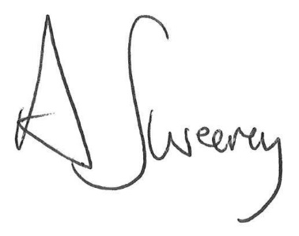

Andrew Sweeney
Head Teacher
Holsworthy Community College

