
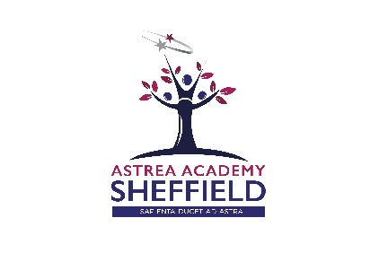

Head of Department - Humanities
Recruitment Pack



Astrea Academy Sheffield
Andover Street
Burngreave
Sheffield
S3 9EJ

Recruitment Pack Contents

- Welcome Letter – Libby Nicholas, CEO of Astrea Academy Trust
- Welcome Letter – Kim Walton, Principal of Astrea Academy Sheffield
- Astrea Academy Sheffield – The Vision
- Astrea Academy Sheffield Floorplan
- Astrea Academy Trust
- Astrea Academy Trust Ethos
- Astrea Academy Trust Family
- Job Description
- Person Specification
- Child Safeguarding Policy
- Explanatory Notes
- How do I apply?




Welcome Letter from Libby Nicholas, CEO
Thank you for your interest in this role with Astrea Academy Sheffield. At Astrea, we are passionate about education that inspires beyond measure. The Astrea Academy Sheffield, Astreas first purpose built all-through academy, will be a beacon for the area – both literally and metaphorically: looking out over the city, it will provide an absolutely exceptional education for 2-18 year olds.

Astrea was established in 2015. Our schools – primary, secondary and all-through – do not subscribe to the typical notion of “schooling” where everything is driven by results. Our pupils achieve to the very highest levels, but we believe that education is about so much more than just attainment. To deliver this, we focus on encouraging and nurturing Resilience, Empathy, Aspiration, Contribution and Happiness in all of our children and young people. We also have the highest expectations of the staff in our family: responsibility and leadership; aspiration and development; honesty and integrity; enjoyment and innovation; and collaboration and inclusion. These values are used as a measure of progress with individuals, academies and overall as a trust. We have the highest expectations of pupil behaviour, so that our teachers are able to focus on teaching to the ‘Astrea Teacher Standards’.

This is a hugely exciting time for our family of academies. The Trust has been recognised by the Department for Education as being well placed to raise standards and achieve excellence for pupils in a growing number of academies. We are presented with a rare opportunity to make a real difference to the lives and life chances of so many primary and secondary school children – many of whom haven’t previously received the educational opportunities they deserve. The Trust currently has 20 academies based across South Yorkshire and Cambridgeshire, including academies at various stages of development. As a Trust, we are clear about the importance of achieving long term sustainability for our academies. Our vision is to enable individual academies to flourish with real autonomy, whilst also ensuring a strong ethos of support and collaboration across our Academies.

Those we recruit need to demonstrate that they share our values, are highly motivated to work with colleagues within and beyond their academy to continuously develop their skills and pursue professional excellence, and are committed to providing the highest standards of teaching for all children. If that is you then we would be delighted to receive your application. At Astrea, we are all dedicated to providing an education with no boundaries so that every pupil can fly, and I hope you will join us on this exciting journey.

Libby Nicholas
Chief Executive, Astrea Academy Trust

A Warm Welcome from the Principal
‘Sapienta ducet ad astra – Wisdom leads to the stars’
Dear potential candidate,
We are delighted that you are interested in applying for this role at Astrea Academy Sheffield.
Astrea Academy Trust is thrilled to have the opportunity to cultivate a brand new academy that compliments the existing provision in the area and meets the basic need for additional school places in the area. This is a rare and unique opportunity to join us on our journey from day one - where ambition has no limits!
The Academy will be opening its doors for the first time in September 2018 and will be a 3 – 18 provision for children in the Burngreave area. September will see the first children in nursery, reception and year 7 arrive, as well as our new compliment of staff.
With the combination of a Grade II listed building and a brand new building, there is a real physical heritage to our new school. With an investment in excess of £25M, the facilities will be cutting edge, including science and technology laboratories, modern classrooms, a 300 seated hall, 4G pitch, an underground sports hall, outside amphitheater and forest school learning area. This ground breaking campus is truly breathtaking.
The Academy is located on Andover Street, Sheffield, S3 9EL.
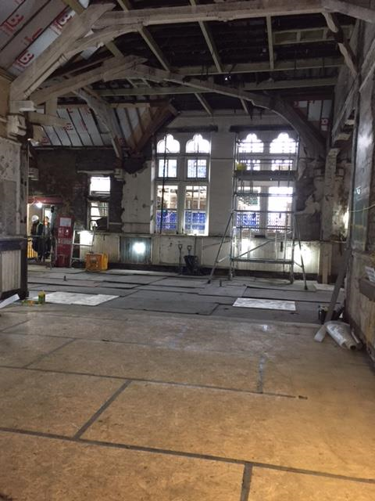
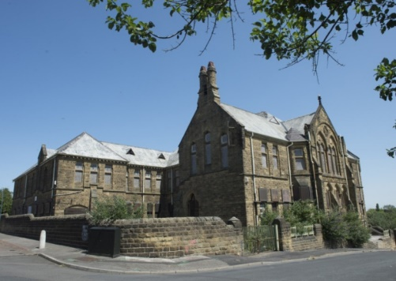

It is a rare opportunity and an exciting time to join the Academy. Key work at this moment in time includes collaborating with the Trust, architects, designers and local community to create a legacy for the future. Our location will be at the heart of a new learning community which will continue to grow as we forge these ever essential relationships with families and businesses in the area.
We work within a supportive learning community of staff, parents and students, enabling a world of learning opportunities which will inspire and motivate students of Astrea Academy Sheffield to achieve excellence and create the successful path for their future. We are creating an academy where each day will be a journey of discovery to fire their imagination, establish their sense of worth, and to gain the confidence and courage to take a full part in the wider world.
This is a truly unique and once in a life time opportunity and we are seeking distinctive and exceptional individuals who are able to offer the absolute best they can to enhance the life chances of children at Astrea Academy Sheffield.
This is an exciting and challenging role which offers:
- The opportunity to be part of something truly special – to be part of our family from its infancy.
- The opportunity to make a significant impact and ensure a lasting legacy in an academy that will grow with you as an individual.
- The unwavering support of an experienced Principal and dedicated teams within the academy.
- Investment in your professional development.
- The chance to work with a vibrant and enthusiastic cohorts of students aged 3 – 18.
- The opportunity to be part of a true all – through education provision.
- The opportunity to contribute to the development of our curriculum, professional development and quality teaching networks across the entire Astrea Academy Trust.
Ideal candidates will:
- have a true passion for excellence in education
- be a great teacher - we are looking for someone who really knows what great learning looks like in the classroom and how to achieve it
- be dedicated to the creation of an education with no boundaries
- be committed to community cohesion and developing the whole child, not just academically
- have a very clear understanding of what makes a great school and the skills and character to be part of this (rigorous planning, high expectations, great CPD, honesty, kindness, passion, commitment and resilience) day in, day out
- be excited by, and committed to, supporting practices that will drive great progress at Astrea Academy Sheffield
- be fully aligned with Astrea’s Value Partners
Everything we achieve is underpinned by all, in these Value Partners;
- Responsibility and Leadership (#4equity)
- Enjoyment and Innovation (#go4it)
- Aspiration and Development (#Reach4thestars)
- Collaboration and Inclusion (#all4one)
- Honesty and Integrity (#4good)

If you think you have what it takes to further unleash Astrea Academy Sheffield’s incredible potential, and be part of this amazing journey - we want to hear from you!
Miss Kim Walton
Principal, Astrea Academy Sheffield
Astrea Academy Sheffield – The Vision
Our Mission
A broad and balanced curriculum based on knowledge, skills and experiences will enrich pupils’ lives, build cultural capital and instil a love of learning. They will be able to apply their learning to real world contexts and problems, creating solutions in collaboration with others. Pupils will learn to value family, community and the environment. They will make a positive contribution to the life of the school and those around them. Pupils will become resilient learners who are motivated to take responsibility for their learning, health, well-being and happiness. Pupils will have high expectations of themselves, a culture of craftsmanship and a drive for excellence. They will understand the scope of possibilities that lie ahead of them and what is required to achieve their ambitions with the confidence and belief to make them a reality.
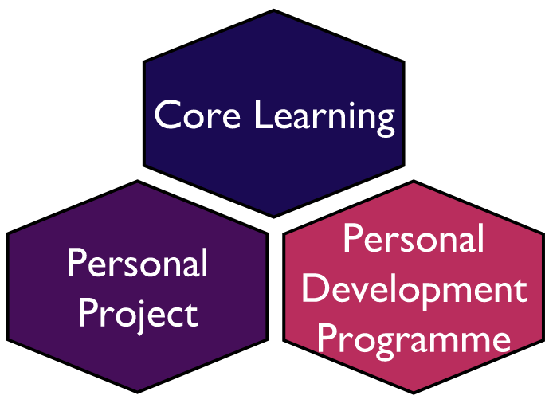
A Unique Education
At Astrea Academy Sheffield, our curriculum is the purpose of our school. The curriculum is everything that we want our pupils to know and to understand. It includes learning about discrete subject disciplines such as the sciences, humanities and the arts and how these disciplines relate to one another. Our curriculum is also what we want pupils to achieve, the opportunities we offer them and the experiences we believe all pupils are entitled to.

Astrea Academy Sheffield Campus

Academy Sheffield encompasses two contrasting facilities that bring together the traditions and history of education in Sheffield and the latest technology and facilities to provide pupils and the community with an outstanding environment for learning. Overlooking Sheffield city centre, the new state of the art building will feature a full complement of highly equipped classrooms providing a bright and colourful learning environment for all pupils with additional open learning spaces for independent and small group study.

For further information about the Astrea Academy Sheffield, please view our dedicated website http://astreasheffield.org/

Astrea Academy Sheffield Floor Plan
First Floor
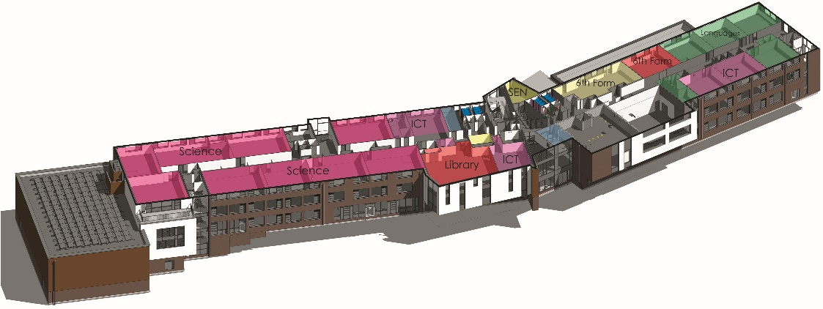
Upper Ground Floor
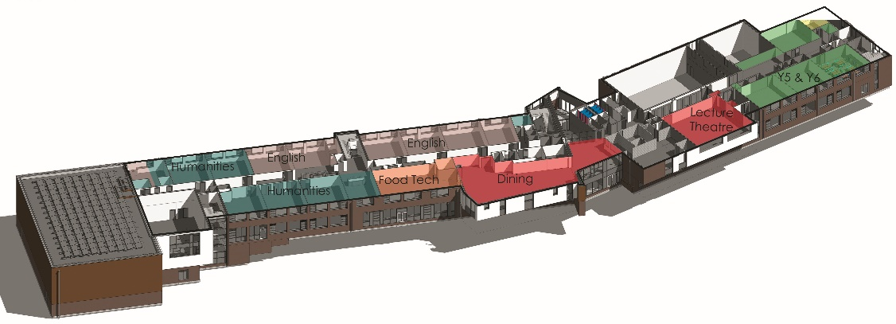
Ground Floor
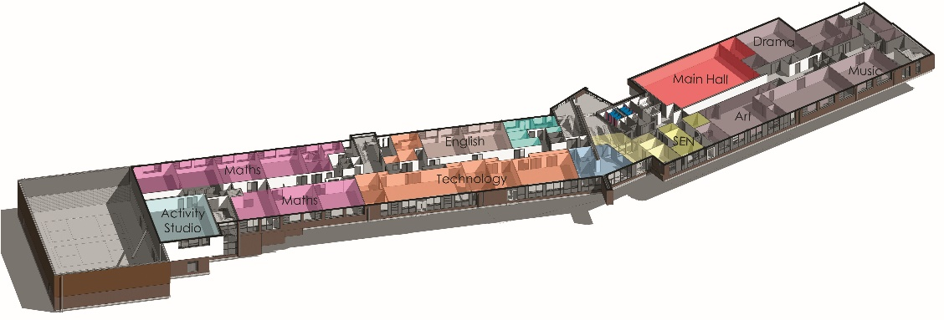
Lower Ground Floor
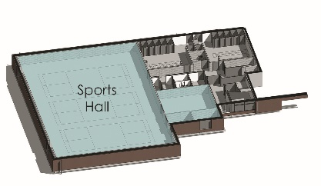

Astrea Academy Trust
We value all-round development of the individual, through arts, sports, leadership opportunities, enrichment and community. This is encapsulated in the skills, qualities and personalities we foster in our pupils.

The Astrea Academy Trust logo communicates the values collaboration, development and aspiration. The three figures are coming together in the shape of a tree, which represents growth, whilst the tallest figure reaches upwards, towards a star, which is above and beyond the highest branch of the tree.
Academies, staff and children within the Trust benefit from a strong ethos of support and collaboration across the Astrea family. Teachers within Astrea belong to a national community of professionals, and benefit from a wide range of networks and development opportunities across the Trust.
Astrea benefits from the involvement of leading educationalists, including our Professional Adviser Professor John West-Burnham, and strong links to prestigious institutions such as the Institute of Education.


Astrea Academy Trust Ethos

The work of the Astrea Academy Trust is underpinned by five core Value Partners, which are equally applicable to pupils, staff and the work of the Trust itself.

Each pair of Value Partners is accompanied by a call for action in the form of a hashtag, which is used in verbal, digital and hard copy communications.

The Value Partners can be used as a measure of individual, Academy and Trust progress and as a guide to inform the direction of change.

Responsibility and Leadership
Individuals in the Astrea community are accountable for their own decisions and actions and are supported by strong leaders, while trailblazers are encouraged to develop skills and talents in others. The Trust has a strong commitment to developing and nurturing our own leaders. #4equity

Enjoyment and Innovation
We know that everyone learns best when they enjoy what they do and can follow their innate desire to achieve. Astrea pushes boundaries so that pioneering ideas are tried and tested so that our academies remain leaders in the advancement of teaching and learning methods. #go4it

Aspiration and Development
Every member of the Astrea community, from the youngest pupil to the oldest member of staff, is encouraged to cultivate opportunities to grow. We achieve excellence by being inspired to become the best we can be. The progress and well-being of pupils is our top priority, at the centre of every decision. #Reach4thestars

Collaboration and Inclusion
Astrea honours and applauds the differences that make us unique whilst actively seeking and celebrating the common ground that binds us together as a strong community. We work together in a productive environment where dynamic ideas are shared in partnership, so that every member of the community may thrive #all4one

Honesty and Integrity
We are honest and open. Astrea decisions and responses are grounded in time-honoured moral principles that remain constant in the face of challenges and change #4good
You can learn more about the Values, and hear from staff and pupils across Astrea Academies, at our website: https://astreaacademytrust.org/

Astrea Academy Trust Family

Academies currently within Astrea Academy Trust:

Primary
- Atlas Primary Academy, Doncaster
- Byron Wood Academy, Sheffield
- Carrfield Primary Academy, Rotherham
- Castle Academy, Doncaster
- Denaby Main Primary Academy, Doncaster
- Edenthorpe Hall Academy, Edenthorpe
- Gooseacre Primary Academy, Rotherham
- Greengate Lane Academy, Sheffield
- Hartley Brook Primary Academy, Sheffield
- Hatfield Primary Academy, Sheffield
- Hexthorpe Primary Academy, Doncaster
- Highgate Primary Academy, Rotherham
- Hillside Academy, Doncaster
- Intake Primary Academy, Doncaster
- Kingfisher Primary Academy, Doncaster
- Lower Meadow Primary Academy, Sheffield
- The Hill Primary Academy, Rotherham
Secondary
- Cottenham Village College, Cambridgeshire
- Netherwood Academy, Barnsley
Special School
- The Centre School, Cambridgeshire
All-through
- Astrea Academy Sheffield, Sheffield

All members of staff and encouraged to use the Astrea Academy Sheffield Nursery for any eligible children in their care. The Nursery and Primary prospectus can be found here http://astreasheffield.org/assets/DownloadPageFiles/ASTREA-SHEFFIELD-PRIMARY-PROSPECTUS-v7.pdf
Job Description
Position: Head of Department - Humanities
Salary: Competitive salary
Contract: Permanent
Reporting to: Principal
Location of this position: Astrea Academy Sheffield, Burngreave, Sheffield
Purpose of this role:
The Head of Humanities will ensure that the highest standards of learning, development and achievement for students throughout the academy. This will be achieved through the clear and effective leadership of the department. The Head of Humanities will be an integral leader in the academy and embody a passion for all-through education.
Key Responsibilities
- Formulating the aims and objectives within the curriculum which achieve the job purpose
- Achieving high levels of pupil progress across the Academy
- Establishing activities and engagements through which they shall be achieved
- Undertaking any professional duties reasonably delegated to them by the Principal
- Upholding the Academy values and ethos of an all through provision, ensuring pupils life chances and destinations are the drivers for success

Main Duties:
- To lead on an identified group of key issues as outlined in the Job Purpose and initially leading the development of the academic and Vocational Curriculum in the department
- Along with other members of the Wider Leadership Team, ensure the Health and Safety of pupils over lunchtimes, breaks and other times when pupils are allowed on the promises (This will usually be organised on a rota basis)
- To ensure Wider leadership team presence at public meetings, events and functions as appropriate
- To represent the Directorate at meetings and functions when required
- To set the highest expectations and raise standards
- To be accountable for student progress and attainment levels within the subject area
- To ensure that strategies are in place to maximise levels of attainment for all students
- To take responsibility for the development of the quality of learning and teaching within the discipline across the whole department
- To develop and enhance the practice of other members of staff in the subject area aspiring to being outstanding from all
- To lead and manage the subject area, including contributing to extra-curricular activities and the wider life of the academy
- To contribute to the strategic leadership of the department, as a member of the Wider Leadership Team, developing, implementing and evaluating systems, policies and procedures
- To actively promote the academy and liaise with outside agencies as necessary, representing the academy as appropriate
- To maintain a high, visible presence around the academy to ensure that the highest standards of behaviour and site-usage are upheld
- To contribute to discussions and decisions at Wider Leadership Team meetings
- To communicate and liaise with staff, students, parents, governors and members of the local community as appropriate
- To be active in issues of staff and student welfare and support
- To maintain a teaching timetable, modelling outstanding practice in terms of classroom teaching, preparation, marking and assessment
- To demonstrate a commitment to Equality of Opportunity for all members of the academies community
- To be aware of, and comply with, policies and procedures relating to child protection, health, safety and security, confidentiality and data protection, reporting all concerns to an appropriate person
- To take responsibility for the implementation of, and compliance with, policies and procedures relating to child protection, health safety and security, confidentiality and data protection, reporting all concerns to an appropriate person

As a member of the Wider Leadership Team (generic senior leadership responsibilities)
- Supporting the leading of Teaching and Learning
- To ensure a realistic consistent and continuous academy-wide focus on student achievement, using data and benchmarks to monitor progress in every child’s learning
- To ensure that learning is at the centre of strategic planning and resource management
- To establish creative responsive and effective approaches to learning
- To ensure a culture and ethos of challenge and support where all pupils can achieve success and become engaged in their own learning
- To demonstrate and articulate high expectations and set realistic, obtainable targets for the whole Academy community
- To implement strategies which secure high standards of behaviour and attendance
- To determine, organise and implement a diverse and flexible curriculum and implement an effective assessment framework
- To take a strategic role in the development of new and emerging technologies to enhance and extend the learning experience of pupils and staff
- To monitor, evaluate and review classroom practice and promote improvement strategies
- To challenge underperformance at all levels and ensure effective corrective action and follow-up

- Working to developing self and working with others
- To behave with all staff in a manner which creates and maintains a positive Academy culture
- To build a collaborative learning culture within the academy and actively engage with other schools/academies to build effective learning communities
- To develop and maintain effective strategies and procedures for staff induction, professional development and performance review
- To acknowledge the responsibilities and celebrate the achievements of individuals and teams
- To develop and maintain a realistic culture of high expectations for self and for others and take appropriate action when performance is unsatisfactory
- To regularly review own practice, set personal targets and takes responsibility for own personal development
- To safeguard self and staff from the destructive dangers of over-work and to encourage colleagues to retain a healthy balance in their professional and personal lives

- Working to manage the organisation
- To create an organisational structure which reflects our values, and enables the management systems, structures and processes to work effectively in line with legal requirements
- To produce and implement clear, evidence based improvement plans and policies for the development of the department and its facilities
- To ensure that, within an autonomous culture, policies and practices take account of national and local circumstances, policies and initiatives
- To manage our financial and human resources effectively and efficiently to achieve the educational goals and priorities
- To manage and organise the environment efficiently and effectively to ensure that it meets the needs of the curriculum, health and safety regulations
- To ensure that the range, quality and use of all available resources is monitored, evaluated and reviewed to improve the quality of education for all students and provide value for money
- To use and integrate a range of technologies effectively and efficiently to manage the academy
- To comply with policies and procedures relating to the Code of Conduct, safeguarding, health and safety, security, confidentiality and data protection etc
- To actively engage in projects and/or initiatives across the family of schools as and when directed by the Principal and/or CEO
- Working to secure accountability
- To fulfil commitments arising from contractual accountability to the governing body
- To develop an ethos which enables everyone to work collaboratively, share knowledge and understanding, celebrate success and accept responsibility for outcomes
- To ensure individual staff accountabilities are clearly defined, understood and agreed and are subject to rigorous review and evaluation
- To work with the governing body (providing information, objective advice and support) to enable it to meets is responsibilities
- To develop and present a coherent, understandable and accurate account of the Academies performance to a range of audiences including governors, parents and carers
- To reflect on personal contribution to Academy achievements and to take account of feedback from others

- Working to strengthen community
- To champion the academy within the community and build an ethos around a 2 – 18 provision that encompasses the highest expectations from all
- To build an academy culture and curriculum which takes account of the richness and diversity of our communities
- To create and promote positive strategies for challenging racial and other prejudices and dealing with racial harassment
- To ensure learning experiences for students are linked into and integrated with the wider community and to ensure that students have opportunities to take on leadership roles within the academy and the wider community
- To ensure a range of community based learning experiences
- To collaborate with other agencies, including other providers in the provision for the academic, spiritual, moral, social, emotional and cultural well-being of students and their families
- To create and maintain an effective partnership with parents and carers to support and improve student achievement and personal development
- To seek opportunities to invite parents and carers, community figures, businesses or other organisations into the academy to enhance and enrich the work of the academy and its value to the wider community
- To contribute to the development of the education system by, for example, sharing effective practice, working in partnership with other academies, schools and colleges and promoting innovative initiatives
- To co-operate and work with relevant agencies to protect children

General
All Astrea Academy Sheffield employees are required to:
- Abide by the Health & Safety at Work Act
- Attend training as required
- Respect confidentiality
- Work within the Academy and Trust policies and procedures
- Comply with the Academy and Trust no smoking policy
- Participate and contribute to team meetings
- Co-operate and liaise with departmental colleagues
- Demonstrate a commitment to their own development, to take advantage of education and training opportunities and develop their own competence
- Support and encourage harmonious internal and external working relationships
- Make a positive contribution to raising the profile of the academy

The Academy Trust is committed to safeguarding and promoting the welfare of children and young people and expects all staff and volunteers to share in this commitment.

The above duties are not exhaustive and the post holder may be required to undertake tasks, roles and responsibilities as may be reasonably assigned to them by the Principal.

Person Specification
This part will allow you to understand who we are looking for within this role and the skills knowledge or experience that we would expect.
Knowledge, Qualifications and Experience | Essential | Desirable
Relevant Experience

Teaching of Key Stage 3 and 4 in their subject area | *
Teaching of Key Stages other than 3 and 4 |  | *
Experience in teaching in an all through provision |  | *
Coaching and mentoring staff within their discipline | *
Line Management of staff within an accountability structure | *
Education and Training

Qualified teacher status | *
Knowledge

An awareness of current issues in subject area leadership | *
Understanding of health and safety issues and good practice | *
Up to date knowledge in subject, national and local policy, classroom management strategies, research/inspection findings, statutory requirements surrounding their area of the curriculum | *
Skills and Ability
An outstanding classroom practitioner | *
Good organisational and personal management skills | *
Exemplary planning and teaching | *
Exemplary behaviour management | *
An ability to manage a team of both teachers and associate staff | *
Able to monitor and evaluate standards of teaching, learning and achievement | *
An ability to develop good working relationships with students and staff | *
Ability to monitor and evaluate classroom standards including lesson observation | *
Effective time-management | *
Good ICT skills and understanding of the role of new technologies to enhance teaching and learning in the area of their responsibility and wider | *
Additional

The holder will hold an enhanced DBS | *
Use data to set appropriate and challenging targets for student performance and provide focus for strategic development of the curriculum area | *
Using data to inform the strategic deployment of teachers and to monitor and evaluate standards both within the department and national context | *
Commitment to self and team development | *
Work in ways that promote equality of opportunity, participation, diversity and responsibility | *
A commitment to abide by and promote the academies Equal Opportunities, Health and Safety and Child Protection Policies | *
A professional responsibility to promote and safeguard the welfare of children and young people | *
Be a role model in setting professional standards in all aspects of the role | *

Child Safeguarding Policy

The Trust is committed to Safeguarding and Promoting the Welfare of all its students. Each student’s welfare is of paramount importance. We recognise that some children may be especially vulnerable to abuse e.g. those with Special Educational Needs, those living in adverse circumstances.

We recognise that children who are abused or neglected may find it difficult to develop a sense of self-worth and to view the world in a positive way. Whilst at the Academies, their behaviour may be challenging. We will always take a considered and sensitive approach in order that we can support all our students.

The Trust’s Child Safeguarding Policy applies to all adults, including volunteers, working in or on behalf of the Trust.

Everyone in the education service shares an objective to help keep children and young people safe by contributing to:
- Providing a safe environment for children and young people to learn in education settings; and
- Identifying children and young people who are suffering or likely to suffer significant harm, and taking appropriate action with the aim of making sure they are kept safe both at home and in the education setting’
Keeping Children Safe in Education 2016

The Trust pays full regard to ‘Keeping Children Safe in Education’ guidance 2016. We ensure that all appropriate measures are applied in relation to everyone who works for the Trust who is likely to be perceived by the children as a safe and trustworthy adult including e.g. volunteers and staff employed by contractors. Safer recruitment practice includes scrutinising applicants, verifying identity and academic or vocational qualifications, obtaining professional and character references, checking previous employment history and ensuring that a candidate has the health and physical capacity for the job. It also includes undertaking interviews and an Enhanced DBS check.
Please visit https://astreaacademytrust.org/about-us/statutory-documents/ for the full policy.

Explanatory Notes
Applications will only be accepted from candidates completing the Trust’s Application Form. Please complete ALL sections of the Application Form which are relevant to you as clearly and fully as possible. CVs will not be accepted in place of a completed Application Form.

Safeguarding Children and Young People
We are committed to safeguarding and promoting the welfare of children and young people. We expect all staff to share this commitment and to undergo appropriate checks, including an enhanced DBS check.

- Candidates should be aware that all posts in Astrea Academy Trust involve some degree of responsibility for safeguarding children and young people, although the extent of that responsibility will vary depending on the nature of the post. Please see the job description enclosed in this Application Pack for further details.
- Accordingly, this post is exempt from the Rehabilitation of Offenders Act 1974 and therefore all convictions, cautions and bind-overs, including those regarded as “spent” must be declared.
- If you are currently working with children, on either a paid or voluntary basis, your current employer will be asked about disciplinary offence, including those related to children or young people (whether disciplinary sanction is current or time-expired), and whether you have been the subject of any child protection allegations or concerns and if so the outcome of any investigation or disciplinary proceedings. If you are not currently working with children, but have done in the past, that previous employer will be asked about these issues.
- Where neither your current or previous employment has involved working with children, your current employer will be asked about your suitability to work with children, although it may be answered not applicable where it is appropriate; if your duties have not brought you into contact with children or young people for instance.

Interview Process
After the closing date, short listing will be conducted by a Panel. You will be selected for interview entirely on the contents of your application form, so please read the Job Description and Person Specification carefully before you complete your form.

All candidates invited to interview must bring the following documents:

- Documentary evidence of right to work in the UK
- Documentary evidence of identity that will satisfy DBS requirements
- Documentary proof of current name and address
- Where appropriate any documentation evidencing change of name
- Documents confirming any educational or professional qualifications that are necessary or relevant for the post

Please note that originals of the above are necessary, photocopies or certified copies are not sufficient.

We will seek references on shortlisted candidates for Trust based positions and may approach previous employers for information to verify experience or qualifications before interview. Any relevant issues arising from references will be taken up at interview.

In addition to candidate’s ability to perform the duties of the post, the interview will also explore issues relating to safeguarding and promoting the welfare of children, including:

- Motivation to work with children and young people
- Ability to form and maintain appropriate relationships and personal boundaries with children and young people
- Emotional resilience in working with challenging behaviours
- Attitudes to use of authority and maintaining discipline

Conditional Offer: Pre-Employment Checks
Any offer to a successful candidate will be conditional upon:

- Verification of right to work in the UK
- Receipt of at least two satisfactory references (if these have not already been received)
- Verification of identity checks and qualifications
- Satisfactory Enhanced DBS Check
- Verification of professional status such as QTS Status, NPQH (where required)
- Satisfactory completion of a Health Assessment
- Satisfactory completion of the probationary period (where relevant)
- Where the successful candidate has worked, or been resident overseas in the previous five years, such checks and confirmations as may be required in accordance with statutory guidance
How can I Apply?
This is an exciting and very rewarding role and we look forward to receiving your application.

Please complete and send the Astrea Application Form and Equal Opportunities Monitoring Form which are available together with this document to the below contact;

Name: Vicki Russell
Position: Recruitment Officer
Contact: recruitment@astreaacademytrust.org

The Application Process
All applications will receive an email confirmation within 24 hours of receipt of application; if you do not receive this please contact Astrea Recruitment on 0114 478 3837. The candidates selected for interview will be informed after shortlisting and full details of the interview programme will be provided. If you do not hear from us within 14 days of the closing date of this position, unfortunately you have been unsuccessful on this occasion.
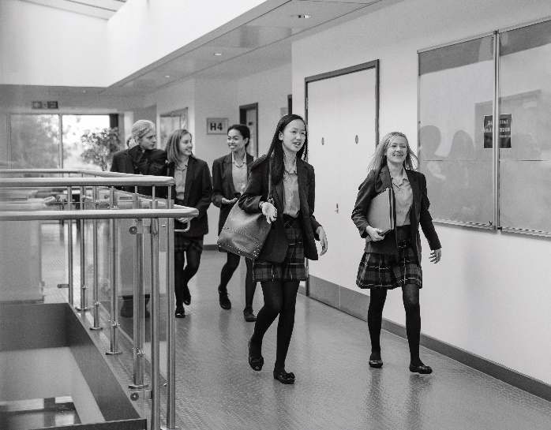
Astrea Academy Trust pays full regard to ‘Keeping Children Safe in Education’ guidance 2016. We ensure that all appropriate measures are applied in relation to everyone who works for the Trust. Safer recruitment practice includes scrutinising applicants, verifying identity and academic or vocational qualifications, obtaining professional and character references, checking previous employment history and ensuring that a candidate has the health and physical capacity for the job. It also includes undertaking interviews and an Enhanced DBS check. Please visit https://astreaacademytrust.org/about-us/statutory-documents/ for the full policy.

