

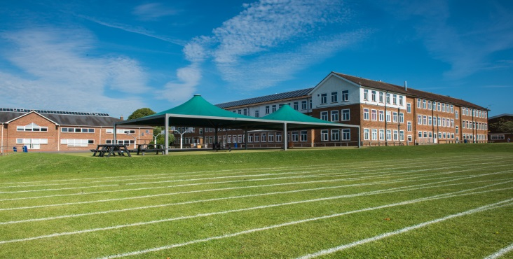

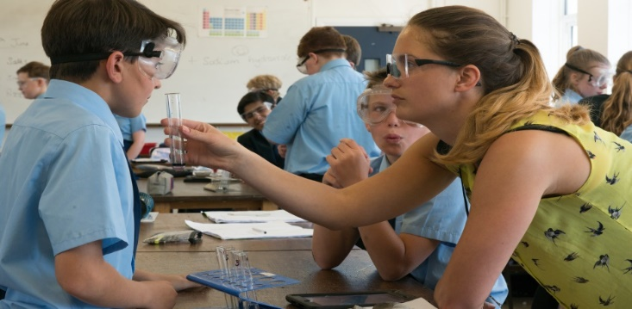

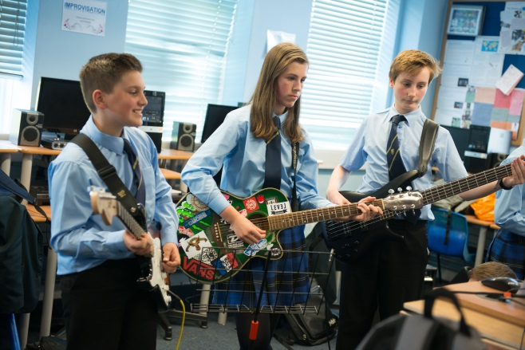

Information for Prospective Candidates

For the post of
SCIENCE TEACHER
(September 2018)

Dear Potential Candidates January 2018

Thank you for your interest in this teaching vacancy and I hope that the information contained in this pack helps answer your questions about the post and the academy and that this leads to an application from you.

The most important thing you need to know is that Warden Park Secondary Academy is a fantastic school to work in! The academy is very well respected in the local community and has a long tradition for excellence and our students’ outcomes are very strong. Our students are excellent - generally above average ability on intake they have an excellent work ethic, standards of behaviour are very high and they are enthusiastic in their support of the academy evidenced, for example, by the very high numbers who engage in extra-curricular activities. You will therefore not be surprised to hear that the academy is significantly over-subscribed for the 300 places on offer in Year 7 each year. Places in our excellent SSC which caters for 18 students with Education Health and Care Plans are equally sought after.

I have been in post since September 2017 as Headteacher of the academy which, along with two local primary schools, Warden Park Primary Academy and Northlands Wood Primary, make up the Sussex Learning Trust. The three Headteachers work closely and opportunities for partnership work across the curriculum are evolving as the Trust develops.

There is a strong focus in the academy on developing teacher practice. It is our stated intention to become a research driven learning institution and our professional development is focused on reviewing best practice and carrying out our own research in order to improve the quality of teaching in our classrooms. There is excellent pastoral care in the school coordinated by a very experienced team of Heads of Year and Pastoral Support Officers who contribute to ensuring that, even in a large academy such as ours, every student is known and well-cared for.

Ensuring students leave Year 11 with the best possible GCSE results is a priority for all who work in the academy. In 2017, 56% achieved Grade 5 or above in both English and Maths making Warden Park Secondary Academy one of the highest attaining schools in the county. However, it is also a priority that students leave well-equipped to be successful in the next phase of their learning and, beyond that, to be confident and empowered with the skills and capabilities to go one to be successful employees, citizens, partners and parents. These are equally important outcomes.

The Science Department
The Science department at Warden Park is very successful and has many strengths, not least the friendly, experienced and supportive team of teacher staff and technicians. This is evident from the school’s self-evaluation process, inspection reports and examination results which are consistently well above the national average. Triple Science is studied by around a third of the year group in years 10 and 11 and around 95% get C grade or above in all three science GCSEs with over 40% at A*-A grade). All pupils in year 10 and 11 study for at least two GCSE qualifications in science. We have recently initiated a three year Key Stage 4 programme of study where all students will now work towards three GCSEs in the separate sciences (Biology, Chemistry and Physics). Students enjoy learning in science and the department is committed to delivering practical, experimental science lessons.

There are eleven well-equipped laboratories with three preparation rooms serviced by an excellent team of three technicians. The department and school have very good ICT provision including Interactive White Boards or flat screen TVs in all labs. All pupils in years 7-11 and all staff have an iPad. The Learning Resource Centre offers additional support across the whole school and all these resources are well used by teachers and students.

It is currently the policy of the department that teaching staff experience all years and abilities where possible. Currently, mixed ability groups are taught in years 7 and 8. Each group gets six hours per fortnight of science. Year 9 is taught in broad bands of ability before being put into sets for years ten and eleven. Year 9 will get 10 hours of science per fortnight as do year 10 and year 11 double science groups, all groups have two teachers. The students in year 10 and 11 triple science get 15 hours per fortnight spread evenly between the three sciences.

Comprehensive schemes of work are used at Key Stages Three and Four, with integral testing and data profiling of students built into the scheme. The department is developing a range of strategies to support increased differentiation and independent learning. The science department have led on many aspects of integrating ipad use in the classroom and there are many opportunities to develop expertise in this area including Apple Teacher recognition.

At Key Stage 3 we currently use the ACTIVATE book 1 and book 2 Scheme which has been enhanced with materials to support the ever increasing use of ipads in the classroom and at home. From September 2015 onwards Key Stage three has been successfully covered in years 7 and 8.

The Science Department at Warden Park is proud of the support it offers to all staff joining us, we have a dedicated member of staff who as part of their role as lead teacher of science mentors and supports new staff as they integrate into the department.

Job Description – the following is indicative rather than exhaustive

This post is subject to the current conditions of employment for Class Teachers contained in the School Teachers' Pay and Conditions Document, the 1998 School Standards and Framework Act, the required standards for Qualified Teacher Status and Class Teachers and other current legislation.

This job description may be amended at any time following discussion between the head teacher and member of staff, and will be reviewed annually.

Job Purpose

- To ensure effective learning for each student taught
- To plan and deliver effective lessons
- To be accountable for high standards of student achievement and behaviour

Responsibilities:

- Responsible to the Curriculum Leader
- Responsible for students’ learning, development and progress

Main duties:

- To individually and with colleagues, plan inspiring lessons and teach with a focus on ensuring that all students make better than expected progress
- To have a secure knowledge of students’ prior attainment, individual learning needs and any barriers they may have to learning
- To use a broad range of assessment strategies to identify gaps in students’ knowledge, understanding and capabilities and modify and/or plan learning to address these
- To record student progress information as required and provide data as necessary for reporting to parents
- To effective utilise the classroom and department environment to support students’ learning
- To utilise and develop the opportunities that iPads and other technologies provide to enhance, deepen and accelerate students’ learning
- To engage in the professional development structured by the academy and to work independently and with colleagues to develop own practice through research, collaboration and peer observation
- To maintain and develop positive professional relationships with colleagues, students and parents
- To undertake required student supervision duties
- To act as a positive role model and set and uphold high expectations in relation to students’ conduct
- To act as a Form Tutor

Whilst every effort has been made to explain the main duties and responsibilities of the post, each individual task undertaken may not be identified.

Employees will be expected to comply with any reasonable request from a line manager to undertake work of a similar level that is not specified in this job description.

In Conclusion:

Securing the best possible outcomes for the young people in our care is the absolute priority for me and in applying you will be seeking to join a highly professional and supportive team of colleagues committed to achieving exactly this. As an individual you will possess a growth mindset, be relentlessly optimistic, enthusiastic and determined with an unwavering energy and determination to make a significant contribution to the on-going success of the academy.

Visits from prospective candidates are very much encouraged. We look forward to meeting you!
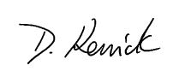

Dom Kenrick
Headteacher

Candidate information

Individual visits:

We would be delighted to organise individual visits with any potential candidate who wishes to visit or find out more detail about a particular area of the Academy. Please contact our Reception staff on 01444 457881 to arrange a tour.

Submitting your application:

If you would like to apply for this post:
- Please complete an application form, available on the Warden Park website
- Submit a letter of application, no longer than two sides of A4. In your letter please focus on the following:

  - How will you ensure that all students in your classes make outstanding progress?

Your completed application should be emailed to jobs@wardenpark.co.uk by 9 am, Monday 29th January 2018. Please note that we will be considering applications as they are submitted up until the closing date. Our HR Manager, Roseanne Gainsford (rgainsford@wardenpark.co.uk ) will be happy to answer any questions you may have about this process or vacancy.

Safer Recruitment:

Warden Park Academy is committed to safeguarding and promoting the welfare of children and young people and expects all staff and volunteers to share this commitment. We will ensure that all our recruitment and selection practices reflect this commitment. All successful candidates will be subject to DBS checks along with other relevant employment checks

Short listing:

The selection panel with undertake short listing wherever possible on the same day as the vacancy closing date, however if there is no closing date we will contact successfully shortlisted candidates as soon as possible. Shortlisted candidates will be notified by telephone and/or email giving them as much notice of the date of interview as possible. If shortlisted, Please bring with you your passport, driving licence (both parts) and a recent bill or statement less than 3 months old along with your degree/educational certificates when you attend for interview. This is for DBS purposes and will save time later should you be appointed.

Local information

Location:

The school is ideally situated in the lovely Sussex village of Cuckfield, in a rural location, yet within easy reach of excellent facilities and communications. There are a good range of local amenities, including restaurants, boutiques and pubs found in Cuckfield and the nearby town of Haywards Heath. Haywards Heath lies in the centre of the Mid Sussex District of West Sussex, surrounded on all sides by stunning countryside, which is less than a five-minute drive in any direction from the town centre.

The vibrant seaside city of Brighton (15 miles) offers first-rate shopping, restaurants and cultural facilities.

Transport:

There are regular trains from Haywards Heath to London and the South East (London Bridge/Victoria from 42 minutes). Gatwick airport (14 miles) has a fast rail connection to London (Victoria 30 minutes).

www.southernrailway.com

There is very easy access to the A23/M23 and in turn the M25 and national motorway network.

Schools:

There are a number of highly regarded primary schools in the area:

www.wardenparkprimary.co.uk

www.northlandswood.co.uk

www.harlandsprimaryschool.org

www.holytrinity-cuckfield.w-sussex.sch.uk

www.bolnorevillage.w-sussex.sch.uk

