
WALTHAMSTOW SCHOOL FOR GIRLS
“Neglect not the gift that is in me”

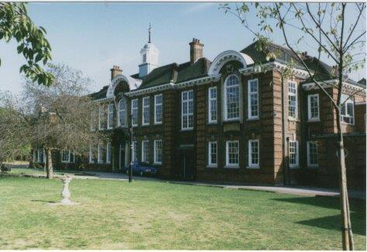

Information for applicants for the post of
French Foreign Language Assistant
January 2018

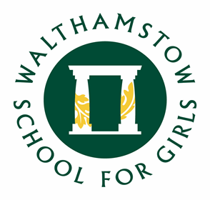

January 2018
Dear Applicant
Thank you for requesting an application pack for the post of French Foreign Language Assistant at Walthamstow School for Girls. This is a temporary post until the end of the Summer term 2019.
Walthamstow School for Girls is a high achieving, oversubscribed multi-cultural school which is regularly in the top 5% nationally for progress and the top 10% nationally for attainment. We have an ambition to become ‘world class’ and a commitment to work with other professionals both locally and nationally. In 2015 we won the national High Aspiration Award for the progress made by disadvantaged students and have won SSAT Achievement and Progress awards annually since 2014. Our students are ambitious and hard-working, they embrace the opportunities offered to them and this is highlighted by our exceptional examination results. They are a delight to work with.
We offer excellent facilities to both staff and students. Our acclaimed architect designed site is a pleasure to work in and is well served by transport connections, being just ten minutes’ walk away from Walthamstow Central tube and overground station and five minutes’ walk from the popular Walthamstow ‘village’, and creative and restaurant quarter. We pride ourselves on working hard to retain our role as an important part of the local community. Examples of this commitment can be seen in our weekly Greensheets. Our staff are inclusive and friendly, with social and wellbeing events organised on a regular basis. Other incentives for staff include membership of a child care voucher and cycle to work scheme.
We are committed to Safer Recruitment practices and procedures and shortlisted applicants will be questioned about their commitment to the safeguarding of young people. The successful candidate will be subject to an enhanced DBS clearance.
Thank you for taking an interest in this position. I do hope that having read more about the school you will decide to apply for the post. I look forward to receiving your application. Please note that it will not be possible to give feedback to unsuccessful applicants, other than those called for interview. Thank you for your understanding and good luck with your career in education.
Ms Meryl Davies
Headteacher

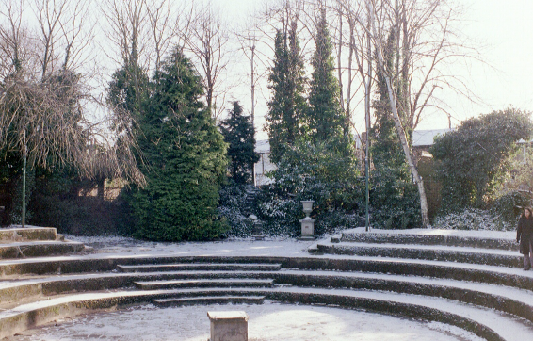

The History of Walthamstow School for Girls
In January 1890, a circular stated that a “school for girls” was to be opened. Walthamstow was described as a pleasant suburb on the borders of Epping Forest. Hoe Street was almost a country road, with a few houses on either side and meadows in which were sheep, cattle, hawthorn and wild roses.
Miss Hewett was the first Headmistress, at the age of 27 until she retired in 1924. There were 49 girls, whose ages ranged from 7-16 years. At this time there were only five teachers, two of whom were graduates. The School’s original Staff Book gives details of the first one hundred teachers. Of them 30 remained at the school for ten years or more, 22 giving over twenty years’ service. Until 1944 all the teachers were women and not married.
The original building was in West Avenue Road and when the numbers grew the school moved to Church Hill House, where a church now stands. At this time there were also boys up to the age of 13 years at the school. It was in September 1913 that 243 girls came into the present building with the Greek Theatre being added in the 1920s. However in July 2008 the whole school moved off site for a period of four school terms to facilitate the building and refurbishment programme that has resulted in the unique blend of traditional and state of the art facilities found at the school today.
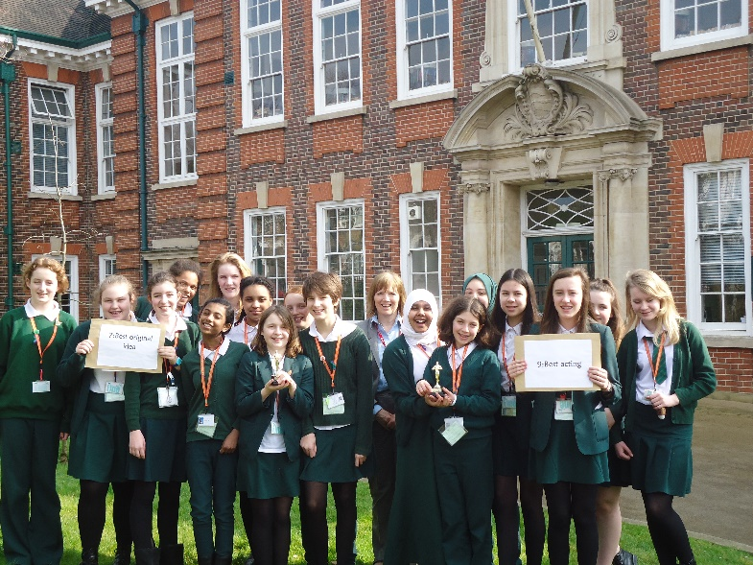
Walthamstow School for Girls is a place of high achievement. Effective teaching and learning are at the heart of our school. The school motto “Neglect not the gift that is in thee” underpins all the school’s work. Every girl is expected, encouraged and supported to achieve her very best academically and our pastoral system supports our students’ academic and social experiences.
Our role is to educate tomorrow’s women through a range of activities and opportunities to be confident, secure and happy individuals as they prepare for further education, careers and future lives.


WALTHAMSTOW SCHOOL FOR GIRLS
JOB DESCRIPTION

Post Title: Foreign Language Assistant
Reporting to: Head of Faculty (MFL)
Liaising with: Teachers and other support staff.
Working time: 17 hours per week (4 days per week – Term-time only).
Salary/Grade Scale 3

JOB PURPOSE

A Foreign Language Assistant will either assist the language teacher with the language classes or support small groups. Your role will be to improve students’ confidence in communicating in your language and help classes to become more interactive and fun by discussing contemporary aspects of youth culture in your country such as current affairs, education, sport, fashion, films, TV, lifestyles and celebrations.

MAIN DUTIES / RESPONSIBILITIES
- To support the language sessions in the target language through conversations and activities.
- To liaise with class teacher on a regular basis regarding content and structure of teacher sessions.
- To support the class teacher with preparation of authentic materials.
- To be prepared to use the target language at all times and to adapt it according to the level and ability of the student group.
- To assist the Head of Faculty in identifying resource needs.
- To co-operate with other staff to ensure a sharing and effective usage of resources to the benefit of the School, Faculty and the students.

GENERAL
- Be aware of and comply with policies and procedures relating to child protection, health, safety and security and confidentiality, reporting all concerns to an appropriate person
- Contribute to the overall ethos/work/aims of the school
- Contribute to the extra-curricular activities run by the MFL faculty
- There is an expectation to attend all key school events out of hours as directed in the school calendar e.g. Opening Evenings, all Faculty and Staff Meetings and relevant twilight Inset sessions

- Present a positive personal image, contributing to a welcoming school environment which supports equal opportunities for all. To treat all users of the school with courtesy and consideration

- Promote and ensure the health and safety of pupils, staff & visitor (in accordance with appropriate health & safety legislation) at all times

- The above mentioned duties are neither exclusive nor exhaustive and the post holder may be required to be flexible and carry out other relevant and/or reasonable duties as directed by their Head Teacher/Line Manager commensurate with the skills, abilities and grade of the post

This school is committed to safeguarding and promoting the welfare of children and young people and expects all staff and volunteers to share this commitment.

January 2018

WALTHAMSTOW SCHOOL FOR GIRLS
PERSON SPECIFICATION
Foreign Languages Assistant

- Experience
- Native speaker of French or Spanish
- Good knowledge of grammar and structure of the native language
- Experience of working with young people

2. Qualifications
    - Good standard of English
    - Fluency in either French or Spanish

3. Knowledge, Skills and Abilities
    - Excellent communication skills written and oral
    - An enthusiasm for the target language and an ability to promote a sense that French/Spanish is enjoyable
    - Knowledge of the culture associated with French/Spanish
    - Ability to work as part of a team
    - Ability to effectively organise day-to-day workload ensure deadlines are met
    - Ability to relate well to children and adults
    - Willingness to work flexibly according to the needs of the School
    - Commitment to Equal Opportunities

January 2018

Walthamstow School for Girls – The Languages Faculty

The Languages Faculty at Walthamstow School for Girls is a very successful faculty. All Language staff are fully committed to ensuring our students really enjoy their language learning experience and achieve their full potential in this subject area. We strive to ensure that our students develop a real interest in the cultural aspects of the languages we teach which will enrich their lives and lead them to view language learning as something they will continue with in the future.
Our success as a faculty has been achieved principally by strong team work, effective planning, and the delivery of consistently high quality teaching. We have very high expectations of our students in terms of motivation and effort. They respond extremely well to our teaching and have high expectations of themselves and of us. This is evident through our consistently outstanding GCSE results. In 2016, French achieved 87% A* - C, Spanish 77% A* - C and Urdu 100% A* - C.
We are very well supported by our Leadership Team and this has enabled us to be very well resourced with some of the best language teaching materials available. These include the Métro and Studio for French as well as the Listos and Viva courses at KS3. In KS4, we have recently updated all our resources in both French and Spanish to support the new 2016 GCSE Specification.
We have access to excellent ICT facilities which provide the opportunity for our students to use the Internet and to work independently on Métro Électro and Linguascope. All of our classrooms are fully equipped with interactive whiteboards enabling staff to fully utilise a range of teaching materials including Boardworks in French and Spanish. All our listening materials are stored on the school computer network which is accessible from all classrooms.
In terms of the curriculum, Year 7 students will study both French and Spanish. A noteworthy feature of our Year 7 curriculum is that all of our Year 7 students have the opportunity to study Urdu. Some of them subsequently choose to continue with this language through to GCSE in Year 11. A very high percentage of our students opt to continue with their language to GCSE. Usually we have two or three French groups, two or three Spanish groups and one or two GCSE Urdu group in Years 10 and 11. Group sizes are usually between 20 and 25.
We are fortunate to have French and Spanish language assistants each year and our students benefit enormously from working with them. The faculty has successfully organised trips to France and Spain. Many other extra-curricular activities are organized such as lunch-time language clubs and after-school and lunch-time support.

June 2017

The diversity of all the students and accepting all religions, cultures and traditions.
It is welcoming, my daughter quickly settled into school life. It has high expectations of students but these are adapted for each individual so each is encouraged to do the best they can.

The value placed on education for young women, standards of behaviour expected, opportunities for activities which extend my daughter's understanding and interests, diverse community.

That the school provides opportunities for each girl to feel confident to strive to push beyond their current capabilities to achieve through hard endeavour and a belief that anything is possible.

What do you value most
about our school?
A sample of responses from a survey of parents (February 2016)
The sense of community; the high standards and expectations set by the school; the holistic approach to learning for the girls; the extra curriculum activities which supports learning and the fact that the staff team is a good diverse one.

High-quality learning environment and culture: comprising motivated, well-behaved pupils, strong and inspiring teachers and good resources.

The professionalism and reputation over such a long number of years.

