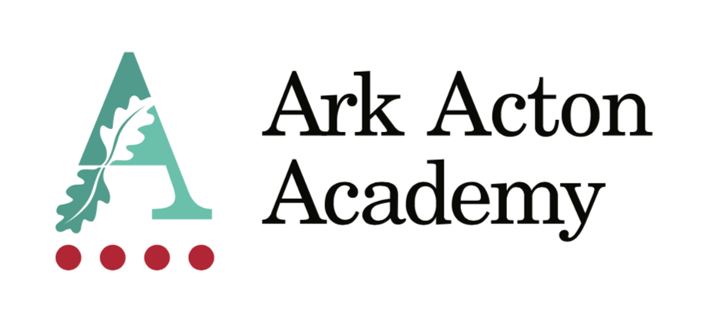

Appointment to the post of
Head of Music

Information for Applicants

January 2021

Dear Applicant,

Thank you for taking the time to find out more about Ark Acton Academy. This pack is intended to give you information about the role of Head of Music, together with details of the Academy’s vision and ethos and our aspirations.

Ark Acton Academy is on an incredible improvement journey and we are sowing the seeds of greatness for our local community. However, there is still much to do and we are looking for an expert leader of Music who can help drive us forwards. You will share our firm belief in the importance of Music as being the very essence of a knowledge-rich curriculum and you will want to join a school that invests in its staff.

At Ark Acton we have stripped away anything we feel gets in the way of being a great teacher so that we can focus on the main thing. This includes:

- Feedback policies that sit at department level
- No graded lesson observations
- No report writing
- No parent’s evenings
- Only 2 data points a year
- No ½ termly data metrics to track progress
- Protected Department meeting time built into the timetable
- Two protected co-planning slots a week built into staff loadings to provide space for curricular discussions.

We are heavily committed to staff welfare and development and this includes:

- weekly staff training
- Coaching for every teacher
- each member of staff has a personal development pathway to help ensure they have the feedback and space necessary to keep improving
- free use of our leisure centre
- access to the school counsellor
- access to Ark schools network and support.

We place the curriculum – what we teach – at the heart of the academy and it informs all decisions we make. We are looking for someone who shares our belief in disciplinary thinking and who will help improve and refine our curriculum thinking. In the words of Alex Standish we believe that “school subjects then are a way of inducting children into the intellectual habits of humankind, and hence into a disciplinary conversation about knowing our world” and we are looking for someone who shares this belief to join our team.

I look forward to receiving your application and welcoming you to our Academy.

Yours sincerely,

Oli Knight
Principal
Head of Music – Job description

Job Title: Head of Music
Reports to: Assistant Principal
Responsible for: Delivering the highest quality learning experiences to pupils in the MUSIC Department.
Start date: January 2021
Salary: Main Scale (Inner London) + TLR 2c
Disclosure level: Enhanced
Roles included: Head of Department, Classroom teacher, Form Tutor

Job purpose

To contribute to developing Ark Acton Academy into a great school by designing and implementing a challenging Music curriculum that is designed following a mastery approach to ensure that strong foundations for subject progression are in place, enabling all students to fall in love with the study and practice of Music. We share the belief (Rogers, 2019) that a truly musical school holds three distinct, but interlinked, areas of music education in balance and we are looking for a Head of Music to translate this vision into reality for our students.

Objectives:

- To develop a knowledge-rich music curriculum in-line with the Ark Music Mastery programme and to raise the number of students studying Music at GCSE and A-Level.
- To ensure all students have access to instrumental and vocal tuition (in groups or one to one) and ensemble membership.
- To develop musical events and opportunities, for example singing in assemblies, concerts and shows, as well as trips to professional concerts to see music in action.

Subject rationale:

“Musical learning in the classroom should be the living embodiment of the term ‘knowledge-rich’…The teacher develops students’ existing musical knowledge through making music of increasing complexity and diversity, understanding its constituent parts and responding with increasing depth and awareness of their own emotional responses. Musical knowledge is continually applied, whether practically through performing and rehearsing, conceptually through improvising or composing, or critically through speech and writing.” (Toyne, S. ‘What should schools teach.’ UCL 2nd edition, 2021)

Outcomes and activities

- LEADERSHIP OF MUSIC

- Establish a clear department development plan and monitor and evaluate its delivery and effectiveness.
- Design and implement a knowledge-led curriculum model that aligns itself to the Ark Acton Way.
- Monitor the effectiveness of teaching and learning and planning processes within your department.
- Support the professional development of teachers and their training where appropriate.
- Follow the Academy structure for mentoring, coaching and monitoring staff (including supervision of NQT’s and beginner teachers).
- Manage the deployment of department resources effectively and efficiently.
- Monitor the progress of all pupils and sub-groups of pupils with staff and plan appropriate support / interventions to remedy slow progress.
- Produce, in line with the Academy self-evaluation cycle, Department Improvement Plans and Data Analyses to the highest possible standard and ensure all members of your department engage with these.
- Liaise with all appropriate personnel regarding support for student progress.

- CURRICULUM AND ASSESSMENT DESIGN

As a teacher:
- Implement the Academy approach to marking and feedback to inform planning, develop learning and evaluate pupils’ progress.
- Make effective and regular use of the Academy’s assessment criteria and reporting procedures to inform learning.
- Set targets for raising pupil attainment in the context of whole school targets and work towards their achievement.
- Maintain regular records of pupils’ attainment and progress.
- Attend parent events and Open Evenings as required.
- Assess how well learning objectives have been achieved and use this assessment and Academy provided data on a regular basis for future teaching and target-setting, as well as implementing strategies to address pupil underachievement.
- Liaise with external agencies about individual pupils as required.

As a Head of Department:
- Work with the Academy Curriculum Leads to review and develop the curriculum on an on-going basis, taking into account the findings from monitoring and self-evaluation, and ensure all staff have short and medium-term plans to deliver highly effective lessons.
- Set regular, measurable and significant assessments for pupils in line with the academy assessment calendar.
- Ensure all pupil data is understood and interpreted by staff and pupils and used to modify lesson planning.
- Analyse and interpret data on pupils’ achievement in your subject, ensure pupil performance data is used effectively and is in line with departmental targets.
- Review with teachers their assessments of progress for classes and quality-assure such assessments through moderation, sampling and review.
- Ensure procedures for both internal and external exams are carried out according to the Academy’s procedures and the Boards’ regulations as appropriate.
- Ensure the maintenance of accurate and up-to-date information on the management information system.
- Disseminate and make use of analysis and evaluate performance data provided.
- Identify and take appropriate action on issues arising from data, systems and reports; setting deadlines where necessary and reviewing progress on the action taken.
- Oversee the production of reports on pupil progress in line with Ark Acton policies.
- Produce reports on examination performance, including the use of value-added data.
- Oversee your subject’s collection of data.
- Provide the Senior Leadership Team with relevant information relating to the subject areas’ performance and development as requested.

- PROFESSIONAL DEVELOPMENT

As a teacher:
- Take responsibility for your own professional development and demonstrate a commitment to continuous professional development by undertaking, and seeking out, opportunities to build your capabilities as a teacher.
- Maintain an up-to-date expert knowledge of your subject area, related teaching pedagogy and relevant aspects of the National Curriculum, exam board requirements and other statutory provisions, including developments and reforms in broader education policy.
- Ensure you understand your professional responsibilities in relation to Academy policies and practices.
- Evaluate your own teaching critically and use this to improve your effectiveness.
- Engage, positively, with the Ark Acton appraisal policy.

As a Head of Department:
- Actively monitor, and respond to, curriculum developments and initiatives in your subject at national, regional and local level.

D NON-SUBJECT RESPONSIBILITIES

- Demonstrate consistently high expectations of all pupils and a commitment to raising their achievement and social and emotional wellbeing. Promote the positive values, attitudes and behaviour expected from all pupils by treating them with respect and consideration.
- Develop strong and positive relationships with pupils.
- Implement all Academy policies, including the Academy’s behaviour policy.
- Contribute to the design and delivery of the Academy’s enrichment curriculum in line with your timetable and the Ark Acton enrichment policy.
- Model the ethos and vision of the Academy at all times.
- Communicate promptly and sensitively with parents, carers and other relevant bodies where necessary.
- Contribute to the Academy’s liaison, marketing and pupil recruitment activities, e.g. the collection of material for press releases.
- Help to develop effective subject links with partners and the community, including attendance where necessary at liaison events in partner Schools and Academies and the effective promotion of your subject at Open Days/Evenings and other events.
- Establish and maintain effective working relationships with colleagues including support staff.
- Be familiar with and comply with the Academy’s Health and Safety policies
- Be responsible for the health & safety of pupils when they are authorised to be on Academy premises and when engaged in authorised activities elsewhere
- Adhere, at all times, to the expectations of teachers at Ark Acton Academy, outlined on the final page of this document.
- Any other duties as required by the Principal commensurate with the post.

H FORM TUTOR RESPONSIBILITIES

- Maintain a holistic overview of the academic and pastoral progress of your tutees, including monitoring their wellbeing, academic attainment and progress.
- Develop strong, trusted, relationships with each tutee to act as his or her mentor.
- Deliver the PSHCE curriculum to tutees in tutor time.
- Implement Ark Acton’s attendance, rewards, sanctions, behaviour and monitoring policies, including being the primary behavioural point of contact for tutees and maintaining a weekly check of tutees’ planners.
- Identify the need for, and support the design of, interventions to support pupils who are not meeting expectations.
- Monitor the safeguarding and welfare of tutees.
- Engage tutees’ teaching staff to facilitate the sharing of relevant pupil specific strategies, information and best practice.
- Make specialist staff (SENDCO) and senior staff (Heads of Year and SLT) aware of any issues with tutees as required.
- Proactively engage parents of tutees and endeavour to build positive home-Academy relationships. Act as the primary point of contact for parents of your tutees.
- Model the ethos and vision of the Academy.
- Keep the form register and monitor patterns of pupil attendance/ absence.

No job description can be fully comprehensive, and from time to time the successful candidate may have to undertake other professional duties as directed by the Principal.

Person Specification

 | Essential | Desirable
Qualifications | - Qualified to at least degree level in the subject being taught.  - Qualified to teach in the UK.  - Qualified to work in the UK.  - QTS or equivalent. | - Further professional qualifications.  - Experience of teaching A Level in this subject.
Experience | - Ability to deliver consistently outstanding lessons in this subject to pupils of all ages and abilities.  - Proven record of significantly raising achievement with all groups of pupils across the age and ability range and of helping them achieve impressive examination outcomes.  - Proven commitment to continued professional development and a readiness to reflect and self-evaluate to change, improve and develop. | - Experience of having worked successfully in at least one school in an urban, multi-cultural setting, teaching pupils from backgrounds of socio-economic disadvantage.  - Successful experience of working particularly with high ability or SEN pupils.
Knowledge | - Thorough knowledge of the requirements of the National Curriculum in the subject.  - An understanding of the current thinking around cognitive science and learning and how this influences curriculum thinking.  - An understanding of the strategies needed to establish consistently high aspirations and academic / behavioural standards in an urban school setting, and a commitment to relentlessly implementing these strategies.  - Knowledge & experience of Safeguarding & Child Protection issues. | - Thorough knowledge of Key Stage 4 and Key Stage 5 specifications in the subject.  - Actively informed of developments in your subject area, and of broader pedagogic developments at local, national and international levels.
Skills | - Excellent interpersonal and listening skills; a high degree of emotional intelligence; and an effective oral and written communicator with children, staff and parents.  - The ability to develop positive relationships with all young people.  - Well-developed planning & organising skills including time management, prioritisation, delegation and administration.  - Sound judgement and problem-solving skills. | - An ability and willingness to teach across more than one subject.  - A proven ability to use data confidently and forensically to inform and diagnose weaknesses that need addressing, and ability to plan effectively in order to raise individuals’ and cohorts’ attainment.  - Competent user of ICT.
Motivation | - Willing to be fully engaged in the whole life of the school including extracurricular activities.  - Willing to be a form tutor.  - Committed to team work and working collaboratively with colleagues.  - A commitment to the safeguarding and welfare of all pupils. | - Experience of leading successful enrichment and extracurricular activities, which inspire and motivate learners.
Attributes | - A clear passion for your subject.  - The ability to enthuse and inspire others.  - Passion, resilience, maturity and optimism to lead through day-to-day challenges while maintaining a clear strategic vision and direction.  - Confidence and self-motivation to work well and be decisive under pressure.  - A high level of honesty and integrity.  - Personal stamina & energy including a good record of attendance and health.  - A firm and constant belief in the unlimited potential of every pupil and a commitment to inclusive educational provision. | - An entrepreneurial attitude.

- This post is subject to an enhanced DBS disclosure.
- The post holder must be committed to safeguarding the welfare of children.

