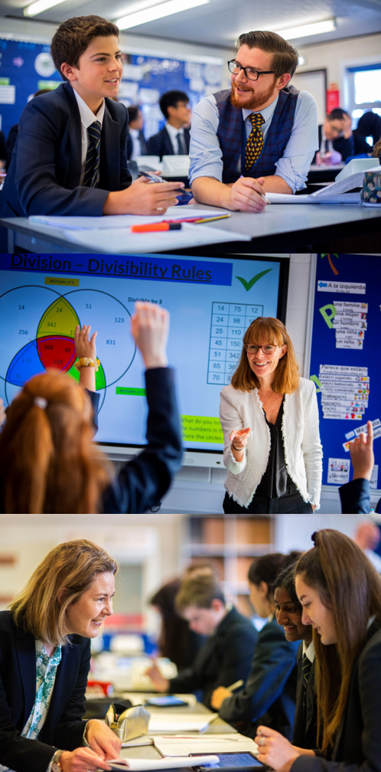

LEARNING SUPPORT ADMIN

Starting your Salesian journey
Salesian
Enlightening minds, uplifting hearts
Learning Support Administrator

To commence: 4th September 2023
Salary: SP4 (£21,103 to £22,716 depending on experience)
Salary will be pro-rated over 40 weeks a year and 25 hours a week

Closing date: 22nd June 2023

Responsible to: Head of Learning Centre and Office Manager
Person Specification
- Commitment to supporting the distinctive nature of a Catholic school
- Good levels of literacy and numeracy
- Experience of procedures for a range of general office activities
- Competence with a range of ICT packages including SIMS, Microsoft Word and Excel
- Genuine desire to work for the good of young people
- Ability to work effectively with a range of staff and parents
- Ability to work in an environment where work is regularly interrupted
- Ability to manage resources efficiently
- Excellent organisation skills
- High level of initiative
- Excellent communication skills
- Commitment to working as a team player
- Boundless enthusiasm and a positive outlook
- Capacity to work very hard under pressure
- Personal integrity and the drive to do what is best for the students
- Sense of humour
- Commitment to ensuring that Salesian School and particularly the Learning Centre offer first class provision
Responsibilities
Learning Support Administrator
- Ensure welcoming and dynamic front of house reception
- Work as part of the Learning Support team
- Manage diaries for Learning Support staff
- In-putting, retrieving and analysing data relating to student performance and attendance
- Communicating with parents, carers, staff, students and external agencies as appropriate
- Work with Learning Support Leads with regards to Access Arrangements
- To support in organisation of CP training events
- Tracking data as directed by SENDCos
- Carrying out any other related tasks as designated by SENDCos
General
The position is based within a busy school. The post holder will also be expected to perform general administrative functions as defined and directed by line manager, some of which are listed below:
- Produce lists, information and data as requested by staff or external agencies
- Deal with enquiries either by telephone or face-to-face and sign in visitors
- Assist with arrangements for school visits and events for example coach bookings
- To carry out filing duties in both electronic and paper form
Pastoral Care
- To deal with or report, to the nearest member of the teaching staff, incidents of behaviour that fall below expectation or concerns for a students’ welfare

Continuing Professional Development
- To take responsibility for personal professional development, in conjunction with the line manager, keeping up-to-date with developments related to school efficiency, which may lead to improvements in the day-to-day running of the school

Other
- To undertake any other duties, commensurate with the grade, as reasonably requested by the Office Manager and Headteacher
- To undertake administration in regards to Safeguarding and Child Protection particularly around the storing and sharing of files for incoming and departing students.



The Salesian community is dedicated to ensuring our young people are able to go out into the world prepared for life beyond the school gates. All members of our teaching body are expected to contribute to this development through our PSHE curriculum. Whether that be delivering lessons as a tutor, covering lessons, to adding your own expert knowledge to enhance our curriculum. All teaching staff are committed to the development of the individual, to build happy, safe and successful citizens in modern Britain.

Salesian School is committed to safeguarding and promoting the welfare of children. Enhanced DBS checks will be sought prior to appointment

Appointments at Salesian

Information for Candidates
Thank you for your interest in the positions currently being advertised at Salesian School. I would like to take this opportunity to share some thoughts with you.
Salesian is a co-educational 11-18 Catholic comprehensive school and part of the Xavier Catholic Education Trust. The school ethos is based on the work of Don Bosco, a Salesian priest. Community and great relations are central to our work. As a consequence, both students and staff are happy, positive and enjoy their time at school.
Standards at the school are outstanding and students achieve exceptionally well. In last year’s GCSE examinations 90% of students gained five or more standard passes including English & Maths and our Progress 8 was +0.95. The pass rate at A’ level was 100% with 66% A*-B grades.
The school has 1780 students and is situated on two sites approximately one mile apart, near to the centre of Chertsey. The main school is situated at Guildford Road and our Sixth Form College has 400 students on its own site at Highfield Road.
A great deal of emphasis is placed on extra-curricular life at Salesian and outside the formal curriculum there are numerous opportunities for students to take part in a wide range of activities - drama, sport, music, exchanges, away days, Duke of Edinburgh, retreats and trips.
We work hard to ensure that staff and students are well looked after but we also set exceedingly high expectations of everyone at the school and underperformance is always challenged. When you get the balance right between challenge and support you get great teaching, when you have great teaching the school becomes heavily-oversubscribed and when this is the case parents believe in what you are trying to do and support you in doing it. All of this results in us having the privilege of working with children who are, on the whole, an absolute delight!
Our last Ofsted Inspection was in September of 2013 when we were judged to be “outstanding” in all categories. We were obviously delighted with this recognition and are all very proud of our achievements which are a great tribute to the staff and students who have worked so hard to enable us to reach this point.
Salesian was designated as a Teaching School in September 2014 in recognition of our track record of success in training teachers and supporting schools in difficulty. The Teaching School offers a range of exciting opportunities for staff to engage in professional development and school-to-school support activities and from 2015 we have been accrediting our own trainee teachers as part of the Teach South East SCITT partnership.
Regardless of all this, we don’t think we’ve got it cracked; the challenge now is to keep improving on what we do. Are you the person to help us continue on this journey?
Candidates are welcome to contact the school to find out more information about specific departments or pay us a visit. We take recruitment very seriously and want to do all we can to find the best staff for our students.
The ideal candidates will be energetic, enthusiastic, ambitious and excellent practitioners. We would expect at least two years’ hard work and good service. In exchange we will prepare you for the next step in your career.
I believe Salesian is a fantastic place to work and I am excited about the prospect of appointing colleagues with whom we can work closely in order to drive the school forward. There are great opportunities here for the right candidates to provide a high quality service for our community and make a real difference to children’s futures. I very much look forward to meeting you.

Paul Gower
Headteacher



