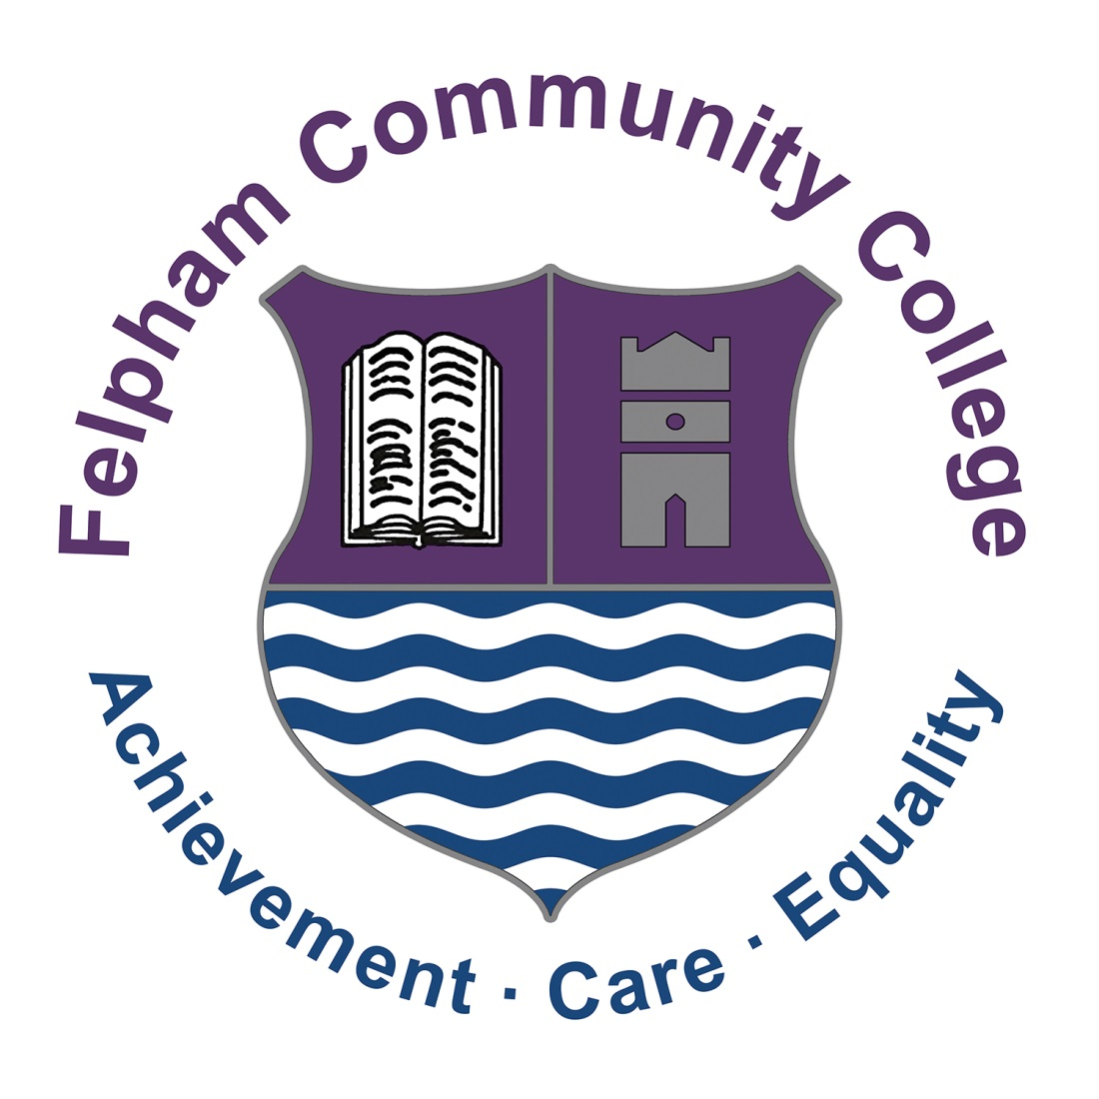

*Headteacher: Mark Anstiss*

May 2024

|  |  |
| --- | --- |
| Dear Applicant, | *Headteacher: Mark Anstiss* |

**Facilities Officer**

**Required ASAP**

**Full time, permanent contract, all year**

Thank you for your interest in the post of Facilities Officer at Felpham Community College.

FCC is an 11-18 local authority, mixed comprehensive with over 1600 students on roll and a thriving sixth form. In March 2019, our one-day, short OFSTED inspection confirmed our OFSTED ‘Good’ status originally achieved in January 2016.

The school has a good record of academic outcomes and pastoral support and our core values of achievement, care and equality underpin our work, creating a happy and vibrant school.

Felpham is in a strong position academically. Our exam results have been historically good and we anticipate this continuing with our current year 11 and year 13 students. A well planned and resourced curriculum, along with support from staff and governors in partnership with students and parents has helped us to achieve this, and we will continue to strive to improve further.

We do recognise that great schools are about more than just exam results and we have worked hard to create an exciting, engaging and broad curriculum for all students. At Felpham, we believe in getting the basics right so we have also focussed on developing a safe, calm and purposeful learning environment, with excellent student behaviour and a smart school uniform.

In late 2019, the school saw the completion of significant building work costing £11.5M. Students now benefit from fantastic modern facilities in our new three-storey block that replaced all of our older classrooms.  Whilst great schools are about the people in them and not just the buildings, the enhanced facilities at Felpham are a massive boost.

Visitors to our school regularly comment on our happy and enthusiastic students, excellent school uniform and good behaviour. This does not happen in a school by accident and requires constant attention and commitment from all staff.

We are not complacent at Felpham and are continually planning for progress. In 2023 we became one of a select group of secondary schools in England to achieve the UNICEF Rights Respecting Schools Gold Award and student leadership remains a strength of the school that we wish to enhance further.

Our staff take part in a comprehensive CPD programme that puts quality teaching and learning at the forefront of classroom practice.

Our strong pastoral system is based around linear tutor groups and year groups led by Year Leaders (who are teachers) and Year Managers (who are non-teaching associate members of staff). We are an inclusive school and benefit from a successful on-site Learning Support Unit.

In order to find out more about our school please take a look at our website (<http://www.felpham.com>) which provides links to our OFSTED report, details about the school, recent newsletters, our prospectus and other information.

I hope that having explored our website and reviewed the information provided you will be interested in applying. Completed application forms should be posted or emailed to my HR Manager & PA, Sarah Buswell, at [jobs@felpham.org.uk](mailto:jobs@felpham.org.uk) In addition to your application form you should include a letter of application of no more than two sides of A4 (size 11 font min.) which clearly addresses the following points:

* Professional experience and achievements
* What you will bring to Felpham Community College

If you would like any more information on the post please contact Sarah Enticott, Facilities Manager on the school number or email [SEnticott@felpham.org.uk](mailto:SEnticott@felpham.org.uk) Visits to the school are welcomed.

The closing date for applications is **10.00am Monday 17th May 2024.**

Interviews dates to be advised.

This is an extremely exciting time to join Felpham Community College and to play a vital role in continuing our success.

I look forward to hearing from you.

Yours sincerely



**Suzanne Pike**

**Headteacher**

*Please ensure that you complete your full employment history on the application form (including any study, voluntary work and with explanations for any periods not covered). Any employment gaps will be investigated. Because of the nature of this job, if you are successful in your application you will be subject to a criminal record check from the DBS before the appointment can be confirmed. This will be done by means of applying for an Enhanced Disclosure. Disclosures include details of cautions, reprimands or final warnings as well as convictions, spent or unspent. Online searches may be done as part of due diligence checks.*

Felpham Way, Felpham, Bognor Regis

West Sussex PO22 8EL

School Tel: 01243 826511

Email: fcc@felpham.org.uk

Website: www.felpham.com

image006