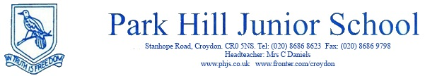
LEARNING SUPPORT ASSISTANT

Salary Scale: Learning Support Assistant
Grade 3 - Scp: 15- 17 - £18,603 - £19,374 (pro rata)
Term Time plus insets

Hours: 37.5 hours per week – (Monday – Friday)

We are looking for a motivated, enthusiastic and reliable applicant to join our enthusiastic, hard-working, supportive and friendly team at our school. To work under the direct instruction of teaching/senior staff, usually in the classroom with the teacher, to support access to learning for pupils and provide general support to the teacher in the management of pupils and the classroom.

The position would be ideal for a graduate wanting to work towards teacher training, although a degree is not essential and all applicants with great skills in supporting the learning of children will be considered.

Park Hill Junior School is committed to safeguarding and promoting the welfare of our children. This post is subject to a satisfactory Enhanced DBS certification and references.

Park Hill Junior School is working towards equalities in employment and service delivery and welcomes applications through all diverse communities. We welcome applications from people with disabilities.

Application forms are available to download from Croydon Council or on our website: www.phjs.co.uk. Visits to the school are welcome. We do not accept CVs.

By post to: Park Hill Junior School, Stanhope Road, Croydon, Surrey CR0 5NS

By email to: hr@parkhill-jun.croydon.sch.uk

Closing date: Friday 30th June at 12 noon 2017
Interviews: Tuesday 4th July 2017
Starting Date: 31st August 2017

