

**Copthall School**

**Candidate Information Pack**

**Director of Learning**

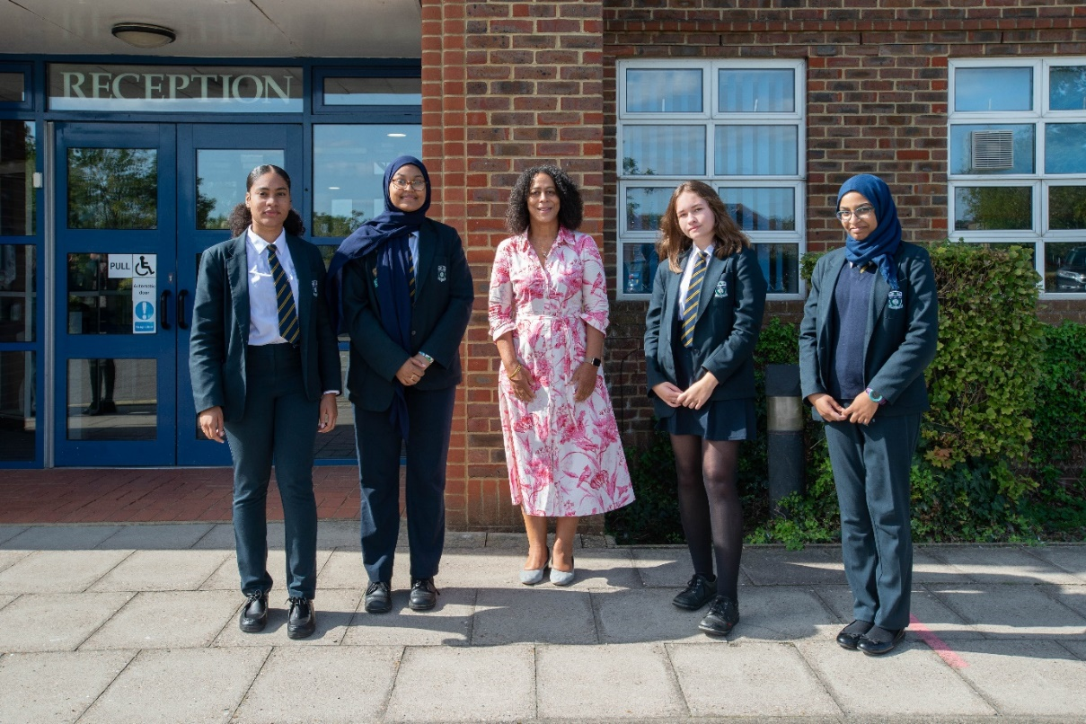



***A Positive Learning Environment that inspires a passion for learning so that every student progresses and thrives***



Dear Candidate

Thank you for your interest in the position of Director of Learning at this exciting time for our organisation. I would like to welcome you personally, and I hope that you will find here all the information you need to inspire you to join our team.

2020 was an immensely challenging year for our school community and the world at large, it meant that our school gates closed on 20th March and did not fully re-open until September 2020. This meant that as educators we were unable to do what we do best, which is building relationships with our students so that they become confident and aspirational learners. However, we quickly adapted to new ways of working. Both staff and students rose to the challenge and we weathered the storm, which made us stronger as a school community.

On return, we spent time reintegrating and re-establishing the important things which bind us together; our school values. They permeate our school and make us a great school to work at and a wonderful place to learn. We put well-being and relationships at the heart of what we do, so that no student or staff member is left behind and everyone feels like they have a voice and a place on our school.

Copthall’s journey thus far has been one of success and collaboration and I remain immensely proud to lead this wonderful school.

Our school is unstoppable in its pursuit of Excellent Education for All, which has been highlighted by Ofsted 2018. We have been recognised for the rapid transformation and excellent progress of students and have been awarded **Good** status. The full report can be accessed using the following link: <http://www.copthallschool.org.uk/226/ofsted>

Our Governing Body is strong and highly ambitious for the school. Their recent award by the NGA for Outstanding Governance is further evidence of their ambition. They have a wealth of expertise in a range of areas and are very committed to ensuring we deliver first class educational opportunities to the communities we serve and make a difference to the lives of the girls who learn with us.

Copthall continues to go from strength to strength as we raise standards, enrich the lives of our students, focus on staff wellbeing and workload and continue to be a good and improving school. Our priority remains the same in that we offer our students a highly personalised academic experience – one that ensures that all our students receive an excellent education. We have an extensive enrichment programme involving mentoring, cultural activities/visits/trips, STEM workshops, a full careers programme and a range of partnership opportunities involving universities, businesses, charities and alumnae.

In addition, our collaboration with Mill Hill Independent School offers a range of joint opportunities for all students from leadership, tutoring, philanthropy extended projects and a variety of bespoke and unrivalled programmes that benefit our young people.

In preparing our students for the future we will endeavour to provide them with the skill set they will need including complex problem solving; critical thinking; creativity; emotional intelligence; judgement; and decision making; negotiation and cognitive flexibility. We want to ensure they play important influential and aspirational roles, ready to make a positive contribution to society.

We want you to look forward to each day at our school. We expect hard work, skill and dedication to our core values, and in return we will provide you with outstanding experiences and training opportunities. We have a strong focus on staff well-being and have a range of incentives including staff yoga and staff well-being days.

If you feel you can make a positive contribution to our school, please apply online via our website, [www.copthall.barnet.sch.uk](http://www.copthall.barnet.sch.uk). If you would like to discuss a role or have any queries, please call 0208 959 1937 or email [recruitment@copthall.barnet.sch.uk](mailto:recruitment@copthall.barnet.sch.uk). Visits to the school are also encouraged and welcomed.

I look forward to receiving your application.

Yours sincerely



Evelyn Forde MBE

**Headteacher**



***A Positive Learning Environment that inspires a passion for learning so that every student progresses and thrives***

**ABOUT COPTHALL**

As a girls’ non-selective comprehensive academy, Copthall offers the rare opportunity of single-sex education for students of all abilities. We are a values driven school which was noted by Inspectors in May 2018 when they commented “The school’s values of respect, equality for all, support and safety, aspiration and responsibility underpin this improving school’

Many girls stay on to join our vibrant Sixth Form, from where the vast majority progress to higher education, with a number achieving places at Russell Group universities. In addition, the school also offers a strong and varied vocational curriculum. “Students benefit from strong teaching and outcomes, which are rigorously checked by effective leadership in the sixth form” *Ofsted 2018.*

**OUR LOCATION**

Copthall School is located in one of London’s more prosperous and leafy boroughs and the area offers a wealth of good quality social, sporting and shopping facilities. That does not mean however, that we do not have to face social issues similar to many inner-city schools and there is a substantial amount of deprivation in our catchment area.

**VISION AND VALUES**

Our Vision and Value statements are borne from our commitment to girls’ education, we want to ensure that they can take their rightful place in society. We work together to communicate the vision so that any obstacles to success are removed.

**Mission Statement:** Excellent education for all - *A Positive Learning Environment that inspires a passion for learning so that every student progresses and thrives*

**Values:**

* **Respect:** Pride and respect in the cultural diversity of our school and the global environment in which we live
* **Equality for all:** An environment of kindness and tolerance that demonstrates equality for all
* **Support and Safety:** A school that cares and is inclusive, supportive and safe for all
* **Aspiration:** Expectation and celebration of high standards of aspiration and achievement in learning and life
* **Responsibility:** Being responsible and ready for learning

**Vision Statements:**

* **EMPOWER**: To create an environment that empowers every member of our diverse school community to thrive
* **PREPARE**: To foster progression, adaptability, resilience, creativity and empathy in our young women preparing them with the skills and qualities to succeed and have choices in their adult life
* **FIRST CHOICE**: To be a first-choice school for young women
* **BROAD & ASPIRATIONAL**: To provide a broad, relevant and aspirational education
* **PASSION FOR LEARNING**: To create a positive learning environment that inspires a passion for learning so that every student progresses and thrives
* To create a positive learning environment that inspires a passion for learning so that every student progresses and thrives (this is the teaching and learning vision)

**FOCUS**

We have a relentless focus on improving teaching and learning; this includes collaborative planning and coaching, both of which have been hugely developmental for staff. The way we improve teaching is through a series of steps which allow teachers to improve on one aspect of their teaching at a time before moving onto another area. We also use leadership coaching, according to need. Both models facilitate teachers to spend significant time on chosen aspects of their practice, in line with research into effective professional development and the motivating effect of autonomy.

The DNA of our school is *good* and we will continue to strive for excellence. The Governors and I hope you would want to be part of our journey.

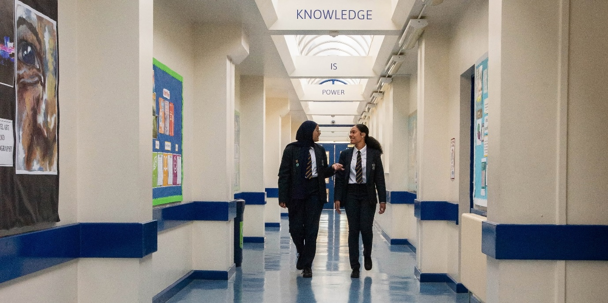



**Copthall School is committed to the protection and safety of Children and young people. All staff are expected to share this commitment.**

**Job Description: Director of Learning**

**Salary:**  **SCP 24 – SCP 27**

**Hours: 36 hours per week / 42 weeks per year**

**Responsible to: Assistant Headteacher for the year group**

**Liaison with: All stakeholders**

**External Agencies**

**Job Purpose**

To support the Headteacher by taking primary responsibility for the learning, progress and attainment, behaviour and well-being of students within their dedicated year group. This includes being the designated child protection officer for students within their year group and being the primary point of contact for parents/carers.

**Duties**

Leadership and Management

* Contribute to the Pastoral care of all students in their year group.
* Be the first line of communication between parents / carers, staff and students concerning pastoral issues, where appropriate inviting parents / carers in for meetings to discuss issues around under-performance/target setting/behaviour/well-being
* Keep parents informed, either by letter or by phone, regarding both sanctions and rewards and maintain a positive and professional communication link.
* Respond to parental enquiries about academic matters or personal matters and keep records of meetings or conversations within 48 hours.
* Uphold the vision and values of the school and promote them via assemblies, year events, social functions and external visits
* Organise, promote and take part in the annual Summer School during the month of August, year group celebration events and enrichment activities throughout the academic year.
* Promote the work of the Student Senate through assemblies and Form Time.
* Be responsible for the training, guidance, and support resourcing and line management of a team of Form Tutors including weekly briefings; ensuring the consistent implementation of school’s policies, procedures, dialogue and feedback.
* Deliver INSET for colleagues within the tutor team and across the whole school as required.
* Work and share good practice with other members of the pastoral team to develop a consistent approach to school policy.
* Create and lead the weekly assembly program in line with all Key Stages.
* Create a tutorial programme to be delivered by all Tutors during form time and ensure the consistent implementation of this.
* Monitor the activities undertaken during tutor time.
* Support the development of any PSHE courses for the year group.
* Aid transmission and transfer of data between Key Stages and plan for transition in each Key Stage.
* When necessary, to support out-of-hours extra-curricular activities.
* Carry out weekly lunchtime supervision.
* Meet with the Attendance Officer and the Educational Welfare Officer on a regular basis to monitor attendance and initiate appropriate intervention practice where necessary.
* Meet with internal colleagues and outside agencies as the need arises, including attending regular Inter-services meetings.
* Make referrals as necessary to external agencies, tracking the progress of support programmes and regularly reviewing the effectiveness of the support in place for students in their year group.
* Maintain an up-to-date knowledge of safeguarding procedures in line with ‘Keeping Children Safe in Education’.
* Promote high expectations for attendance, punctuality and conduct by actively using appropriate support and sanctions where necessary.
* Have overall supervision of the students’ attendance, lateness and uniform.
* Liaise with the School Welfare Officers and the appropriate School health services.
* Interview new parents and students (casual admissions) during the school year to gather information and secure appropriate courses.
* Investigate allegations by students/parents, of assault, bullying, theft and other breaches of expected behavior standards. This includes interviewing students and taking detailed statements if necessary.
* Liaise with Assistant Headteachers to determine and implement suitable behaviour sanctions and contact parents where necessary.
* Arrange and attend re-admission meetings following exclusion, setting appropriate targets and agreeing regular communication with parents / carers.
* Create support plans (behaviour, pastoral, emotional) to meet the needs of individual students in their year group.
* Monitor sanctions via SIMS and rewards via Epraise; tracking patterns of student behaviour. Produce reports as requested by the Headteacher.
* Be responsible for maintaining detailed safeguarding and well-being logs on CPOMs.
* Consistently implement the school’s policies and procedures.
* Liaise with the School’s Police Liaison Officer, this includes arranging and holding meetings with students and parents / carers when evidence of minor criminal offences is obtained, or where there are concerns that a student’s behaviour may lead to criminal offences being committed if they do not receive appropriate guidance/advice.
* Support staff and students when behaviour issues arise around the school and provide, appropriate interventions and follow up where necessary.
* Offer support to students with welfare problems through discussion, practical resolutions, and where necessary, arrange counselling either inside or outside of school. Liaise with parents/carers where appropriate.
* Support staff and students across the school as a first aider as directed.
* Support Senior Leaders in the school to implement strategies to promote the school’s visions.
* Undertake regular monitoring of dedicated year group’s registers.

**Achievement**

* Monitor the academic progress and pastoral well-being of all students and regularly report to parents / carers.
* Report on the development, progress and attainment of students in their year group to the Senior Leadership Team.
* Liaise with Curriculum Leaders or subject teachers where concerns arise with individual student progress.
* Use assessment data provided to identify under-achievement and consider appropriate interventions where necessary.
* Contribute to the mentoring of under-performing students.
* Measure and monitor the impact of the interventions on the outcomes of students
* Know all students especially those who have specific needs/are statemented/on the register/at risk and monitor progress. Disseminate relevant information and keep teaching staff informed on student well-being.
* Collate student information prior to meetings i.e. generating ‘round robins’.
* Promote and facilitate the general progress and well-being of individual students in assigned groups providing appropriate educational guidance on matters relating to their subjects and progression.
* Analyse absence, attendance, exclusion and behaviour data alongside student progress data to improve and secure student outcomes.
* Undertake spot checks of student planners to ensure that form tutors fully participate in the monitoring of student progress.

**Teaching and Learning**

* Create a Short Term Planning Document to address the priorities in the year group and monitor effectively. Report weekly key indicators to SLT line manager.
* Be aware of the curriculum needs of individual students and work with SLT towards personalising their timetable to maximise their learning potential.
* Work with Curriculum Leaders, subject teachers and support staff to identify the impact of intervention on student learning and present to SLT on a regular basis.
* Disseminate knowledge of the learning needs of students to staff to help inform the adoption of appropriate teaching techniques.

**Designated Person for Child Protection**

* Be the designated Child Protection Officer for the attached year group.
* Be alert to the signs and symptoms of abuse / neglect.
* Receive disclosures from students, or information regarding suspicions / concerns from other members of staff.
* Manage information confidentially and sensitively, in line with the school’s policies.
* Meet with parents / carers where appropriate/necessary to express concerns.
* Make appropriate referrals about actual or suspected safeguarding issues.
* Inform parents/carers of the above, where appropriate.
* Liaise with Social Care and other external agencies after initial referral is made.
* Attend and contribute to child protection case conferences.
* Monitor students who are subject to referrals or on the “vulnerable” register; providing ongoing support.
* Attend training sessions where appropriate.
* Liaise with and refer to MASH, the Secondary Project, CAMHS and any other external support agency as necessary.
* Complete and submit EPEPS where required.

**Administration**

* Complete the day-to-day administrative tasks including: preparation of letters, filing of student logs and information and data input for the designated year group.
* Liaise with relevant colleagues when dealing with administration for specific calendared events, e.g. parents’ evenings.
* Prepare reports for example DOL’s weekly report, contribution to Governors reports and pastoral reviews.
* Present to governors where lengthy or permanent exclusions may follow behaviour breaches.

**General**

* The duties may be varied by the Headteacher and/or Governing Body to meet changed circumstances in a manner compatible with the post held.
* The Governing Body is committed to safeguarding and promoting the welfare of children and young people and expects all staff and volunteers to share in this commitment.
* Participate in the performance and development review process, taking personal responsibility for identification of learning, development and training opportunities in discussion with line manager.
* Comply with individual responsibilities, in accordance with the role, for health & safety in the workplace.
* Work with Line Managers to set and achieve professional objectives in line with the school’s performance management policy.
* Ensure that all duties and services provided are in accordance with the School’s Equal Opportunities Policy.

**Person Specification of Director of Learning**

|  |  |  |
| --- | --- | --- |
|  | **Essential** | **Desirable** |
| **Qualifications** | * Have a good relevant higher education to A-level (or equivalent) or beyond. | * Show evidence of further professional development * Show excellent pastoral knowledge |
| **Experience** | * Have experience of dealing with young people * Demonstrate clear leadership potential | * Previous pastoral experience |
| **Ability/Skills** | * Be able to motivate young people * Be able to work with and inspire others |  |
| **Equal Opportunities and Safeguarding** | * An understanding of and commitment to Equal opportunities and safeguarding for all |  |
| **Disposition** | * Be optimistic and resilient * Be a team leader * Be organised, energetic and self-directed * Have a calm and supportive manner * Show excellent attendance and punctuality * Be committed to the achievement of all students | * Have a sense of humour |
| **Professional Development** | * Be willing to take part in all relevant training * Be able to lead professional development training sessions |  |