COMMUNICATIONS MANAGER
APPLICATION PACK

Closing Date: 21st May 2021

Dear Applicant,
Thank you for your interest in the position of a Communications Manager at Viridis Schools. I hope that you will find this information pack helpful. If you would like to learn more about our schools partnership, we would be delighted to answer any questions you may have. Our school websites also offer much information about our staff, curriculum and the way that we work.

Orchard, Southwold and Hoxton Garden Schools are in the vibrant and diverse community of Hackney, East London with easy transport links into and out of Central London. With a joint pupil roll of over 1300 pupils, we are a very successful organisation with a passion for making a difference. We provide a very rich and exciting curriculum and a no excuses culture for low standards. Because of this, our pupils achieve well above national averages regardless of their starting points and Ofsted have been full of praise about our provision.

Orchard & Southwold have been in partnership since January 2012 with Hoxton Garden joining us in April 2014. We have a joint Governing Body and strong links to our Local Authority. Each school has its own leadership team who work together with the common aim of giving children the very best. We have set an ambitious vision for the future and have very high standards for what can be achieved with the benefits of a shared expertise. We have a skilled team of highly committed and professional administrative teams, teaching teams and leaders.
Contents
- Welcome!
- Why work with us?
- What are we looking for?
- How to apply
- Job description & person specification

We wish to appoint a highly motivated Communications Manager that will join our vibrant and diverse Federation to lead on publications, marketing and media across out schools. This is a new and unique opportunity to grow a brand new role and enable enhanced opportunities to ensure the highest standards of communication internally and externally.
recruitment@vs.hackney.sch.uk

We look forward to receiving your application!
Detmold Road London E5 9NL

Ivy Street
London N1 5JD
Holcroft Road London E9 7BB

Rachel Davie
Executive Headteacher

Why work with us?
.
- An enthusiastic, talented and supportive team
- A superbly resourced teaching and learning environment
- Excellent opportunities for CPD
- A warm, friendly and positive working environment where everyone is valued

We are looking for a Communication Manager who has:

- Excellent numeracy and literacy skills
- Ability to design and create high quality material for publication
- Good interpersonal, organisational and communication skills
- Ability to work in a multi-disciplinary team effectively

, disability, sexual orientation or age.

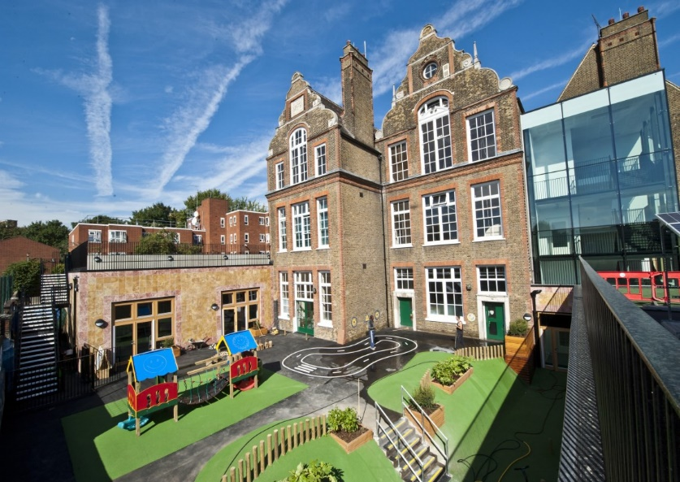

HOW TO APPLY
- Read the job description and person specification carefully.

- Complete the application form either electronically or print it off and hand write it.

- Ensure your supporting statement relates to the competencies outlined in the person specification.

- Email your competed application to Ms Beverley Shore at
recruitment@vs.hackney.sch.uk
or send by post:
Recruitment
c/o Southwold Primary School Detmold Road
London E5 9NL

- Please make sure that your application form indicates the name & address of the school where you have most recently taught and the age group that you currently working (if applicable).

Closing Date: 21st May 2021

Our schools are committed to safeguarding and promoting the welfare of children and young people and expects all staff and volunteers to share this commitment.

Successful candidates will be required to complete an enhanced DBS disclosure.

We welcome applications from all sections of the community, regardless of gender, race, religion, disability, sexual orientation or age.

Should you have any queries or would like to arrange to visit our schools please contact Ms Beverley Shore on: 0208 806 5201 or email her: recruitment@vs.hackney.sch.uk

We look forward to receiving your application!

COMMUNICATIONS MANAGER JOB DESCRIPTION

Salary (SO2, Point 27- 29)
Salary Range £34,689.00 – £ 35,949.00.
Hours of work – 36 Hours per Week, 42 Weeks per Annum
(pro rata: actual salary £32,267.00 – £33,439.00)

Purpose of the post

Manage and develop communication and marketing strategies (incorporating both internal and external communications) to positively promote the profile of the Federation in order to:

- Foster excellent relationships with parents and the local community
- Increase pupil recruitment at all points of entry so that the schools remain highly regarded and pupil numbers increase
- Support the recruitment and retention of high quality teaching and associate staff

To work alongside the Executive Headteacher and School Business Manager and central administration team, to improve communication and sharing of information, to enhance the presentation of the school and to build strong, effective school branding.

Main duties and Responsibilities

Leadership
- Develop and implement marketing and communication strategies through an annual action plan for the Federation, monitoring and reviewing on an annual basis.
- To plan and implement market research, interpret results and make recommendations to school leaders on future marketing actions.

Communication
- To take a lead in ensuring outward communication from the school is accurate, professional and timely including implementing strategies to improve responsiveness to parents and other stakeholders.
- Manage the school websites – posting information, creating regular news stories and ensuring all pages remain up to date and DfE compliant.
- Manage all digital content for the Federation. This includes social media pages such as Twitter, Instagram, Facebook and LinkedIn.
- Develop and manage relations with local and national media to promote Federation achievements and maximise positive reporting.
- Manage the Life Channel System – posting information, creating regular news stories and ensuring all pages remain up to date and complaint with GDPR.

Production
- To design, create and produce a variety of high quality material for marketing and publication purposes to all school audiences.
- To organise distribution of promotional materials via a variety of methods to local households, schools and associated partners, organisations and venues.
- Produce high quality PowerPoint presentations, or other media, for use by the Headteacher and other members of the Leadership Team for marketing and promotion use.
- Brand management for the Federation, both on and off line, including development of consistent brand guidelines and templates.
- Lead the production and mounting of award displays for public reception areas.

Events
- Manage and contribute to all high profile events for the school, for example enrichment and celebratory events.
- Publicise and event manage CPD sessions.
- Capture high quality photographs/video footage of school life and events to use in publications, marketing materials and display.
- Manage provision of marketing merchandise, promotional material, signs and displays for promotion of teacher training at recruitment fairs, exhibitions and open events.

Recruitment
- Manage recruitment processes including advert design and upload, tours, interview processes and recruitment events for new employees and ITT.

General Requirements
      - Take part in the school’s performance management system.
      - Enhanced DBS Check.
      - Attend governing body meetings on a regular basis as required.
      - Strong commitment to furthering equalities in both service delivery and employment practice.

You must promote and safeguard the welfare of children, young and vulnerable people that you are responsible for or come into contact with.

Communications Manager
Personal Specification
Qualifications (Essential)
Grade ‘C’ or above in GCSE or equivalent
NVQ Level 3 or equivalent qualification or equivalent in relevant discipline

Experience (Essential)
A minimum of three years’ experience in communications management

Knowledge (Essential)
Experience of using information technology in terms of using a computer, Microsoft software, publication software, photography and media platforms
Skills (Essential)
Excellent numeracy and literacy skills
Ability to design and create high quality material for publication
Good interpersonal, organisational and communication skills
Ability to work in a multi-disciplinary team effectively
Excellent numeracy and literacy skills

