

INFORMATION FOR
APPLICANTS

2025/2026

Table of Contents

- INTRODUCTION 4
  - What you will experience whilst working at GIS
  - The school and the school community
  - Our students and their families
  - Governance
  - Our Staff
  - Our Mission, Vision & Values
  - Child Protection
  - A Learning Culture
  - Learning at GIS
  - GIS Learner Skills
  - An Internationally Minded Curriculum
  - Digital Learning
  - Academic Results, Value Added & Universities Attended
  - English as an additional language
  - Learning support
  - Co-curricular activities

- LIVING IN MALAYSIA 14
  - Malaysia, Truly Asia
  - Geography and climate
  - Cost of living & Setting up Costs
  - Prices & Shopping Guide
  - Accommodation
  - Banking
2.7 Transport & Driving in Malaysia
2.8 Safety & Security
2.9 Internet Access & Computers
2.10 Dress Code

- CONTRACTS AND BENEFITS 18
  - What happens once you are appointed
  - Criminal Records Check/ICPC
  - Baggage Allowance
  - Immigration
  - Salary and Contracts
  - Superannuation
  - Interest Free Setting Up Loan
  - UK National Insurance
  - Health care
  - Marital status
  - Income Tax & Malaysian Income Tax

YOU WANT TO LIVE ABROAD?

Advice on Making the Adjustment

“Patience, an open mind and a ready sense of humour will get you through the rough times.”

TEN COMMANDMENTS OF RELOCATING OVERSEAS

- Learn as much as possible about the host country in order to have realistic expectations.

- Anticipate a challenging adjustment period of at least SIX months. Do not decide if you like it until these six months have passed.

- Do not expect to replicate your current lifestyle. Look for what is there, not for what isn’t.

- Develop a tolerance for ambiguity and frustration by being flexible and open towards the new culture.

- Look for ways to strengthen and maintain your enthusiasm.

- Do not expect the new culture to have the same sense of urgency or availability of conveniences.

- Try to understand the host country perspective.

- In all things, be flexible.

- Maintain a sense of humour, but most importantly be ready to laugh at yourself.

- Surround yourself with positive people. Do not allow negative comments and attitudes to darken your outlook.

We hope that this guide is useful. The School, as a caring employer, takes great pains to ensure that newly appointed staff are helped to settle into their new environment as quickly as possible. The majority of us have been in the same situation of moving to a new school in a new country. We therefore understand the anxieties and uncertainties that newly appointed staff face. By working together as a team we are able to remove many of those uncertainties and allow new staff to quickly settle into their new home.

NOTE: GIS wishes to emphasise that all information contained in this guide is correct at the time of printing and is subject to change. Any changes will be incorporated in subsequent editions.

INTRODUCTION

Thank you for taking the time and interest to apply for positions at Garden International School, Malaysia. We trust the following information will act as a useful guide in helping you understand more about the school and about setting up and living in Malaysia. The accompanying links should also provide you with a glimpse into the GIS community.

Garden International School (GIS) is one of the world’s leading international schools with a strong academic track record. Our high quality, holistic education ensures that our students leave us well equipped for life; it is not surprising that GIS students are in demand across the world and are sought after by the world’s best universities. GIS students benefit from our unique, innovative teaching and learning philosophy, integrating knowledge and skill development, supported by 71 years of heritage and a thriving alumni network.
Accredited by the Council of International Schools, GIS is one of the oldest and most distinguished schools in Malaysia with a main campus in Bukit Kiara, Kuala Lumpur and an Early Years Centre in Desa Sri Hartamas, a 10 mins walk from the main campus.
As you consider applying, we hope that the following information will be useful to you.



GIS: Bringing out the best in you

1.1 WHAT YOU WILL EXPERIENCE WHILST WORKING AT GIS

- A truly international environment that provides students with opportunities to develop a global perspective.
- High achieving students who are tremendously motivated and enjoy coming to school.
- A forward looking school that believes in continuous improvement.
- An atmosphere that allows you to do what you are trained to do: teach rather than control.
- A supportive work environment within a highly qualified professional team.
- Access to 2 hours of dedicated Professional Learning Time every Friday.
- Partnerships with supportive parents who value education.
- A British based curriculum with a global perspective, that draws on the experiences of our international school community.
- A well-resourced learning environment.
- A school with excellent facilities and probably one of the best ICT resourced schools in the region.
- An extensive range of co-curricular activities that develop and extend student learning.
- The opportunity to offer activities based on personal interests and passions to students across the school.
- An extensive programme of local and international field trips.
- A truly enjoyable lifestyle in a city that has excellent infrastructure.
- The opportunity to travel extensively and experience the beauty of Malaysia and S.E. Asia.

GIS prides itself on providing a safe, engaging and exciting working environment. Hear from some members of our community about being part of GIS through the QR code here:


GIS Stories

We feature individual and group personalities within the GIS community on our website, allowing you to gain further insight into school life from the point of view of many different people e.g. students, teachers, parents and alumni. Check out some recent events and news via this LINK.

1.2 THE SCHOOL AND THE SCHOOL COMMUNITY

Garden International School was founded in 1951 and is the largest international school in Malaysia with an enrolment of approximately 1,800 students, aged 3-18 years. The main campus is situated in a pleasant residential suburb of Kuala Lumpur, which has become one of the main centres for expatriate life in the city. A purpose designed Early Years Centre, opened in September 2008, is located approximately 1km from our main Kuala Lumpur Campus (please note if you have nursery or reception-aged children they will attend the EYC).

Garden International School is a member of Taylor’s Education Group, Taylor’s Schools. This group comprises Garden International School, The Australian International School of Malaysia, Nexus International School (Putrajaya), Nexus International School (Singapore) and Taylor’s International School (Kuala Lumpur and Puchong). Taylor’s Education Group also operates Taylor’s University and Taylor’s College in Subang Jaya, which are renowned institutions of further and higher education situated within Kuala Lumpur.

Garden International School benchmarks its services and quality of education against the highest standards. GIS is accredited by The Council of International Schools (CIS) and Western Association of Schools and Colleges (WASC).

The School is a very active member of the Federation of British International Schools of South and East Asia (FOBISIA) and the East Asia Regional Council of Schools (EARCOS), and is one of the founding members of the Association of Malaysian International Schools (AIMS). International sporting and cultural opportunities are provided to students through these organisations and GIS staff have the opportunity to participate in the extensive Professional Development and teacher networking opportunities provided by these organisations and others.

Garden International School is a GL Centre of Excellence as a result of its pioneering work on the use of data in schools and our support of other schools. We are also the recipient of several awards relating to education.

The School is accredited by The University of Cambridge International Examinations Board for IGCSE and A level exam. GIS is also a centre for Edexcel exams.

The school has a smoke free environment policy.

1.3 OUR STUDENTS AND THEIR FAMILIES

Our students, aged between 3 and 18 years, are mainly from the expatriate community of Kuala Lumpur and come from over 65 different countries. The GIS roll currently comprises approximately 35% Malaysian students, the second largest nationality group is British.

Parents are well engaged in every aspect of school life, from leading community service projects to sharing their knowledge and expertise in parent workshops, there is a thriving Parent Teacher Friends Association (PTF).

1.4 GOVERNANCE

The Governance of the school is the responsibility of the Board of Governors. The overall management of the Taylor’s Education Group is overseen by the President, Taylor’s Schools. The day to day Management and operations of GIS are the responsibility of the Principal.

1.5 OUR STAFF

Senior Positions within the School are:

Principal | Peter J. Derby-Crook MBE, M.Ed, Bed (Hons), COBIS, FOBISIA, CIA
Head of Secondary | Amy Ward, BSc (Hons), MA, PGCE, NPQH
Deputy Head, Admin | Lim Lee Ping, BSc (Hons), Dip Ed
Deputy Head | Caroline Berthold, BSc (Hons), PGCE, NPQH
Deputy Head | Daniel Plant, MSc, BSc (Hons), PGCE
Assistant Head (KS5) | Dr Michael Browning, PhD, MSc, BSc (Hons), PGCE
Assistant Head (KS4) | Mark Solomons, MBA, BSc (Hons), PGCE, MCCT
Assistant Head (KS3) | Catherina Carragher, BSc (Hons), PGCE
Head of Primary | Nicola Nelson, BA (Hons), PGCE, NPQH
Deputy Head | Etienne Visser, BEd (Hons)
Deputy Head | Kelly Hersey, ​​BA (Hons), MA
Assistant Head | Tiffany Lacey-Edwards, BSc (Hons), PGCE, MA
Assistant Head | Antonia Confalone, LLB, PGCE
Assistant Head | Samuel Crews, BA (Hons), PGCE, NPQSL
Assistant Head | Benjamin Sykes, BA (Hons), PGCE
Whole School Directors
Director of Enrichment | Ted McGrath, B.Ed (Hons)
Director of Professional Learning | Adam Shaw, MSc, BA i(Hons), PGCE
Director of Inclusion and Global Citizenship | Robert Davies, BA (Hons), PGCE
Director of Digital Learning and Entrepreneurship | James Philip Abela, BA (Hons), MA, PGCE (UK), QTS

Our staff is made up of teachers from a number of different countries who are recruited in the UK, Malaysia and internationally.

1.6 OUR MISSION, VISION & VALUES

OUR MISSION

To be global leaders in building brave, brilliant and inquisitive young people who are committed to the positive growth of themselves and others.
OUR VISION

To prepare our young people for a rapidly changing world by providing a holistic and personalised curriculum which instills in them a global perspective and a commitment to our core values.

OUR CORE VALUES
Respect: We take pride in the respect we have for ourselves, each other, and the world around us and take responsible action toward sustainability and collective well-being. We will promote an environment where every member is valued and appreciated; where personal and cultural differences are respected; and where every member will have a safe place for expression and their efforts recognised.

Excellence: We strive for continuous improvement in everything we do.

Communication: We communicate openly, with an amenable and transparent manner, with those from all cultural backgrounds both in person and online.

Integrity: We act with honesty, fairness and compassion even in the face of challenges to build and sustain a healthy culture of openness and trust within the school community and society at large.

Passion: We have a belief that what we do is both meaningful and fulfilling. We do what we do with love, commitment and excitement.

Enjoyable Environments: We create enjoyable environments by nurturing and caring for the physical, emotional and social wellbeing of ourselves and others.

1.7 CHILD PROTECTION

At GIS we are committed to safeguarding and promoting the welfare of young people and expect all staff to share this commitment. Everyone who comes into contact with children and their families and carers has a role to play in safeguarding children. We expect all staff to share this commitment. All posts are subject to an enhanced DBS disclosure/police check and full reference checks. Child Protection training forms an integral part of induction and staff receive regular Child Protection training throughout their time at GIS.
1.8 A LEARNING CULTURE
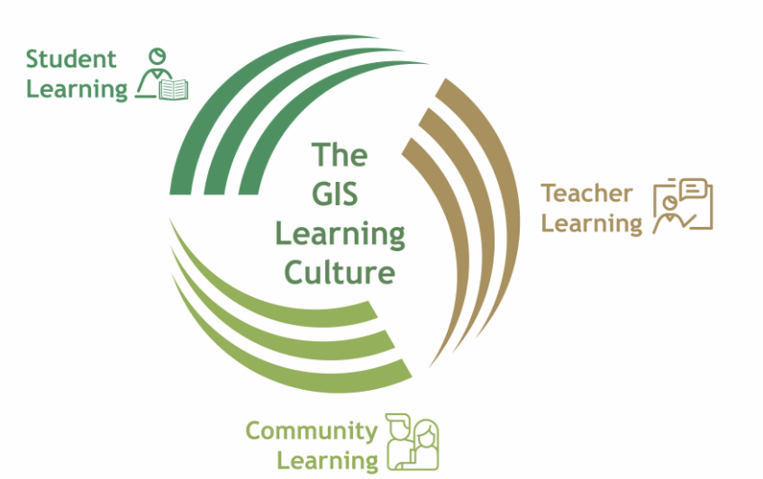
GIS has a unique learning culture. We believe that we can grow and learn together as a community. At GIS we aim to constantly develop each learner’s full potential by providing a world class learning environment. We achieve this through impactful learning for our students, nurturing strong partnership with families and the wider community, and investing in the continuous professional development of our world class teachers through our extensive professional learning programme.
At GIS, we aim constantly to develop each child’s potential. To achieve this, we invest heavily in all our staff so they feel valued and are provided with professional learning opportunities that will enable them to grow and develop professionally. We believe that ongoing professional learning is the basis for continued improvement in the quality of learning at GIS and is a central feature of our learning culture.

Staff are provided with opportunities to further their professional careers through a wide range of professional learning opportunities both within the school and across the region through links with a variety of leading organisations, such as FOBISIA (Federation of British International Schools in Asia) and EARCOS (East Asia Regional Conference of Schools). Postgraduate study is encouraged and opportunities for leadership development are strongly supported.

In 2015 we increased the internal professional learning opportunities with the introduction of the Professional Learning Time programme. This initiative provides 2 hours per week of dedicated professional learning time to all academic staff. With 75 hours of internally dedicated professional learning time consisting of bespoke internal courses, personal learning time, external courses and resources, and extensive PD libraries, GIS is known internationally for its exceptional development for staff and offers support to other schools seeking to replicate this provision.

We are a Teacher Development Trust (TDT) school, and have a silver award currently on the strength of our provision for staff across both the academic and administrative teams. TDT supports us in ensuring that our professional learning programmes are high quality and they conduct an audit on a biannual basis to support the development of our programme. The continual review and evaluation of professional learning opportunities ensures that all staff feel valued and are developing to be their best in a strong, vibrant professional learning culture.
1.9 LEARNING AT GIS
At GIS, we believe that effective learning is where the learner is engaged and motivated to explore and investigate, develop knowledge, skills and understanding and can apply these with a sense of purpose, progress and achievement in different contexts.
We are guided by our GIS Learning Statements:
Effective learning will take place when:
- Learners contribute to a learning-centred environment, which supports everyone in feeling safe, supported and valued and promotes positive wellbeing for self and others.
- Learners understand what, how and why they are learning.
- Learners develop knowledge, skills and understanding in order to apply and transfer them in different situations and contexts.
- Learners engage in learning experiences that inspire, motivate and challenge them to achieve.
- Learners know how well they are doing and how to improve and can use this information to make progress.
- Learners develop key competencies and skills that facilitate character development to become lifelong learners.

We have two core intended outcomes for learners:
- The long-term retention of essential knowledge, skills and understanding.
- The ability to transfer what has been retained into different contexts and situations.

1.10 GIS LEARNER SKILLS
The GIS Learner Skills are a set of skills, qualities and competencies that we want to see in all of our students.
GIS students consistently achieve some of the best examination results in the world. While we take great pride in this, we believe that a complete education extends beyond numbers. We strive to nurture well-rounded individuals who leave our school with skills, competencies and qualities that will allow them to succeed in the world as young adults and beyond. We call these our Learner Skills.
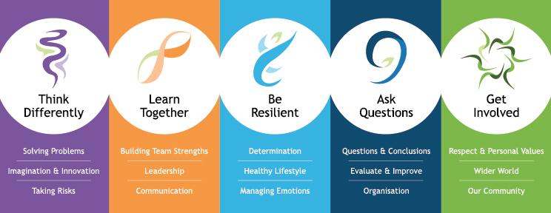 | GIS students learn to think creatively and solve problems. They are encouraged to use their imaginations, and to analyse and take risks in the name of learning.
 | GIS students learn to work as a team, as well as effective and persuasive communication. They are developed as leaders, who are able to positively influence the people around them.
 | Mastery of body, mind and soul is essential in the development of a well-rounded learner. As well as leading active, healthy lifestyles, GIS students learn determination and control over their emotions.
 | GIS students are not mere absorbers. They question what they are taught and conduct their own research, analysing varying sources to come up with their own conclusions. GIS students learn to evaluate themselves and find ways to improve, as well as organisational skills crucial for a balanced lifestyle.
 | GIS students care about learning, but they also care for the people around them. They learn respect and adhere to personal values, with a desire to make constructive changes. They are committed to their community and the world, gradually working towards acquiring the capabilities to make a positive impact.
1.11 AN INTERNATIONALLY MINDED CURRICULUM
At Garden International School we believe that the curriculum encompasses the total learning experiences of the students, both inside and outside of the classroom. We refer here to the ‘taught curriculum’ that occurs within the classroom. This curriculum is designed to bring out the best in international students and to provide a high quality and broad education which enables students to move to any other country fully equipped to succeed.
Across the school our courses are designed to enable students to acquire important subject knowledge, understanding and skills and also to develop their GIS Learner Skills as they strive to become effective Global Citizens.
The Primary School bases its standards on the English National Curriculum, and uses a topic approach that reflects and engages our international school culture.

The Secondary School curriculum follows the English National Curriculum (including IGCSEs and A-Levels), modified to include a strong international flavour.

Bahasa Malaysia (the national language) and Islamic studies are provided for Malaysian and Muslim children respectively.

Our whole school curriculum is planned with a UbD (backwards design) approach and mapped to ensure a consistent and coherent curriculum from EYC through to 6th Form with students leaving the school with ambitious transfer goals and prepared for the next stage of their lives, not just exam results.

The ‘wider curriculum’ refers to opportunities for learning outside of the classroom including the co-curricular activities (CCA) programme, the camps and trips programme, Sports and Arts.
1.12 DIGITAL LEARNING
GIS places a high value in the effective use of technology to enhance learning both within and beyond the classroom. Our 1:1 BYOD iPad program starts for students at Year 3 up until Year 9. Older students can choose to bring a MacBook to school or continue with an iPad. Our early years classes have a range of Apple devices available to them. At GIS, we have a world class infrastructure and digital ecosystem to support the learning. We use the Google Apps for Education suite of tools as well as a wide variety of third party apps and add-ons. In 2016, we were recognised by Apple for excellence in innovation leadership and learning and received Apple Distinguished School Status, one of the few schools in the region to receive this award. We have remained an ADS school since then and were successfully reaccredited in 2022.
Continual professional development is in place to support teachers to transform the learning experiences for students using the technology available. Digital Learning Leads are in place in both primary and secondary school and work across the whole school to support innovation and the effective use of technology.

Through the use of devices and applications, we are seeking new frontiers beyond traditional paradigms of education, to enrich and develop a high-quality learning environment for all members of our community. This learning is captured at our Digital Learning Page.

1.13 ACADEMIC RESULTS, VALUE ADDED & UNIVERSITIES ATTENDED
Academic results throughout the school have been excellent for many years as illustrated in the tables below. Our results are particularly impressive, given the large size of our student cohorts and the inclusive nature of our school. We accept students from a wide range of abilities and academic backgrounds, and yet consistently achieve some of the finest academic results in the world.

At Garden International, we use Standardised, Summative and Formative Assessment approaches to build part of the picture of learning and is a process by which assessment information is used by teachers to understand and personalise the support for every child in their care. We triangulate Aptitude, Attitudinal and Attainment data to help reduce the risk of the individual child falling through the nets of anonymity and becoming the very ‘disappointed, disaffected and disappeared'. Our data triangulation enables Garden to personalise our support and intervention to ensure that we help students to not only reach but go beyond what they perceive their potential to be.

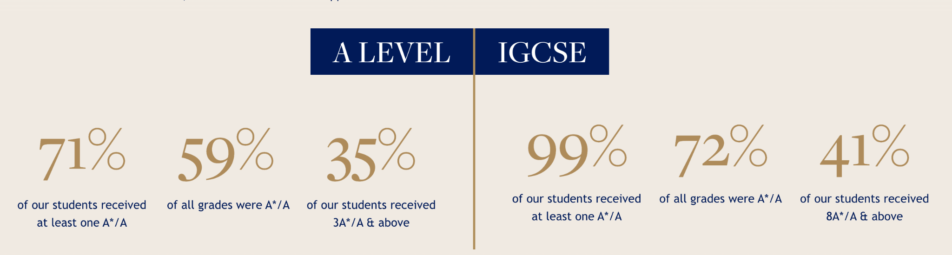
IGCSE and A-Level results for the year 2024 are shown below.

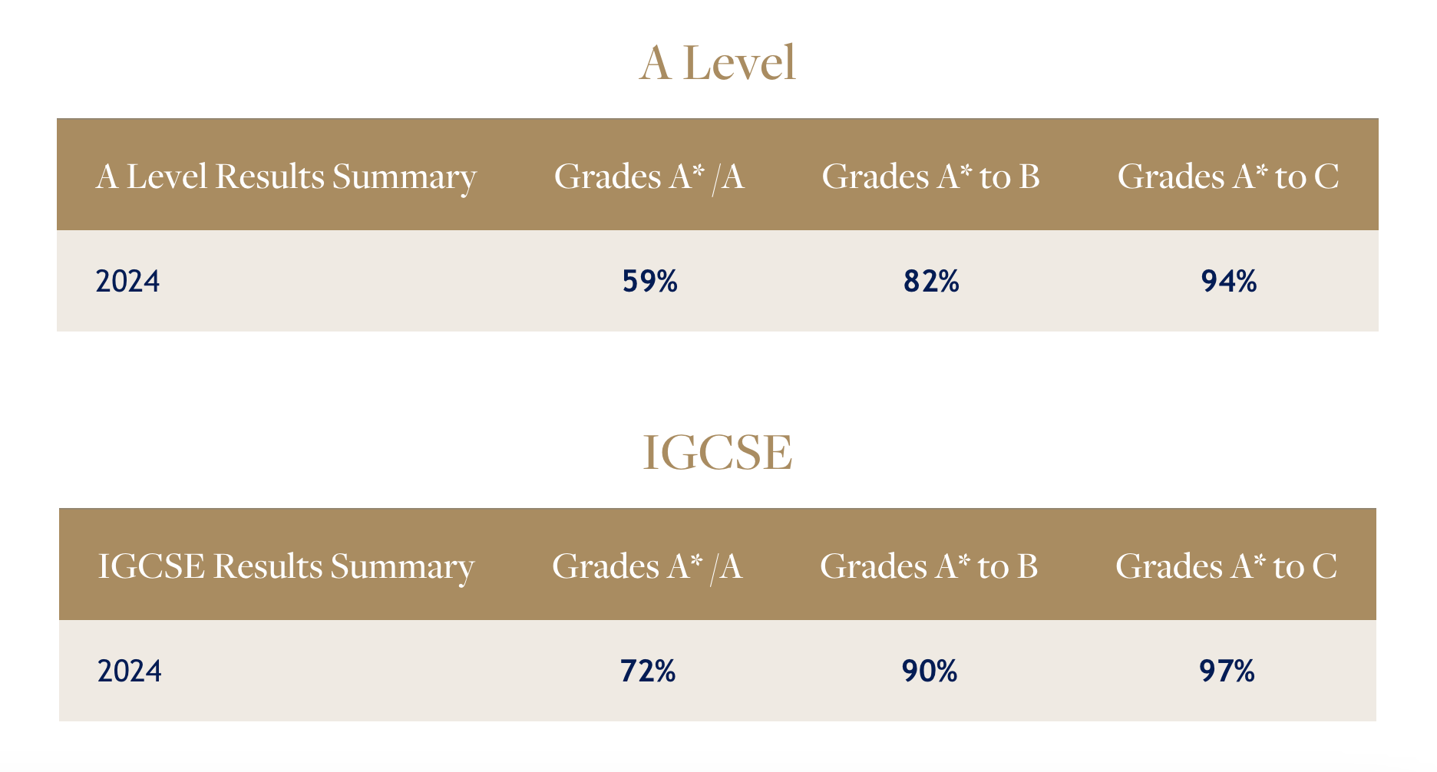
Further details can be accessed via our website.

VALUE ADDED
We are incredibly proud that the Value-Added (VA) result for our 2024 GIS Graduates continues the positive trend at GIS, with our A Level students achieving +0.41 grade higher on average than forecast, and our IGCSE students achieving on average an incredible +1.5 higher on average than forecast. This means that, on average, in addition to a student’s aptitude for learning, the GIS experience improved each student’s outcome by between +0.41 and +1.5 of a grade. This is a true testament to the quality of our personalised approach to teaching and learning and the dedication of our teachers and students.
UNIVERSITIES ATTENDED
Our students go on to study a wide range of different courses across the world, including notable Universities such as Oxford, Cambridge, Stanford, Harvard, and Imperial. Courses range from Neuroscience, Medicine and Veterinary Science, Law and Economics, Computer Science and Engineering to Musical Theatre and Fine Art.
1.14 ENGLISH AS AN ADDITIONAL LANGUAGE
The school provides extensive support for students whose first language is not English. The school believes in providing for students with EAL needs within the mainstream classroom and a full team of EAL specialists teachers and Teaching Assistants work alongside classroom teachers to provide quality learning experiences for these students and enable them to access the curriculum.
1.15 LEARNING SUPPORT
GIS has a Learning Support Department providing specific ‘in-class’ and withdrawn support for students who have special learning requirements. They also work with teachers and support teachers to develop strategies to support a range of strategies in the classroom. The school caters for students with a range of learning needs.
1.16 CO-CURRICULAR ACTIVITIES
GIS offers an exceptional programme of Co-Curricular Activities (CCA). One of the largest programmes offered by an international school in Malaysia, the CCA schedule includes over 150 different activities and clubs across eight key areas: Arts, Sports, Language and Culture, STEAM, Service and Sustainability, Enterprise and Entrepreneurship, Clubs and Societies, and Mindfulness and Wellness. Activities run after school, with some sport before school.

In addition to our CCA programme we offer a lot of personalised support outside of the classroom. For older students, we are able to offer specialist programmes such as MedSoc which provides students valuable insights into medically related professions in preparation for the competitive university application process. We also offer significant Oxbridge support, and support for applications to the Ivy League Universities.

LIVING IN MALAYSIA

2.1 MALAYSIA, TRULY ASIA
You have probably seen or heard this slogan and to be honest even though being in the school is a little like being on an island, once you go out of the school gates those words really do have meaning.

For those who like to travel, Kuala Lumpur acts as a gateway to destinations all over South East Asia and beyond. Being a base for Air Asia (modelled on Europe’s Ryanair), fares to many cities in the region are relatively inexpensive. Good deals can also be obtained for those interested in travelling with full service airlines within Malaysia and further afield. And for travel within Kuala Lumpur, Malaysia has a comprehensive network of monorail, light rail transit and commuter trains that provide convenient and quick access to various parts of the city and its surrounding.

For those who like watersports Malaysia is an excellent location. Many staff first learn to dive whilst working at GIS and some come to Malaysia because they wish to take advantage of the opportunities of the crystal clear water off Malaysia’s coast allowing for some spectacular diving opportunities. Some of the islands around Malaysia provide excellent diving locations, but there are also attractions for those who require more sedentary activities: Langkawi is known for its duty free status and Penang for its hawker food. Just three hours away from Kuala Lumpur on the East Coast is the small town of Kuantan where swimming in the South China Sea can feel as though you are in a warm bath. You can even climb a mountain or view orang-utans in Borneo. It is no exaggeration to say that whatever your interests you can indulge them in Malaysia.

Malaysia is not just beaches and holidays. In between other activities there is also eating. Malaysians love their food. It is in the food and restaurants that ‘truly Asia’ comes through. There is an amazing variety of food available, which reflects on the different backgrounds and ethnic groups of the population. These range from the local stalls where a meal can be had for just a few Ringgit to restaurants catering for Western and Asian food. Whatever you want to eat it is usually possible to find in KL - and for those coming from the UK the price of meals out is considerably less than you will be used to paying back home. A word of caution, however, the cost of wine can be relatively expensive if you want good quality.

Living in KL is a very pleasant experience. New staff are often amazed at how inexpensive supplies and services are especially when compared to Europe – though there are times when it is necessary to remember that Malaysia is a middle-income country. Despite this, it is still no more difficult to get broadband internet connections installed than in the UK. You can easily subscribe to Netflix, Disney Hotstar, Prime or HBO Go for TV or streaming services.

Malaysia is truly a shopper's paradise with prices for electrical and photographic items being very good. There are shops everywhere and opening hours tend to be 10 to 10 for seven days a week in the main shopping centres which contain a good mix of local and international brands (such as IKEA, Jaya Grocer, Marks and Spencer, Harvey Norman). Supermarkets have an abundant range of goods ranging from fine Australian Cheeses to local fruits and vegetables. Even Marmite for the British and Vegemite for the Australians is easy to find. The more adventurous might look in the local markets where more exotic fruits and vegetables can be found at very reasonable prices.

Like any big city with a significant expatriate population there are many clubs and organisations, which bring locals and expats together. For those who like sport there are opportunities to indulge in almost any activity from golf to soccer to cricket and rugby.

So whereas teaching at GIS brings you the World, living in KL brings you Asia. Malaysia, truly Asia.

2.2 GEOGRAPHY & CLIMATE
Malaysia consists of two regions, which are separated by the South China Sea: Peninsular Malaysia and East Malaysia (Sabah and Sarawak on the island of Borneo). The former is divided into 11 states and 2 federal territories.

The climate in Malaysia is pleasant all year round (29⁰C – 34⁰C) although there is a relatively high level of humidity. There is little difference in temperature throughout the year and there are no distinct seasons except for the wet season, which runs from October to January. Lightweight clothing is adequate throughout day and night unless you visit the surrounding hill resorts where it is cooler. A four-hour drive south will take you to Singapore and a four-hour drive north will take you to Penang. Most buildings, including all rooms in the school, are air-conditioned.

2.3 COST OF LIVING & SETTING UP COSTS
According to the Cost of Living Survey from Mercer, Kuala Lumpur is ranked 181 in the list of the most expensive cities in the world. The survey covers 209 cities across six continents and measures the comparative cost of over 200 items in each location, including housing, transport, food, clothing, household goods and entertainment.

Every person who moves from one city to another finds that they part with a lot of money during their first few months. Moving to Kuala Lumpur is no exception. It is strongly advised to bring some private funds and cash to help you through this period. Staff coming from the UK recommend that applicants bring with them between ₤3,000 - ₤6,500 depending on their circumstances, e.g. coming by yourself, spouse or a family etc. Further guidance can be provided during the interview process.

The interest free setting up loan available to new staff - see Contract & Benefits section - is normally used up in paying the respective refundable housing and utility deposits. The bulk of costs incurred during the first few months are in the form of these deposits – the deposit for most types of accommodation is two months’ rental and an additional one month rent paid in advance i.e. the cost of moving in, is equivalent to three months’ rent! The other deposit is a utilities deposit (covering electricity, water and gas) which is paid to your landlord. This varies according to your landlord but can be as high as half month rent.

You can easily get a Malaysia SIM card when you arrive at the airport, prepaid or postpaid – purchase price ranging from RM10 to RM30, which can be topped up when necessary. WhatsApp is one of the most popular messaging apps for communicating with one another. Other startup costs will include purchase of household items and this amount will depend upon the type of accommodation you seek i.e. furnished / unfurnished.

2.4 PRICES & SHOPPING GUIDE
Living in KL is as expensive or as cheap as you want to make it. The selection of Western and Asian foodstuffs and other household items is plentiful. You can buy almost everything here that you can back home. There are lots of supermarkets and outdoor markets from which to buy fresh produce. Fruit is abundant all year round and is relatively cheap. Local food is very reasonably priced and one of the pleasures of being in Malaysia is to frequent the enormous number of restaurants and food stalls. Alcohol is relatively expensive, i.e. beer RM10.00 per can, wine RM55.00+ per bottle.

Chicken, pork, fish, fresh fruit and vegetables are readily available and relatively inexpensive at the wet markets and other local stores. Supermarkets, such as Lotus (formerly TESCO), Jaya Grocer, Village Grocer, Ben’s Grocer and Marks & Spencer, are also available - see https://www.lotuss.com.my/en for further price comparisons. Imported goods are available at the supermarkets but are more expensive. Local food is plentiful and much cheaper than Western food as the latter incurs import tax. The above prices would vary depending on the brand of product and can be found very cheaply in ‘local’ areas. Malaysians eat out much more than in the United Kingdom, and there is a huge variety of restaurants and the cost of eating out is very cheap compared to the United Kingdom.

A more detailed list comparing the price of goods in Malaysia with other international cities can be found via this LINK. The data is based on 3186 entries from 458 different contributors in the past 18 months and provides a good snapshot of costs.
2.5 ACCOMMODATION
Staff receive an accommodation allowance as part of the remuneration. This allowance is paid as part of the salary and is taxable. Upon arrival in Malaysia, the school will provide hotel accommodation up to 14 nights for newly appointed staff. We also provide support and guidance in finding suitable accommodation.
2.6 BANKING
Salaries are automatically paid into each teacher’s bank account at the end of every month, (usually on the 28th day of the month). The School will assist newly appointed teachers to open an account with a local branch of HSBC as soon as they arrive in Malaysia. Other bank options are available should staff prefer.

2.7 TRANSPORT AND DRIVING IN MALAYSIA
Most foreign driving licence holders must convert their domestic driving licence to a Malaysian one when here if they want to drive in Malaysia over an extended period of time. Some nationalities can continue to drive with their home licence if they also have an International Driving Permit. Alternatively, you are able to apply for a Malaysian driving licence via authorised driving schools once you are here. This includes 6 hours of theory classes and 15 hours of practical driving lessons. The estimated cost of getting a Malaysia driving licence for an automatic car is RM2,000.

There is a good interconnecting system of rail, light rail and monorail services around the city and a newly constructed express train runs from Central Station to KL International Airport. Main trains travel South to Singapore and North to Ipoh, Penang and Thailand. Bus travel within the city is a little erratic, but long distance bus services provide good and incredibly cheap connections to other parts of Malaysia and Singapore.

2.8 SAFETY AND SECURITY
Malaysia is one of the safest and most secure countries within the South-East. Asia. In addition, the School has a very well developed security and crisis management plan. Close liaison with Malaysian, British, Australian and United States security advisors is maintained at all times. The School also employs an independent security company to carry out regular security audits. A team of full time security guards is employed by the school and a range of security precautions, including an extensive CCTV system, are in place. It is compulsory for staff to wear identity badges whilst on the school campus, which are supplied on arrival.

Malaysia is relatively crime free, but as in all major cities one has to be aware of petty street crime.
2.9 INTERNET ACCESS & COMPUTERS
All staff are provided with a Macbook for loan whilst employed at the school. Staff have a school email account. Malaysia is technically advanced in the field of IT and computers, laptops and peripherals are readily available at excellent prices. Students from year 3 upwards will also bring their own ipad or laptop to use during lessons.

2.10 DRESS CODE
It is always summer in Malaysia! It can however be chilly in the School’s air-conditioning. With Malaysia being a predominantly Islamic community, a sensible degree of modesty in dress is expected (example: shoulders should be covered). Most female teachers wear lighter versions of the smart business wear that you would wear in a temperate climate. Male teachers are expected to wear long trousers and a business shirt. Around KLCC just about anything goes but one should always be aware of cultural sensitivity. Outside of KL, be aware of local customs and dress more modestly.

- CONTRACTS AND BENEFITS
3.1 WHAT HAPPENS ONCE YOU ARE APPOINTED
We are aware that the transition from one job to another and one country to another can be a very stressful event. At GIS we try very hard to keep you fully informed and to support you through the transition period and beyond. Our extensive Induction Programme begins before your arrival in Malaysia and continues throughout your first year at GIS.

Soon after a new teacher is appointed, a People & Culture Department personnel will contact him or her for all the details required to process their Employment Pass. It is crucial that you provide all required documents in a timely manner to ensure employment pass is approved before you enter Malaysia.

You will also be contacted by the Director of Professional Learning and provided with an email buddy. A GIS Induction site provides you with a range of information about the school and moving to Malaysia. We also utilise other online platforms to provide you with opportunities to connect with other newly appointed teachers before you arrive in Malaysia if you choose.
Various members of the academic staff will make contact, giving their e-mail addresses and will be able to answer any specific questions. We will provide you with access to our staff intranet so that you can access the information you need to prepare to teach.

A flight will be booked from the nearest home airport to Kuala Lumpur. The departure dates will be given as soon as possible (teachers are given options of dates for arrival). Teachers’ contracts commence in early-mid August (exact date to be advised) and new staff will be required to travel to Malaysia in late July/early August for our Professional Induction Programme and to allow enough time for the processing of Employment Passes. Air tickets will be sent via e-mail approximately two or three weeks before departure. There will probably be several teachers on the same flight and this provides an opportunity to get to know others before arrival in KL.

Newly arrived teachers will be met at the airport and taken to hotel accommodation, which the school provides for the first two weeks in Malaysia.
All new staff participate in our Professional Induction Programme. The GIS Professional Induction Programme has been highly praised by new staff and has been improved on each year following feedback from participants. The Principal, Heads of School, Whole School Directors, members of the People & Culture Department (Human Resources), and other leaders are all involved in the induction programme.

The two-week induction period (exact dates to be advised) includes an introduction to the school, an introduction to Malaysia, introduction to housing agents, advice on finding accommodation and the opening of bank accounts. A crèche is provided for accompanying children during the induction period.
3.2 CRIMINAL RECORD CHECK/ICPC
Garden International School is committed to safeguarding and promoting the welfare of children and young people and expects all staff and volunteers to share this commitment. As such, all offers of employment are subject to a criminal record check (ICPC or equivalent).
3.3 BAGGAGE ALLOWANCE
The baggage allowance is designed to cover both personal items and any personal teaching resources. It is strongly advised that the services of a reputable door-to-door international freight company are used to avoid numerous hassles and agent costs when unaccompanied baggage arrives in Malaysia. Electrical goods are meant to be declared and are subject to a special duty – a good freight agent will get personal goods into Malaysia without difficulty. When entering the country, it is not advisable to bring plant matter. Drugs are absolutely out of the question – the offence carries a mandatory death penalty.
3.4 IMMIGRATION
Employment Passes (EP) and Dependent Passes (DP) are endorsed in the respective passports upon arrival at the airport in the country. There is no standard fast track system to have a passport endorsed beforehand. The People & Culture department will email the related documents - Visa Approval Letter, Visa Endorsement Approval Letter and Successful Visa Payment Notification Letter before your departure to Malaysia. You must produce these hardcopy documents at the Immigration Counter in the Malaysia airport upon your arrival. You will be updated accordingly about any changes to our Immigration requirements before your arrival to Malaysia.

Passports must be valid for at least 2.5 years before arriving in Malaysia and have at least six (6) empty pages for visa endorsement. All dependents must be travelling on their own passport.

3.5 SALARY AND CONTRACTS
Teachers are offered two-year contracts and paid monthly (end of the month) in Malaysian Ringgit. New members of staff are placed on a salary scale according to their qualifications and experience. All teachers (local and overseas recruited) are paid a basic salary (in Ringgit) according to qualifications and years of post PGCE/B Ed experience. Income tax is deducted at source. Funds are easily transferable in and out of Malaysia.

In real terms, our UK teachers, as long as they do not have to remit significant sums of money back to the UK on a regular basis, are better off here in many ways. If you spend locally and travel within Asia, you will do very well on the salary and benefit package we are offering.

Garden International School recognises a maximum of 6 years full time teaching experience on joining the school. An annual increment is paid at the beginning of the new academic year with the School for staff joining below Step 6. A system of threshold payments will be introduced for staff joining at Step 6.

Responsibility Allowances are paid monthly depending on the level of responsibility.
3.6 SUPERANNUATION
Staff automatically participate in the Malaysian Government’s Employees Provident Fund (EPF). Staff contributes a minimum of 11% of gross salary to the fund which is matched by an additional 12% contribution from the School. At the end of employment in Malaysia this money is refunded to the teacher as a lump sum. Each year a very good rate of interest is added to the sum invested in the scheme. It is a very effective way of saving.
3.7 INTEREST FREE SETTING UP LOAN
The school offers new staff an interest free loan. This is primarily used by staff for settling-in expenses. This should be applied for before arrival in KL and it will be transferred to your newly opened local bank account during induction (normally the second week of induction). The loan is repaid at a monthly rate commencing from the first pay date.
3.8 UK NATIONAL INSURANCE
Contributions may be continued in Malaysia. Leaflet NI 38 “Social Security Abroad”, or its current equivalent is a useful document to consult. Some expatriates pay Class Three Contributions to maintain full entitlement to the UK State Pension and certain other rights.

3.9 HEALTH CARE
Health care in Malaysia is as good as, if not better than, that found in the UK or Australia. Malaysia has become a centre for Health and Medical Tourism. There are excellent specialist clinics and hospitals in KL. Health care is also much cheaper than in the UK or Australia. A trip to a general practitioner for a common cold costs about RM50 to RM100 (including medicine) or a little more expensive if antibiotic drugs are prescribed.

Teachers are covered under the Group International Medical Insurance Scheme (Scholars), and will be covered to an annual maximum of MYR500,000 in Malaysia with emergency coverage outside of Malaysia. The medical insurance also covers the dependents of staff. Staff have the option to upgrade their medical coverage, the difference in premium costs to be borne by the member of staff.

All staff are strongly advised to have Hepatitis A & B injections before coming to Malaysia. Precautions against Malaria are not necessary unless a lot of jungle trekking is on the agenda. Most pharmaceutical items are available and optical supplies are plentiful.

The Malaysian Ministry of Education requires all applicants to obtain a letter from their GP to say that he or she is fit for teaching. The cost of this is borne by the school up to a maximum of £50 if the candidate is offered a position. A full medical examination is not necessary.

3.10 MARITAL STATUS
Marital status must be declared at the interview. It is relatively easy for the non-working spouse to obtain a dependent's pass.
3.11 INCOME TAX & MALAYSIA INCOME TAX
Salaries are taxed at source in Malaysia. The tax rate is on a graduated scale and is generally lower than in the UK and Australia, with a maximum rate of about 30%. The School’s People & Culture Department will organise all tax payments and will provide more detailed advice on tax issues as part of the induction programme.

Staff leaving employment in the UK until July and joining GIS in August are eligible for a tax rebate from the UK Inland Revenue (January to July). The following is our understanding of the tax situation with regard to British expatriates living in Malaysia. Please note however, that we cannot be held liable if the following interpretation is proven to be inaccurate.

Before coming to Malaysia, staff should obtain the status of being non-resident for taxation purposes. Local UK tax offices will be able to provide assistance with this. With this established there will be no tax liability on earnings derived outside of the UK provided the teacher remains resident outside of the UK for at least one complete tax year, there are certain limits on the number of days that can be spent in the UK each year in order to retain the non-resident status. Many high street banks can give you advice on this issue. A similar situation exists for Australian teachers.

For income tax purposes, there are only 2 types of status, namely ‘resident’ or ‘non-resident’. The distinction between these 2 types of residence status is imperative because if a person is a resident, any income received in or remitted to Malaysia is taxable at scale rates (which is dependant on your income), whereas a non-resident is liable to Malaysian income tax only on income received from a Malaysia source at a flat rate of 30% (effective year of assessment 2025).

An individual is considered as a resident in Malaysia for the basis year for a particular year of assessment if he is in Malaysia in that basis year for a period or periods amounting in all to 182 days or more.

To qualify as tax resident for income earned in 2025, staff who join GIS in August 2025:

- MUST BE in Malaysia on 31 December 2025 and 1 January 2026 (2 days);
- DO NOT TRAVEL out of Malaysia for more than 14 days for social visits between 1 January 2026 to 1 July 2026.

Staff are allowed to travel domestically from 1 January 2026 until the People & Culture department submits your tax refund application, which will be in early July 2026.

As required by the Inland Revenue Board of Malaysia, the monthly deduction applicable to an employee who is not resident or not known to be resident in Malaysia shall be at a rate of 30% of his remuneration. Therefore, for the months of August 2025 to February 2026, you will be taxed at 30%. However, once you qualify as a tax resident for the year 2025 in July 2026, the School will assist you in applying for your tax refund. This will be explained in further detail during induction.

By March 2026, monthly tax deduction will follow the Scheduled Monthly Deduction from the Inland Revenue Board, Malaysia.

Housing allowances are taxed.
Flights are also taxed as a benefit in kind, however tax relief is offered up to RM 3,000 for each member of staff on flights per annum (only applicable upon receiving flight equivalent in 2026, if contract remains with GIS).

