KING HENRY VIII COLLEGE

Job Description & Information

KH8 Primary

Key Stage 1/Key Stage 2

Class Teacher

Appointment for January 2020

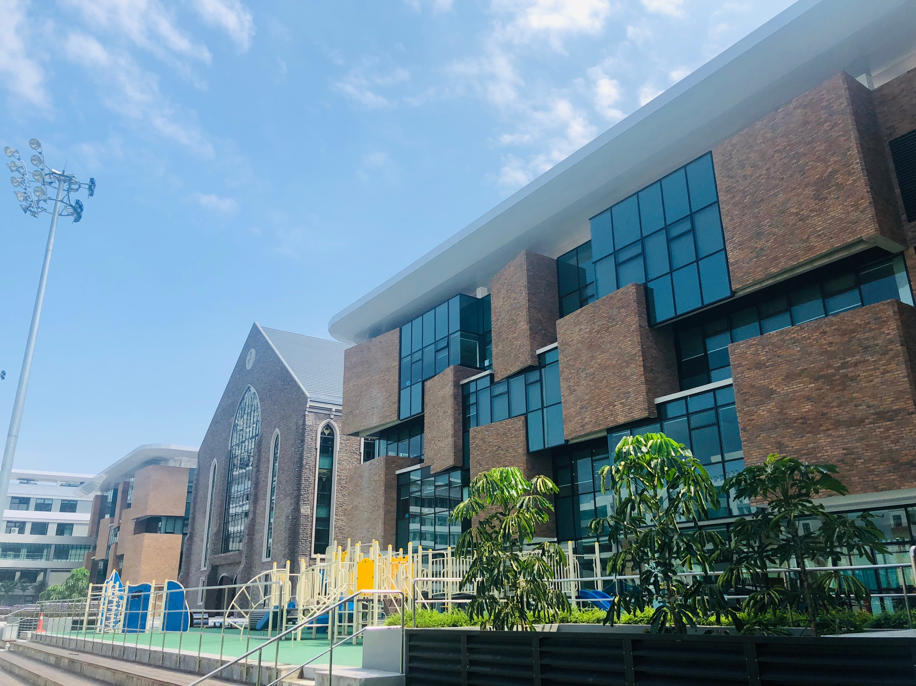

Dear Applicant,

Thank you for your interest in joining the team at King Henry VIII College Malaysia.

King Henry VIII College is a new school, and is a close collaboration between Christ College Brecon, one of the UK’s most ancient schools, and DBH Holdings Sdn Bhd of Malaysia. King Henry VIII College is a fully-fledged sister school to Christ College, and our aim is to replicate its structure, ethos, and achievements.

Christ College is an historic co-educational independent day and boarding school set in the Brecon Beacons National Park - one of the most beautiful areas of the United Kingdom.
King Henry VIII College has a rather more modern, urban setting in the global tech hub that is Cyberjaya - a rapidly-developing planned township, mid-way between Kuala Lumpur City Centre and KL International Airport.

King Henry VIII College opened in September 2018, and the Primary and Early Years sections of KH8 Primary have already proved very popular, hence the need for further appointments at this level.

Our founding group of teachers is undoubtedly our greatest asset, and the successful applicant for this Class Teacher position will join a lively pioneering team. Each member of that team has a vital role in setting the tone at the school, and ensuring the school establishes itself successfully in Malaysia and South East Asia.

We look forward to receiving your application for this teaching role, which is described here.

Best wishes,

Simon Spencer

Founding Head
KS1/KS2 CLASS TEACHER - PRIMARY SECTION

Job summary:

All class teachers in the Primary section report to the Head of Primary, and are expected to provide imaginative and dedicated teaching for our Primary students, supporting their development and transition to the senior part of the school. We are looking for inspirational teachers who will put the students’ needs first, and identify with the ethos of this new sister school in Malaysia.

Teachers in KH8 Primary will teach in all relevant core areas and will lead and manage educational assistants where appropriate.

Candidate profile

The successful applicants will have appropriate professional qualifications, and a clear understanding of professional expectations.

These include, but are not limited to:

- being a dedicated teacher, supporting all students with their learning
- demonstrating excellent subject knowledge in core subjects
- having a close understanding of the UK National Curriculum
- keeping abreast of teaching and learning developments
- understanding the applications of ICT in classroom teaching
- being prepared to work with students from many nationalities
- having a positive approach to working within school structures
- meeting deadlines set by senior colleagues
- sharing good practice
- setting consistently high expectations for students
- ensuring lessons are thoroughly planned and prepared
- demonstrating an ability to assess and evaluate effectively
- understanding and applying relevant school policies
- becoming fully involved in the life of the school
- taking part in the School’s staff development programme
- contributing to co-curricular activities for Primary students
- keeping up to date with child protection issues
- undertaking any reasonable task as directed by the Head of Primary
- attend INSET training courses and taking responsibility for CPD
- contributing to the marketing and promotion of the school

Safeguarding:

King Henry VIII College Malaysia is committed to the well-being of all the children in our care, and to all acknowledged Safeguarding procedures.

All teachers at the school must have up-to-date Safeguarding training and understand their safeguarding responsibilities.

Checks & paperwork: This post - prior to contract - is subject to:

- An Enhanced Disclosure and Barring Service Check (DBS)
- Formal proof of identity with photo ID (Passport/Driving Licence)
- 2 confidential references (including current Head)
- Verification of original qualifications

Salary: The King Henry VIII College QTS (or equivalent) salary scale applies

Benefits: An excellent package of benefits is on offer, including:

- Two-year renewable contract (extended each year by agreement)
- Fully-furnished accommodation in an apartment near the campus
- Family transfer at the beginning and end of contract
- Annual travel allowance
- Relocation allowance
- International healthcare
- Full EPF contribution
- Generous remission on King Henry VIII College school fees for all children
- Support for professional development

Applications must be submitted on the official King Henry VIII College Application Form.

CV’s should be submitted along with the form

Closing Date for applications: November 1st 2019

We reserve the right to fill posts in advance of the deadline for applications,

if a suitable candidate is found.

