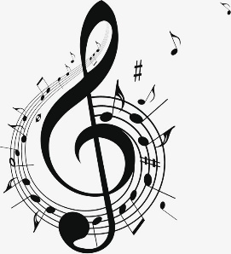
Music Department

Our Community:
The music department at PHS consists of two full time music teachers, one part time music teacher and five peripatetic instrumental teachers who currently teach on the following instruments: Guitar (acoustic, bass and Electric), ukulele, violin, piano, keyboard, flute, sax, clarinet, drums and singing.
The Curriculum:
The curriculum consists of GCSE foundation students having 2 lessons per fortnight concentrating on mainly practical music making lessons on topics that link to GCSE music. These include The Blues, Film Music, Ukulele skills, keyboard skills and instruments of the orchestra. GCSE music is a 3-year GCSE course and we run one class in each year. We also teach Music A Level.
Resources and Facilities Available:
The music department has great facilities for students to use during class time, break, lunch and after school. This consists of two fully equipped teaching rooms with keyboards. Five practice rooms, a fully equipped recording studio, practice hall and a mini computer suite (15 computers) running the music software Cubase 10 and sore writing programme Sibelius.
Results and Achievements:
Results are good in the music department with GCSE music results being above the national average and students gaining particularly high marks with performance. A number of students take instrumental exams with ABRSM, Rock School and Lambda and are highly successful with these.
Team Activities, Teamwork and Planning:
The music department has a variety extracurricular activities run by the music staff and peripatetic teachers. They include jazz band, Orchestra, wind group, guitar club, ukulele club, theory club, junior and senior choirs and steel Pans.
Other exciting things that happen:
Throughout the year, there are opportunities for our students to perform to an audience. The school Christmas concert features a variety of performances from year 7 to 13. In the summer, younger students are invited to take part in the summer concert showing their instrumental skills learnt through the year. Students also have the chance to take part in the school production whether as part of the cast or the band.

