
  - Candidate information Pack

  - Closing date FOR APPLICATIONS:
  - Midnight Tuesday 15th July 2025

Early applications are encouraged, and the school reserves the right to close the application process early should a suitable candidate be found.

STUDENT VISA CO-Ordinator
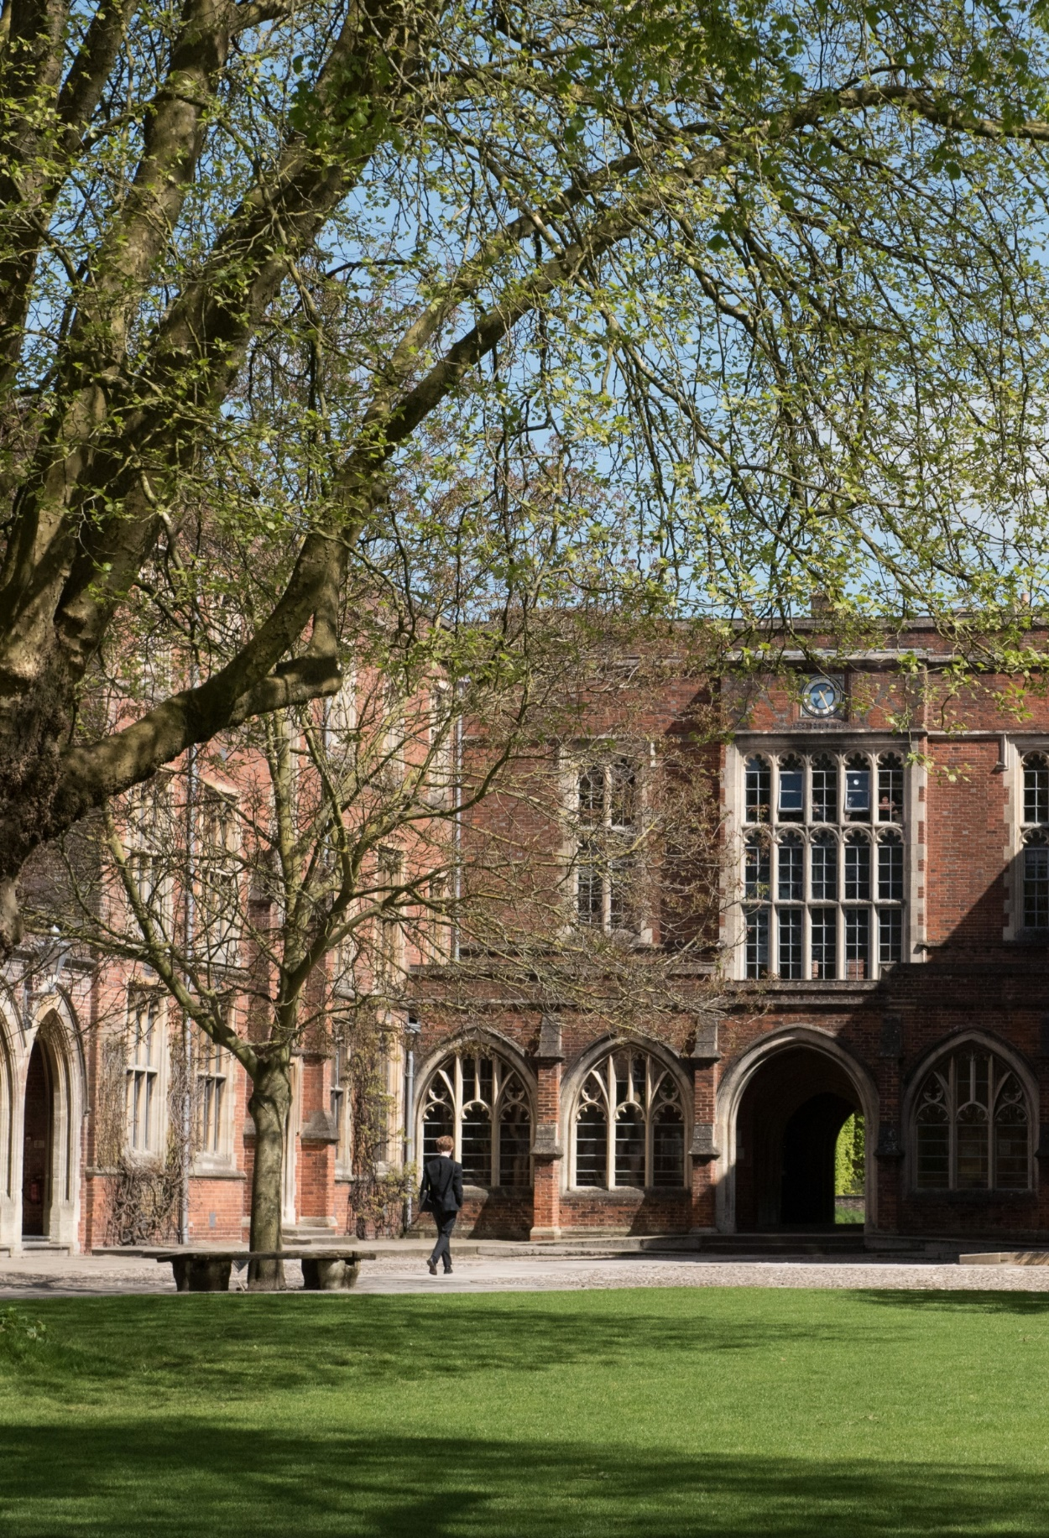


PART I: ABOUT THE ROLE

The Visa Coordinator is responsible for all aspects of child student visa compliance and administration, including creation of Confirmation of Acceptance for Study (CAS) documents.
The Visa Coordinator is part of the admissions team at Winchester College and reports to the Director of Admissions, who sets the overall strategy for the department and leads the Admissions team.
Winchester places a premium on quality of relationships and this begins with the Admissions experience.



PART II: RESPONSIBLITIES OF HEAD OF CAREERS

Key Responsibilities
The key responsibilities of the Visa Coordinator are to:
- Act as a UK Visas and Immigration (UKVI) Authority Level 1 User
- Ensure that the school meets all obligations regarding sponsorship status
- Assist with sponsorship activities such as licence renewal and on-site audits
- Keep informed of all immigration and visa legislation and guidelines relevant to students
- Maintain the school’s visa database regarding inspection by UKVI, expiring visas and passports, withdrawals from study, visa refusal and child student visa reporting, ensuring that record keeping, and reporting requirements are maintained
- Check immigration status of all new students including those holding indefinite leave to remain status and settlement status
- Communicate with families regarding visa applications to ensure that all documentation is completed accurately and received in a timely manner, providing guidance
- Ensure all student documents are correct before the creation of a CAS
- Process CAS through the UK Visas and Immigration (UKVI) website to facilitate the acceptance of the student
- Facilitate, where required, an enhanced Disclosure and Barring Service (DBS) check for Family Guardians and evidence of AEGIS membership of Family Guardians where required
- Ensure that Family Guardians are aware of their responsibilities including safeguarding responsibilities
- Processing of letter of undertaking regarding the responsibilities of guardians
- Attend training by the Boarding Schools Association and other sector bodies to ensure best practice is always followed and current regulations and guidelines are understood
- Work closely with specialist visa lawyers to oversee the Child Student visa application process.

Additional Responsibilities

- Support the Director of Admissions and Registrars in booking visits to schools
- To assist with Admissions administration and any duties relating to the efficient running of the Admissions Office.
- Any other duties that your line manager sees fit, providing that such duties are appropriate to your role.

PART III: PERSON SPECIFICATION AND KEY QUALITIES

Person Specification

- Excellent administrative and organisation skills
- Ability to understand changing legislative requirements
- Excellent interpersonal skills
- A self-starter with the ability to work independently
- Flexibility to meet the demands of the role
- Ability to work with a wide range of stakeholders

Skills and Knowledge
- Previous experience dealing with visa compliance and administration is essential
- Experience of visa compliance and administration in relation to child students is desirable

PART IV: BENEFITS, TERMS AND CONDITIONS
AND APPLICATION
Start date
Flexible start date for the right candidate with preference for commencement at the beginning of the next academic year 1 September 2025.
Hours of Work
This is a full-time role, 37.5 hours per week, and such other hours as are reasonably necessary to meet the needs of the College and the demands of the role.
Salary
£30,000 per annum, commensurate with qualifications and experience. Salary is paid monthly, in arrears, to a nominated back account in 12 equal payments.
Induction and Continuous Training and Development
The school is fully committed to the induction, training and development of all our staff, with staff supported to grow and reach their full potential.
We deliver a range of training, run by both our own staff and external providers, varying from highly practical First Aid courses to seminars and learning lunches on many aspects of teaching and learning.
There is an annual cycle of appraisal offering the opportunity to reflect on professional practice and development opportunities.
The school also offers a wide range of apprenticeships supporting staff development and progression.
Pension and Life Cover
On employment, employees will be auto-enrolled into the College’s pension scheme according to legislative thresholds. Those who are not eligible for auto-enrolment may still elect to join the College’s pension scheme.
Initially, when joining the College’s pension scheme, employees will become a member of the College’s Group Personal Pension Plan (GPP). For this Plan, known as Tier 1, the employee contributes 4% and the employer 3%.
After 9 month’s membership of the Tier 1 plan, employees may opt to join Tier 2, which is also a GPP, where the employee contributes 5% and the employer 9%.
Employees in Tier 1 automatically qualify for a Life Cover of 2 times salary. On entry to Tier 2, Life Cover changes to 4 times salary.

Annual Leave
The College leave year runs from 1 September to 31 August. This position will be entitled to 28 days holiday per year, which includes the usual Public Bank Holidays. Any Public Bank Holiday occurring during term time is deemed to be a normal working day. All leave must be taken by prior arrangement and must be taken outside of the school’s term times.
Subject to the discretion of the school’s Bursar, a gift may also be given of extra time off during the Christmas period.
Wider Benefits
- Free staff lunches during term time
- Free use of some sports facilities and discounted hire charges for others
- Tour of the College, with discounted rates available for booking venues within the school’s grounds for hospitality events.
- Cycle to work scheme
- Access to a rich programme of cultural, musical, theatrical and sporting talks and events
- Employee Referral Scheme, with a reward of up to £250 for staff (subject to scheme conditions)
- Free Library membership with access to a range of online journals and magazines.
- Reduced green fee rates for local golf course

Probation, Notice Periods
The first six months of employment will be a probationary period. Regular reviews with line managers take place over the probationary period with the opportunity to discuss progress, identify any areas for action and ensure that there is appropriate guidance and support in place to enable successful completion of the probationary period.
During the probationary period, the notice required by either party to terminate employment will be one month.
Once employment is confirmed, the notice period will be three months.
Disclosure Check
As Winchester College is an educational establishment, a condition of employment will be that the successful candidate must consent to the school obtaining an Enhanced Level Disclosure Check through the Disclosure and Barring Service (DBS). This will reveal all spent and unspent convictions, warnings, cautions and bind-overs. A policy on the recruitment of ex-offenders is available on the school’s website.

Safeguarding is one of the primary responsibilities of this role. The jobholder is responsible for promoting and safeguarding the welfare of children and young persons for whom they are responsible, or with whom they come into contact with, and will need to adhere to and ensure compliance with the school’s Child Protection and Safeguarding Policy at all times. The postholder should be conversant with the responsibilities and procedures detailed in this policy and with the Department for Education’s Keeping Children Safe in Education. If, in the course of carrying out the duties of the post, the postholder becomes aware of any actual or potential risks to the safety or welfare of children in the school, they must report any concerns to the school’s Designated Safeguarding Lead, or in their absence, the Deputy Designated Safeguarding Leads.
References and Other Pre-employment Checks
The appointment will be dependent upon the receipt of a successful medical check and satisfactory references. The College will usually seek references from shortlisted candidates before interview and may approach previous employers for information to verify particular experience or qualifications. At least one referee must be the current or most recent employer. Where applicants are not currently working with children but have done so in the past, one referee must be the person by whom they were most recently employed when working with children.

HOW TO APPLY
Only applications completed on the school website will be accepted. Please attach a full CV with your application, and email a covering letter to recruitment@wincoll.ac.uk.
Please note that applications will be dealt with as they arrive. Winchester College reserves the right to appoint before the deadline passes.
Closing date for applications: Midnight Tuesday 15th July 2025.
Interviews are expected to be held on the 28th July.
Those wishing for an informal conversation about this role are invited to speak to Ivan Wise, Director of Admissions, isw@wincoll.ac.uk .
If you have any questions about this vacancy or the recruitment process, please email recruitment@wincoll.ac.uk.
APPLY HERE
Diversity and Inclusion
We embrace diversity and inclusion in the workplace and are committed to promoting a fair and supportive environment for all our employees. We are keen to welcome applications from all applicants that feel that they meet the requirements of the role, regardless of their background and culture.
Data Protection
Winchester College collects and processes relevant personal data as part of its everyday operations and is obliged to process it in accordance with the General Data Protection Regulation and Data Act 2018. The school is the Data Controller of this data under the Act and is registered with the Information Commissioner's Office. Its registration number is Z5751669.
If you have any queries or comments about this policy or how personal data is processed by the school, please contact the Bursar and his team by emailing: dataprotection@wincoll.ac.uk or by writing to: Data Protection, The Bursary, Winchester College, College Street, Winchester, SO23 9NA.

PART V: ABOUT WINCHESTER COLLEGE
Winchester College was a pioneering institution when it was founded in 1382 and continues to be a global leader in education today. Renowned for its intellectual excellence and impressive academic record, Winchester is sought after for its combination of superb teaching, outstanding pastoral care, and an exceptional breadth of sports and other activities.
Winchester currently has 735 pupils from Junior Part (Year 9) to Sixth Book (Years 12 and 13). The majority of these pupils are boarders, with around day pupils (boys and girls) in each year in Sixth Book. The first girl boarders will join in 2026.
At all levels Winchester encourages pupils to look beyond the curriculum. We are famous for Div, our unique programme of cultural studies which promotes independence and flexibility of mind and offers an excellent preparation for university study. In these lessons, pupils engage in wide-ranging inquiry across disciplinary lines, from English Literature to Ancient History to the History of Science.
Pupils in the Sixth Form study linear A-level courses and will ordinarily study three A-level subjects and Div, with the option of Extended Project Qualification (EPQ). Linear A-levels are complemented by the flexibility of both Div and the EPQ where pupils are able to explore their cross-curricular research interests more deeply.
Music has been central to life at Winchester ever since its foundation, and the school is unique in having maintained its Choral Foundation to the present day. The Music Department is now one of the leading departments in the country and offers outstanding opportunities to all.
Sport is a major part of Winchester life, supported by the recent opening of a state-of-the-art Sports Centre. There are many fixtures against other schools and excellent facilities allow all pupils to enjoy and participate in a variety of sports and enable the most talented and driven pupils to train and compete at the highest level.
Much energy is also invested in the Combined Cadet Force, the Duke of Edinburgh Award Scheme, Community Service, and in links with local primary and secondary maintained schools. This commitment provides pupils with many opportunities to work for the benefit of others, inside and outside the classroom, developing the knowledge and skills, and the rights and responsibilities, which will enable them to grow into valuable and productive members of society.
Pupils eat all meals in their boarding houses, talking with their Housemaster/mistress, and interacting with friends, visitors and teachers. We believe that conversational ability, developed both inside and outside the community, equips pupils to talk to anyone, about anything, in practically any situation. This unparalleled combination attracts pupils from across the world, making Winchester a truly international and diverse community which celebrates every pupil’s individuality, passions and potential.
Winchester College is committed to maintaining the Founder’s original intention of offering an outstanding education to any pupil who would benefit from it, regardless of their financial circumstances, and many of the pupils in the College are being helped financially through the school with substantial bursaries.
Winchester College is committed to providing a respectful and inclusive workplace and a fair and supportive environment for all. We attract staff with a diverse range of backgrounds, experiences and perspectives, and we work hard to recruit from the widest possible pool of talent, believing that this is for the benefit of our pupils and every member of our community.
Sustainability: You can learn more about our goal of creating a more sustainable school here.


Twitter: @WinColl Winchester College
Instagram: @winchestercollege College Street
Winchester
SO23 9NA

www.winchestercollege.org

