Dear colleague,

I am delighted that you are interested in the post of Teacher of Science with experience of teaching Biology GCSE (full time, maternity cover) at Priestnall School. All appointments are of immense importance to us as a whole school team as they offer the successful candidate the opportunity to contribute to our already very successful school as we aim to improve even further from our current ‘Outstanding’ status.

This role will provide the post holder with the opportunity to join a vibrant and forward thinking staff and to gain excellent professional development as they progress in their career. Applications for this role are invited from both newly qualified as well as more experienced colleagues. Our Science subject area delivers a vibrant and engaging curriculum at both Key Stage 3 and Key Stage 4. This core subject achieves excellent examination results on a consistent basis across a range of qualification pathways including Separate Sciences and Combined Sciences.

If you are interested in applying for this post, please complete the accompanying application form, including the very important ‘supporting evidence’ section: in this final section of the form, you should communicate:

- your own personal values and philosophy of education;
- your experience to date and how it has prepared you for this role.

The closing date for the receipt of applications is noon on Monday 24th September 2018. Completed application forms should be marked for the attention of Mr J Cregg, Headteacher and either posted to the school address or e-mailed to Mrs Fitzpatrick, Headteacher’s PA at recruitment@priestnall.stockport.sch.uk

Interviews are scheduled to take place in the week commencing Monday 1st October 2018.

I look forward to reading your application and wish you every success.

Yours sincerely,
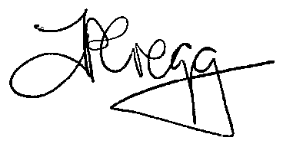

John Cregg
Headteacher

