


ICT Engineer

CANDIDATE INFORMATION PACK

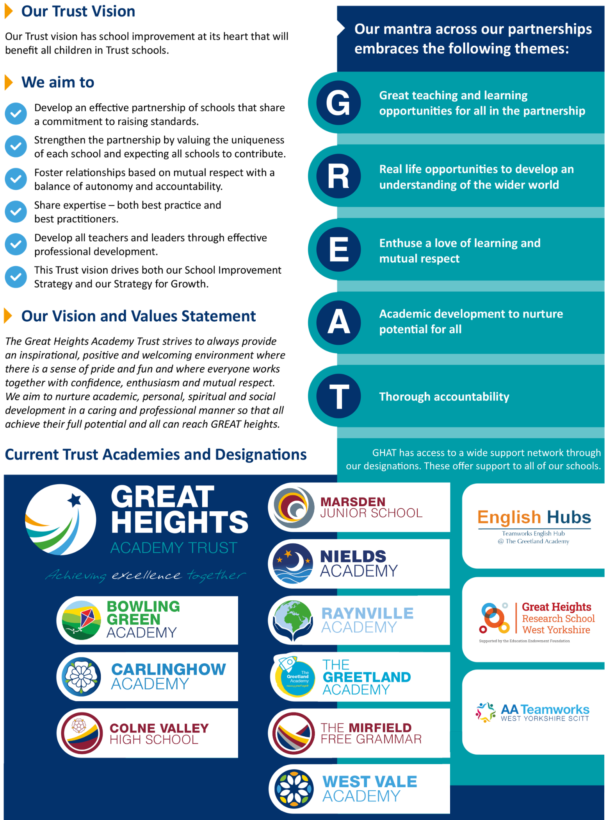

JOB DESCRIPTION

Position: ICT Engineer

Pay range: Scale 4, Scale Points 7 – 11

Hours of work: 37 hours per week, all year round

Responsible to: IT Infrastructure Manager / Deputy IT Manager

Prime Objectives of the Post
- To assist in the support, management and development of the IT infrastructure within the academies.
- Contribute to the Continual Service Improvement of IT Support Services.
- To provide day-to-day maintenance and support in the use of computer facilities within the academies, to support staff, students and the curriculum.

Statutory Requirements
- It is aligned to the Local Government Terms and Conditions, set out in the statutory guidance.

Membership of the Trust
- To be an ambassador for the developing MAT, ensuring both internal and external colleagues are aware of the vision, culture, and ethos within the trust.
- To contribute to the delivery of the MAT school improvement offer and subsequent gains of being in Great Heights Academy Trust.
- To ensure all trust systems, processes and procedures are adhered to as requested from the Trust post holders.

Main Duties and Responsibilities

Support, Administration and Service Improvement
  - Undertake repairs, replacement of IT and multi-media equipment, including liaison with external suppliers.
  - Assist all staff & students in all Trust academies and designations both remotely and offsite.
  - Provide proactive and timely IT support.
  - Assist in receiving and checking deliveries and associated invoices to allow for payment by the Academies’ Finance Teams.
  - Assist in maintaining records and systems used by the Academies to ensure relevant and accurate information is kept. Including, but not limited to, asset registers, stock control and software licensing systems.
  - Provide support and guidance to facilitate effective use of IT.
  - Manage and support managed print services and the print software.
  - Attendance at appropriate meetings which require input relating to aspects of IT support, services, projects and security.
  - Escalate IT issues to the Senior IT team the relevant person where necessary, in a timely manner to minimise downtime or disruption.
  - Provide support on the creation of digital content for the Academies website, digital signage and any other systems as required.
Server Support & Maintenance
  - Assist with the daily running of the Academies’ servers and Active Directory services.
  - Assist the carrying out of maintenance to Academies’ servers.
  - Assist in ensuring backup systems are fully functional and data integrity is maintained, carrying out data restores as required.
  - Providing support and guidance on the secure and efficient use of data storage.
  - To assist in the development and commissioning of new servers and server applications.
  - To support the use of Academy applications including but not limited to MIS and Finance software.

Network Installation, Management and Maintenance
  - Assist in supporting use of the academies’ network Switches, Controllers, Vlans, Filtering and Firewalls on the wired and wireless local area networks.
  - Assist in the use of academies’ email, internet and VOIP systems.
  - Report any network installation requirements to the IT Infrastructure Manager and senior IT team.
  - Diagnose & fault find physical & wireless network issues.
  - Supporting the development & usage of the Trust IT helpdesk.

End Point Installation, Management and Maintenance
  - Carry out the install and support of PCs, printers and miscellaneous peripherals.
  - Assist in the installation, configuration and upgrade application software.
  - Provide first line support for application, software and hardware problem solving.
  - Monitor student use of the network, identifying and reporting any misuse to the senior IT team & DSL / SLT.
  - Set up and maintenance of user accounts at all academies.
  - Assist in supporting the effective and secure deployment of applications, operating systems and updates across the network.

Health and Safety
  - Ensure that you take care of your own Health and Safety and that of your colleagues in line with the academies and MAT Health and Safety policy.

Miscellaneous
  - Undertake any other duties as may reasonably be required.
  - Work with the IT Infrastructure Manager and stakeholders to foster ties between all schools in the Trust, sharing best practices and effective support tools.
  - Work at other Trust academies where appropriate and required.
  - Keep up to date with technological developments, reporting to the Trust ICT Services Manager on a regular basis and assisting in the implementation of those which would benefit the academies.
  - Keep an up-to-date knowledge of hardware and software in use, ensuring an appropriate level of expertise is maintained.
  - Play a full part in the life of the Trust’s community supporting its culture and ethos actively promoting its policies and practices.
  - Be involved in setting up and liaising with staff for Open evenings, Parents evenings and similar events.
  - An expectation to support after school events and activities, such as Parents Evening and Open Evenings.
  - Work as a member of a designated team and contribute positively to effective working relations within the Academy by attending all appropriate meetings.
  - Engage actively in the Performance Management Review process.
  - Participate in the MAT Staff Development Programme by attending INSET, meetings and opportunities for further training and professional development as outlined in your Performance Review and whole school training plan.

General
- To uphold the Nolan Principals of public life.
- To support the Trust climate for learning and a culture of achievement and high expectation.
- To develop effective working relationships within our Trust schools, external partners, and other agencies to promote continuity of learning.
- To act as a positive role model to staff, maintaining high professional standards and high levels of care for pupils.
- To fully participate in CPD and appraisal activities.
- The post holder will also be expected to undertake any professional duties of the CEO/Principal as required.
- The post holder is responsible, alongside the Strategic designation boards, core staff and key stakeholders, for implementing the vision for the Trust, which inspires and motivates the Trust partners and community.
- This job description is not intended to be comprehensive, and the job holder may be asked to perform other duties commensurate with the post as directed, to meet the needs of the Trust.

Safeguarding
As part of your wider duties and responsibilities you are required to promote and actively support the Trust’s responsibilities and policies towards safeguarding and promoting the welfare of children, young people, and vulnerable adults. Safeguarding is about keeping people safe and protecting people from harm, neglect, abuse, and injury. It is about creating safe places, being vigilant and doing something about any concerns you might have. It isn’t just about the very old and the very young, it is about everyone who may be vulnerable.

Notes
The above responsibilities are subject to the general duties and responsibilities contained in the statement of Conditions of Employment. This job description allocates duties and responsibilities but does not direct the particular amount of time to be spent on carrying them out and no part of it may be so construed. This job description is not necessarily a comprehensive definition of the post.
It will be reviewed at least once a year and it may be subject to modification or amendment at any time after consultation with the holder of the post. The duties may be varied to meet the changing demands of the Academy at the reasonable discretion of the Principal. This job description does not form part of the contract of employment. It describes the way the post holder is expected and required to perform and complete the duties as set out in the foregoing.

Name: ………………………………………………………………………. Date: ….…………………………………………

Signed: ………………………………………………………………………

Person Specification: ICT Engineer
Key to identification: A = Application I = Interview R = Reference
Education and Training | Essential | Desirable | A/I/R
ICT NVQ level 3. |  | ü | A/I/R
Computing or IT Degree. |  | ü | A/I/R
Experience | Essential | Desirable | A/I/R
At least 2 years of experience in delivery of ICT support. | ü |  | A/I
At least 2 years of experience and knowledge of computer software and hardware technologies. |  | ü | A/I
Hardware and software installation and maintenance. | ü |  | A/I
Administrating Microsoft Desktop Operating Systems | ü |  | A/I
Experience of VLEs | ü |  | A/I
Support and maintenance ICT Systems infrastructure (e.g. desktops, laptops, Apple Macs etc.) | ü |  | A/I
Providing both hardware and software support to users. | ü |  | A/I
Performing PC hardware repairs and upgrades. | ü |  | A/I
Diagnosing and resolving PC, peripheral and application errors | ü |  | A/I
Management of smart boards, projectors, printers, interactive displays & AV equipment | ü |  | A/I
Liaison with external suppliers. | ü
Administrating Computer Networks (Wired and Wireless). | ü |  | A/I
Skills | Essential | Desirable | A/I/R
Excellent spoken, written and verbal skills with an eye for detail, design and attention to detail. | ü |  | A/I
Able to create and maintain operational manuals and produce reports. | ü |  | A/I
Able to produce reports. | ü |  | A/I
Ability to work independently and, at the same time, understand the value of teamwork and the overall strategy of the department, for the benefit of young people. | ü |  | A/I
Excellent customer facing skills and the ability to communicate clearly at all levels. | ü |  | A/I
Ability to take initiative and work proactively to provide solutions to unexpected problems and situations. | ü |  | A/I
Ability to plan and prioritise own workload, act on own initiative and manage conflicting demands, with minimum supervision. | ü |  | A/I
Ability to handle considerable levels of work-related pressure from meeting deadlines, system interruptions or conflicting demands. | ü
Personal Qualities | Essential | Desirable | A/I/R
Able to quickly establish positive working relationships with students, staff and a wide range of people from within and outside the school. | ü |  | A/I
Ability to handle difficult situations with sensitivity, confidentiality and discretion always, combined with a calm personality, a practical approach and sound judgement. | ü |  | A/I
Ability to be a good role model to young people – demonstrate and promote positive values, attitudes and behaviour | ü |  | A/I
Additional Requirements | Essential | Desirable | A/I/R
Ability to lift and carry, moving computer equipment on a regular basis. | ü |  | A/I
Ability to occasionally work in awkward positions, (e.g. under desks). | ü |  | A/I

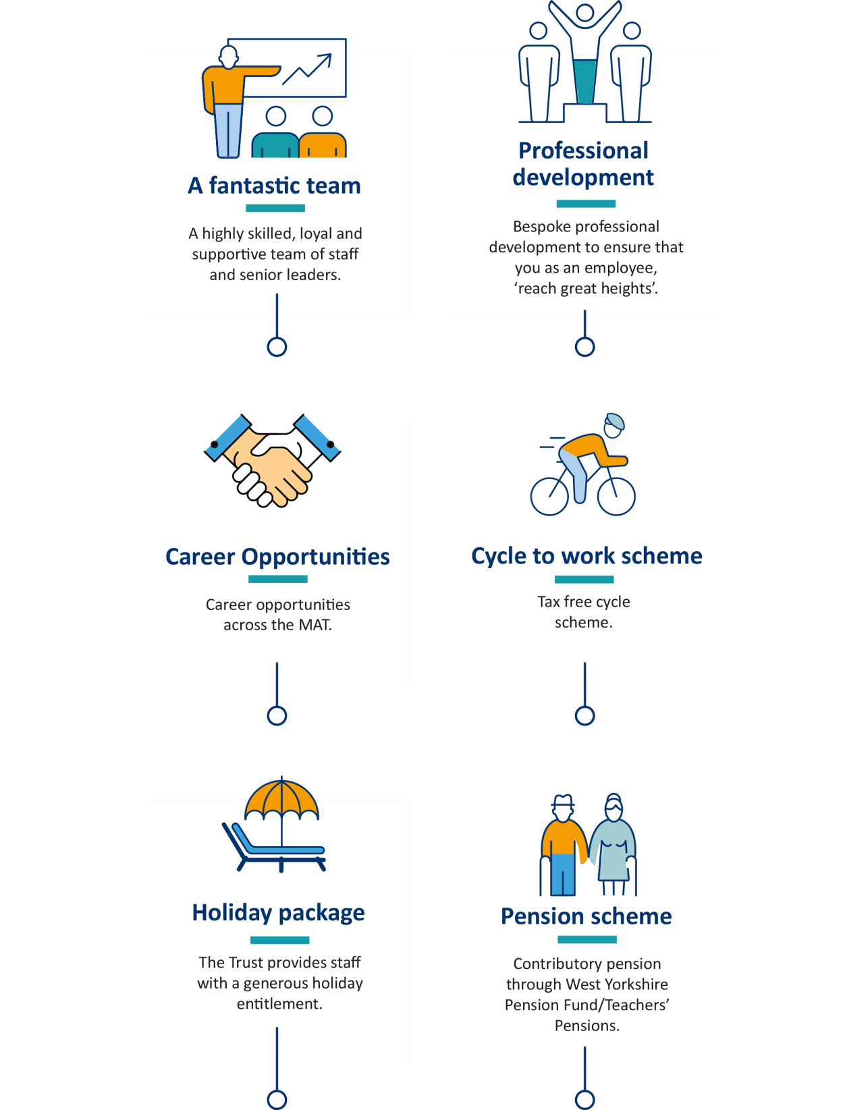
Reasons to work at Great Heights
Academy Trust

