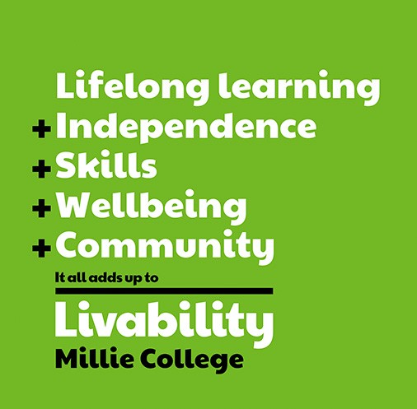
Job Description

Job Title: Receptionist/Administrator
Unit/Directorate: Millie College
Reports To: TBC

Supervises: N/A
Hours: 8.00am-4.30pm (37.5 hours per week)
Salary: TBC

Date: April 2024

Purpose of The Job

Millie College is part of the Livability family of services. Based in Holton Lee, Poole, we provide education, therapy and support for young people and adults with disabilities. We are seeking to appoint a Receptionist to join our college administration team which provides high quality support to the running of our college. To provide an efficient and professional service to parents, staff, professional visitors and members of the public.
The main purpose of the role is to ensure the security of the college main entrance, to receive and monitor visitors to the premises and provide general administration support.

Main Duties
- Receive and welcome all visitors to the college whilst maintaining security of the front entrance. Ensure that all visitors are comfortable, and that the reception area is neat and tidy at all times.
- Miscellaneous reception duties to include, taking in post and deliveries, liaising with site/facilities staff regarding distribution of post and deliver parking, displays, meeting room bookings, college diary, lost property, student and staff badges, photocopying, filing, special events, new staff files, etc
- Register staff cars and issue passes. Contact staff when their car needs to be moved.
- Work as a member of the administration team and support them when required.
- Take/Redirect incoming calls and answer all email all enquiries.
- Daily recording and/or checking of student attendance using the Management Information System (MIS) in use. Report to Senior Leaders and/or Designated Safeguarding Lead on non-attendance in accordance with safeguarding policies and procedures.
- Use of radio and telephone systems to send and receive messages as required across the college site.
- The typing of specific student related information for distribution within the college and where applicable, to parents, carers and external agencies/partners.
- Assist parents regarding clinics, and liaison issues with the therapy and nursing staff.
- Maintain the College’s Management Information System (MIS) for student records.
- To carry out all duties in a manner which is consistent with Livability values, policies, procedures and practices.

WORKING RELATIONSHIPS AND CONTACTS

Internal: All Staff across the College and other Livability Staff.

SAFEGUARDING

Livability is committed to safeguarding and promoting the welfare of adult, young people and children and expects all employees to share this commitment and follow our safeguarding policies and procedures.

EQUALITY AND DIVERSITY

Livability is an equal opportunities employer and positively encourages applications from suitably qualified and eligible candidates regardless of sex, race, disability, age, sexual orientation, gender reassignment, religion or belief, marital status, or pregnancy and maternity.

Livability aims to create and sustain an inclusive work environment which provides equality of opportunity for everyone and reflects the diversity of the communities we serve. The post holder is required to uphold the Equality and Diversity policy and comply with the code of conduct which sets out our standards of behaviour towards those who use our services or work within them.

CHRISTIAN ETHOS AND VALUES

The post holder must carry out all duties in a manner which is consistent with Livability values which are based on an inclusive Christian ethos.

POLICIES AND PROCEDURES

The post holder must also maintain the policies, procedures and practices of the organisation and as far as possible, must ensure that all activities within the work setting are consistent with those values, policies, procedure and practices.

CONFIDENTIALITY

The post holder must ensure that any information relating to employees, service users and volunteers (future, current and past) is treated in strictest confidence and must be discussed only within the confines of the work setting with the appropriate members of the team or managers.

HEALTH AND SAFETY

The post holder must be familiar with Livability Health and Safety policies and guidelines. All work should be undertaken so as to be consistent with these, and so as to ensure own health and safety and that of others affected by their work.

For further information or if you have any questions, contact: KStroud@livability.org.uk

 | Essential | Desirable | Assessment Method
Qualifications | - Level 1,2 or equivalent in English, Maths and ICT, or willingness to achieve.  - Evidence of continued professional and personal development  - Advanced level in Microsoft Excel |  | A/I
Experience | - Experience of visitor management and call handling  - Experience of Data Administration  - Experience of working within a multi-disciplined team | - Experience of working with in a similar environment (SEN)  - Experience of School/College Management Information Systems (MIS) such as SIMS, Arbor, Civica etc. | A/I
Technical/  Work-based Skills | - Word processing skills  - Good ICT skills | - Good working knowledge of Microsoft office (Word, Outlook) | A/I
General Skills/  Attributes | - Ability to show initiative and work independently  - Understanding of a busy college environment  - Accuracy/Attention to detail  - Ability to evaluate and prioritise own workload  - Excellent literacy/communication skills  - Willingness to learn new tasks  - Willingness to work part of the college team  - Punctuality and reliability  - Able to maintain respect and confidentiality issues | - Flexible approach to working hours | A/I

