Early Years Teacher
Application Pack

Principal & Vice Principal’s Welcome

We hope that you get a sense of the passion and energy here at Hovingham where we strive to provide the very best education for every child and the very best professional development, guidance, and support for every member of staff.

In a nutshell, we are on a mission to ‘Aim High’ in all that we do and be a ‘Great school with a Great team.’ We have the highest ambitions for the children and families we serve in all aspects of their education, academic, physical, emotional and cultural development.

Hovingham is a special place to work because it is a vibrant and diverse community of caring individuals all willing to go the extra mile, overcome challenges and strive for success. Although we are not where we want to be from an attainment point of view, we are determined, proud and striving to be a great school with a great team. We are looking for teachers who can continue to take our great school forward and be part of something extraordinary!

To be part of Team Hovingham, you need a sense of humour, passion, energy and drive – the rest we will teach you!

If you’re inspired and motivated by the opportunities and challenges at Hovingham, then we would very much welcome an application from you.

Good luck with your application.

Kellie Halliday Kim Andrews
Principal Vice Principal

Hovingham Primary School is committed to safeguarding and promoting the welfare of children and young people and expects all staff and volunteers to share this commitment.

About Team Hovingham Structure

Teaching and Learning is of course at the heart of our school but what makes Hovingham different is the support teams whose main role is to remove barriers to teaching and learning – so teachers can teach!
The Inclusion Team is intrinsically linked to the Teaching & Learning Team ensuring children with any need is identified early and any support required is planned and delivered successfully.

The SEMH Team is intrinsically linked to the inclusion team, but has targeted specialist SEMH support to support children, staff and parents.

The Family Team are responsible for ensuring attendance is consistently high, by supporting children and families to achieve this, as well as ensuring a smooth transition into school from the initial admissions stage to a child’s first day at school. They plan and deliver a range of parental engagement activities too.

The Safeguarding Team is responsible for keeping children safe and happy.

The Business Support Team are responsible for the smooth operations of school from ensuring a clean, well-maintained environment, delivered by a team of cleaners and facilities staff, to ensuring the systems and processes are in place from booking school trips, handling cash or simply meeting and greeting visitors.

All the teams are led by experienced Senior Leaders within their area of expertise such as EYFS, KS1, KS2, Maths and English. All the teaching staff leading their areas do not have a full-time class commitment so can provide support, guidance, and coaching to all our teachers and support staff in their key areas.

Each team has a dedicated Team Leader who help nurture our great culture.

Strategic leadership is provided by the Principal and the Vice Principals who combine their educational and business acumen to lead a successful school.

Leadership Structure at Hovingham Primary

To be a great school with a great team requires a leadership structure which is robust and knowledgeable.

Our structure is designed to enable our leaders to create strategies and put them into operation, using internal relationships.

Every decision, action, and strategy is strongly linked to improving the outcomes for our children.
Principal
Vice Principal

Vice Principal
Assistant Principal
Assistant Principal
Team Leaders
Business Manager
Subject Leaders

Board of Governors

Chair of Governors | Colin Noble  Juliet Bailey
Governor | Sally Blunt
Governor | Claudia John
Governor | Ishrat Nazir
Governor | Al McFadyen
Governor (staff representative) | Saleem Ali
Governor (staff representative) | Kim Andrews
Governor (staff representative) | Anna Delaney

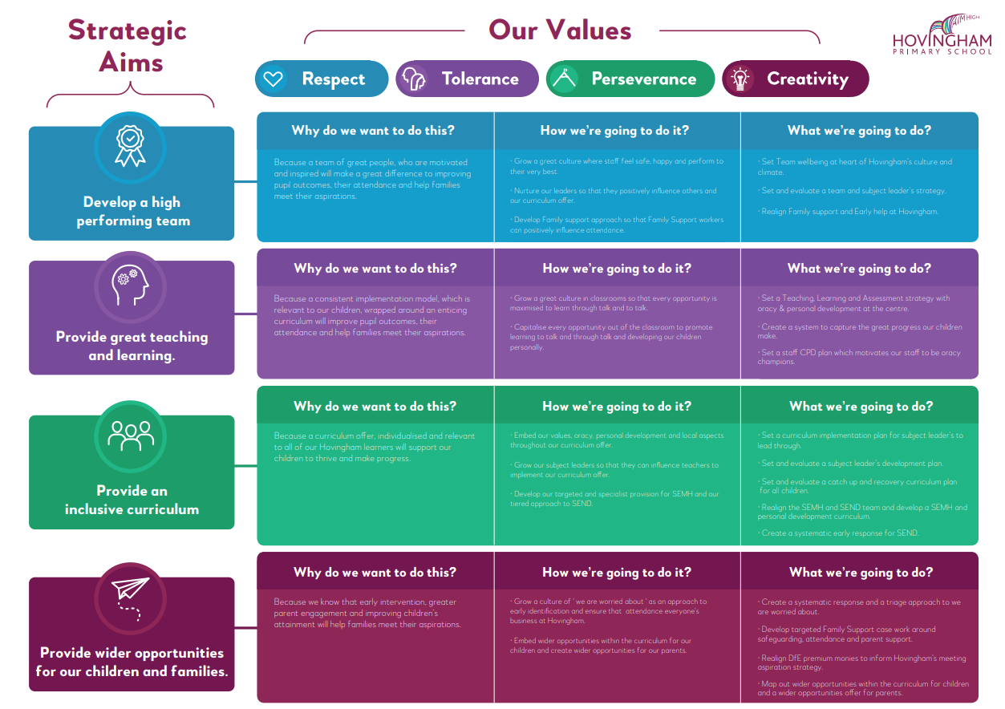

Job Profile

Purpose of the Role:

Facilitate and encourage learning which enables students to achieve high standards; share and support the corporate responsibility for the well-being, education and discipline of all children.

The Job Description should be read alongside the range of professional duties of Teachers as set out in Part X11 of the Teachers’ Pay and Conditions Document, sections 48 to 50. You will be expected to undertake duties in line with the professional standards for qualified teachers and uphold the professional code of the General Teaching Council for England.

Key Responsibilities:

Teaching and Managing Pupil Learning
- Ensure effective teaching of whole classes, groups and individuals so that teaching objectives are met, momentum and challenge are maintained, and best use is made of teaching time.
- Use teaching methods which keep pupils engaged, including stimulating pupils’ intellectual curiosity, effective questioning and response, clear presentation and good use of resources.
- Set high expectations for pupils' behaviour, establishing and maintaining a good standard of discipline through well-focused teaching and through positive and productive relationships.

Planning and Setting Expectations/Pupil Achievement
- Identify clear teaching objectives, content, lesson structures and sequences appropriate to the subject matter and the pupils being taught.
- Set appropriate and demanding expectations for pupils’ learning and motivation. Set clear targets for pupils' learning, building on prior attainment.
- Identify pupils who have special educational needs, and know where to get help in order to give positive and targeted support. Implement and keep records on Individual Education Plans (IEPs).

Assessment and Evaluation
- Assess how well learning objectives have been achieved and use this assessment for future teaching.
- Mark and monitor pupils’ class and homework providing constructive oral and written feedback, setting targets for pupils’ progress.
- When applicable, understand the demands expected of pupils in relation to the National Curriculum, KS4 and post-16 courses

Relationship with Parents and the Wider community
- Prepare and present informative reports to parents.
- Provide opportunities to develop pupils' understanding by relating their learning to real and work-related examples, recognising that learning takes place outside the school context.
- Liaise with agencies responsible for pupils' welfare.

Manage Own Performance and Development
- Take responsibility for their own professional development and to keep up to date with research and developments in pedagogy and in the subjects they teach.
- Share corporate responsibility the implementation of school policies and practices.
- Set a good example to the pupils they teach in their presentation and their personal conduct.
- Evaluate their own teaching critically and use this to improve their effectiveness.

Managing and Developing Staff and Other Adults

- Establish effective working relationships with professional colleagues including, where applicable, associate staff.

Managing Resources

- Select and make good use of textbooks, ICT and other learning resources which enable teaching objectives to be met.

Class Teacher
Person Specification
This person specification outlines the key skills, knowledge, experience and behavior required to deliver this job profile and be the right fit within a high performing team.

 | Essential | Desirable
Qualifications | - Teaching Certificate  - Evidence of CPD | - Degree  - Relevant post graduate certificate
Experience | - Recent experience in relevant KS.  - Planning and delivering the curriculum in relevant KS. | - Teaching in more than 1 school.
Knowledge | - A thorough knowledge and understanding of all relevant aspects of the National Curriculum in relation to the post.  - Knowledge and experience of managing behavior.
Personal Qualities | - Ability to relate to and build relationships with pupils, parents and other members of the school community.  - Enthusiasm and commitment to the aims and objectives of the school.  - Good communication skills. | - Willingness to participate fully in school activities.
Self-Management | - Achieving challenging professional goals.  - Prioritising work.  - Working to deadlines.
Attributes | - Personal impact and presence.  - Self-confidence.  - Resilience in challenging and changing environment.
Safeguarding & promoting the welfare of children | - Ability to form and maintain appropriate relationships and personal boundaries with children  - Emotional resilience in working with challenging behaviours; and attitudes to use of authority and maintaining discipline.

Safeguarding

Hovingham Primary School is committed to safeguarding and promoting the welfare of children and young people and expects all staff and volunteers to share this commitment.

- References
As part of safer recruitment, we are required to ask for two references. One of which must be your current employer and if working in a school, must be your Headteacher. If, currently, you are not working with children, please ensure one of your references is from a previous employer where the role involved working with children.
- Application Form
The form must be completed fully in accordance with the application form instructions. The presentation of the form and the supporting statement will form part of the assessment of communication skills. Ensure the application form is fully completed with no employment gaps.
- Appointment
Appointment will be conditional pending satisfactory pre-employment checks which include:– health, identity, relevant work qualifications, right to work in the UK and an enhanced DBS check.

How to Apply
Please complete the teacher application form available at www.leeds.gov.uk/jobs, eTeach or TES, and return to recruitment@hovingham.org.

Along with the form please also submit a handwritten letter addressed to the children at Hovingham outlining why Hovingham? and why now?

Recruitment event
We are hosting an open evening on Thursday 27th May from 3.30pm. An opportunity for you to meet Team Hovingham and find out why our school is an extraordinary place. If you’re interested in finding out more about Team Hovingham and would like to attend, please email recruitment@hovingham.org. Alternatively, contact Anna Lattimer on 0113 248 9537 or email anna.lattimer@hovingham.org to book your place.

Closing Date

- Closing date for applications is 12 noon on Monday 7th June.
- Interviews will take place week commencing 14th June.

We are Located Here

Hovingham Avenue, Harehills, Leeds LS8 3QY

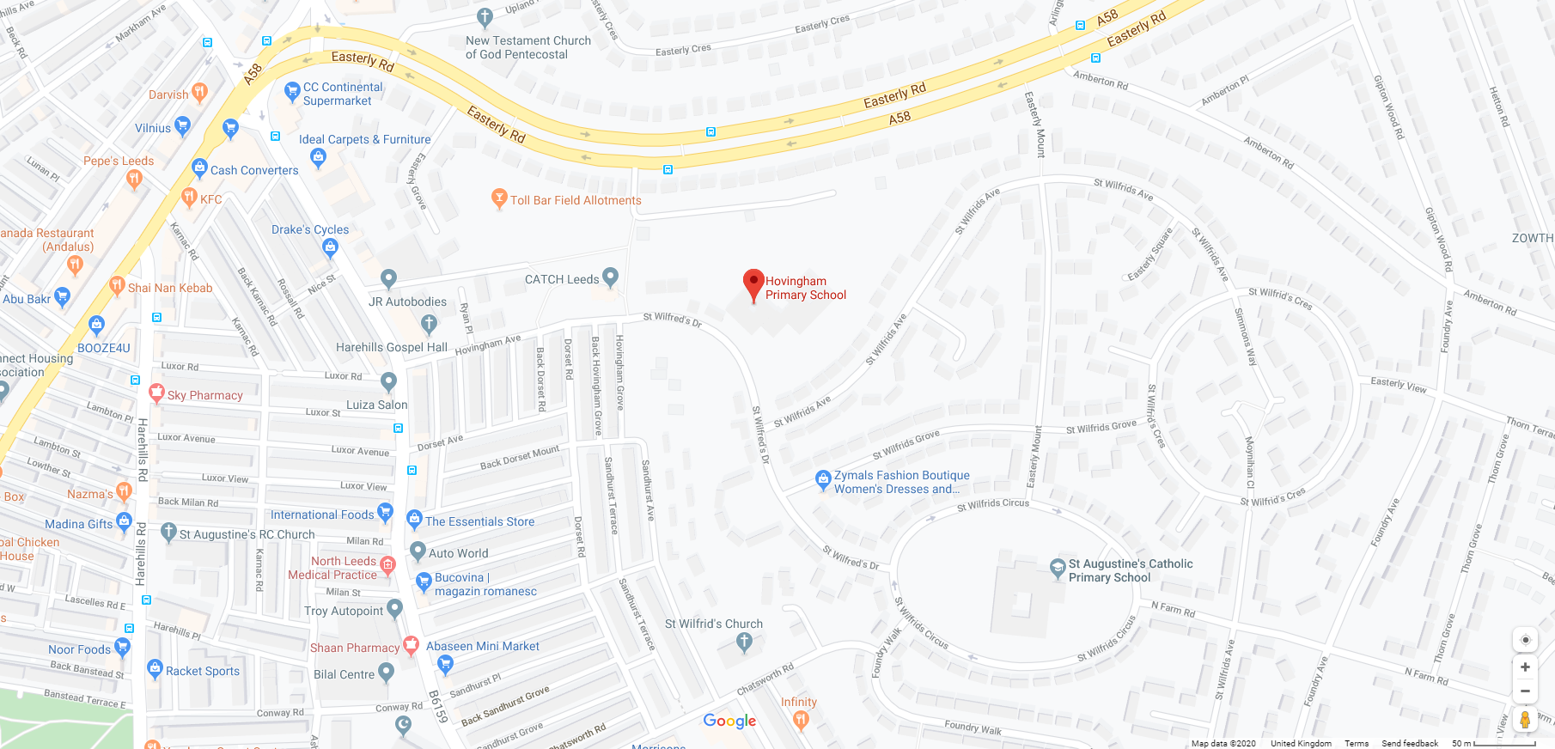

Useful Information

For information about school: www.hovingham.leeds.sch.uk

For information about safeguarding in Leeds: www.leeds.gov.uk/childfriendlyleeds
www.leedsscp.org.uk

For general information about Leeds: www.leeds.gov.uk

For information about Yorkshire: www.yorkshire.com

