Science
Teacher

Lynn Grove Academy
Recruitment Pack

Dear Colleague
Thank you for your interest in Lynn Grove Academy.
Our pupils make Lynn Grove a great place to work.
In our school, you will find lively positive young people with open minds who are ready to make the best of opportunities that come their way. They understand and uphold our core values of mutual respect, hard work and kindness. They are polite, considerate and engaging; we have many reasons to be proud of them.
We are a large and friendly staff team who understand the importance of collaboration to support all our pupils to achieve their full potential. We invest
heavily in professional development and believe in working closely with our neighbouring primary schools.
Our ambition is that every young person should leave us with the attributes of a successful young adult ready for the next stage of their education or training. Through our lessons and through our extracurricular offer we aim to foster a love of learning and interests that will be enriching and sustaining well into adult life.
“We know that every learner can be successful if we find a way to tap in to their interests”
We are committed to offering a broad and balanced curriculum that allows all pupils to follow their interests and supports them to achieve highly. We never underestimate the importance of pastoral support and have structures in place to provide care and guidance through the challenges of teenage years. The pastoral
team makes a significant contribution to the positive social, moral,
cultural and spiritual life of the school.
We are proud to be members of the Creative Education Trust family of schools. As a CET school we have access to outstanding support from the very best experts in school improvement and professional development. Our pupils
benefit from an exciting offer of cross trust enrichment activities and an innovative approach to cross-curricular development through the ‘Knowledge Connected’ programme.
We are fortunate to enjoy great support from Lynn Grove parents who show
a real interest in the progress of their sons and daughters and contribute to
the sense that our school is at the very heart of our community.
Lynn Grove is situated between Bradwell and Gorleston, which form part of Great Yarmouth. The school is situated in a quiet residential area surrounded by extensive playing fields. We are well positioned for very easy access from Norwich or North Suffolk and we have ample parking for all our staff. Our school is very popular and is expanding but remains oversubscribed; currently 1050 pupils attend.
I look forward to receiving your application.
Yours sincerely

Alison Mobbs
Principal

- Raise their attainment in exams and tests through outstanding teaching
- Make them intellectually curious with a sense of confidence
- Increase their participation in HE, FE and apprenticeships
- Ensure they have employable skills and attitudes
- Create rounded individuals through a wide choice of co-curricular activities
ABOUT
CREATIVE
EDUCATION
TRUST

Creative Education Trust inspires and enables young people to build successful lives on foundations of learning, resilience and employability. We believe that a rewarding educational experience and the highest possible qualifications are the best way to ensure social mobility for young people.
Creative Education Trust is a growing multi-academy trust educating over 13,000 children in England. It was established in 2010 to work in England’s post-industrial cities and coastal towns: areas of economic disadvantage and with a history of academic underachievement. We transform these schools by integrating a knowledge-rich curriculum with skills and creativity.
Creative Education Trust defines creativity as the ability to find connections between the things we know and turn these connections into new ideas and action. The academic arts and the sciences, practical subjects and life skills all need this creativity, and creativity is valued highly by employers. Our staff and expert advisers use imaginative methods for linking knowledge across subject boundaries, fostering personal development and resilience and developing practical skills that prepare
students for their transition to adult life and employment.
Educational rigour
Emphasis on professional development
Extensive enrichment programme
Organisational effectiveness
Emphasis on teamwork
Quality not quantity
Promoting practical creativity
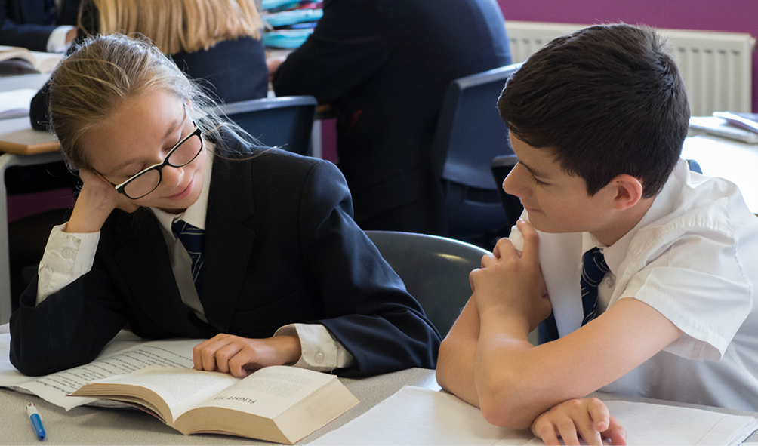

Summary of Lynn Grove Academy’s
Progress Scores in 2019:

- Progress 8 score: +0.1
- Attainment 8 score: 45.27
- Staying in Education or entering employment: 99%
To see full details of the school performance data please visit:
https://www.compare-school-performance.service.gov.uk/school/137541/lynn-grove-academy
ABOUT
LYNN GROVE
ACADEMY

Our on-site facilities include:
- Library open daily from 0800 to 1730
- Suites of subject areas
- Excellent ICT provision
- Impressive Virtual Learning Environment
- Extensive playing fields
- 3G all-weather pitch
- Extensive social space for our learners

The Science Department
Our department ably led by Helen Paul, comprises nine teachers, all science specialists, and we have a wide range of interests and experience. Our specialist higher level teaching assistant and our two technicians provide us with excellent support and we all enjoy working collaboratively. We have spacious laboratories, which are all located in the same area of the school with technicians’ facilities on both floors. We are fortunate to have good resources of equipment and textbooks.

Well supported by our schemes of work, we teach across the sciences in years 7, 8 and 9 with opportunities for specialising in years 10 & 11. We have a long tradition of teaching GCSE science to all our pupils and every year a pleasing number opt to study Biology, Physics and Chemistry.

We want to engender a sense of awe and wonder in our pupils, inspiring a passion for our subject. We are determined to provide our pupils with a great science education so that they will be well equipped to make informed and ethical choices in their lives. We aim to teach them to think like scientists, develop transferable skills and perhaps most importantly to develop a secure body of scientific knowledge to underpin their thinking.

Our generous allocation of CPD time enables us to meet very regularly to
work together on developing our curriculum. We have ample opportunities
to engage in subject specific CPD both individually and as a team. The
work of the Education Endowment Foundation has informed our approach
to science education and we participate regularly in courses run by the
National STEM Centre in York. We make good use of information
technology to support learning.

We are an outward looking department and have a well-deserved
reputation for the excellent quality of our extracurricular enrichment offer.
STEM week always goes off with a bang and our STEM pupil ambassadors
are a lively bunch of enthusiasts. We have recently participated in the Norfolk
FIRST Lego league, and the Salters Festival of Chemistry and are
always keen to develop this area of our work.

We are committed to developing the next generation of science teachers and work in partnership with a number of local HEI partners. Most members of the team are trained as ITT mentors and gain from experience.

SUPPORT
FOR OUR STAFF

For our pupils to achieve to their full potential we know that it is essential that our staff thrive professionally. We value team work highly and provide ample opportunities for all our teachers to work collaboratively with their colleagues. As teachers, we believe that we never stop learning and we support each other to develop professionally. We share ideas and good practice regularly and encourage everyone to contribute to the professional development programme.
With careful planning, we have arranged our school day to give everyone two hours a week in their teams to devote to professional development. The time spent with colleagues focussing on department and school improvement is much appreciated.
We understand the importance of working with other schools in our trust and beyond. Our middle leaders have benefited from their participation in the Ambition School Leadership Teaching Leaders Programme and some have embarked on NPQ qualifications. We value subject specific CPD highly and are members of the Prince’s Teaching Institute which provides access for our teachers to high quality subject specific professional development.
Newly qualified teachers at Lynn Grove will benefit from high quality mentoring and access to a customised induction course designed specifically to smooth their progress through the NQT year.
We are keen to welcome trainee teachers from a range of Higher Education Institutes. We work in partnership with the University of East Anglia, TeachFirst, Suffolk and Norfolk ITT, the TEN group and our ITT providers

SCIENCE TEACHER
JOB DESCRIPTION AND PERSON SPECIFICATION

PURPOSE AND SCOPE

To be responsible for achieving the best possible standards in work and conduct for all pupils in the class and to promote and safeguard the welfare of all pupils within the school
All Teachers are required to carry out the duties of a school teacher as set out in the current ‘School Teachers’ Pay and Conditions Document’ and all Teachers job descriptions are linked to the DfE Teachers’ Standards 2012. Teachers’ work performance will be assessed against the Teachers’ Standards as part of the performance management process

ORGANISATIONAL RELATIONSHIP

The post holder is responsible to the Principal but to the Head of Department in the first instance.

PRINCIPAL DUTIES AND RESPONSIBILITIES

- Teach pupils across the age and ability range
- Establish clear targets for achievement and evaluate progress through the use of appropriate assessments and take into account analysis of this data.
- Prepare, develop and deliver teaching programmes using materials and techniques that will engage and stimulate pupils of all abilities.
- Give pupils regular feedback, both orally and through accurate marking and encourage pupils to respond to the feedback, reflect on progress and take a responsible and conscientious attitude to their own work and study.

- Maintain a secure up to date knowledge of relevant subject areas through participation in training and development opportunities identified by the school or as an outcome of appraisal process.
- Deliver the curriculum as relevant to the age and ability group/subject.
- Set appropriate homework in line with school policy and the homework timetable.
- Support the development of the pupils’ reading, writing, maths and communication skills through the curriculum offer.
- Demonstrate an understanding of and take responsibility for promoting high standards of literacy including the correct use of spoken English (whatever the specialist subject being taught)

- Contribute to the development of schemes of work.
- Engage in short medium and long term planning of lessons and sequences of lessons.
- Demonstrate a clear understanding of appropriate teaching strategies relevant to the age/range of abilities within the group.
- Plan and undertake enrichment & extension activities where possible to consolidate and extent the knowledge and understanding pupils have acquired.

- Monitor the progress of groups to close the gap between them.
- Teach appropriately differentiated lessons which will enable pupils of lower ability to engage with the subject and learn effectively and challenge/ stretch pupils of higher ability.

- Use Assessment for Learning and Assessment of Learning opportunities to maximise pupil progress.
- Use relevant data to monitor progress, set targets, set homework and plan subsequent lessons.

- Implement whole school strategies to support behaviour for learning.
- Carry out morning afternoon and break time duties as directed.
- Establish a framework for discipline with a range of strategies using praise, sanctions and rewards consistently and fairly.
- Maintain good relationships with pupils, exercise appropriate authority and act decisively as necessary.
- Be a positive role model and consistently demonstrate the positive attitudes, values and behaviour which are expected of pupils.
- Promote and safeguard the welfare of all pupils within school, raising any concerns in accordance with the school’s protocols and procedures.

- Support the school’s Initial Teacher Training activity as appropriate.
- Take opportunities to develop professionally and share good practice to develop consistently high standards of teaching and learning.
- Work collaboratively with our partner schools to support pupils’ transition
- Facilitate the work of support staff to enhance pupil progress
- Work collaboratively with parents and carers to support pupil progress
- Support pupils to develop wider key skills
- Uphold all school policies
- Attend and actively participate in meetings
- Make a positive contribution to the wider life and ethos of the school.
- Perform additional duties and tasks required for the effective operation of the academy.
- Undertake other various responsibilities as directed by the Principal.

PERSON SPECIFICATION

 | ESSENTIAL | DESIRABLE
QUALIFICATIONS | Qualified teacher status  Degree in relevant subject  Recent and relevant CPD | Masters level degree
EXPERIENCE | Successful experience of teaching at Key Stage 3 and 4 | Experience of teaching at KS5
KNOWLEDGE AND  UNDERSTANDING | Proven ability to deliver well-planned and stimulating lessons  Demonstrable knowledge and understanding of effective behaviour management strategies and the ability to put these in to practice  Good knowledge of what constitutes effective teaching and learning  Experience of devising strategies to support less able children and extend the more able  Knowledge of current educational trends and initiatives  Understanding of the principles and practice of assessment for learning
SKILLS AND  PERSONAL  ATTRIBUTES | Data analysis skills  Good organisational skills  Good communication skills  Proven ability to establish productive professional relationships with children, colleagues and parents
EQUAL  OPPORTUNITIES | A demonstrable commitment to supporting and promoting safeguarding, student welfare, equality and diversity
SAFEGUARDING | A thorough understanding of up-to-date safeguarding requirements and best practice
OTHER  REQUIREMENTS | High expectations for every pupil and a proven track record of making a difference to the learning and experiences of pupils inside and outside the classroom.
Creative Education Trust is committed to safeguarding and promoting the welfare of our children and young people and expects all staff and volunteers to share this commitment. The successful applicant will be required to undertake relevant safeguarding checks in line with Government safer recruitment guidelines.

