February 2020

Dear Applicant,

Re: Post of Teacher of English

Thank you for your interest in the above post at Trinity Academy. Please find attached an applicant’s pack containing:

1. Job Description and Person Specification
2. Guidance on completing the application form
3. Information about Trinity Academy
4. Application form
5. Monitoring form

As you will see from the information, Trinity Academy is now an established over-subscribed new school and, in applying for this post, you will have an exciting opportunity to contribute to its aim of developing into one of the best schools in South London. Our staff and pupils are enthusiastic and hard working with high aspirations. Pupils are polite and well behaved and the Academy environment is one of calm and purposeful activity. Class sizes are small with a maximum of 26 pupils. We benefit from brand new purpose-built accommodation with excellent facilities and are excited by the opportunities this opens up for pupils, staff and the local community.

If you wish to have an informal discussion about this post, please email recruitment@trinityacademylondon.org

Please note that completed applications should be returned by e-mail to recruitment@trinityacademylondon.org by noon on 17th February 2020.

Thank you once again for your interest in this post and I look forward to receiving your completed application form.

Yours faithfully,

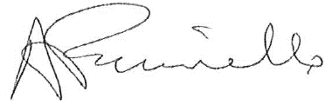

Antony Faccinello
Principal

