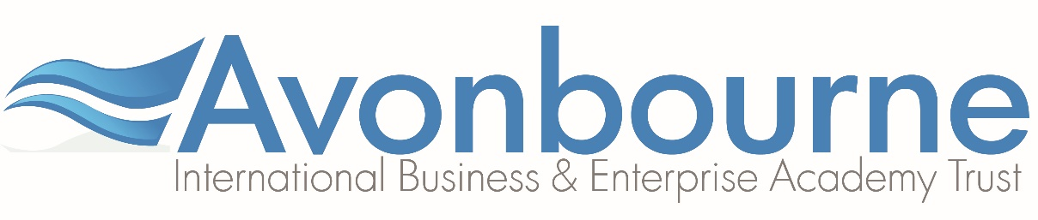

SCIENCE DEPARTMENT

The Science Department at Harewood College aims to deliver a broad and balanced Science curriculum through high quality teaching. We believe that students from all ages and abilities should be given the opportunity to explore and enjoy the scientific world in a supportive and encouraging environment. In order to achieve this we have high expectations of our students as learners, and of ourselves as teachers. The college was rated good in 2015 and in 2017 achieved 21.4% A*-C in core science and 95.7% A*-G.

The department works closely with the Science Department at Avonbourne College; the girl’s secondary school in the Multi-Academy Trust.
Harewood College Science Department is housed in six purpose built laboratories, located along a main corridor of the College and served by a central preparation room. Each fully equipped laboratory has an interactive whiteboard and there is also a staff work room and resource area.
The staff in the department are part of a hardworking, forward thinking and supportive team who also arrange a number of enrichment activities throughout the year, including trips and after school clubs.
In years 7 and 8, students follow the activate scheme linked to the National Curriculum and the International Middle Years curriculum (IMYC). In year 7 students are taught in mixed ability classes. However, as they move into Year 8, they are taught in groups that best suit their ability. Progress is monitored regularly; we assess each half term and use cumulative assessments to build on students memory retrieval.
At KS4, the majority of students study AQA Trilogy. The new combined Science course covers the concepts needed by tomorrow's scientists, to allow them to explain the world around them and solve the problems of the future.

As a joint venture with Avonbourne, the 6th form students are offered OCR A Level Biology, Chemistry, Physics and Psychology – all taught by specialist staff either in the labs or in the new 6th form block. Applications for Science subjects are amongst the highest of all subjects. There are healthy numbers of students studying all the sciences at A Level while 2016 saw some fantastic results; A Level Biology 83% A* - C, Chemistry 100% A* - C, and physics 67% A* - C.
The Faculty:
The Faculty comprises Science, Technology & COPE and is led by a Head of Faculty who is supported by a Deputy Head of Faculty, an Assistant Head of Faculty and a Faculty Assistant.

