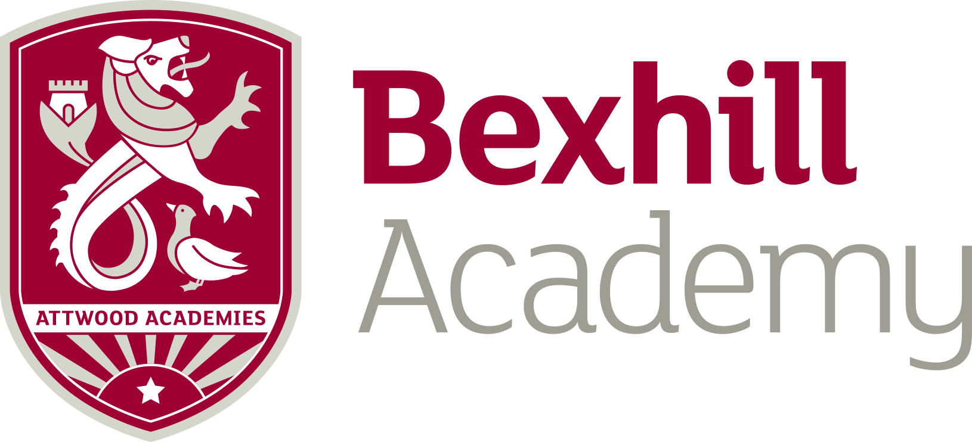

Post: Languages Asssitant
Hours: Circa 10 hours per week.
Basis: Currently fixed term, initially, until Friday 12 July 2019
Salary: Equivalent to Single Status Grade 7, Points 17-19 £20,654 - £21,892 per annum pro rata. Actual salary based on 10 hours (£4,788.00 - £5,075.00 per annum) Pay award pending, from April 2019.

Person Spec:
Native Speaker (Ideally Spanish) | Desirable
Degree Educated | Highly Desirable – Essential if non native (Must be a Languages Degree in this case)
Ability to work freely in the UK | Essential
Flexible approach to working week | Essential
Hardworking, resilient and reliable | Essential
Belief in comprehensive education | Essential
Previous experience of working in schools | Desirable

Job Spec:
Main brief: To assist the languages department in significantly improving spoken language skills.

- To hold ‘conversations’ with students and record and monitor their progress
- To correct and improve students conversational based work
- To conduct speaking tests where appropriate
- To assist with producing resources designed to boost student performance
- To participate in the preparation and delivery of mock examinations
- To aid the teacher in the classroom as directed
- To assist with classroom displays and language promotional work
- To have a positive impact on students confidence as demonstated by improved speaking and listening results
- To give conversational ‘lessons’ to individuals or small groups and help the classroom teacher to improve the students love of languages.
- To uphold the Academy Vision and Ethos

