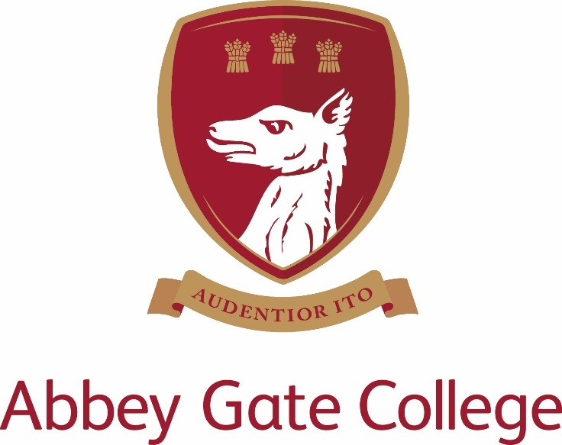
Part Time (4 days per week)
Key Stage 2 Teacher (Maternity Cover)
Required by December 2017

TO START BY DECEMBER 2017

Abbey Gate College – Part Time (4 days per week)

Key stage 2 Teacher (Maternity cover)

The College
Abbey Gate College is the longest-running coeducational independent school in the Chester area, catering for circa 485 pupils aged 4-18 years. Set in the idyllic rural villages of Saighton and Aldford on the outskirts of Chester.
Our pupils are at the heart of everything we do. We believe education is about building self-esteem, a love of learning and igniting a desire in all our students, to ensure they fulfil their academic and personal potential. We strive to guarantee our children leave Abbey Gate College as confident, articulate, respectful and happy young high achievers.
From the youngest in Foundation to our Sixth Formers, we aim to develop skills for life; core values such as respect and compassion within the framework of an excellent education. Developing talents and skills in a wide range of areas are encouraged, success is celebrated and endeavour is recognised.
The Infant and Junior School is an integral part of Abbey Gate College and is located close to the Senior School in the beautiful village of Aldford. There is a robust ‘can do’ where parents and staff work together to give children the very best educational opportunities, be they academic, cultural, artistic or sporting. Pupils are encouraged to be ambitious for themselves and, as such, routinely make excellent progress.

The Post

We are seeking a dynamic and committed teacher of Key Stage 2 to join our enthusiastic department in order to cover maternity leave. We require the candidate to start with us by December 2017. The successful candidate will teach Year 4 in the Infant and Junior School. This role is a part time (4 days per week) role.

The key stage 2 teacher is responsible for teaching year 4 curriculum and the ability to coordinate art would be desirable, though not essential. The successful applicant will be an enthusiastic and capable practitioner with excellent teaching skills and the ability to foster positive relationships with the whole school community.

Key Stage Two:

At Abbey Gate College Infant and Junior School we base our teaching on the English National Curriculum, which we adapt to suit the needs of our pupils. The year 4 teacher is responsible for delivering the majority of the curriculum with French, drama, music, computing and PE being taught by subject specialists. PE, computing and music are taught at the Senior School enabling children to benefit from specialist facilities.

Key responsibilities:

- To manage and deliver the teaching of Key stage 2.
- To maintain and manage a caring, supportive, purposeful and stimulating environment which is conducive to children’s learning.
- To promote learning and celebrate achievement through bright, varied and up to date class displays.
- To plan, prepare and deliver high quality, differentiated lessons across the curriculum in line with the Junior Schemes of Work.
- To plan opportunities to develop spiritual, moral, social and cultural aspects of pupils’ learning.
- To enable pupils to develop and maintain positive attitudes towards learning.
- To monitor and be responsible for the progress of individual students, including thorough marking, assessment, recording and reporting.
- To implement strategies to support MAT, SEND and EAL pupils in the classroom.
- To promote high standards of behaviour and discipline among the pupils, safeguarding their health and safety.
- To attend and participate in staff meetings, briefings and planning meetings, INSET days and to share in a range of supervisory duties throughout the day.
- To ensure that school policies are reflected in daily practice.
- To promote strong relationships with parents and carers, communicating with them about all aspects of their child’s education – academic, social and emotional.
- To attend parents’ evenings and information evenings.

Key qualities and person specification:-

The person appointed should demonstrate the following skills and qualities:-

- Inspirational teacher
- Enthusiastic, innovative and creative teacher with a commitment to the extra-curricular life of the school
- Committed to raising standards and monitoring pupil progress
- Act as a good role model to staff and pupils
- Have outstanding professional and personal qualities
- Caring, supportive and willing to adapt their teaching to suit the educational and pastoral needs of the pupils
- Excellent standard of Literacy and Numeracy skills
- Proficient with the use of ICT in the classroom
- Show good planning skills
- Well organised
- Calm under pressure
- Knowledge of safeguarding procedures

Salary, Terms and Conditions
Core school hours when all teaching staff are expected to be in work are currently 8.30am-4.00pm Monday to Friday, plus a proportional share of pastoral duties. This role is a part time days per week role).
Periods of non-contact time for PPA is included in the weekly timetable and may differ for individual staff.
The salary for this position will depend upon the qualifications and relevant experience of the successful candidate.

Child Protection
Abbey Gate College regards as paramount the welfare and safety of children. Whilst criminal convictions are not necessarily a bar, this safety consideration will be key to all decisions regarding the employment of staff, approval of volunteers and standards of external contractors.

Equal Opportunities
We are committed to treating all employees with dignity and respect regardless of race, ethnic background, nationality, colour, gender, transgender status, pregnancy, age, sexual orientation, religion or belief. We therefore welcome applications from all segments of the community.

Applications
Candidates should complete an Abbey Gate College Application Form and submit this together with a letter explaining their interest in and suitability for the post.

The closing date for applications is 4pm on Wednesday 27 September 2017 ; interviews scheduled for Thursday 5 October 2017.

The interview process will include; the candidates will meet the Headmistress, Deputy Head, Head of the Infant and Junior School and have a tour of the Infant and Junior School. Candidates will be asked to prepare and deliver a lesson (details confirmed before interview).

References will be taken up prior to interview, please inform your referees.

Please mark the envelope:

Rebecca Upton
Human Resources
Abbey Gate College
Saighton Grange
Saighton
Chester CH3 6EN

Alternatively you can make your application electronically by email to: - rebecca.upton@abbeygatecollege.co.uk

