Teacher of English
Required September 2019
Salary Range
MPS 1-6 UPS 1-3
Salisbury’s Sarum Academy would welcome applications for the position of Teacher of English to join our fantastic team. Sarum Academy is a highly successful school with a growing reputation; part of the Magna Learning Partnership Academy Trust. In addition to fulfilling your professional duties as a teacher, in accordance with the Teacher Standards, the post holder will be actively involved in the development of the provision for English working with the Curriculum Team Leader.

The successful applicant will:
- Have a proven track record of success but would welcome new entrants into the profession
- Have high aspirations for all pupils
- Demonstrate a passion and enthusiasm for English
- Be able to teach across the age and ability ranges up to GCSE – A Level if experienced
- Possess a strong team ethos
- Display good communication skills
The Academy offers:
- An enthusiastic and driven team of teachers and support staff
- Ongoing professional development of the highest standard. Outstanding support and training for colleagues new to the profession
- Wider school involvement
- A strong support network both within the school and within the Magna Learning Partnership Academy Trust
- Your own classroom
- A fantastic working environment and wealth of resources including full access to ICT
For further details please visit www.sarumacademy.org or contact Matthew Smith on 01722 342437 or recruitment@sarumacademy.org Closing date: 18th March 2019

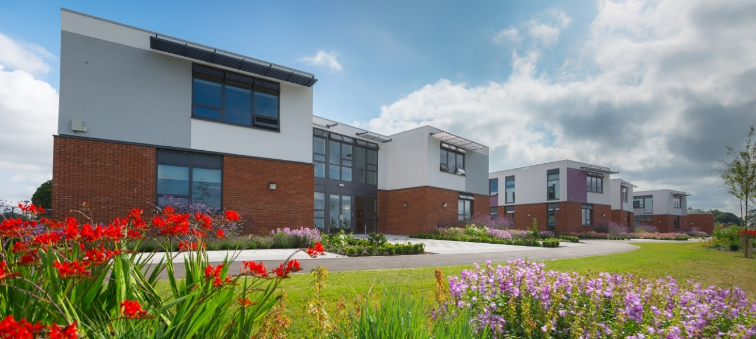

WORKING HARD, ACHIEVING MORE

