**Contents:**

**Page 1 – 2 – Director of Music**

**Page 3 - 6 – SWCHS Music Department**

**Page 7 - 10 – Music Academy**

**Director of Music**

Saffron Academy Trust (SAT) is a family of schools comprising of two secondary schools and two primary schools. Saffron Walden County High School (SWCHS) is an outstanding secondary school within the trust and has an excellent reputation for both academic and extra-curricular music. SWCHS currently holds ‘ArtsMark Platinum’. 299 students have individual instrumental lessons, 219 children are involved in extra-curricular music and the school boasts 16 different musical ensembles. SWCHS also delivers the cutting-edge ‘Music Academy Programme’ (see additional information below), open to all musicians, grade 6 and above, who join our outstanding sixth form. Pupils are drawn from across Essex, Hertfordshire and Cambridge. Students on the Academy Programme have access to masterclasses delivered by professional musicians as well as opportunities to attend concerts and learn about music education by delivering an outreach programme in local primary schools. As such, SWCHS has an excellent track record in securing places for students at the leading music academies and conservatoires in the country. SWCHS is also home to the prestigious ***Saffron Hall***. ***Saffron Hall*** is an award-winning, international concert venue which seats 740 people. The hall’s critically acclaimed acoustic and state-of-the-art facilities surpass many of the world’s more established venues. Saffron Hall offers both classical and jazz concerts and a range of artists including the London Symphony Orchestra, Maxim Vengerov, Penguin Cafe, Nicola Benedetti, Courtney Pine, English Touring Opera and the Sixteen have performed on its stage. The Trust and Saffron Hall work in partnership to enrich the music-making of children across the Trust and to provide them with cutting-edge musical opportunities. In addition, SWCHS, in collaboration with the Guildhall School of Music and Drama and Essex Music Hub, host SCYM (Saffron Centre For Young Musicians), a Saturday morning music school which currently works with 130 children drawn from across Essex, Hertfordshire and Cambridge.

The role of ‘Director of Music’ is an outstanding opportunity for a highly experienced performer and teacher to forge the direction of music-making across the Trust. The successful candidate may already be a Head of Music in a school. The Director of Music would lead the Music Department SWCHS and would also work with the other schools in the Trust, and Saffron Hall, to ensure as many young people as possible have access to high-quality musical opportunities. This is a new role and is, as such, an exciting opportunity for the successful candidate to shape this position and the direction of the post. A generous time allowance would be given to ensure the post-holder can develop and deliver their vision.

**Person Specification:**

Essential:

* Either a teaching qualification or comparable experience in music education
* An outstanding classical or jazz musician
* An outstanding, inspirational and innovative teacher with a proven trackrecord in delivering outstanding academic outcomes at KS3, KS4 or KS5
* An enthusiasm and passion for Music Education at all levels – from access to excellence – encouraging a love of music in all children
* An ability to inspire and motivate children to love music
* A deep commitment to music and a belief that it can be transformational for children
* Excellent interpersonal skills
* Excellent time management skills

Desirable:

* Experience of leadership within a Music Department
* An ability to liaise successfully with professionals across the music industry
* A knowledge of educational outreach programmes
* A vision for music and an ability to think strategically

**Main Responsibilities:**

SWCHS

* To develop an exceptional, broad and inspiring extra-curricular music programme with opportunities for pupils of all musical abilities.
* To direct some of the musical ensembles taking place in the school
* To teach outstanding lessons
* To lead the SWCHS music department: with responsibility for managing the performance of teaching staff, peripatetic staff and department administrators
* To be accountable for academic achievement at KS3, KS4 and KS5 and to use data effectively to ensure all pupils make excellent progress
* To liaise with parents and carers about their child’s progress
* To lead the ‘Music Academy’ programme: responsibility for progress of students on the programme; booking and liaising with musicians leading masterclasses; overseeing the outreach programme
* To work alongside the Drama department, and other arts subjects in the school, to produce high-quality school productions and other performance opportunities

Across SAT schools

* To communicate and realise a vision for music across SAT schools
* To liaise with Saffron Hall on a regular basis to plan educational activities
* To work in collaboration with Saffron Hall, SCYM and the Guildhall School of Music and Drama, and other arts organisations, to ensure pupils from all schools have access to a rich extra-curricular music programme that gives opportunities for access and excellence
* To ensure the Saffron Hall (the venue) is accessible to all schools across SAT
* To encourage musical collaboration between Trust Schools
* To support other Trust schools in realising a musically ambitious programme of extra-curricular activities and support the pedagogy and delivery of music within the classroom, where required.

Time allowance:

The successful candidate would teach *up to* 33, one-hour periods every two weeks. The teaching contact time has been lowered in order to allow the successful post-holder to spend the remaining time in developing and implementing an extra-curricular programme across SAT schools; liaising with the arts organisations that partner with the Trust; leading the Music Academy Programme; leading the Music Department at SWCHS and the other responsibilities above.

Because of the extra-curricular nature of the role, and because of partnerships with organisations such as Saffron Hall, there is an expectation that the post-holder, in addition to the usual concerts and ensembles that any music teacher in the school would run, would be required for a level of evening and weekend commitments during the year. In the light of this, some non-contact time would be timetabled to allow for some flexible working, in agreement with the SLT link, to ensure a work/life balance.

**SWCHS Music Department Information**

**Aims of the Department**

* To encourage the understanding and expression of thoughts and feelings through the medium of music.
* To develop sensitivity towards music through personal experience
* To build on the experiences of KS1 & 2
* To stimulate and develop an appreciation and enjoyment of music through active participation in a full range of activities
* To develop confidence in performance and enable all to access a range of performance activities

To encourage the development of invention, analytical and appraisal skills

* To provide an appropriate body of knowledge, promote understanding and develop skills as a basis for further study or leisure
* To develop a corporate identity within the school and the wider community

**Objectives of the Department**

To develop:

* An awareness of the range and nature of a wide variety of musical sounds and sources
* The confidence to make music individually and in groups with an awareness of tone, pitch and articulation
* The confidence to express their thoughts through both structured and free improvisation
* The skill to compose original music in response to both musical and non-musical stimuli
* The ability to use ICT to help realise their creativity
* Enough skills in reading musical notations to support further study
* The willingness to listen to a wide range of live and recorded music and make a critical, analytical or creative response to it
* A body of knowledge about music from other culture and times

In addition to the objectives above it is hoped that the music curriculum will develop within students the following:

* A preparedness to be increasingly involved in music
* A willingness to respond to unfamiliar music
* A willingness to experiment and take risks
* The understanding that it takes time to develop skills
* A willingness to accept constructive criticism
* A tolerance of the views and opinions of others

**Staffing**

The Music Department is staffed by three full-time and one part-time teacher as well as a team of some 20 visiting peripatetic instrumental teachers. Currently the Director of Music also writes the whole school timetable. The Music Department is supported by two part-time administration staff, one with responsibility for the organisation of instrumental teaching and Music School, the other with responsibility for curriculum support.

**Who are the Music Staff?**

**Mr Alan Broadbent**

B Mus. (Hons) PGCE – Director of Music

A graduate of Bangor University who studied composition with William Mathias and performance at the RLPO, Mr Broadbent was initially a freelance trombonist and peripatetic teacher. He later moved into the classroom at Sawston Village College and was subsequently appointed Area Coordinator – Expressive Arts at SWCHS. He remains a frequent performer and C20 music enthusiast.

**Mrs Jane Patterson**

BA (Hons) PGCE

After studying for her undergraduate degree at Exeter University, Jane completed her PGCE at Homerton College, Cambridge. She has worked at several secondary schools over the last 23 years, including being Head of Department. A first study flautist, Jane also plays the violin, piano and enjoys singing.

**Mr Elis Reed**

BA Mus. (Cantab) LTCL

Recently graduated from Cambridge, Mr Reed is a first study pianist who also plays the trumpet. He is particularly interested in the use of music technology to further learning and is a Logic Pro expert. Always interested in music education, Mr Reed has worked as both a classroom assistant and also for the educational outreach programme at Cambridge. He is also a keen composer and musicologist.

**Miss Lucy Colwill**

BA (Hons) PGCE

A graduate of Bristol University, Miss Colwill plays the oboe and is a member of the Graduate Orchestra in Cambridge. She was a trainee teacher at SWCHS and brings many skills and interests to the department including Historical Studies, harmony and counterpoint as well as conducting and performance. Miss Colwill previously worked with junior music ensembles at home and abroad and enjoys sharing her passion for music with students of all ages and interests.

**Administration Support Staff**

Emma Ure Instrumental Teaching Support

Amanda Wenham Curriculum Teaching Support

**Accommodation**

The Music Department is mostly housed in two separate but adjacent buildings.

The ‘new’ block was opened in 2000 and consists of:

* a large teaching room (M1) equipped with 12 networked computers
* six practice rooms
* the administration office
* the Director of Music’s office
* instrument store cupboards

The ‘old’ block consists of:

* two teaching rooms (M8 & M14), one of which has 15 networked computers
* a staff room
* six practice rooms, one with 3 networked computers.
* storage cupboards

In 2013 we gained an additional room in the main school buildings (E5) which is set up for A level teaching and equipped with 15 iMac computers with Sibelius and Logic Pro software installed.

There is also a fully equipped, purpose built recording studio within the Saffron Hall complex for use by ‘A level’ music technology students.

**Resources**

The Music Department is rich in resources for both curricular and extra-curricular activities.

**ICT**

45 networked computers and Yamaha keyboards with Cubase, and Sibelius software

Ceiling mounted data projectors

2 Interactive whiteboards

**Keyboards**

A variety of additional keyboards of varying specifications

**Recording and Sound Equipment**

Each teaching room is equipped with an amplifier, CD player and DVD player

Boss Portable Hard disk recorder

Several portable Coomber units for staff/student use

Yamaha and Roland hand held digital recorders

Guitar amplifiers, keyboard amplifiers, a selection of Shure microphones

Yamaha PA System

**Audio-visual Equipment**

Two digital video cameras

Three DVD players

**Instruments**

3 clavinovas

Roland Electric Piano

10 pianos

Electric Guitars

Acoustic Guitars

A small number of orchestral instruments for hire

Two full class sets of tuned percussion

A large selection of untuned percussion on two trolleys

Four drum kits and other specialist African and Samba drums

2 Pedal Timpani

**Teaching Resources**

All textbooks, reference books, folders, CDs and so on are kept in the Music Office or E5

Miniature scores are kept in M11.

Reference material for KS5 can be found in the 6th form study centre.

**The Music Curriculum**

Since September 2005 the school has condensed Key Stage 3 into 2 years (7 and 8).

In Year 7 the students are taught in their form groups, in Year 8 they are taught in mixed ability groups. Each of these years usually experiences a cross-arts project, usually devised by a member of the Area Collegiate and further developed by a team of teachers from across the Expressive Arts Area.

In year 8 students’ choose their options for GCSE study.

Although it is no longer compulsory for students to opt for an Expressive Arts subject at GCSE, the design of the curriculum means that many continue do so. Consequently, there are usually at least two GCSE music sets in each of year 9-11.

‘A level’ courses tend to be taught by two members of staff and they will negotiate responsibility for delivering different sections of the syllabus as appropriate.

Four years ago we set up a Sixth Form Music Academy which has attracted some of the most promising performers from the area to come here to further their studies. This combines academic study with a programme of Masterclasses and workshops, leadership opportunities and free concerts. We have a very strong tradition of sending students on to both University and Conservatoire to further their of study music.

**Extra-Curricular Activities**

The music department is a vibrant, exciting and active centre for music making. It seeks to encourage all students to participate in extra-curricular activities regardless of their interests and abilities. The following activities regularly take place either at lunchtime or after school:

Intermediate Choir

Chamber Choir

Samba Band

Intermediate Concert Band

Concert Band

Jazz Band

Intermediate Jazz Band

Show Choir

Orchestra

Senior String Orchestra

Intermediate Strings

Saxophone Quartet

Classical Guitar Ensemble

Flute Ensemble

Brass Group

Voices Choir

In addition, many students book the facilities for their own rehearsals and there are currently several ‘rock’ bands in school.

**Saffron Hall**

We are very fortunate to have a world-class concert venue on site and work very closely with the Hall’s management team to maximise the opportunities that this presents for our students. Most of our senior ensembles rehearse in Saffron Hall on a regular basis, our concerts are staged there, the Masterclass element of our Sixth Form Music Academy is built around the Concert programme and there are often generous offers available for staff and students alike to attend concerts. Further information is available from the school website.

**Saffron Centre for Young Musicians**

Located here, this is a Saturday music centre set up as a joint venture between Guildhall School of Music & Drama, Essex Music Hub, Saffron Hall and the school. It offers a curriculum which balances ensemble work, singing and theory/musicianship and two years on from its start has more than 130 students attending each week.

See additional flyer and the website for further details: [www.saffroncym.org](http://www.saffroncym.org)

**The Music Academy**

**Saffron Hall** is not only one of the best concert venues in the country and boasts a programme to rival any, but also has a keen interest in supporting and promoting music education. These combine to provide opportunities and facilities for young musicians studying at SWCHS that are unrivalled in Eastern England and means that our Post-16 Music Academy now attracts some of the best student musicians from a wide geographical area. Academicians are welcomed to both a regional centre of excellence for music education and a school that sets the highest of academic standards. While most applicants will naturally want to follow the A-Level music route, this is not a pre-requisite as we recognise that at this stage some talented musicians prefer to further develop their musical skills and experience while studying for a career in another discipline.

**What does the Academy provide?**

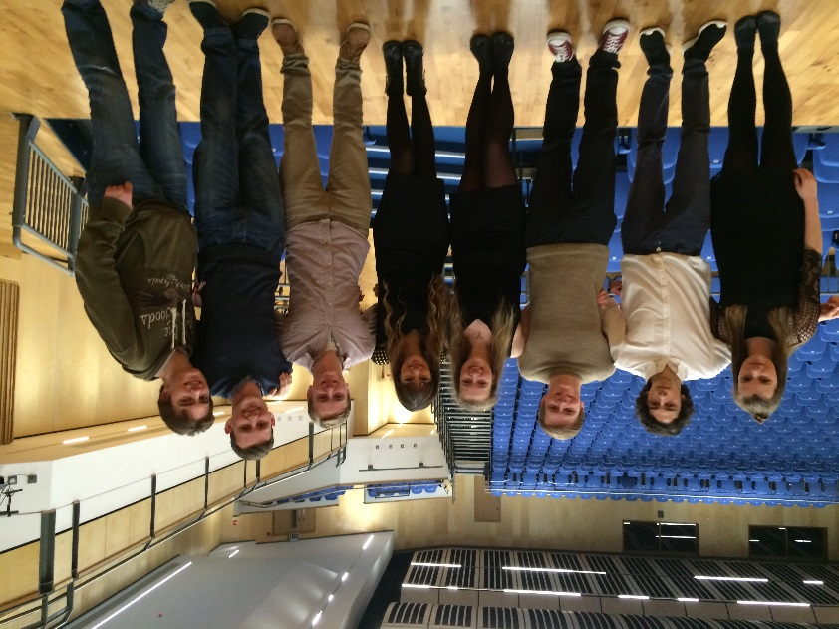Saffron Hall already claims a number of resident ensembles such as The London Symphony Orchestra, The Brodsky Quartet, English Touring Opera and Britten Sinfonia who, along with other professional artists such as Nicola Benedetti work with us. During the past three years, Academy students have taken part in Masterclasses delivered by artists from the Young Classical Artist Trust, Guildhall School of Music and Drama, as well as more established professional musicians such as Janice Watson, Roger Argente and Gary Ryan. This clearly represents an outstanding opportunity to gain advice and tuition from professional musicians of international repute. The academy programme is tailored to specific needs each year but normally covers all instruments and voices in both classical and more popular idioms along with ensemble playing, composition and conducting workshops. In addition, academy students are able to listen to visiting groups in rehearsal, receive free tickets for events in Saffron Hall and the best performers may be invited to join an associate ensemble to extend their repertoire experience. We have worked with The Royal Opera House, Covent Garden to deliver the Gold Arts Award qualification and taken part in exciting outreach projects in other local schools where academy members have worked alongside professional performers and composers. We also have strong links with NYO and Guildhall School of Music, not least through the Saturday morning Saffron Walden Centre for Young Musicians.

Academy students meet Nicola Benedetti

Academy students have the opportunity to regularly make music in a world-class performance venue by joining the most senior of our many ensembles and making a sustained commitment to these. Typically, these are the Senior Jazz Band, Senior Concert Band, Senior Choir, Chamber Choir, Senior String Orchestra or Symphony Orchestra. A number of these ensembles tour to Europe each summer.

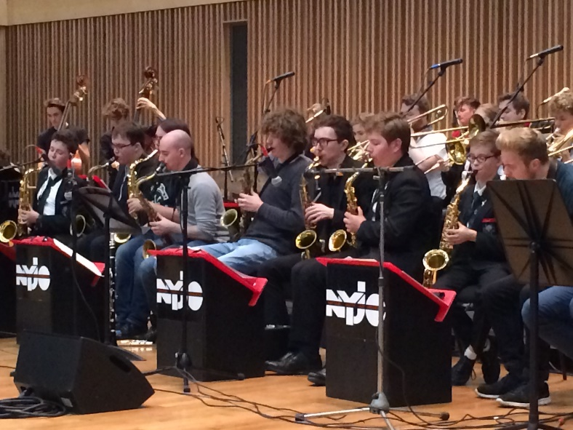

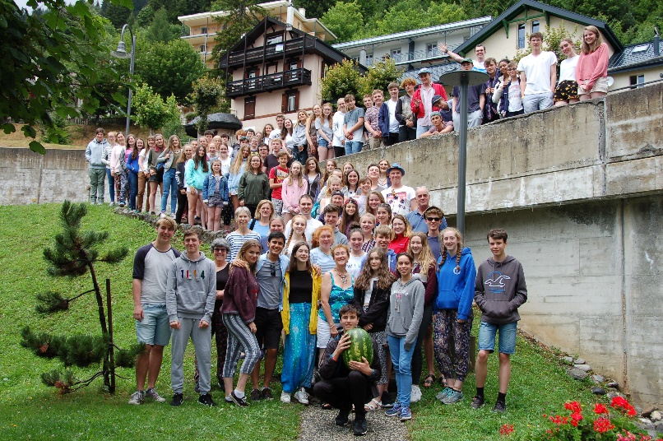

Music Tour 2017

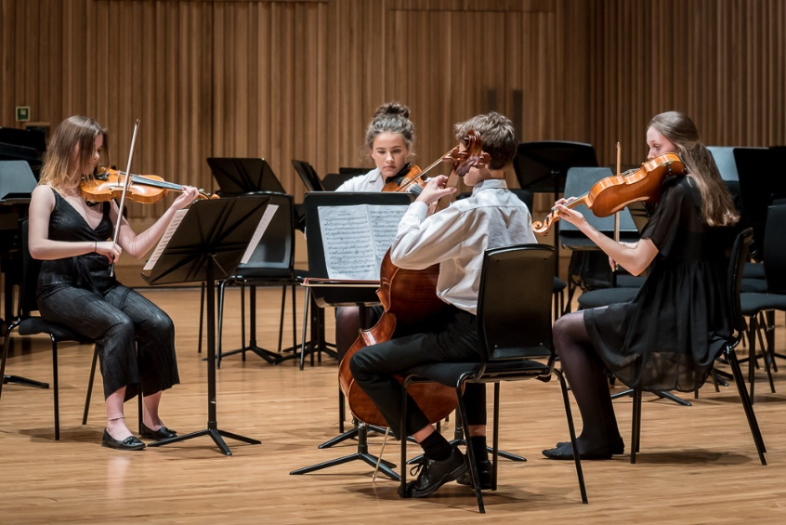All academy students are able to promote their own recitals either in the main hall or as part of our lunchtime series in the Foyer. SWCHS has a team of highly qualified instrumental and vocal teachers and, whilst academy students are free to continue arrangements with an existing teacher, we ensure that those wishing to have their lessons at SWCHS receive excellent tuition. All instrumental and vocal staff will prepare students for ABRSM examinations as required and these take place in school every term.

Senior String Quartet in concert

Each academy student negotiates a Personal Music Development Plan (PMDP) at the start of Year 12 and reviews this on a regular basis with a member of the music staff. This might include measured progression through practical examinations, directing work with a junior ensemble, composing for a specific event or occasion, but will always be tailored to the specific interests and skills of the student.

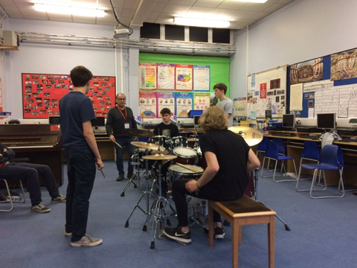

Masterclass with Ralph Salmins

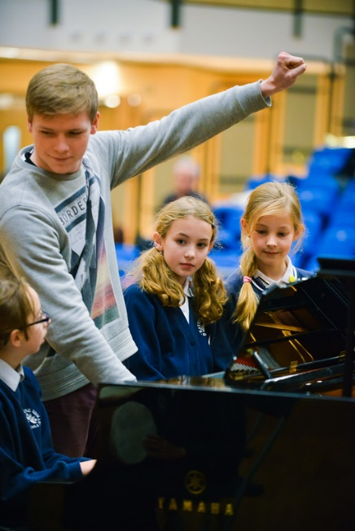In addition to the Masterclass programme, Music Academy students learn leadership skills through delivering an outreach programme in our local primary schools. In the past, we have run summer school programmes alongside players from Britten Sinfonia, developed musical material for a Community Opera commissioned by Saffron Hall with KS2 children and this year, students are working with their instruments to bring to life the story of the ‘Gruffalo’. This will be presented to KS1 pupils in local schools.

Music Academy students delivering their outreach programme

**Admission criteria for SWCHS Post-16 Music Academy**

In addition to the standard academic entry requirements for SWCHS, applicants must have achieved at least Grade 6 at merit or above on any instrument or voice and also have passed Grade 5 theory if not following the ABRSM practical examination series.

**What is expected from Academy students?**

All Academy Members must:

* Attend the Music Academy lessons every week
* Be a regular member of one or more Senior Ensembles
* Agree and adhere to a PMDP
* Participate in the Masterclass programme as appropriate
* Take part in concerts, recitals and festivals as appropriate
* Make a sustained contribution to the wider SWCHS musical community
* Generally seek to maximise the opportunities offered by the Saffron Hall programme and the hall itself

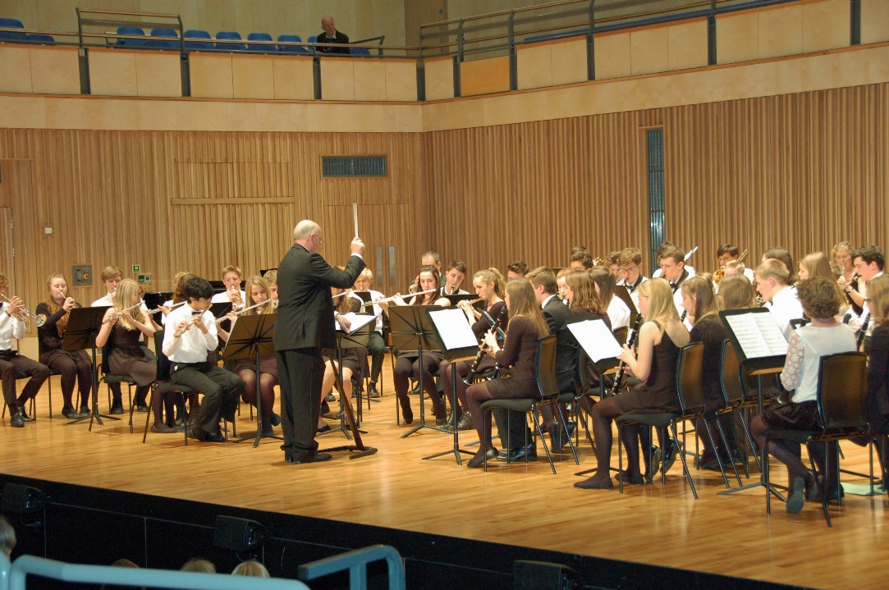

Senior Concert Band in Saffron Hall

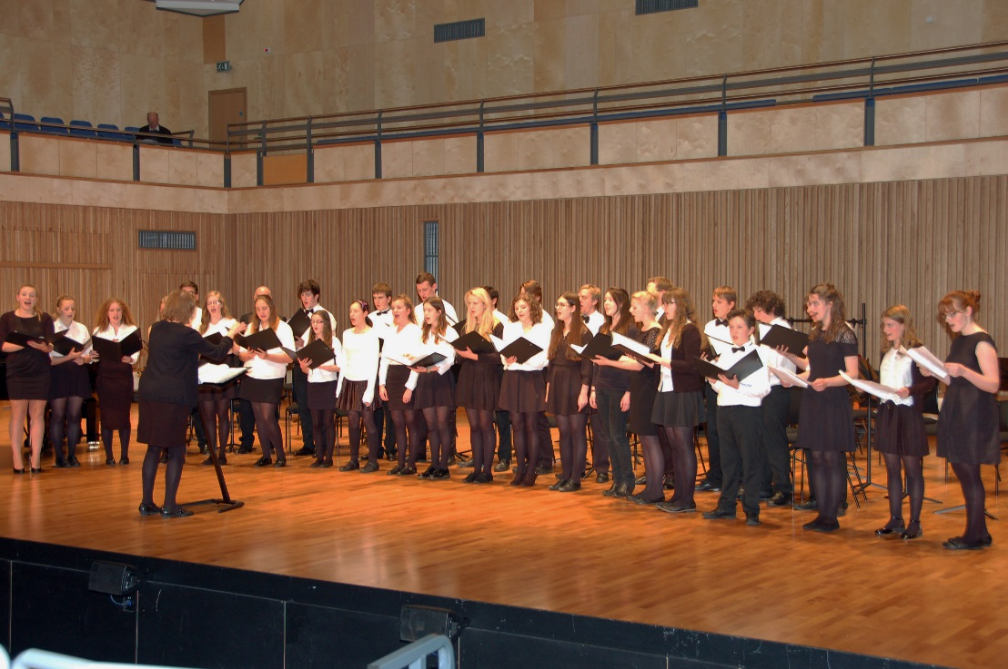

Chamber Choir in concert