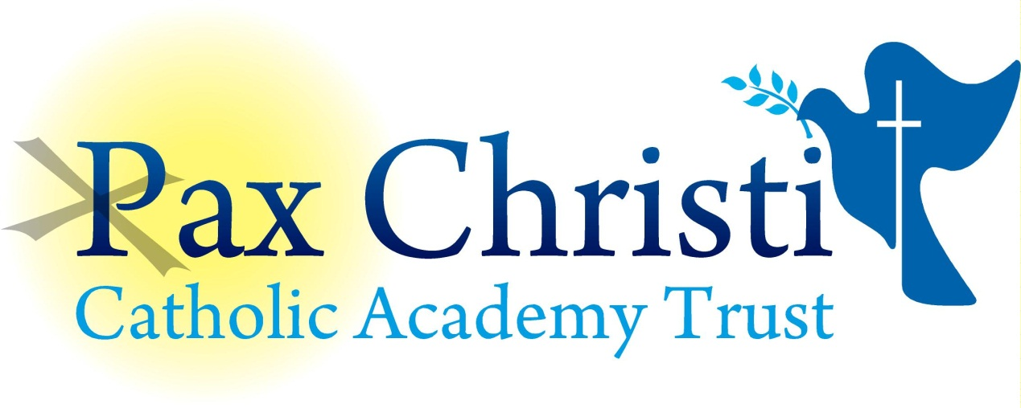

CHRIST THE KING CATHOLIC VOLUNTARY ACADEMY

JOB DESCRIPTION

English Learning Mentor
Grade: 3
18 hours per week term time only

Current Postholder: | Vacancy
Job Description Review Date: | May 2018

Job Purpose
The post holder will ensure pupils achieve their full potential by providing support and assistance which will help pupils to overcome barriers to learning.

The Post holder will work with a range of pupils, many of whom will be from disadvantaged backgrounds and will give priority to those who need the most help. The variety of issues covered will be vast, ranging from punctuality, absence, bullying, challenging behaviour, abuse and low esteem.

The Post holder will provide a range of support services designed to enhance existing provisions, support learning, increase participation and encourage social inclusion.

Line Management
Responsible to: Director of Learning, Principal
Responsible for: N/A

Specific Responsibilities
- Contribute to pupils’ learning and development by:
- Identifying and supporting learning and development needs.
- Developing an appropriate coaching plan to build a relationship designed to engage pupils in order to support improvement.
- Monitoring and evaluating the effectiveness of the coaching support provided.
- Develop appropriate relationships with pupils to engage them in learning and support academic improvement.
- Contribute to and participate in assessment to identify individual barriers to learning.
- Under the guidance of Line Manager develop appropriate strategies, options and alternatives to overcoming barriers to learning.
- Develop, agree and implement a coaching plan with pupils and those involved to set targets, providing meaningful measures of achievement, monitoring progress, identifying additional need and celebrating success.
- Liaise with families and carers to share information about the pupil’s needs and progress as and when appropriate.

- Develop and organise relevant activities to create a stimulating, safe and secure environment to engage children and young people’s in order to support learning.
- Liaise with all relevant staff and any external professionals to ensure understanding, support and commitment to the approaches and strategies being used by the Academic Coach.

- Collate data on pupil progression, produce reports, share information and maintain records to facilitate monitoring and evaluation.
- Work within the Academy’s policies, liaising with teaching/ non-teaching staff and external agencies to support pupils displaying difficult or challenging behaviour drawing from a range of appropriate techniques, skills and strategies.
- Monitor pupils’ conduct and behaviour during individual sessions and take appropriate action when it is required, following the Academy’s Behaviour for Learning policy.
- Attend and participating in relevant training.
- Arrange and run activities designed to support the academic progress of pupils before and after school and during lunch breaks.

Skills and Abilities

The post holder must be educated to GCSE level, and have obtained 5 GCSE’S and ideally GCSE’S in English and Maths (Grade A* to C) must have been awarded and the post holder must be able to demonstrate strong skills in these areas. The post holder will ideally be educated to degree level.
- The post holder will have the ability to communicate, influence, persuade, motivate and engage with a wide range of children/young people, their families and carers in order to achieve maximum engagement by all to support the pupil in achieving their full potential. The post holder will demonstrate good general interpersonal and communication skills.
- The Post holder will have a strong knowledge and understanding of child protection, health, safety and security, confidentiality and data protection, copyright etc.
- The Post holder must have the ability to use ICT for administration and pupil learning.
- The post holder will show a commitment to learn new skills and expand on current skill set and demonstrate a willingness to pass on knowledge and techniques to others.
- The post holder will be able to deal with conflicting demands and work flexibly.

General
The Post holder will;

- Be a positive influence on the climate and culture of the Academy and show a positive example at all times.
- Support the Catholic ethos of the Academy.
- Be aware of and comply with policies and procedures relating to child protection, health, safety and security, confidentiality and data protection, copyright etc. reporting all concerns to line manager.
- Be aware of and support difference and ensure equal opportunities for all.
- Contribute to the overall aims of the Academy.
- Appreciate and support the role of other professionals.
- Attend and participate in relevant meetings as required.
- Participate in training and other learning activities and performance development as required.
- Recognise own strengths and areas of expertise and use these to advise and support others.
- To work in collaboration with other Pax Christi Academies, sharing good practice and supporting during time of absence and/or heavy workload.
This job description contains the main accountabilities relating to this post and does not describe in detail all the tasks required to carry them out. All staff are expected to be flexible to ensure the most effective organisation and delivery of services.
The duties and responsibilities of the post will evolve to meet changes in financial regulations, statutory requirements or the natural development of the Academy and/or Trust. Such changes are, therefore, a normal part of the post and the post holder must be prepared to undertake any other duties commensurate with the general level of responsibility of the post which may be determined from time to time subject to the proviso that any permanent, substantial changes shall be incorporated into the job description and evaluated as such.

