# TONBRIDGE SCHOOL

**Teacher of Economics**

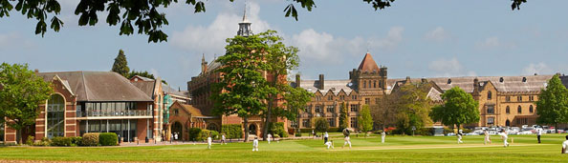

Tonbridge School is one of the leading boys' boarding schools in the country and is highly respected internationally.

The school aims to provide a caring and enlightened environment in which the talents of each individual flourish. We encourage boys to be creative, tolerant and to strive for academic, sporting and cultural excellence. Respect for tradition and an openness to innovation are equally valued.

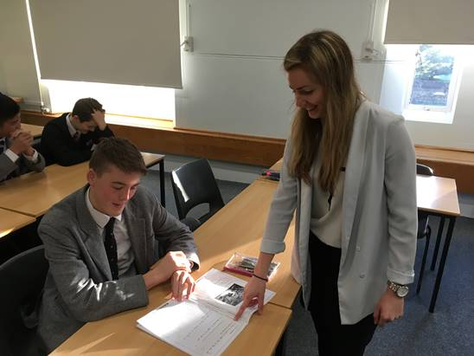 A well-established house system at the heart of the school fosters a strong sense of belonging. Tonbridge seeks to celebrate its distinctive mixture of boarders and day boys; this helps to create a unique broadening and deepening of opportunity. We want boys to enjoy their time here, but also to be made aware of their social and moral responsibilities. Tonbridgians should enter into the adult world with the knowledge and self-belief to fulfil their own potential and to become leaders in their chosen field. Equally, we hope to foster a life-long empathy for the needs and views of others; in the words of the great novelist and Old Tonbridgian E.M. Forster: 'Only Connect'.

**Remuneration and Benefits**

The Tonbridge Salary scale is highly competitive (approximately £31k-£62k) with new members of staff starting at the point on the salary scale which is appropriate to their experience.

Additional benefits include:

* Accommodation. Available if required, with properties – from one-bedroom flats to large family homes, all within an easy walk of the school – allocated according to need. Alternatively, the school offers a generous living out allowance to those who wish to purchase their own property in the area.
* The school will contribute towards removal expenses for the successful candidate;
* Sons of permanent members of staff may be educated at reduced fees as boys at the school, subject to satisfaction of the entry requirements. A reciprocal arrangement exists with a local independent girls’ school which enables the daughters of permanent members of staff to be educated there at reduced fees;
* Some local prep schools offer fee concessions for the children of Tonbridge staff;
* The school strongly encourages staff to attend CPD and provides a large budget to facilitate this;
* Private health insurance, on a group scheme;
* Membership of Teachers Pension Scheme
* Reduced membership rates of the Tonbridge Sports Centre for staff and their families;
* All teaching staff are provided with a Microsoft Surface Pro laptop;
* Lunch is provided during term-time.

**Location**

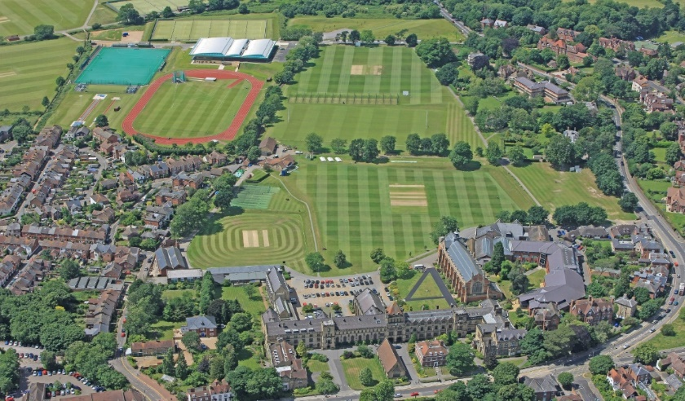Tonbridge School is situated on a campus of 150 acres in the town of Tonbridge in West Kent. The school is placed at the top of the High Street of the town and is surrounded by outstandingly beautiful Kent countryside. Transport links are excellent. Tonbridge is the junction for railway lines to London (approx. 40 minutes to London Bridge, Waterloo East, Charing Cross, 60 minutes to Victoria), Hastings, Ashford International, Canterbury, Dover and Redhill. The M25 and M20 are a short drive from the School. Heathrow, Gatwick and Stansted airports are easily reached, as are the Channel Tunnel and ferry terminals. It is a short drive to the neighbouring towns of Sevenoaks and Tunbridge Wells. Tonbridge has been ranked 16th in the UK’s “best places to live”. This is based on the results of the annual Halifax quality of life study which looks at a range of factors including health, earnings, crime rates and life expectancy: <http://www.bbc.co.uk/news/uk-england-42377578>

**The Social Science Faculty**

An experienced and enthusiastic graduate is sought from September 2019 to join our highly-respected Social Science Faculty to be a teacher of Economics. The ability to provide Politics teaching would be advantageous but is not essential. A PGCE is not essential as training can be provided “on the job” to a suitably qualified candidate.

The Social Science Faculty is made up of three departments, Economics, Business, and Politics, all of which are only taught at A level. Economics is the second-biggest Sixth Form subject area in the school, with approximately 130 students. Business is taken up by a smaller body of boys, typically 40, whilst Government & Politics is studied by around 65 boys each year. The Faculty therefore provides a significant majority of Sixth Form boys with at least one course. It is made up of nine members of staff, all of whom teach, or have taught, more than one of the three subjects, and is located in the heart of the school with eight dedicated teaching classrooms, all of which are Wi-Fi enabled and have smart TV screens.

The AQA A level Economics course is studied. The results are strong, with 94% A*/A/B grades in Economics in the past five years of summer exams (77% A*/A grades). Economics classes are shared between two teachers, who split Micro and Macro teaching, and they typically range in size from 9 to 12 boys. One in four boys studying Economics currently go on to read an Economics-related subject at University, and we regularly send boys to Oxford and/or Cambridge for Economics-related courses.

The Politics Department is focused on the new Edexcel A level course. In the last five years, the average performance has been very good with 90% A*/A/B grades achieved (68% A*/A grades). A focused team is in place, with three teachers delivering the course. Each set is taught by two of these. Politics related courses at university were the second most popular amongst the 2018 cohort – approximately two thirds of the year went on to study something in this area.

Tonbridge School prides itself on its extra-curricular activities and the Faculty is no exception. Last year the Social Science Faculty hosted an IEA Conference at the school at which students from Tonbridge School and local schools listened to speakers on such topics as ‘Is there such a thing a gender pay gap?’ and ‘The Economics of Football’. More regularly, all staff members are expected to offer extra-curricular extension sessions, depending on their area of interest/expertise, and an international trip is run, including a Business and Economics trip to China (2018) and a planned Politics trip to the USA (2019). In the spirit of empowering the boys, there is also a student-run social science society called ISOS that has hosted a range of speakers, from George Galloway to former Apprentice contestant Solomon Akhtar.

**Tonbridge School**

**Job description for Teaching Staff**

**Reporting to: Head of Department (& Housemaster, if also a tutor) and ultimately the Headmaster**

**Main Purpose:** Teaching to the highest possible professional standardsand supporting and upholding the [Aims and Ethos](https://www.tonbridge-school.co.uk/about-the-school/school-management/ethos-aims-and-strategy/) of the School. To be familiar with, and to operate effectively, the many and various policies and systems by which the pupils are cared for and the School is managed.

The Job Description below is, of necessity, brief. Further details of school systems will be provided to the appointed person in various handbooks associated with this post:

* The Common Room handbook
* The Academic handbook
* The Tutor handbook (most new staff are asked to be a tutor)
* The Pastoral handbook (for those with pastoral responsibilities)

The full job description is the sum of all the tasks mentioned in these handbooks as might reasonably apply to a rank and file teacher. What follows is thus a summary of these tasks.

**MAIN DUTIES AND RESPONSIBILITIES**

**Teaching and associated activities**

1. Teaching a range of classes as specified by the Head of Department, who will balance the needs of the pupils and those of the members of the other teaching staff in the department with those of the post-holder, taking into account the particular skills and expertise of the departmental staff.
2. Teaching up to a notional maximum of 56 out of 72 forty minute periods per fortnight, for a full time teacher. It is occasionally necessary to teach more than this in a particular year but every effort will be made not to allow this to persist for more than one academic year.
3. Planning lessons to ensure that departmental schemes of work are effectively covered via interesting, engaging activities, which take account of the differing needs of the pupils in the class.
4. Assessing the work of the pupils according to the departmental and school assessment and marking policies so as to measure progress and inform planning of appropriate lessons. Making pupil marks available to the Head of Department and to other senior colleagues when required.
5. Making use of the rewards and sanctions systems.
6. Reporting on the work of the pupils to parents and pastoral staff via the systems set out in the Common Room handbook.
7. Taking part in Parents’ Evenings.
8. Providing comments on University Applicants for those compiling references.

**Co-curricular activities (including Games)**

Teaching staff are expected to lead and participate in a variety of these activities according to the expertise and interests of the member of staff. No specified commitment is required other than an expectation of involvement at an appropriate level. Training is often available. Enthusiasm and an interest is the key here.

**Pastoral Matters (Tutoring)**

Most teachers are also tutors to a year group within a House, typically a dozen or so boys. Details of what is involved are given in the tutor handbook.

**Other duties**

1. “Duty teams”: being a member on a rotating basis of a team of four staff who carry out various supervisory duties as specified by the Second Master; including, for instance, supervising the road crossing outside the Avenue Entrance at 8.25 a.m., supervising the Orchard Centre Café during morning break, etc.
2. Participating in the “Novi Visit” just after the end of the Lent Term unless engaged in other School activities at this time.
3. Other duties that the Headmaster or Senior Colleagues might reasonably request.

**About Tonbridge School**

**History**

Tonbridge School was founded in 1553 by Sir Andrew Judde. The Charter ordained that the Governors of the school after the death of the Founder were to be the Worshipful Company of Skinners, one of the oldest City Livery Companies. Sir Andrew, himself a distinguished member of this Company, left property in the City of London and in the parish of St Pancras as an endowment for the school. The income from these estates is at the disposal of the Governors for the general benefit of the School. The Skinners Company, especially through the Governors, is still heavily involved in the day to day life of the School.

**The School Facilities**

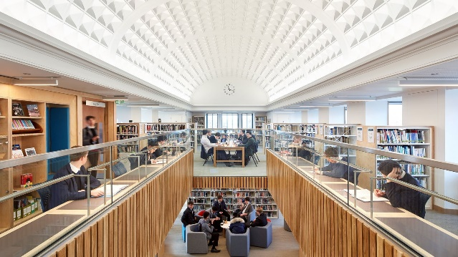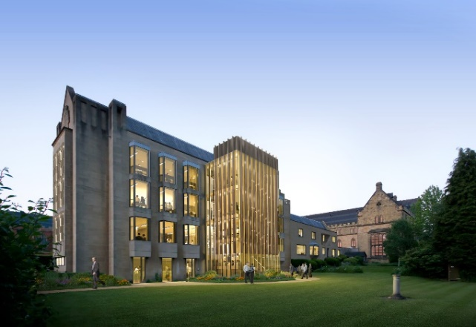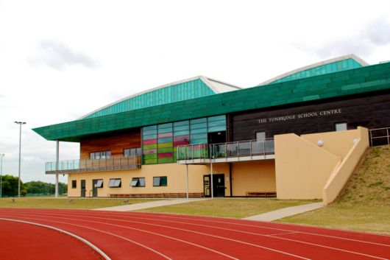Tonbridge is a school with enviable facilities. The buildings are a fine blend of old and new. There is a dedicated music school, an art and DT centre and the E. M. Forster theatre, often used for theatrical and musical events for the general public as well as the school. The newly refurbished Library is central to the boys’ experience of the school. The school is currently building an exciting new state of the art Science facility, due to open in the spring of 2019. The sporting facilities are outstanding. The cricket, rugby and football pitches are well known as some of the finest school pitches in the country and the Hockey astro pitches are among the best of their kind. A second Rackets court was recently built – the first new court built in England for over a century. The outdoor basketball court was opened in 2017. The superb Sports Centre was opened in 2008 by Lord Coe. There is an indoor 25m swimming pool and a full-size athletics track and field facility. The school was chosen by the Australian Athletics team as its training base for the London 2012 Olympic and Paralympic Games and again for the 2017 World Championships. Three floodlit clay tennis courts were opened in the summer of 2015.

**Academic Life**

The School is academically very strong and offers a wide range of subjects for GCSE and A level or Pre-U. In 2017 the School achieved excellent GCSE results with 87% of all grades being A* or A. At A level over two thirds of grades were A* or A or Distinction for Pre-U subjects.  Typically, between 25 and 40 boys win places at either Oxford or Cambridge Universities. Applications to overseas universities are increasingly common.

**The House System**

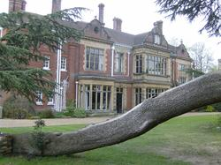Tonbridge has a federal system of school Houses. There are twelve of these, seven boarding and five day. Boys often identify very strongly with their house in their time at Tonbridge. The boys of a House eat their meals together and there is an extensive programme of House competitions for sport, music, art and debating. All the Houses, day and boarding, have their own buildings with study and recreation areas. Each House has its own resident Housemaster and several House tutors who oversee the pastoral and academic care of the boys.

**Co-Curricular Life**

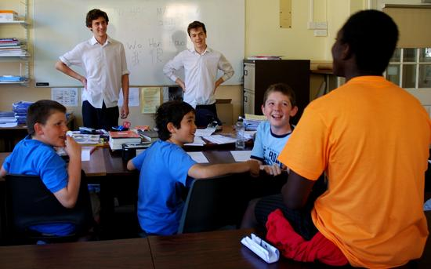Tonbridge School aims to provide an unsurpassed education of excellence and breadth.  We focus our efforts and resources on achieving this by offering, amongst other things, a vibrant and balanced programme of Co-Curricular Breadth and Depth. Involvement in sport, music, art, drama and many other activities underpins a culture of creativity, innovation and excellence. The Co-Curricular programme also provides opportunities for service to others, and the development of self-reliance and leadership skills. This ranges from a full CCF programme to Community Service, Conservation to Music, Social Entrepreneur programmes to the annual full School Charities Day. Outreach is an important part of our work.

*Sixth Formers with primary schoolchildren on Charities Day*

**Sporting Life**

Tonbridge is well known as a school which offers a broad range of sport to its pupils. In addition to the traditional sports of cricket, rugby and hockey there are around twenty other sports offered ranging from football to badminton, rackets to cross country, golf to ultimate Frisbee. All boys are encouraged to take a full and active part in the sporting programme and competition at both inter-school and inter-house level is fierce. A number of Tonbridgians have carried on to professional sporting careers, particularly in cricket and rugby.

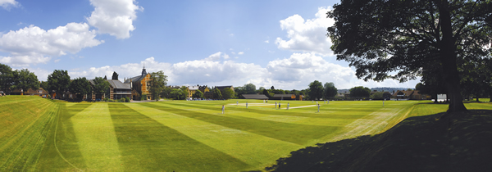

*Cricket played on the Head – the First XI pitch.*



*Colts rugby in action*

**Application Process**

**Tonbridge School is committed to safeguarding and promoting the welfare of children and applicants must be willing to undergo child protection screening appropriate to any post, including checks with past employers and the Disclosure and Barring Service.**

Applications forms, accompanied by a short handwritten letter of application, a current curriculum vitae and the names, addresses, and contact details of three referees, should be made by noon on Wednesday, 14th November 2018 to the Headmaster, Tonbridge School, Tonbridge, Kent, TN9 1JP. Tel: 01732 365555, Email: [jenny.bishop@tonbridge-school.org](mailto:jenny.bishop@tonbridge-school.org)

Website: [www.tonbridge-school.co.uk](http://www.tonbridge-school.co.uk)

**Please make it clear in your letter whether your second subject is Business or Politics (or both), or neither.**

**Note we reserve the right to appoint earlier than September 2019.**

The application form may be found on the Employment Opportunities page of the website: <https://www.tonbridge-school.co.uk/about/employment-opportunities>

A willingness to take part in the wider life of a boarding school is essential and candidates are asked to give an indication of their interests in their letter of application.

It is the post-holder’s responsibility for promoting and safeguarding the welfare of children and young persons for whom he or she is responsible, or with whom he or she comes into contact, and so to adhere to and ensure compliance with the school’s Safeguarding and Child Protection Policy, and the Staff Code of Conduct at all times. If, in the course of carrying out the duties of the post, the post-holder becomes aware of any actual or potential risks to the safety or welfare of children in the school, he or she must report any concerns to the school’s Designated Safeguarding Lead or to the Headmaster.

The selection process will involve spending a day at the School, on **Wednesday 21st November**, along with consideration of references.

The day will consist of:

* a tour of the School taken by a Sixth Former and lunch in a Boarding House
* teaching a 40-minute lesson, the topic to be agreed with the Head of the Social Science Faculty who will contact shortlisted candidates
* an interview with the Headmaster and Second Master
* an interview with the Director of Studies and the Upper Master
* an interview with the Director of Teaching and Learning and the Head of Social Science.
* a chance to meet members of the Faculty.

Details of the members of the Senior Team can be found on the website:

<http://www.tonbridge-school.co.uk/about-the-school/school-management/>