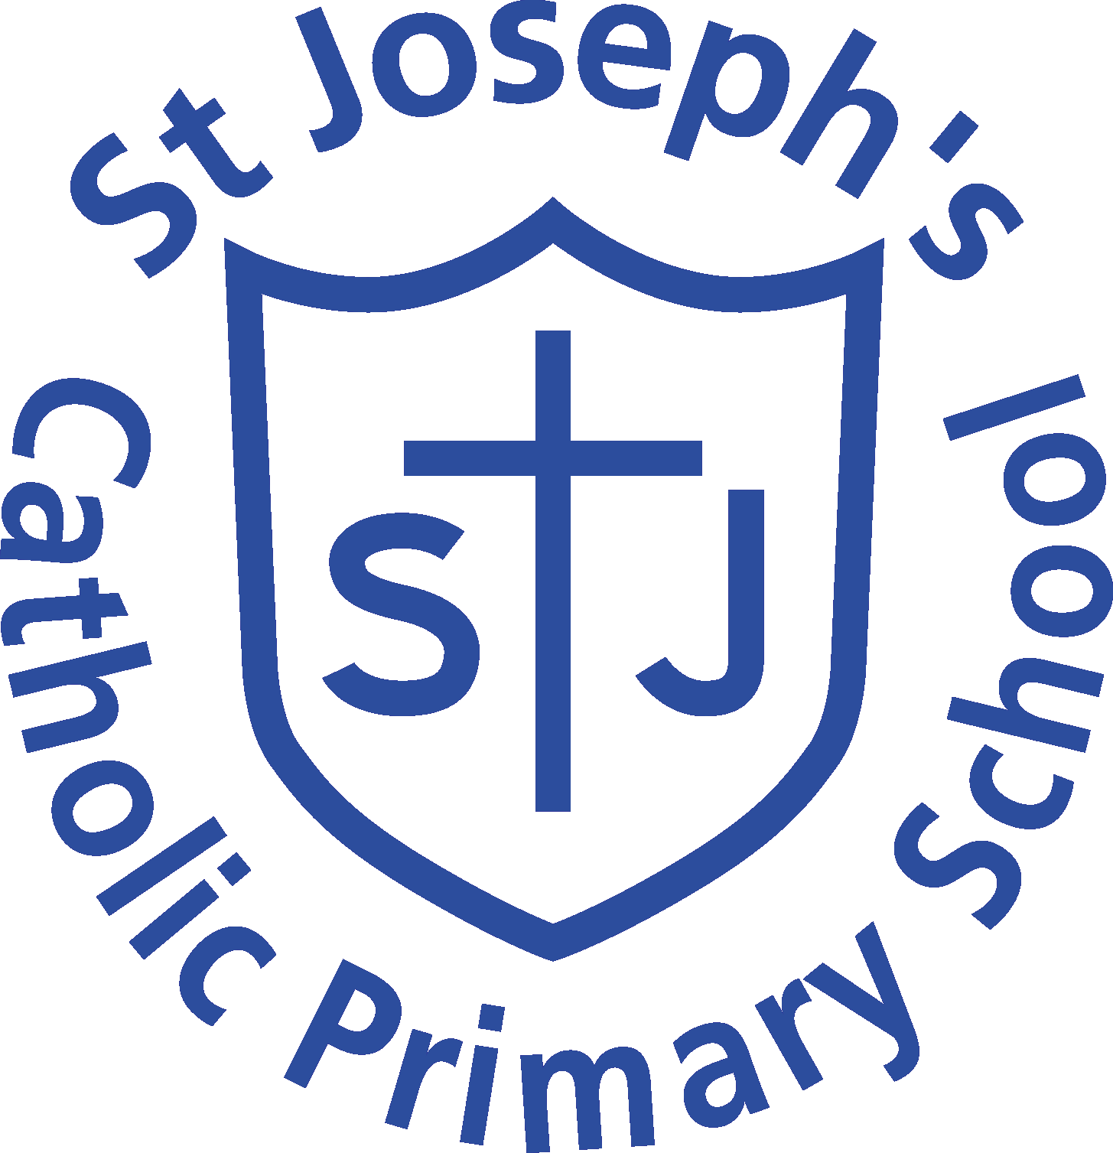

Advert

Job Title: Learning Support Assistant

Salary: BR3 Spinal Point 3 (FT Equivalent £24,012)

Hours: 28.33 hours per week (T erm time only)

Contract type: Permanent (until child leaves)

Reporting to: Head Teacher / Class Teacher / SENCo

Summary of Role

We are looking to recruit a Learning support Assistant (ISA) to assist in promoting the learning and personal development of an individual child, to enable them to make best use of the educational opportunities available to them.

The successful applicant must have completed at least Level 2 or 3 Certificate in Supporting Teaching and Learning in Schools. Level 3 Diploma in Childcare and Education, or other relevant qualification in childcare.

Please see the attached Job Description for details of responsibilities.

Visits to the school are strongly encouraged.

If you would like to contact the school please call the office on 020 8460 1976 or liaise with Mrs Nolan via email: admin@st-josephs.bromley.sch.uk .

This post is subject to a satisfactory Enhanced DBS Check and references. St Joseph’s Catholic Primary School is committed to safeguarding and promoting the welfare of children and young people and expects staff and volunteers to share this commitment. CVs will not be accepted; therefore a St Joseph’s Catholic/CES Application Form must be completed for all applications.

Closing date for the post is Monday 6th March 2023 at 12 midday

Interviews will be held on Wednesday 8th March 2023.

