
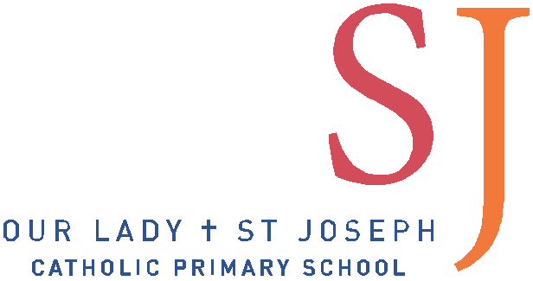
Our Lady & St Joseph Catholic Primary School

Person Specification: Class Teacher

Our Lady & St Joseph Catholic Primary School is committed to safeguarding and promoting the welfare of children and young people and expects all staff and volunteers to share this commitment

 | Essential | Desirable
Qualifications | Qualified Teacher Status | Evidence of continuous INSET and commitment to further professional development
Experience | The Class Teacher should have experience of:  - Teaching across the whole Primary age range | In addition, the Class Teacher might have experience of:  - Working in partnership with parents  - Working in a Church School  - Teaching mixed classes
Knowledge and understanding | The Class Teacher should have knowledge and understanding of:  - The theory and practice of providing effectively for the individual needs of all children (eg classroom organisation and learning strategies)  - Knowledge of teaching synthetic phonics and developing children’s early reading and writing skills.  - The monitoring, assessment, recording and reporting of pupils’ progress (including learning journals & online assessment tools)  - The statutory requirements of legislation concerning Equal Opportunities, Health & Safety, SEND and Safeguarding Children  - The positive links necessary within school and with all its stakeholders  - Effective teaching and learning styles | In addition, the Class Teacher might also have knowledge and understanding of:  - The preparation and administration of statutory National Curriculum tests  - Knowledge of the New EYFS framework and Early Learning Goals
Skills | The Class Teacher will be able to:  - Promote the school’s aims and Catholic ethos positively and use effective strategies to monitor motivation and morale  - Develop good personal relationships within a team  - Establish and develop close relationships with parents, governors and the community  - Communicate effectively (both orally and in writing) to a variety of audiences  - Create a happy, challenging and effective learning environment both inside the classroom and in the outdoor area.  - Adapt planning based on children’s needs and next steps. | In addition, the Class Teacher might also be able to  - Develop strategies for creating community links  - Assess the children reflectively based on the new EYFS framework (all areas of learning)
Personal characteristics | - Good communication skills  - Approachable  - Committed  - Enthusiastic  - Able to motivate self and others  - Calm under pressure  - Flexible  - Well-organised and able to direct support staff efficiently and effectively  - Work effectively as a member of team

