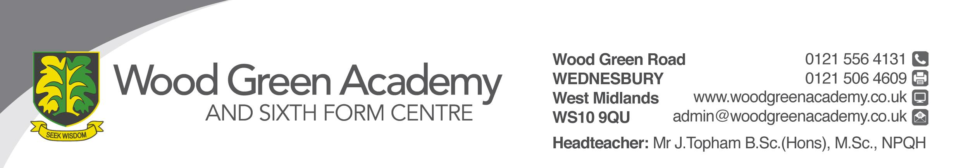
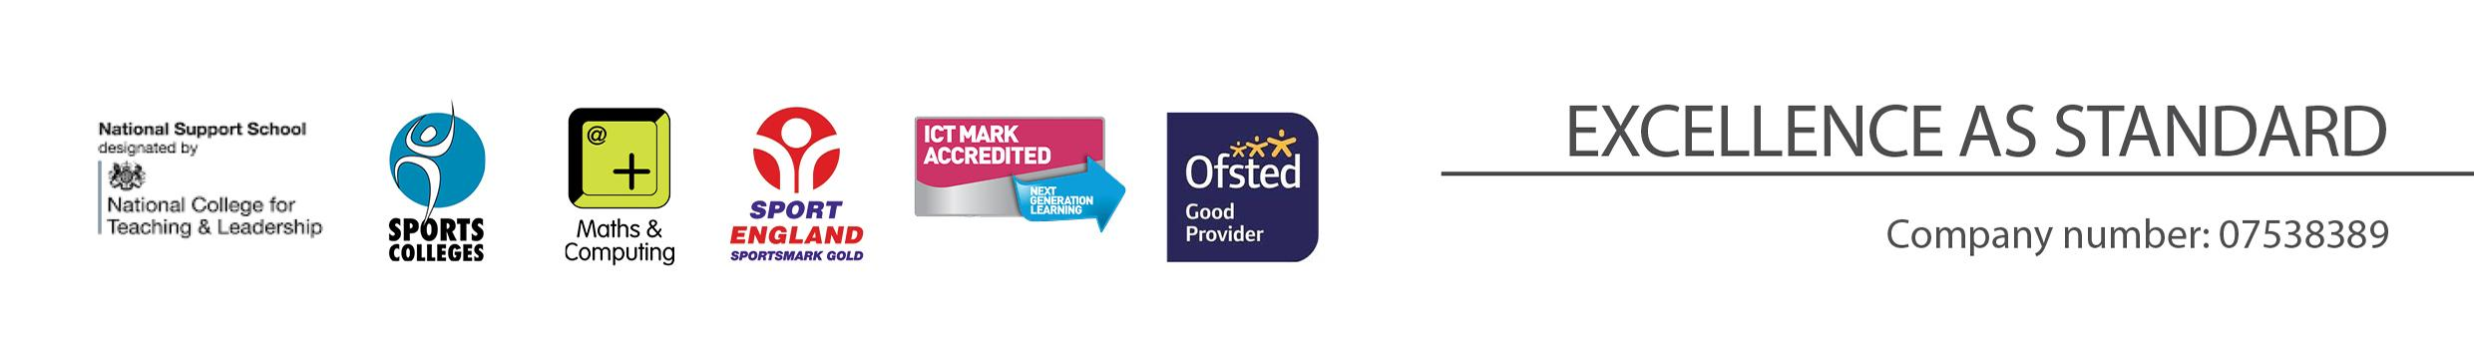
Website Content Creator
Person Specification

REQUIREMENT | ESSENTIAL | DESIRABLE
LEGAL REQUIREMENTS | Enhanced DBS Clearance
QUALIFICATIONS  Principally assessed through letter and application form | GCSE A* - C in English and Maths or equivalent.  Portfolio of work | Graphic design training an advantage.
EXPERIENCE and PROFESSIONAL COMPETENCE  Principally assessed through letter, application form | Experience using Adobe Creative Suite and other desktop publishing software.  Experience with web design and HTML.
KNOWLEDGE  Principally assessed through letter and interview process | Adobe Creative Suite  Excellent ICT Skills  HTML and CSS  Word processing | Microsoft SharePoint and Teams sites
COMMUNICATIONS  Principally assessed through letter and interview process | Excellent communication skills – written and verbal, to a wide range of audiences i.e. Staff, Students, Parents/Guardians, External Institutions  Accurate and precise with an attention to detail  Ability to interpret information while maintain external and internal procedures.  High standard of presentation.
PERSONAL ATTRIBUTES  Principally assessed through references, letter and interview process | To be committed to safeguarding and promoting the welfare of children and young people.  Enthusiasm, energy, vigour, reliability and integrity  Interpersonal skills that equip the appointee to relate effectively to members of staff, students, parents and external partners.  Ability to work under pressure, accurately and meet deadlines.  Ability to manage a range of priorities and prioritise responses.  Flexibility and willingness to be involved in the school.  Committed to continuing to learn through professional development.  Work effectively as a member of a team  Be an effective role model through presentation and personal conduct

