
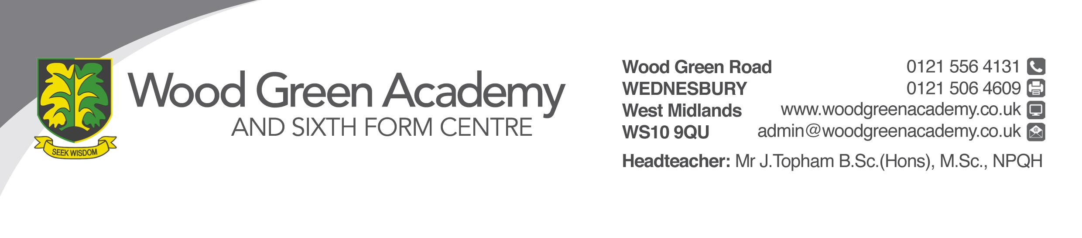

Job Description

POST: Website Content Creator
SALARY SCALE: Band C (pro-rata if term time only)
CONTRACT: Permanent Full time or term time only (negotiable)

General Duties:
Design, maintain, create and update the School website and any content for it. Create and design any promotional materials for the school (print and digital). Maintain and update the School’s social media and App.
Photography and video within school, for use in any promotional materials, website or learning resources. Parent portal users and support.
To whom responsible: IT Manager
Detail of duties and responsibilities:
Website:
- Monitor and update the school website on a daily basis.
- Develop and evolve the look and feel of the website to meet the needs of its users.
- Keep up to date with web standards.
- Liaise with key members of staff regarding the content of the school website.
- Make sure the website is up to date with all Ofsted and DFE Checklists
- Design and create content for the ITT area of the website.

Promotional materials:
- Prospectus, leaflets, banners and all other promotional materials in and out of school
- Continue to develop the brand and identity of the school when creating promotional materials.
- Create and / or post promotional materials for the recruitment of Initial Teacher Trainees and Wood Green staff.
- Liaise with local newspapers and media, providing them with content for promotion of the school.
- Work closely with any external printing companies to ensure a high standard, value and all deadlines are met.

Academy Social Media and App
- Create engaging, informative content to keep people informed with what is happening at the Academy.
- Monitor and manage Social Media channels ensuring all posts and content is appropriate and relevant.

Photography and video:
- Capturing and editing of Photographs and Video for use in promotional materials, website and social media platforms.
- Making sure that all images captured comply with parental permissions information.

Sharepoint
Update content on staff and student hub
Learning Resources:
- Liaise with key members of staff to develop creative and useful learning resources
- Upload learning resources to the appropriate platforms

School TV Screens
- Create content
- Monitor quality and relevance of content

Keep up to date with new developments in software applications, digital and social media trends.
Other:
- The post holder must at all times carry out his/her responsibilities with due regard to the Academy's policy, organisation and arrangements for Health and Safety at Work.
- The post holder must at all times carry out his/her responsibilities with due regard to the Academy’s policy on equality and be sensitive and caring to the needs of the disadvantaged, promoting a positive approach to a harmonious working environment. You should act as an exemplar on these issues in line with this policy, the Equality Standard and obligations under the Race Relations (Amendment) Act 2000.
- The post holder must attend any necessary training.
- Any other duty that may be appropriate to achieve the objectives of the post commensurate with the post holder’s salary grade, abilities and aptitudes.
- This job description may be amended at any time in discussion between the Headteacher and the post holder, but in any case, will be reviewed before the commencement of the next Performance Management cycle.

Signed _______________________ Date _________________

Signed ________________________(Headteacher) Date __________________

